Software Requirements Specification

for

Flex Tracker

**Version 1.0**

**Prepared by**

**Group Name: Hambone Industries**

|  |  |  |
| --- | --- | --- |
| **Justin Largent** | **2125997** | **justinlargent@letu.edu** |
| **David Bergman** | **2134452** | **davidbergman@letu.edu** |
| **Robert Willadsen** | **2128300** | **robertwilladsen@letu.edu** |
|  |  |  |
|  |  |  |

|  |  |
| --- | --- |
| **Instructor:** | **Dr. Brent Baas** |
| **Course:** | **COSC3403 Software Engineering I** |
| **Date:** | **3 February 2017** |
|  |  |

Contents

Table of Contents

1 Introduction 4

1.1 Document Purpose 4

1.2 Product Scope 4

1.3 Intended Audience and Document Overview 4

1.4 Definitions, Acronyms and Abbreviations 4

1.5 Document Conventions 4

2 Overall Description 5

2.1 Product Perspective 5

2.2 Product Functionality 5

2.3 Users and Characteristics 5

2.4 Operating Environment 5

2.5 Design and Implementation Constraints 6

2.6 User Documentation 6

2.7 Assumptions and Dependencies 6

3 Specific Requirements 6

3.1 External Interface Requirements 6

3.1.1 User Interfaces 6

3.1.2 Software Interfaces 6

3.1.3 Communications Interfaces 6

3.2 Functional Requirements 6

3.3 Behaviour Requirements 7

3.3.1 Use Case View 7

4 Other Non-functional Requirements 7

4.1 Performance Requirements 7

4.2 Safety and Security Requirements 7

4.3 Software Quality Attributes 7

**Revisions**

|  |  |  |  |
| --- | --- | --- | --- |
| **Version** | **Primary Author(s)** | **Description of Version** | **Date Completed** |
| 1.0 | David Bergman  Robert Willadsen  Justin Largent | This is the first Requirements specification version for the project. | 02/08/17 |

# Introduction

## Document Purpose

This document specifies software requirements for the Flex Tracker. This document covers the software requirements for the whole document.

## Product Scope

This software will allow students to check their flex money balance at any time, instead of the current method of making a purchase. The app should be accessible online, such as my.letu.edu or the buzz app.

## Intended Audience and Document Overview

The intended audience for this document is the professor, client, and developers. Clients should read the introduction and overall description of the software specifications. Developers should read the overall description and the specific requirements as well as the non-functional requirements.

## Definitions, Acronyms and Abbreviations

Flex money - money used to purchase food or meals at LeTourneau University through the company Bon Appetit.

LetNet - LeTourneau University’s network

MyLetu – website for students and faculty to check information related to LeTourneau

## Document Conventions

This document follows the IEEE formatting requirements. Arial font size 11, or 12 will be used throughout the document for text. Use italics for comments. Document text will be single spaced and maintain the 1” margins found in this template. Section and Subsection titles will follow the template.

# Overall Description

## Product Perspective

This product will be built on the already-existing my.letu.edu website with the intention of expansion of the current system for the betterment and increased quality of life of the average LeTourneau student. This web-page will directly interface with the Bon-Appetit database and extract information for each student upon request.

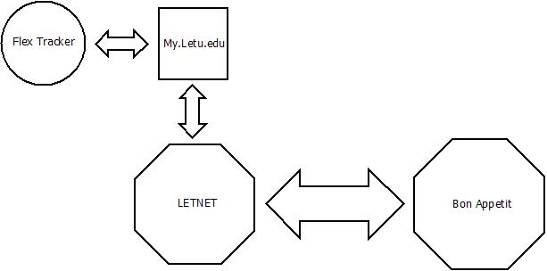

## Product Functionality

* Retrieves flex amount from server
* Displays it to student

## Users and Characteristics

Students: Students using the meal plan through LeTourneau will be the main users for this feature.

## Operating Environment

This project will be operating within the letnet system, and will be accessible by the students through the my.letu.edu website. The only system requirements that the user will need is a decent connection to the internet.

## Design and Implementation Constraints

The Flex Tracker will need to interface with the Bon Appetit database and work within the limitations of MyLETU.

## User Documentation

We may need to write a description of where the tracker is in MyLETU and how to navigate there to access the information.

## Assumptions and Dependencies

First, we assume that there is a way to interface with the Bon Appetit database that we can implement. Second, we assume that there are certain fields in that database such as Number of Meal Swipes Left, Balance Remaining, etc.

# Specific Requirements

## External Interface Requirements

### User Interfaces

The user interface will just be a display of the current flex balance, and the weekly meals remaining. The user can refresh the web page to get an updated balance and meals.

### Software Interfaces

The product will interface with the database that keeps track of flex money. It will also need to interface with LeTourneau’s system to confirm user login.

### Communications Interfaces

The product will be accessed via a web browser and the information will be displayed via HTTP. The database will be read over a TCP connection.

## Functional Requirements

* Pull data from database
* Display data to user

## Behaviour Requirements

### Use Case View

# Other Non-functional Requirements

## Performance Requirements

The program should not take longer than a normal webpage to load the flex money data.

## Safety and Security Requirements

* Display only the student’s meal information
* Display data after authentication
* Authentication will be done by LeTourneau credentials

## Software Quality Attributes

The program should be available to all students at LeTourneau University. The program should display correct flex money information to the student.