For every recorded conformation, we calculate the number of isopropanol molecules in contact with each protein residue, deemed as the isopropanol occupancy for each protein residue. Then, we perform an average over all conformations in the 100ns trajectory except for the first 10ns. We take advantage of the fact that the average number of isopropanol molecules in contact with the protein saturates in the 15-30% volume concentration range (Fig. 1) in order to average the occupancies in this concentration range. There are 39 residues with a high average occupancy, equal or higher than 1.0 (Fig. 2a). There are six residues with a very high average occupancy, equal or higher than 1.9 (Fig. 2b).
A high isopropanol occupancy may be the result of many, short-lived contacts, or the result of few, long-lived contacts between isopropanol and protein. To distinguish between these scenarios, we calculate the residence lifetime of each contact between an isopropanol molecule and a particular protein residue. Of all the contacts that a particular residue participates in, we select the contact with the maximum residence lifetime observed in the simulations spanning the 15%-30% volume concentration range. There are 32 residues with an isopropanol bound for more than 5ns (Fig. 3a) and nine residues with an isopropanol bound for more than 7ns (Fig. 3b). We do not observe any isopropanol bound to the protein for more than 10ns, in agreement with results of X-Rays of DHFR soaked in isopropanol, where no crystallographic isopropanol was found under 30% volume concentration.

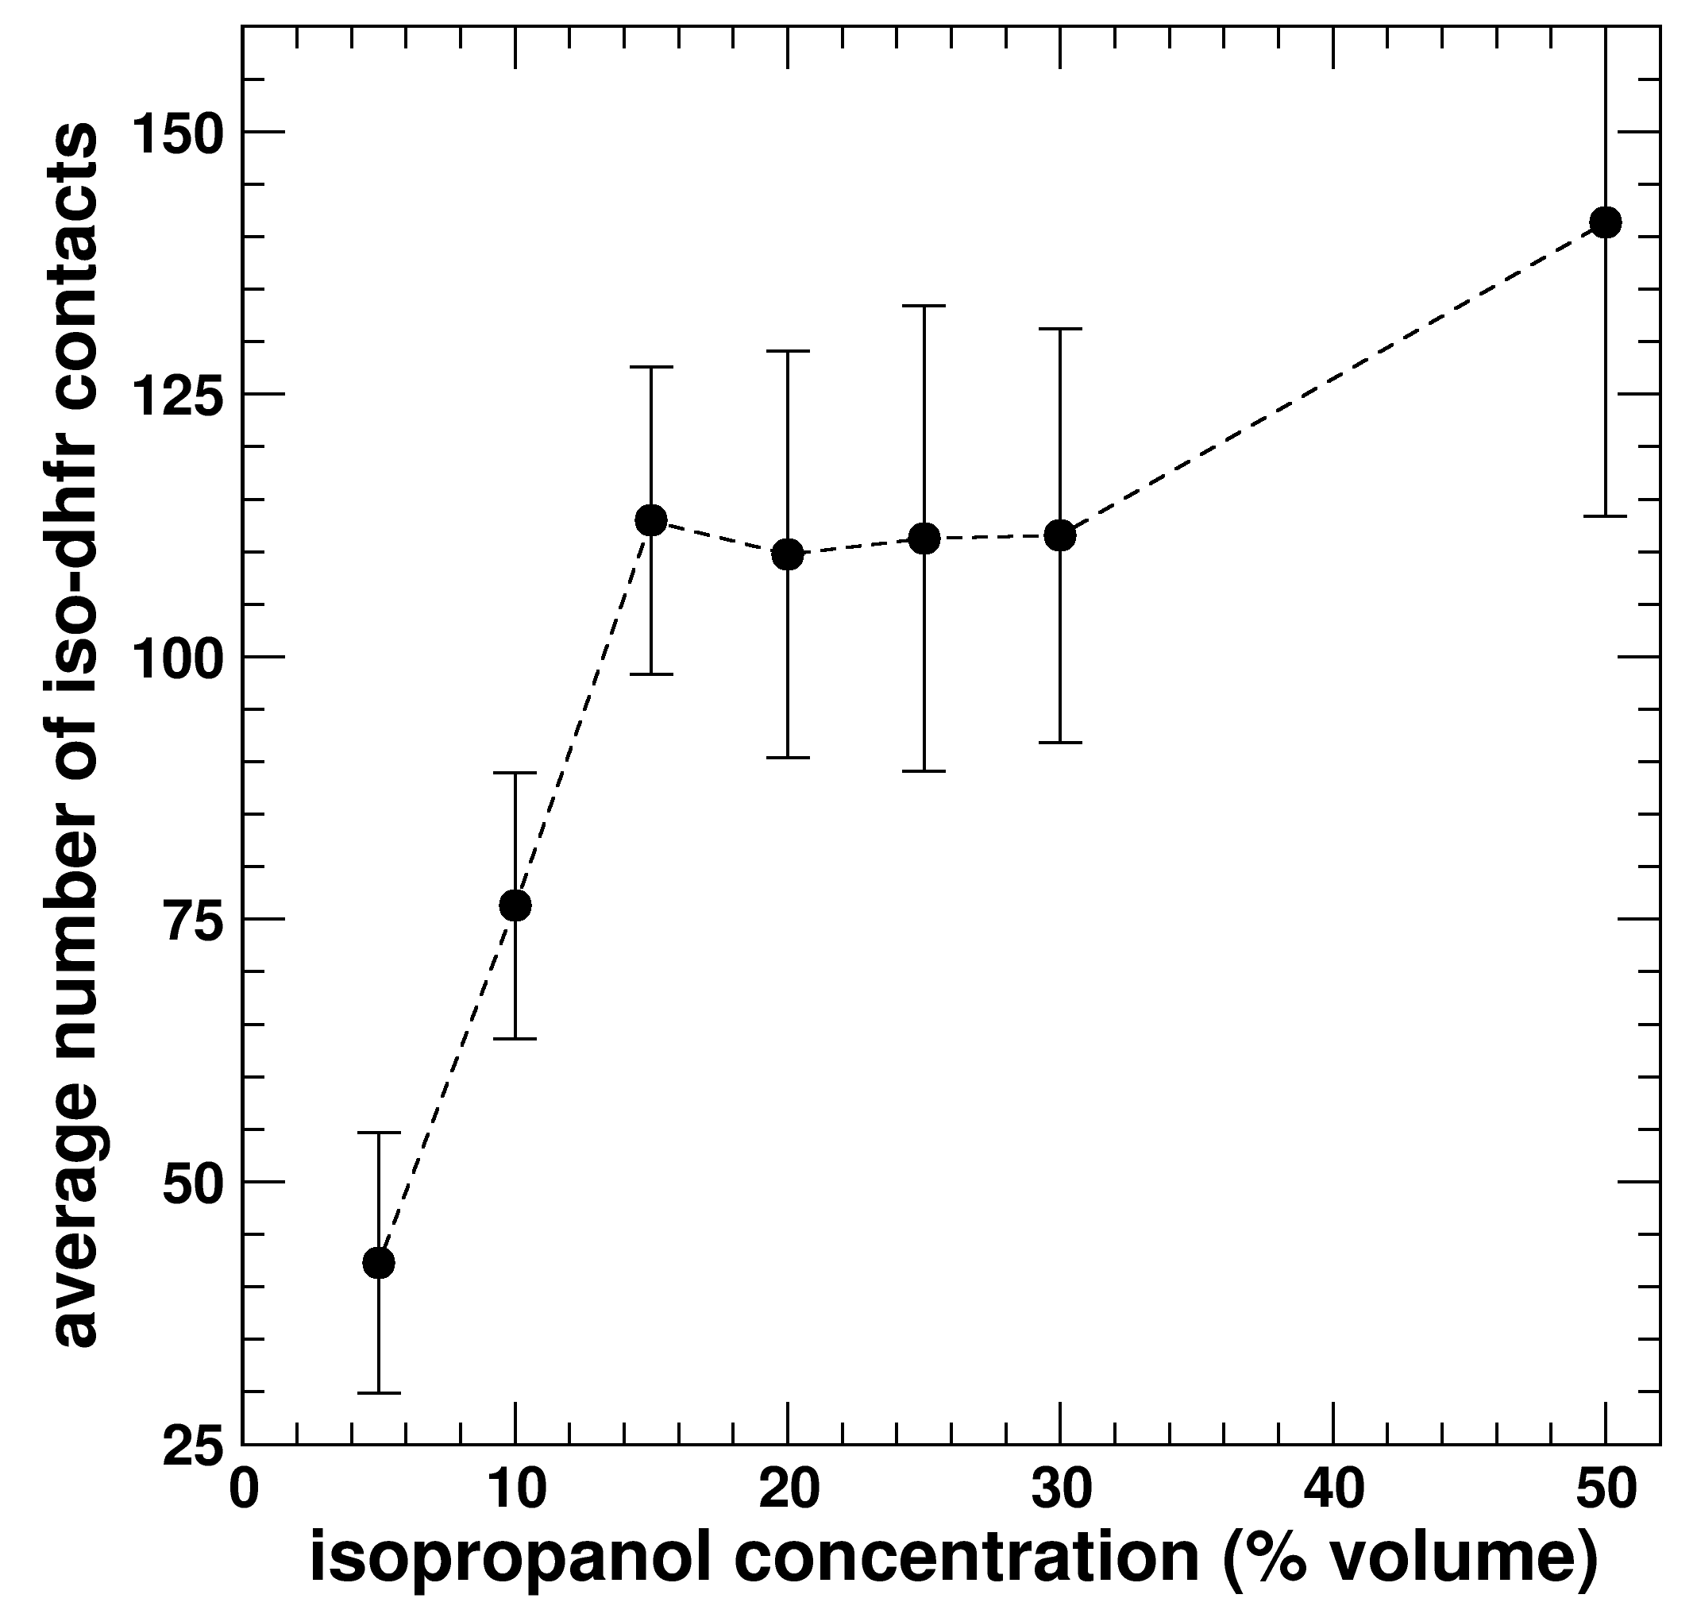
Fig. 1. Average number of isopropanol-protein contacts. Contacts increase linearly in the 0%-15% range and saturate until the concentration reaches approximately 30%.

(a)  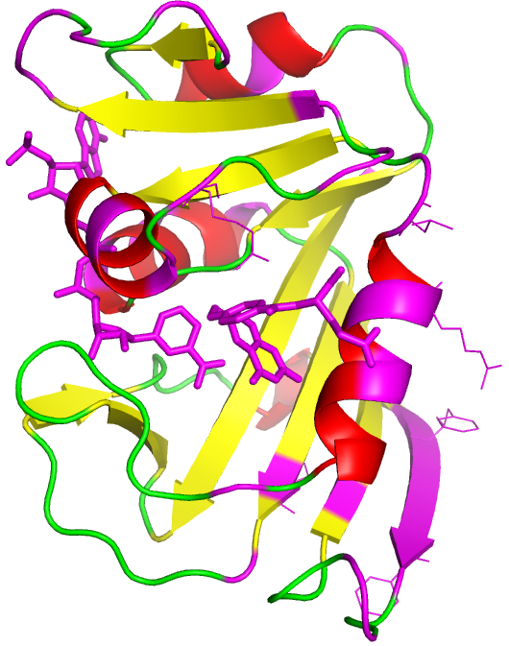 | (b)  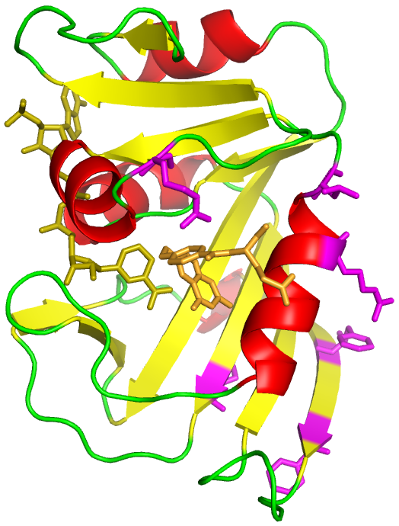

Fig. 2 Average isopropanol occupancy. (a) Residues in magenta and stick representation show a high (>1.0) isopropanol average occupancy in the 15%-30% volume concentration range. (b) Residues showing a very high (>1.9) average occupancy. Note: Pratul, if you want we can have different pictures, like a surface representation instead of the backbone (or both with semi-transparent surface).

(a)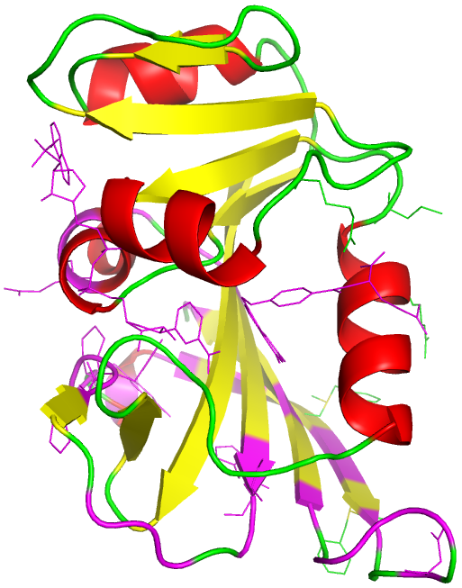 | (b)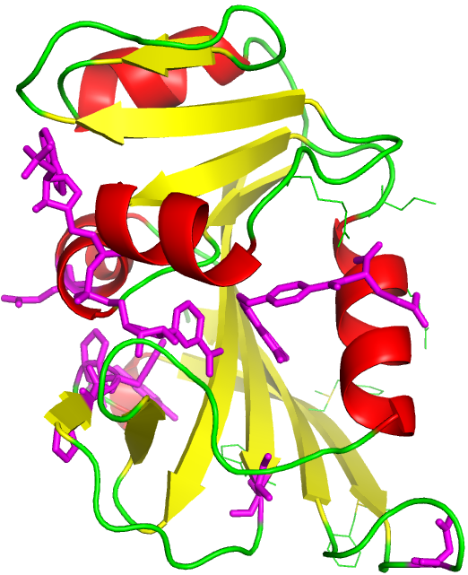

Fig. 3 Maximum residence lifetimes. (a) Residues in magenta and stick representation participated in a contact with an isopropanol molecule for a long (> 5ns) residence lifetime in simulations spanning the 15%-30% volume concentration range. (b) Residues showing a very long (> 7ns) residence lifetime.

