Enzyme catalysis in organic solvent: Insights into structure, dynamics and function

Authors order? Jose M. Borreguero,¹ Junhong He,² Matthew Cuneo,²Arvind Ramanathan,³ Ganesh Kamath,^{3,?} Flora Meilleur,^{2,4} Kenneth Herwig,² Pratul K. Agarwal,^{3,*} Dean A. A. Myles^{2,*}
¹?? Division, Oak Ridge National Laboratory, Oak Ridge, Tennessee, ² Neutron Scattering Science Division, Oak Ridge National Laboratory, Oak Ridge, Tennessee ³Computer Science and Mathematics Division, Oak Ridge National Laboratory, Oak Ridge, Tennessee, ⁴Molecular and Structural Biochemistry Department, North Carolina State University, Raleigh, North Carolina

*Corresponding authors:
Pratul K. Agarwal, Oak Ridge National Laboratory,
P.O. Box 2008, MS 6016, Oak Ridge, TN 37831
Phone: (865) 574-7184; Fax: (865) 576-5491; E-mail: agarwalpk@ornl.gov
Dean A. A. Myles, Oak Ridge National Laboratory,

P.O. Box ???? MS ????, Oak Ridge, TN 37831
Phone: (865) ???- ????; Fax: (865) ???- ????; E-mail: mylesda@ornl.gov

Running title: Enzyme catalysis in organic solvent

Keywords:
dihydrofolate reductase, isopropanol, enzyme catalysis, dynamics

Abbreviations:
C_{A,} acceptor carbon; C_{D}, donor carbon; DHF, dihydrofolate; DHFR, dihydrofolate reductase; EcDHFR, Escherichia coli dihydrofolate reductase; EVB, empirical valence bond; NADPH, reduced form of nicotinamide adenine dinucleotide phosphate; NADP⁺, oxidized form of nicotinamide adenine dinucleotide phosphate; and MD, molecular dynamics.
Abstract
Introduction
Enzymes are able to catalyze the designated chemistry with remarkable efficiency. Even after a century of investigations the understanding of factor that enables the high catalytic efficiency remains incomplete. It is widely accepted that the enzyme structure provides a scaffold for enzyme-substrate interaction is an environment that has properties different from bulk solvent, enabling stabilization of the intermediates. The suggestion that the internal dynamics or the conformational fluctuations of the enzyme play a promoting role in enzyme function remains much debated. Moreover, it is also suggested that the surrounding (hydration layer and bulk) solvent is not a passive standby but is indirectly coupled to reaction through the thermodynamical fluctuations on the enzyme surface as well as the coupled network of protein motions.

Techniques that allow direct investigations have been challenging. In particular the role of solvent on the surface (far from the active-site) has been difficult to explore. To test the hypothesis of the thermodynamical and energetic coupling of solvent and its impact on the enzyme reaction, we have investigated enzyme catalysis in aqueous mixture of organic solvents. The rationale for this approach is the evidence that the protein structure remains intact in moderately high concentration of organic solvents (1-3); however, the enzyme activity is decreased (4, 5). Some evidence indicates that the bulk solvent properties such as dielectric constant may be a contributing factor (6, 7). However, our specific focus is on investigating the impact of organic solvent on suppression on enzyme dynamics and in turn impact on enzyme catalysis.

DHFR catalyzes the reduction of 7,8-dihydrofolate (DHF) to 5,6,7,8-tetrahydrofolate using nicotinamide adenine dinucleotide phosphate (NADPH) as a cofactor. Chromosomally encoded DHFR belongs to a family of proteins sharing the nucleotide binding Rossmann fold (8), characterized by a central core formed β-sheet surrounded by α-helices. Previously, a network of coupled motions promoting hydride transfer in DHFR had been identified using detailed theoretical and computational modeling (9). Similar to the network in CypA, this network is also formed by surface residues present on the flexible loop regions (particularly the βF–βG and the Met20 loop) interacting with other conserved residues all the way to the active-site. The detailed characterization of correlated motions of various residues and this network has led to the identification of a chain of residues as dynamical contributors to hydride transfer reaction (9-12). Long time-scale fluctuations (around milliseconds) in these loop areas have been linked to the mechanism of the hydride transfer. This is particularly intriguing because at pH >8.4, hydride transfer is the rate-limiting step in the entire catalytic cycle (13).

Methods
Sample preparation for DHFR
Circular dichroism (CD) experiments
Enzymology: What pH?
X-ray crystallography
Neutron scattering experiments
Molecular Dynamics Simulations.
Protein ionization state. The concept of pH is not clearly defined in organic solvents, especially in those solvents with a marked hydrophobic character. However, it has been observed that proteins in organic solvents tend to conserve the ionization state of the aqueous solution from which they were transferred, a phenomenon termed “pH memory” (14). In accordance, we have kept the protein ionization state in both pure water and organic solvents the same. A welcomed consequence of equal ionization states is the one-to-one correspondence when comparing the role of charged residues in the aqueous and organic solvent solution.
Isopropanol model. Amber force-field parameters for isopropanol were taken from the study of Marcus (15) on the vapor-liquid coexistence curves and liquid densities for several organic solvents.
Model preparation and equilibration protocol. Water and isopropanol molecules at the appropriate volume ratio υ were randomly placed in a 64Å-side simulation box until the volume V was filled (16). Mild steric clashes were allowed in the placement process. The number of water and isopropanol molecules is determined assuming no volume of mixing:
N_{ISO} = υ ∙ V ∙ ρ_{ISO} / M_{ISO}
N_{WAT} = (1-υ) ∙ V ∙ρ_{WAT} / M_{WAT},
using appropriate densities (ρ) and molecular weights (M) for isopropanol and water.
 | ρ (gr/cm³⁾ | M (gr/mol)
water | 1.00 | 18.01
isopropanol | 0.786 | 60.10
DHFR plus ligand and cofactor were placed at the center of the box prior to solvent placement. The protocol that was followed for system relaxation to equilibrium includes a series of energy minimizations and equilibration steps, and has been described previously (17).

Model preparation: Hydride transfer modeled by EVB:

Results
A number of organic solvents (...) were screened for the impact on DHFR enzyme activity. The enzyme assay for were performed in 5%, 10%, 15%, … 100% mixtures of water and organic solvent. Preliminary studies with EcDHFR in isopropanol indicates that at 25% v/v concentration the activity is reduced to 50% of activity in aqueous buffer, while at 35% the activity is more or less destroyed.

Neutron scattering results:

X-ray results:
Computational results:
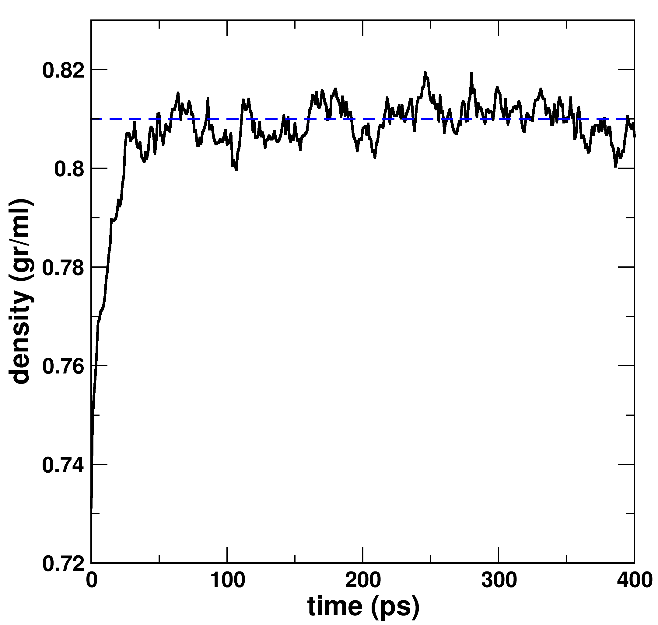
Figure Isopropanol density. A 40Å-side simulation box containing isopropanol with an initial density slightly lower than the experimental one (0.786 g/cm³, 293 K) was simulated in the NPT ensemble at 298 K and 1 at for 400ps. Convergence to the value obtained by Martin (blue dashed-line), who employed the same force-field as the present study, is observed after ~75ps. (This figure should go in the Supplemental Info)

From now onwards, by “protein” is it is understood as DFHR plus cofactor (residue 160) and ligand (residue 161)

(a)  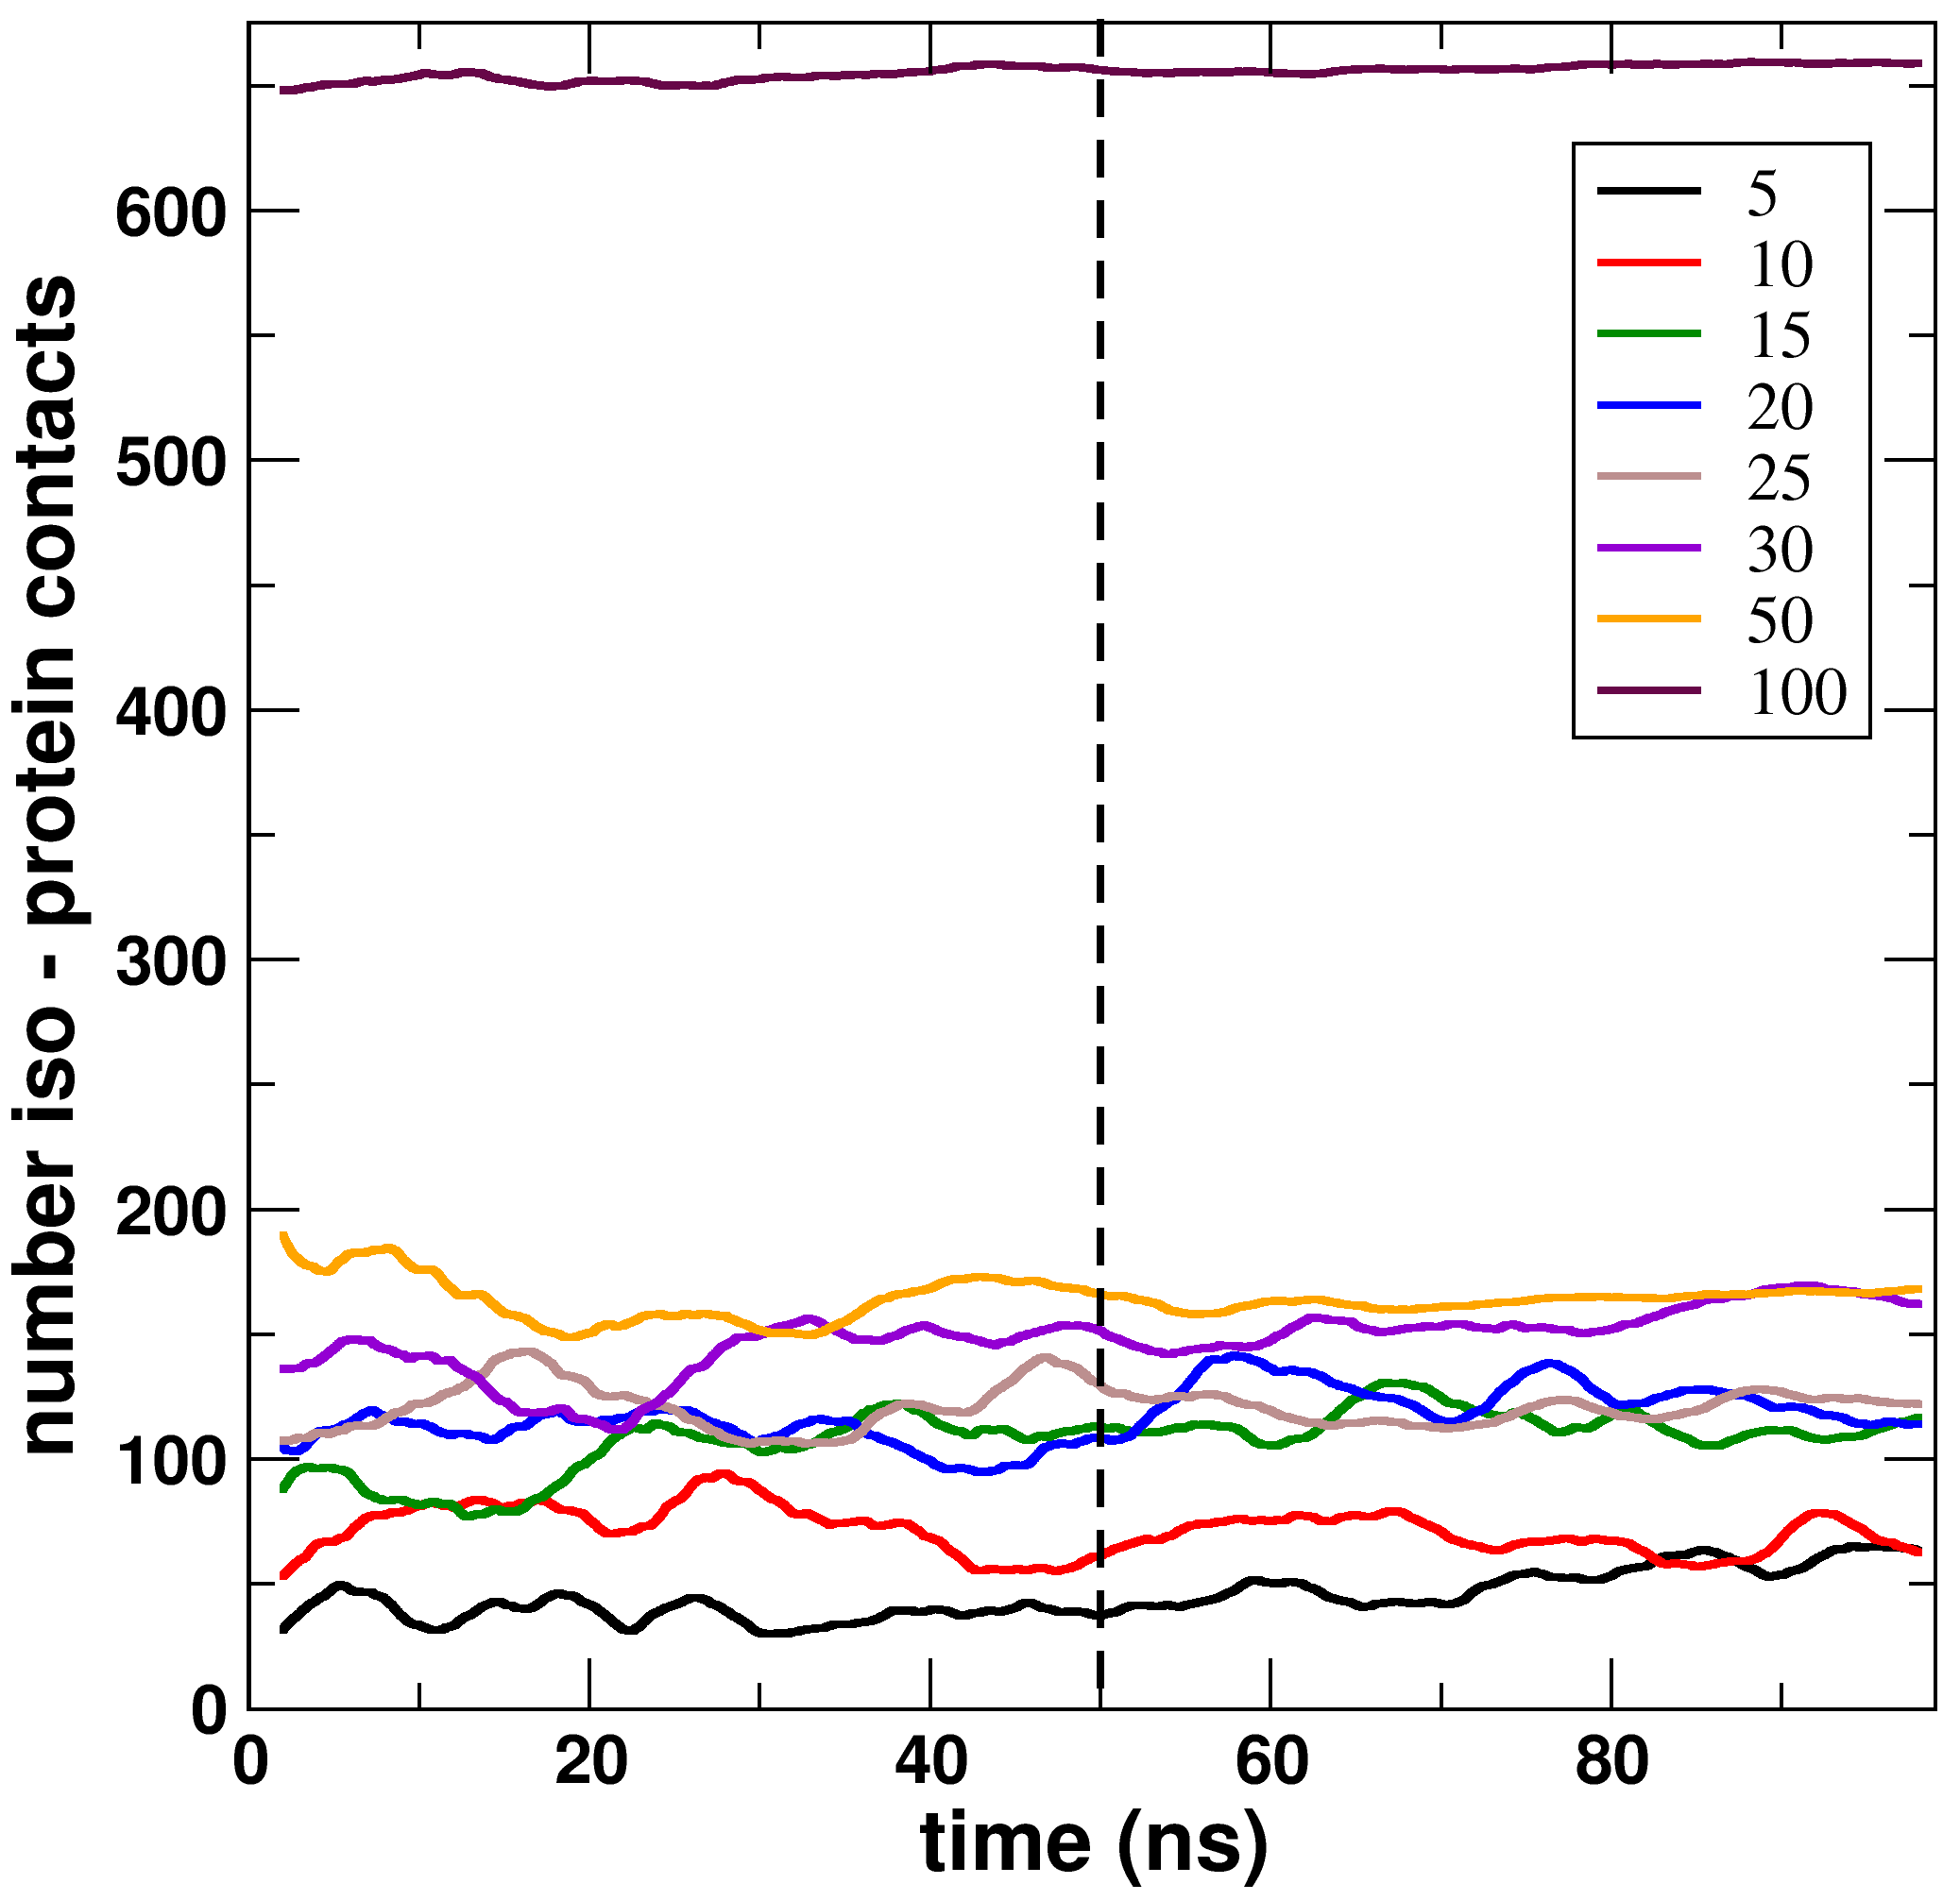 | (b)  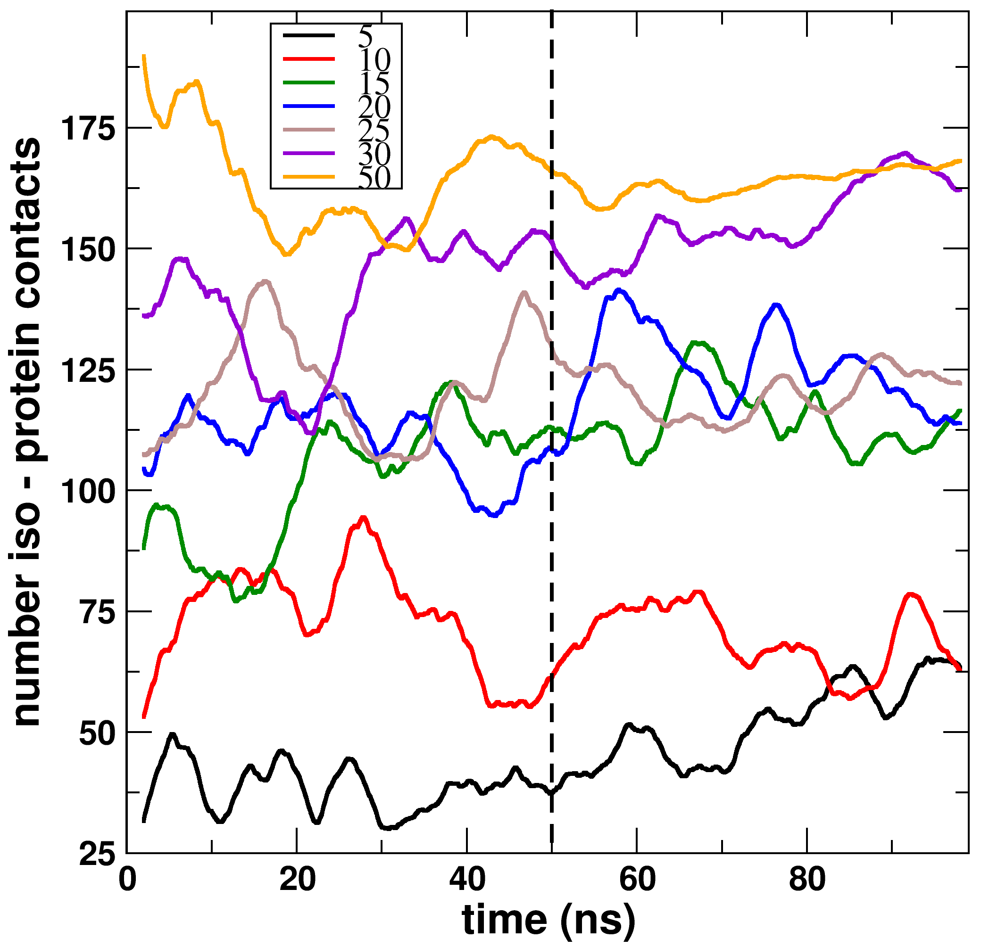

Figure Number of Contacts. Evolution of total number of contacts between the protein and isopropanol. Initially the isopropanol were randomly placed in the simulation cube. The number of contacts fluctuates during the simulation. The second half of the simulations (last 50ns) is used to compute average quantities. (a) shows the plot for 100% isopropanol concentration, while it has been omitted in (b).

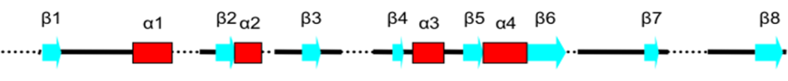
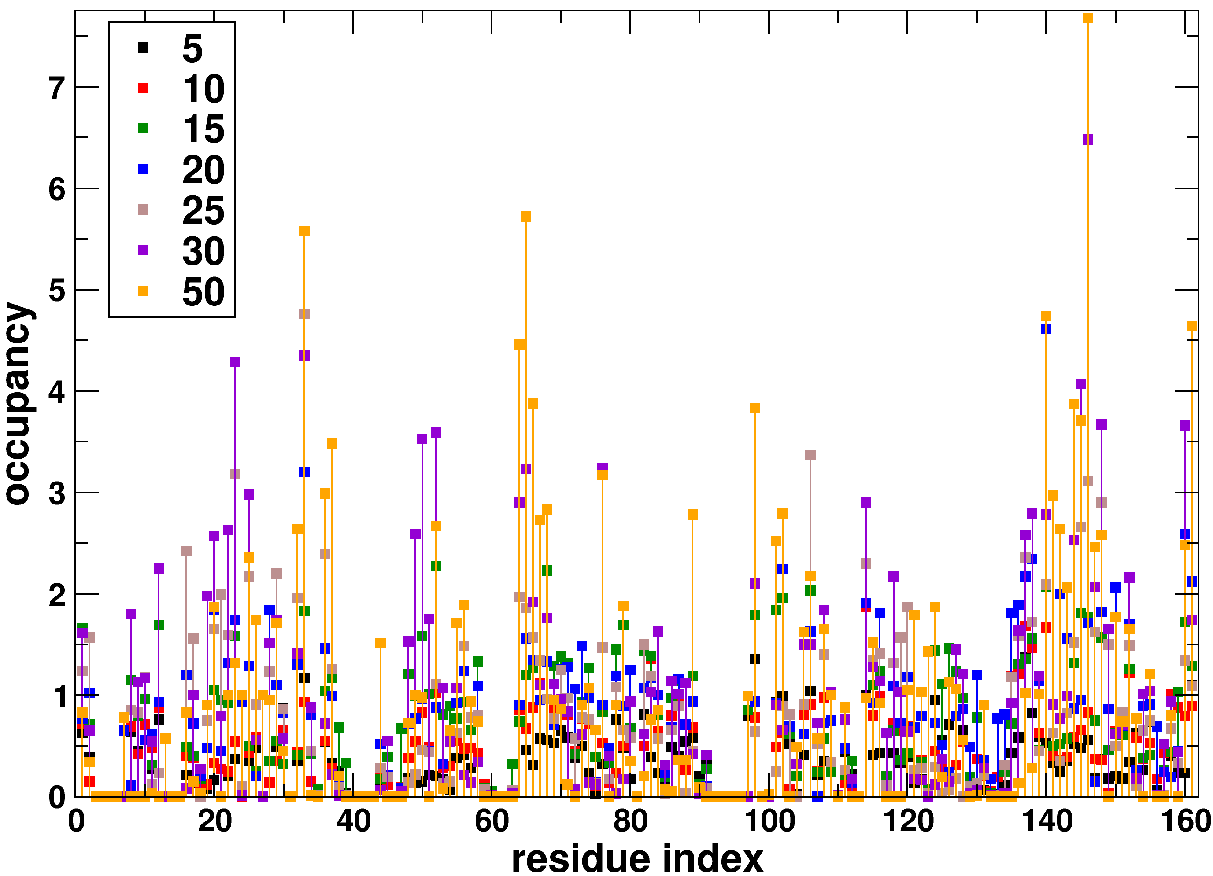
Figure occupancy. Isopropanol occupancy for each protein residue. It is calculated as the number of isopropanol molecules in contact with a given residue, averaged over all considered simulations frames. As first observation, there are residues showing high occupancy for certain isopropanol concentration, but not for other concentrations. For instance, residues 23 and 50 show high occupancy for concentration 30%, but not for concentration 50%. This indicates that 100ns may not be enough time for the system to fully equilibrate. However, reasonable conclusions can be made for residues showing high occupancy for three or more concentrations, since this indicates consensus between three independent simulations. If we set a cut-off of occupancy=1, then 36 residues: 1, 20, 22-23, 25, 28-29, 32-33, 36-37, 52, 64-68, 76, 98, 102, 106, 114-116, 136-138, 140, 144-148, 152, 160-161 have at least three simulations with occupancy above this cut-off. This sequence of residues indicates two regions of preferential binding, namely 20-33 (part of the Met-20 loop and subsequent helix) and 144-148, far in sequence but geometrically close to region 20-33.

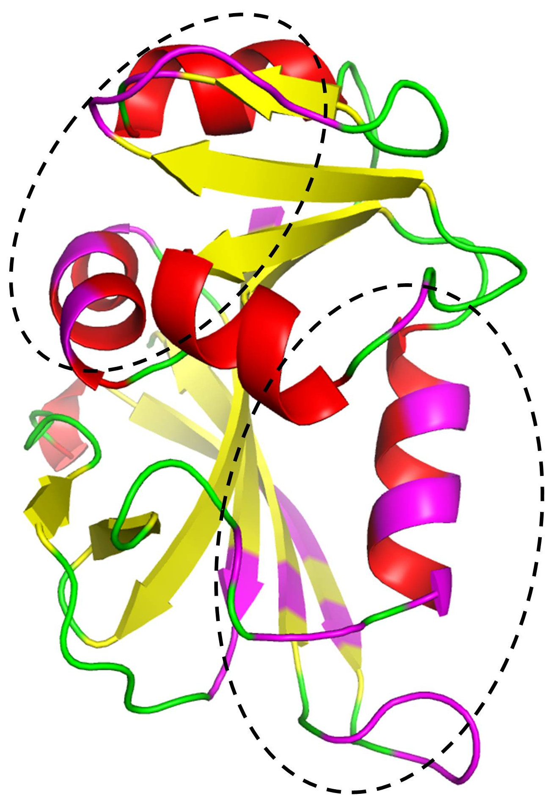
Figure high-occupancy-overlay: Figure showing residues with high occupancy. 36 residues (1, 20, 22-23, 25, 28-29, 32-33, 36-37, 52, 64-68, 76, 98, 102, 106, 114-116, 136-138, 140, 144-148, 152, 160-161) having at least three simulations with occupancy above one are colored in magenta. Two distal regions (enclosed in ellipses) are identified containing residues with high isopropanol occupancy.
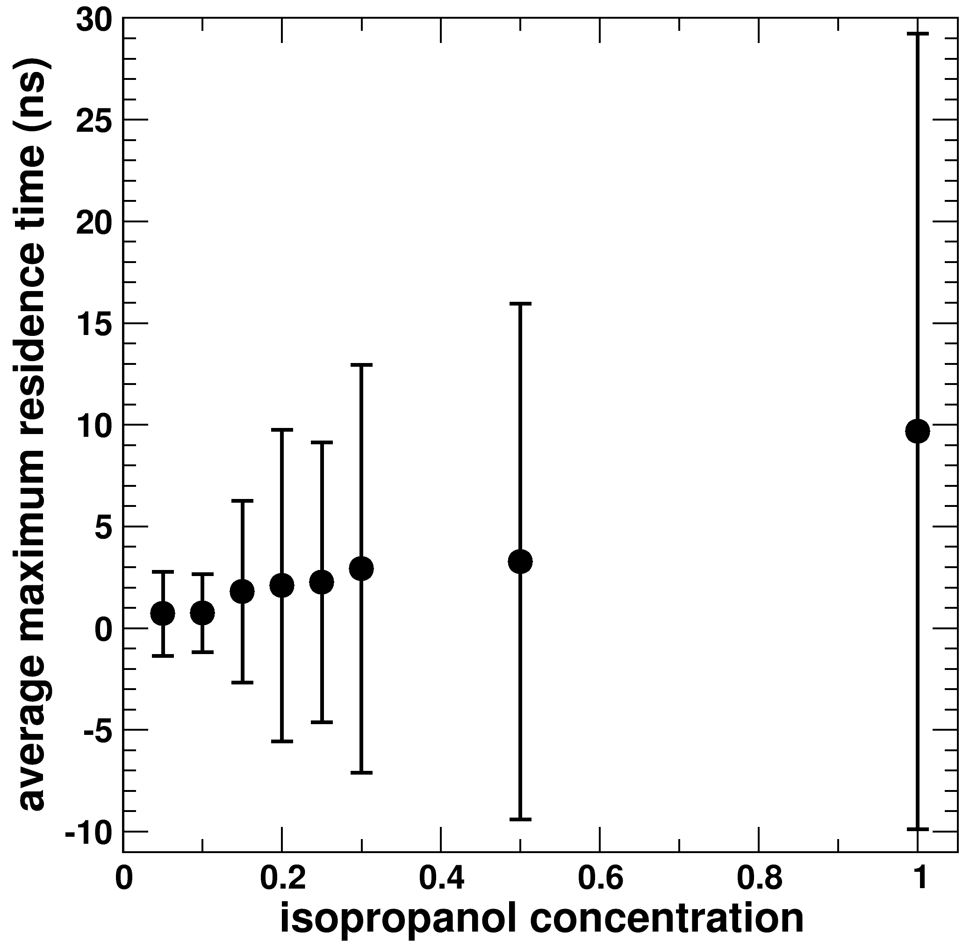
Figure average-maximum-residence-time. Average maximum residence time for a given isopropanol concentration. The residence time of a binding event is the time window during which a particular isopropanol remains in the vicinity of a given residue (bound state). During the simulation, several isopropanol molecules bind and unbind a given residue, each time providing one residence time. The maximum of those times is the maximum residence time for that given residue. The graph shows the maximum residence time averaged for all residues. Values can range from zero up to 50ns, the considered simulation time span (the second half of the trajectory). The large values of the standard deviation indicate that there are residues with maximum residence times much larger than the average. Most of the residues have maximum residence times below 5ns, indicating that isopropanol has weak binding.
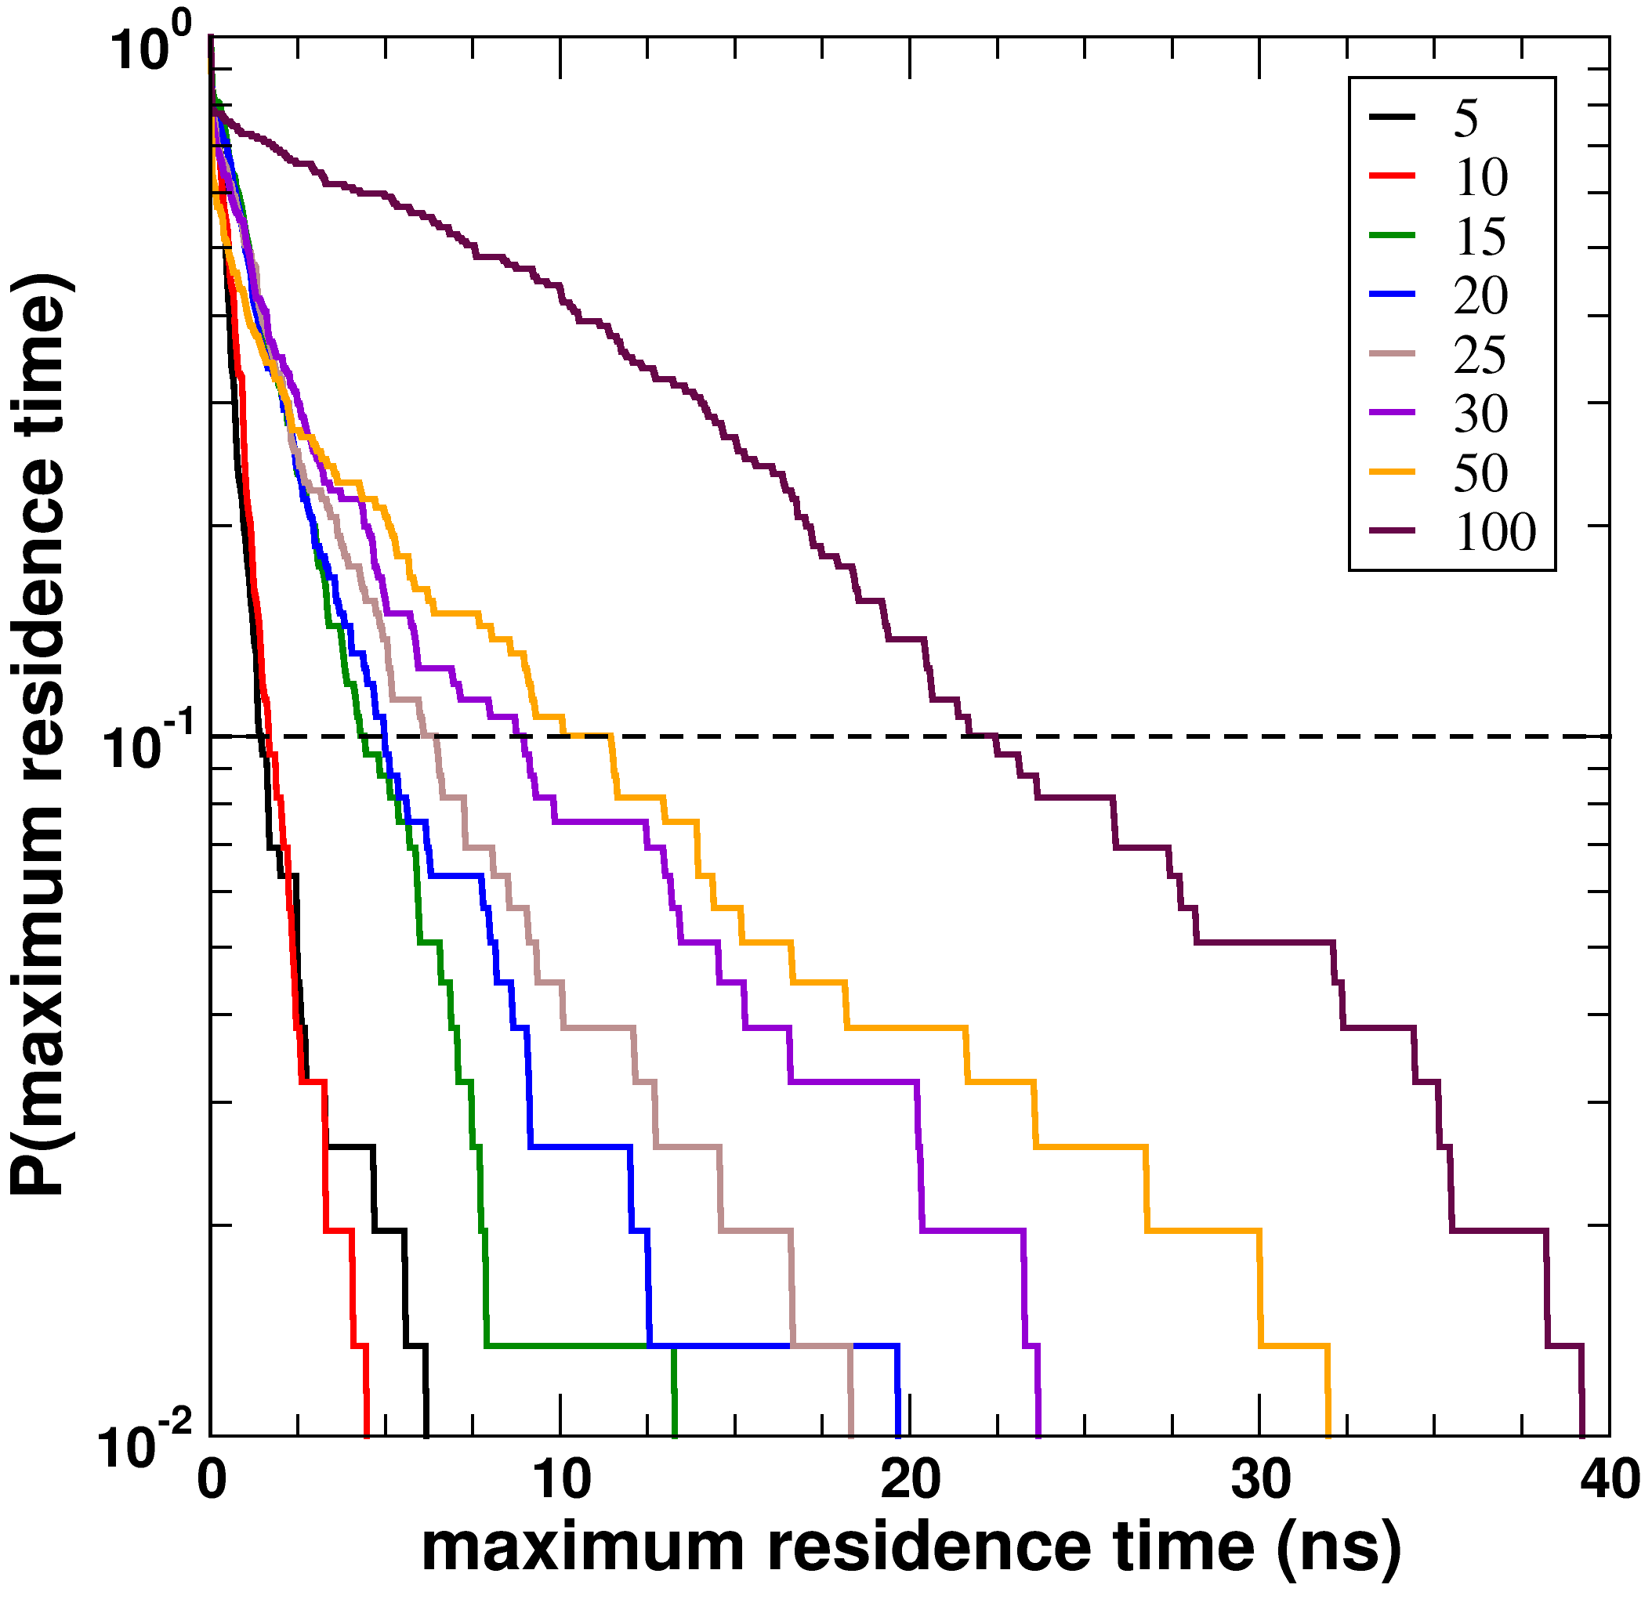
Figure Cumulative-distribution-maximum-residence-times. The cumulative probability distribution of maximum residence times is plotted for each simulation. The maximum residence times can range from 0 to 50ns, the span of the second half of the simulation. Except for the simulation at 100% isopropanol concentration, only a small fraction of the residues have significant maximum residence times. If we consider 10% of all residues, then the maximum residence times cut-off range from 1.4ns at 5%, 6.4ns at 25%, 11.5ns at 50%, and 22.5ns at 100% isopropanol concentration. (NOTE: I don’t consider this graph very useful, but include it nonetheless for completeness).
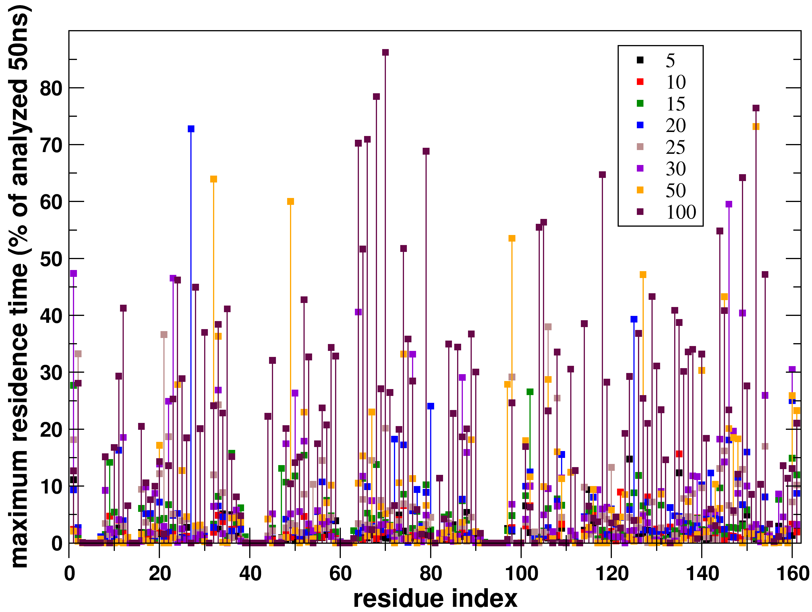
Figure maximum residence times. For a given residue, the maximum residence time of a bound isopropanol is depicted as a percentage of the number of considered frames (5000 frames spanning the last 50ns of each simulation). The residence time of a binding event is the time window during which a particular isopropanol remains in the vicinity of a given residue. During the simulation, several isopropanol molecules bind and unbind a given residue, each time providing one residence time. The maximum of those times is the maximum residence time for that given residue. In analogy to the analysis of the occupancy, some residues show a high residence time for a certain isopropanol concentration, but not for others. For instance, the same residues 23 and 50 as when discussing occupancy show a higher maximum residence time at concentration 30% than at concentration 50%. There are 19 residues (1, 20, 22, 32-33, 50, 53, 65, 74, 98, 106, 108, 135, 144-146, 149, 154, 160-161) having at least three simulations with maximum residence time above 10% of the frames considered (5ns). A sizeable fraction of residues shows maximum residence times at 100% concentration that are lower than at other, lower concentrations. Such is the case for 23 residues (1, 2, 7, 21-23, 27, 32, 47, 49-50, 67, 73, 80, 97-98, 102, 106, 109, 125, 127, 146-147, 160). Possible explanations are: (i) conformational rearrangement in the absence of water such that these residues are more protected from solvent, (ii) the increased number of isopropanol molecules at 100% concentration increases the chance that isopropanol molecules from the bulk will displace already bound isopropanol molecules. There is not necessarily a one-to-one correspondence between residues showing high occupancy and residues showing a high maximum residence time. For instance, a residue will show high occupancy if there is most of the time a bound isopropanol, even if the residence time is short. This scenario may take place when more than one isopropanol are able to bind a residue at the same time. As expected, the residence times increase with isopropanol concentration.
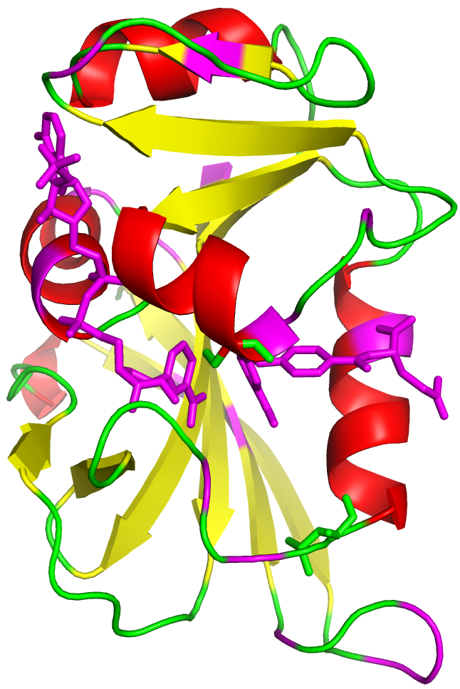
Figure maximum-residence-times-overlay: Figure showing residues with consensus high maximum residence times. There are 19 residues (1, 20, 22, 32-33, 50, 53, 65, 74, 98, 106, 108, 135, 144-146, 149, 154, 160-161) having at least three simulations with maximum residence time above 10% of the frames considered (5ns). Residues belong to the two identified distal regions for preferential binding (see Figure high-occupancy-overlay).
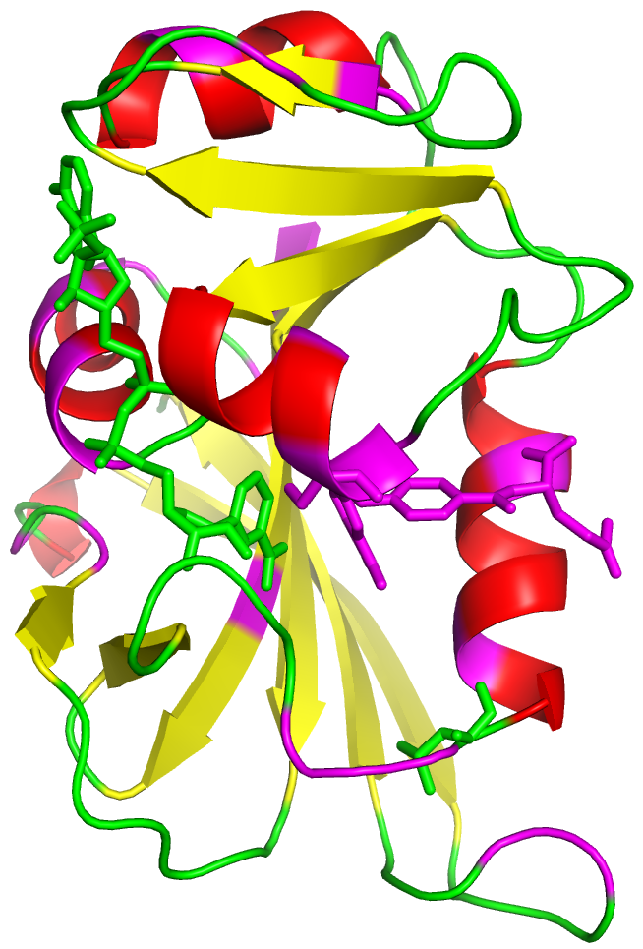
Figure maximum-residence-times-less-at-100%: Figure showing residues having a maximum residence time at 100% isopropanol concentration that is lower than the maximum residence time at other, lower concentration. Such is the case for the 23 residues colored in magenta (1, 2, 7, 21-23, 27, 32, 47, 49-50, 67, 73, 80, 97-98, 102, 106, 109, 125, 127, 146-147, 160). Possible explanations are: (i) conformational rearrangement in the absence of water such that these residues are more protected from solvent, (ii) the increased number of isopropanol molecules at 100% concentration increases the chance that isopropanol molecules from the bulk will displace already bound isopropanol molecules.

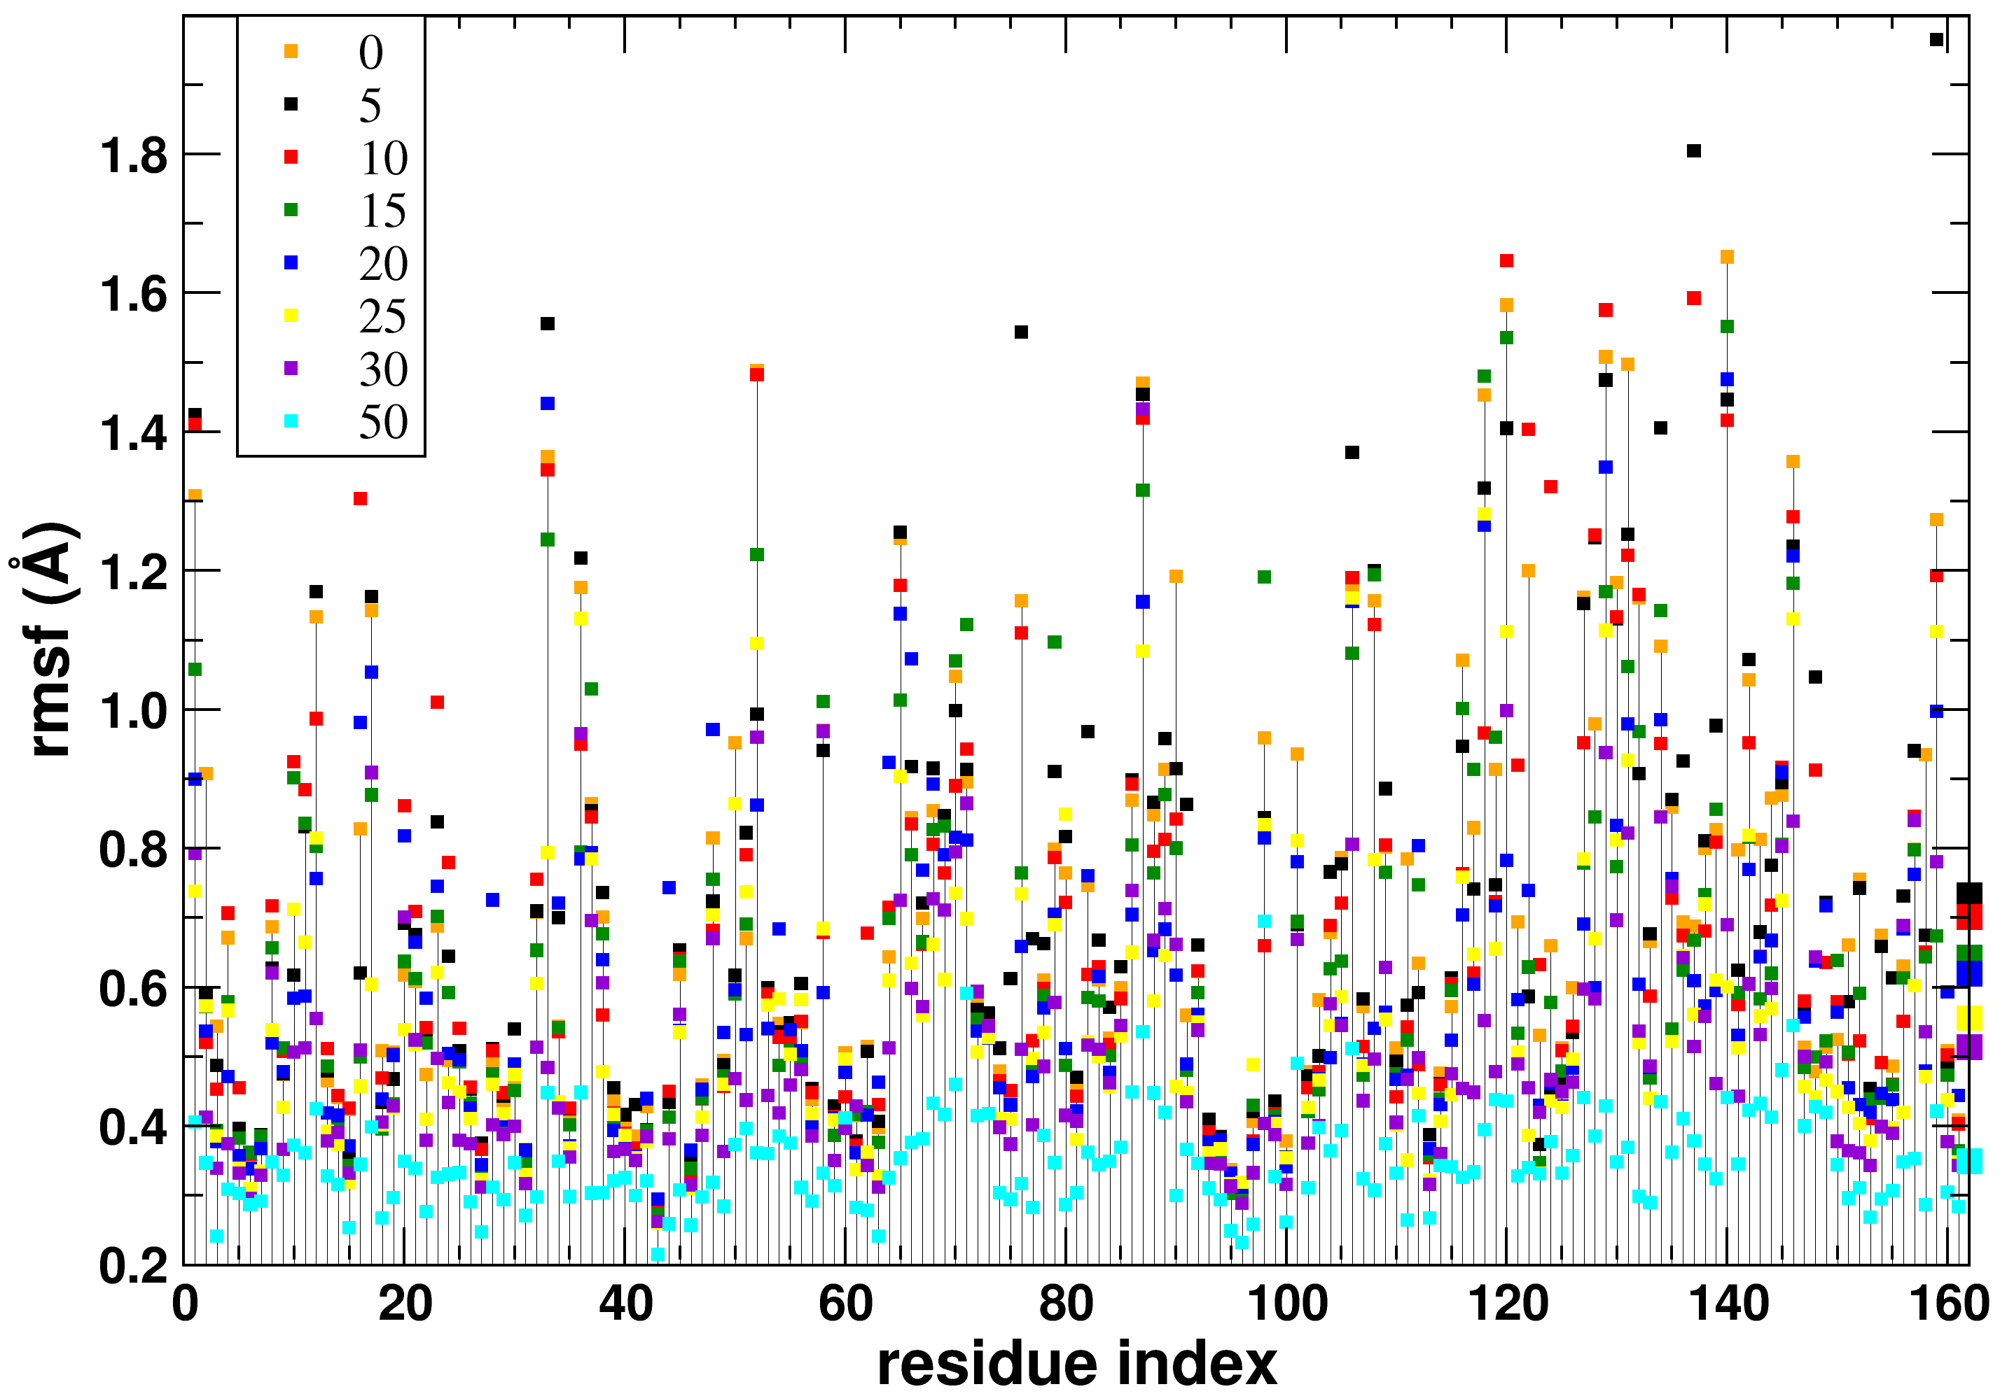
Figure rmsf per residue. Average per residue fluctuations with respect to the average structure during the second half of the simulation. The figure is consistent with Figure rms to average, in the sense that rms decreases with increasing isopropanol concentration.

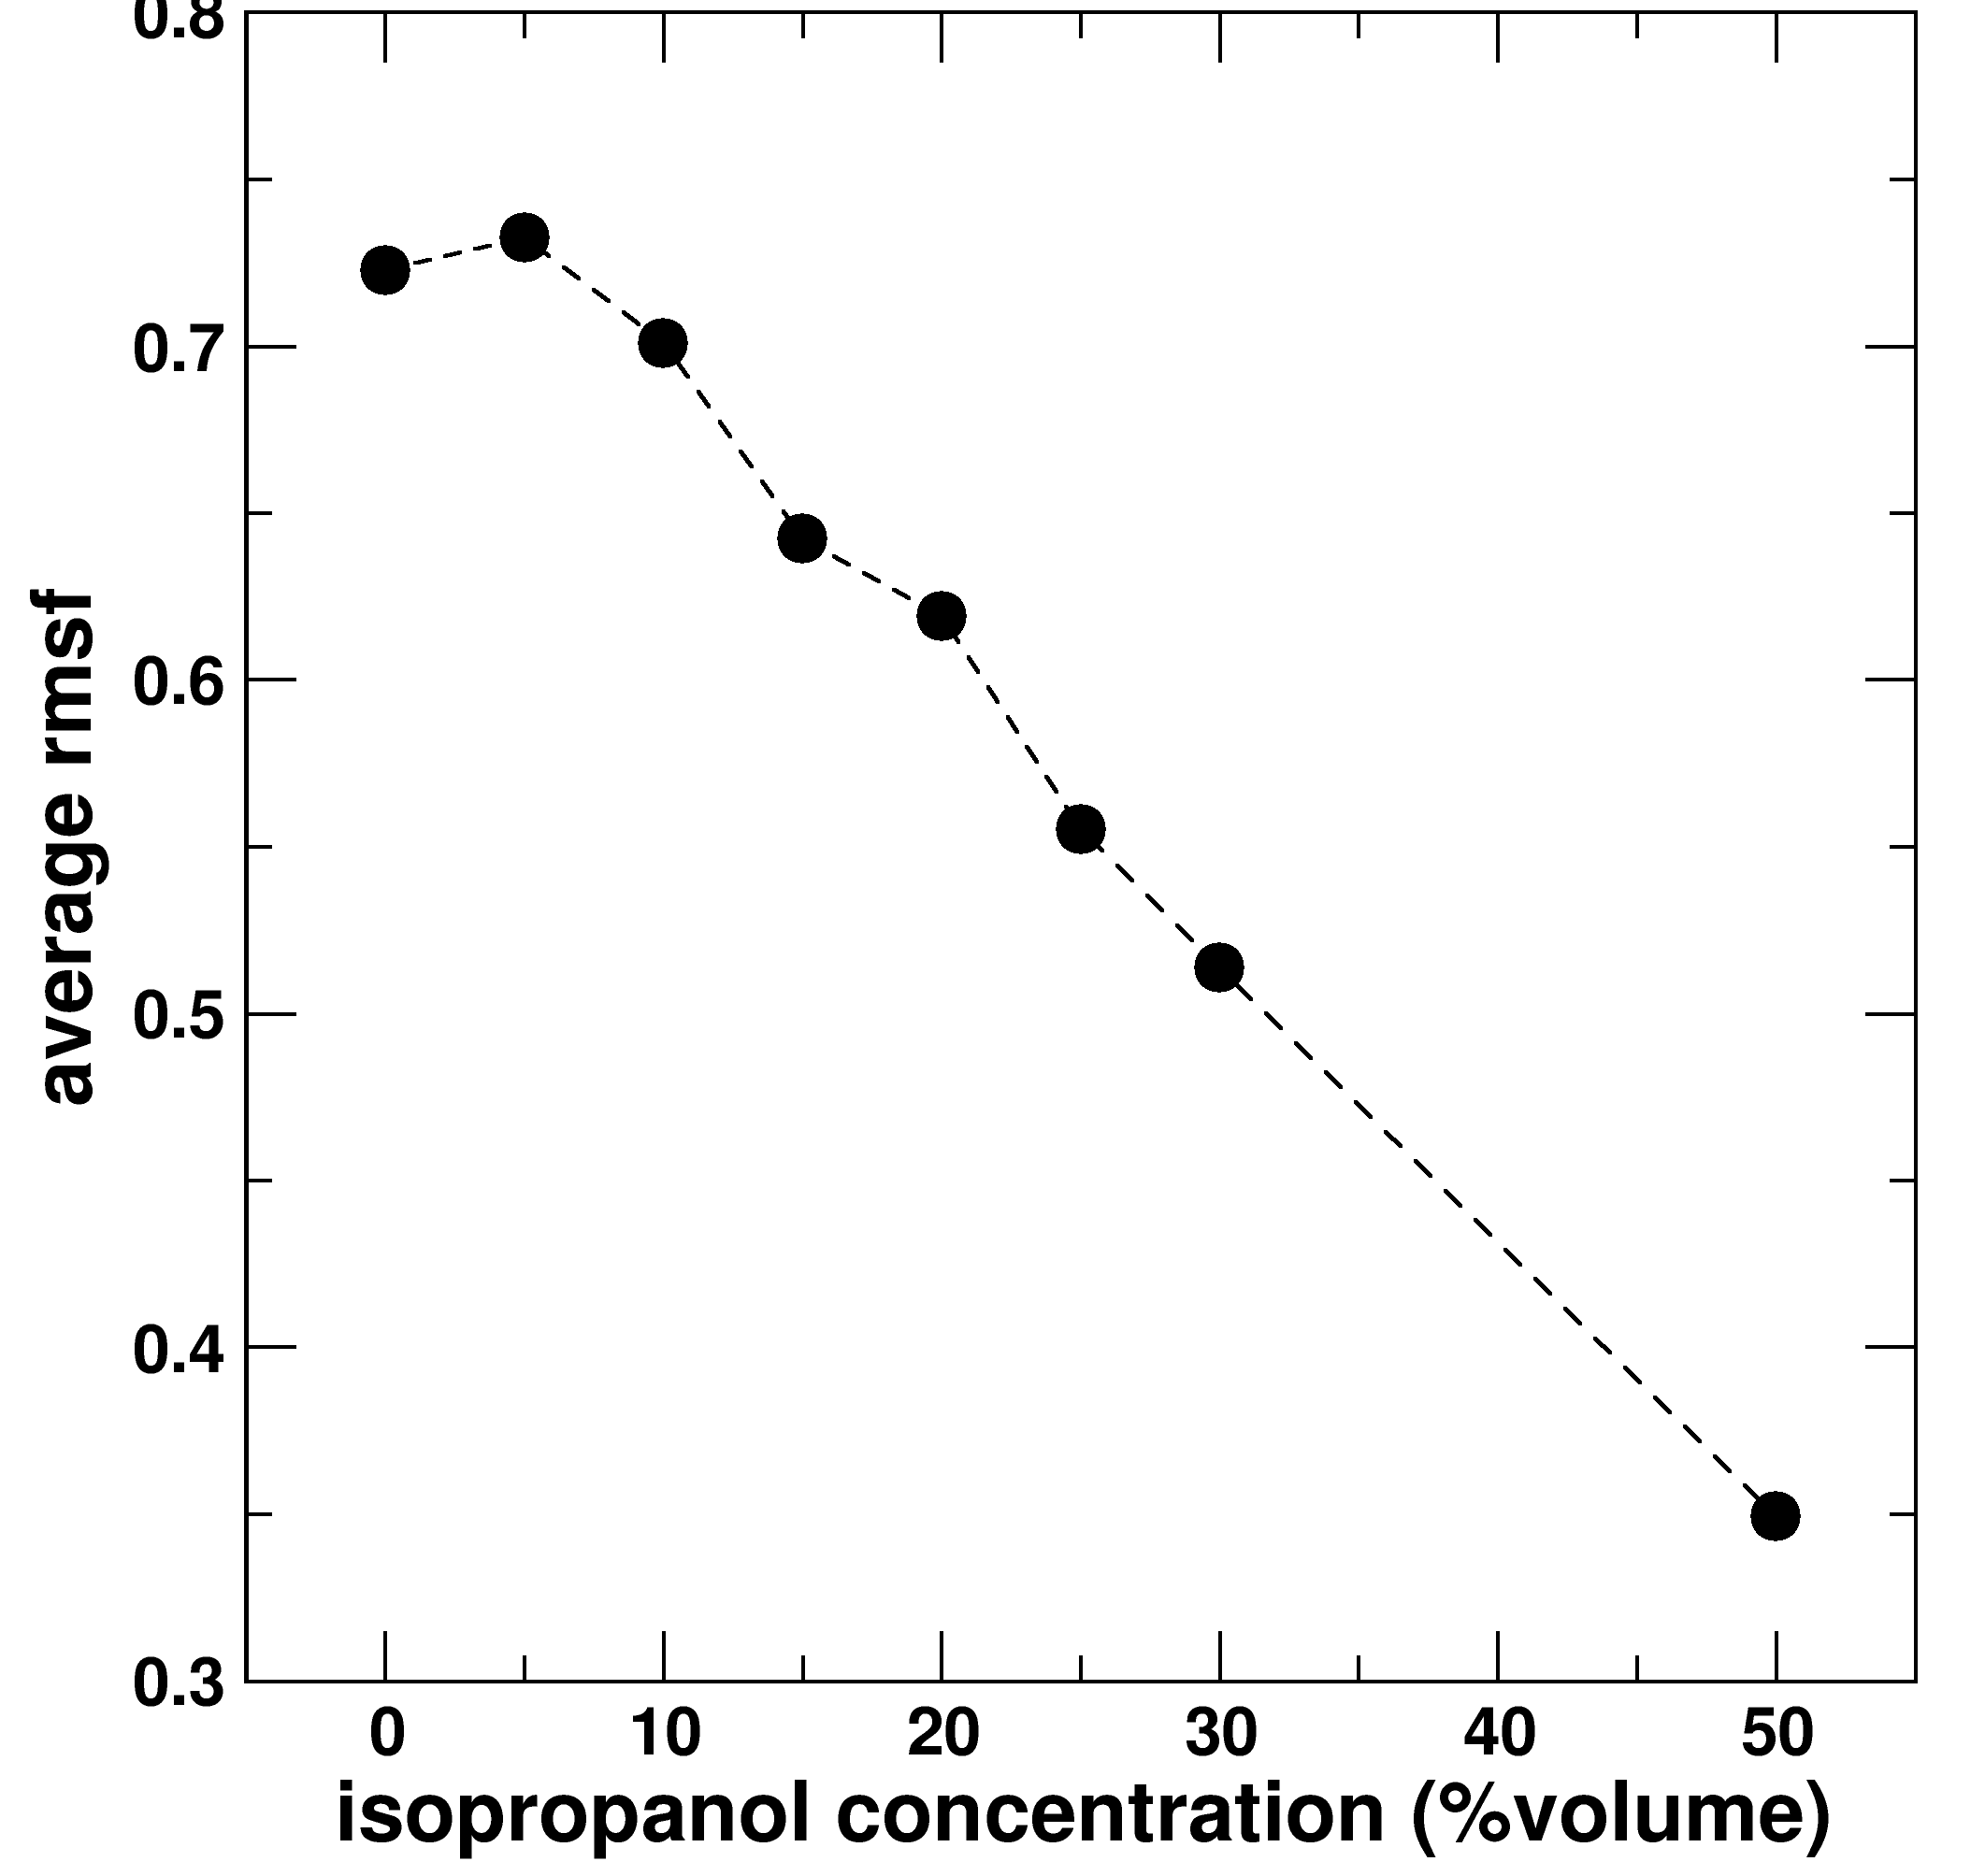
Figure average rmsf. The average rmsf decreases linearly with increasing isopropanol concentration.
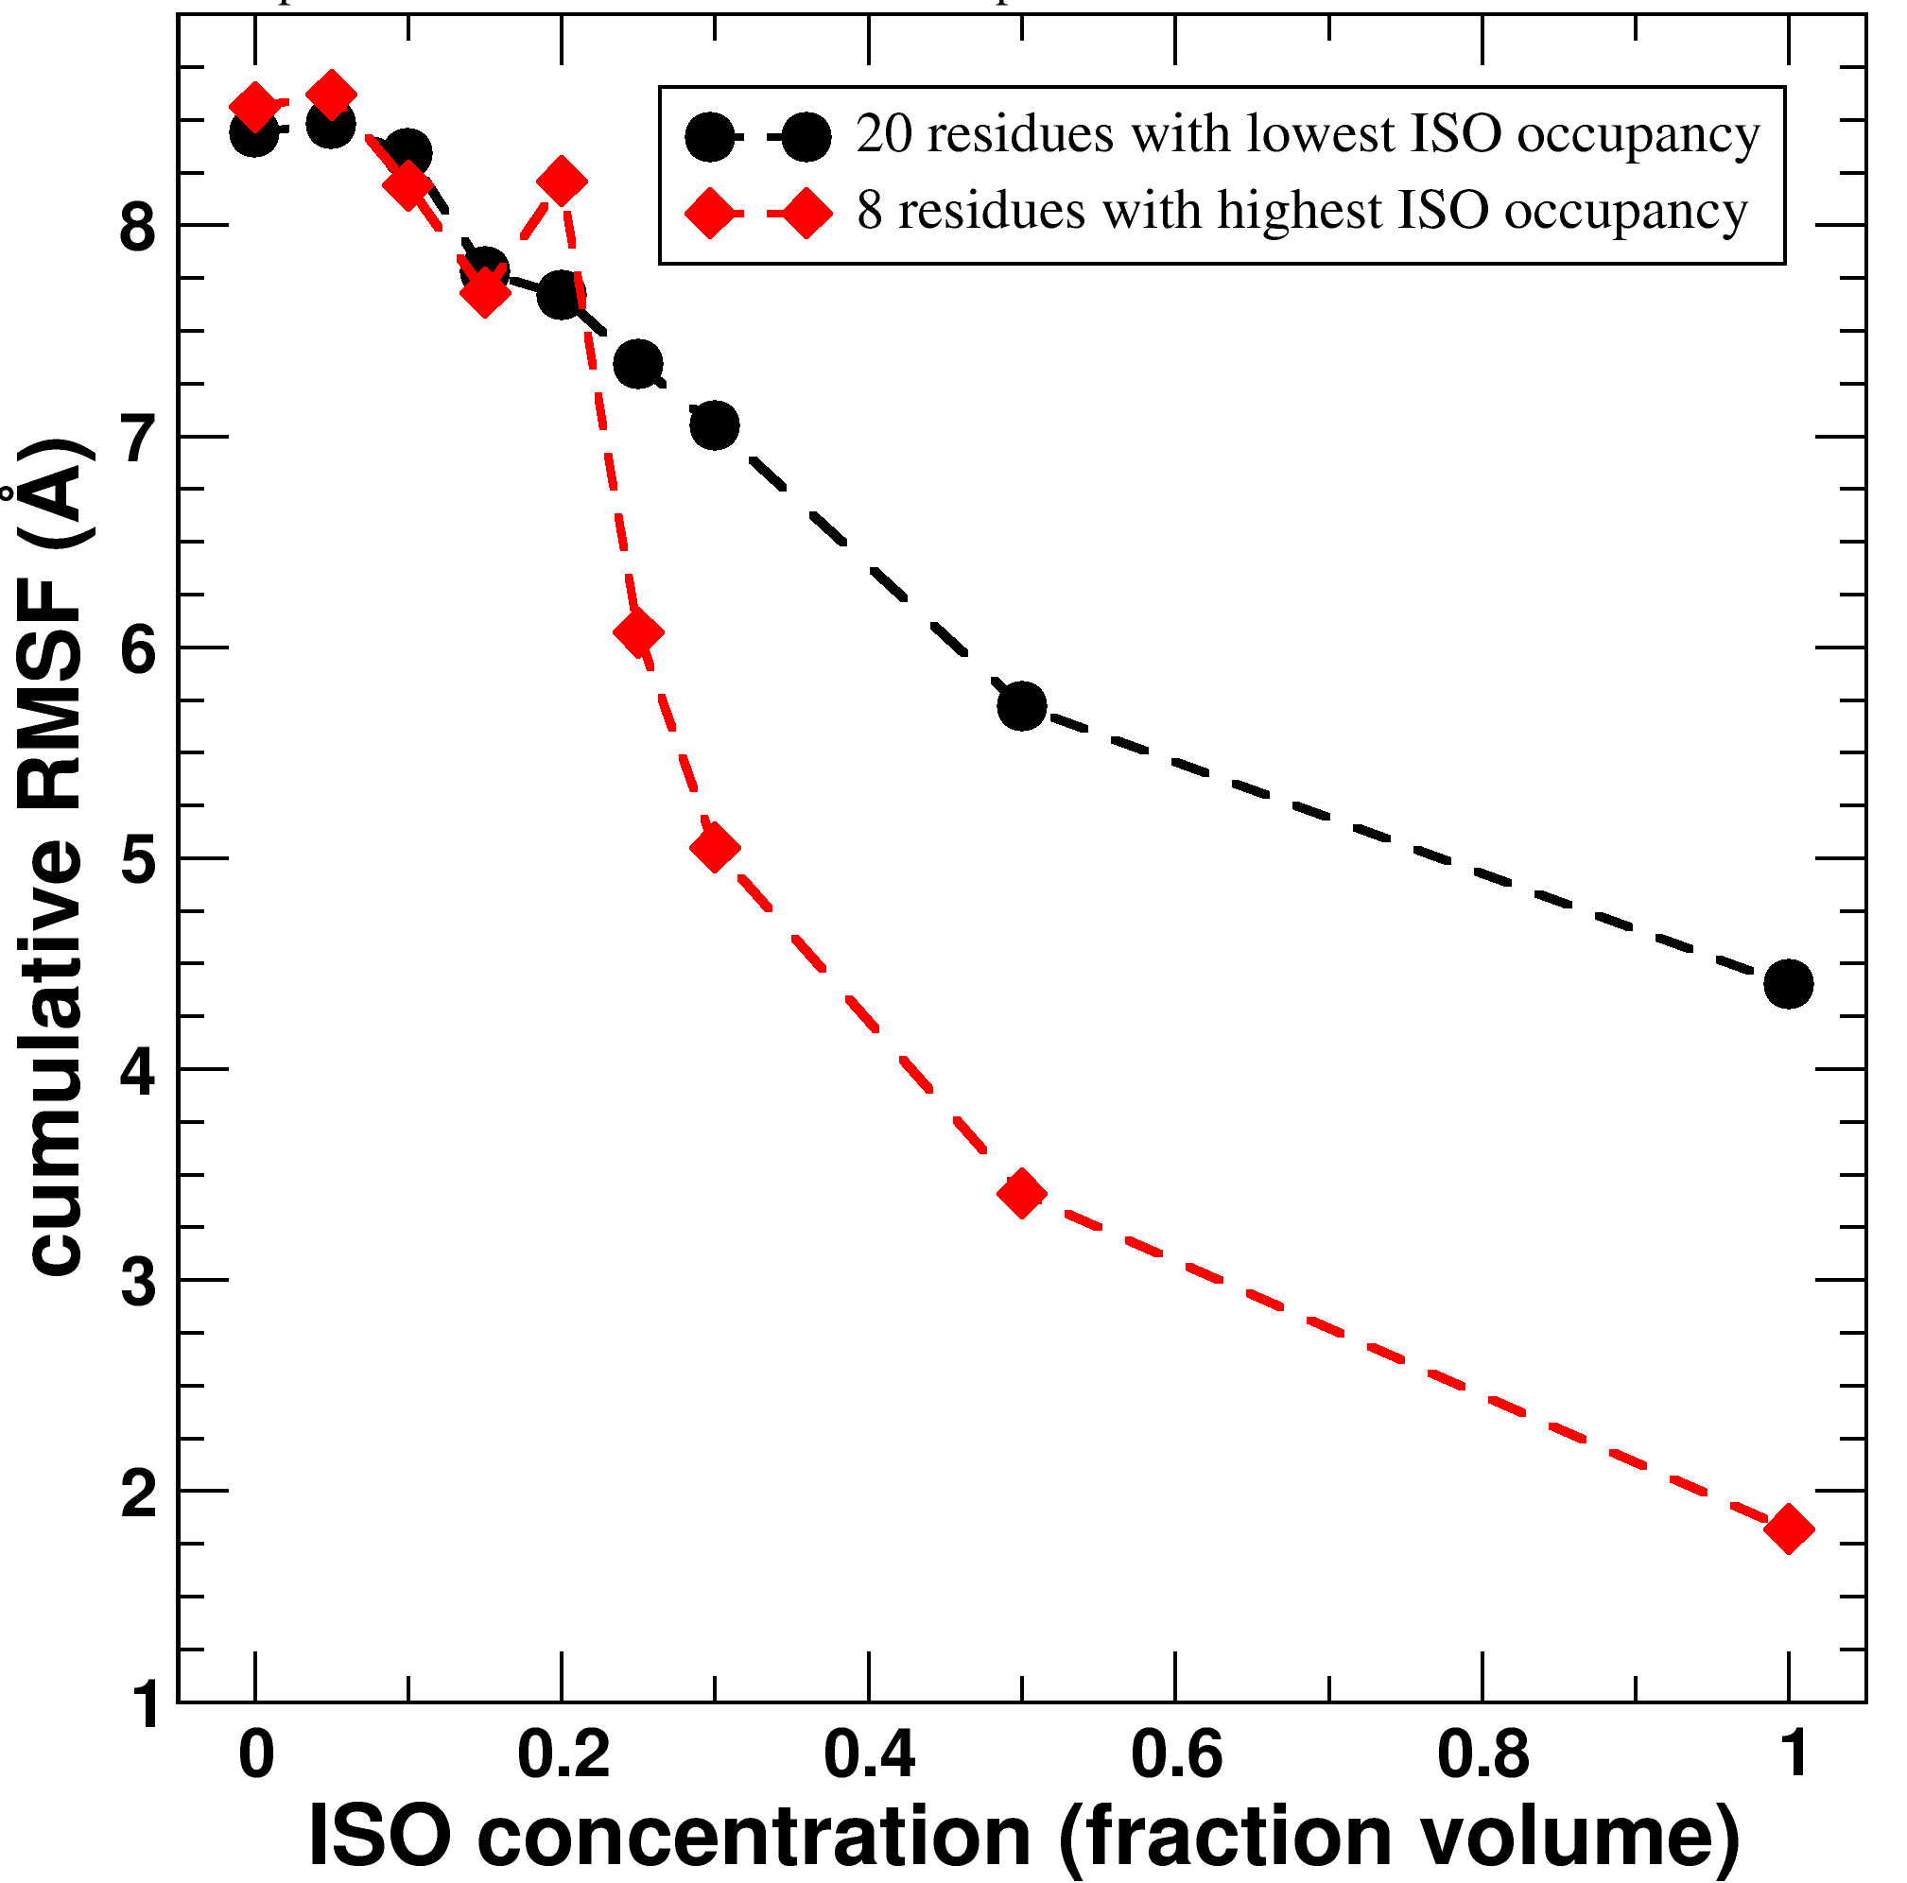
Figure ISO⁺-ISO—RMSF. Evolution of RMSF for ISO⁺ and ISO⁻ sets with isopropanol concentration. Set ISO⁻ is made up of the 20 residues that like the least to bind isopropanol. Set ISO⁺ is made up of the eight residues that like the most to bind isopropanol. Isopropanol preference was estimated as the residue occupancy averaged over all isopropanol concentrations. The eight ISO⁺ residues are on average bulkier than the 20 ISO⁻ residues, thus in the absence of isopropanol, the RMSF is virtually the same for both sets. The evolution of the RMSF for the two sets is very similar for isopropanol concentrations below 20%. It is when the isopropanol concentration exceedes 20% that the two RMSF differ.

Deduction of absorbance decay equations:
The absorbance is produced by the total amount of NADPH, that is, free and bound NADPH. Assuming a Markov model,
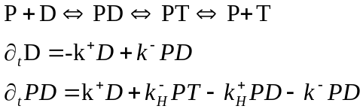
Assume that the backwards hydride transfer reaction doesn’t take place (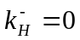). Then the change in the total amount of NADPH (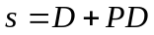) is:
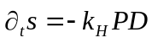, where we used 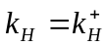for simplicity
If we take the second derivate of s, and use the equation for 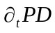we arrive to
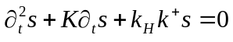, where 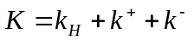
Assuming an exponential solution of the form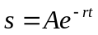we end up with the auxiliary equation 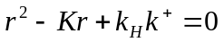which has two roots: 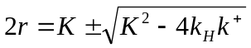
Assuming dissociation of PD very slow, and 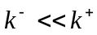, we end up with 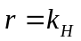, 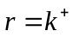such that a general solution for the total amount of NADPH is 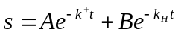.
Assuming initial conditions 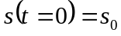and 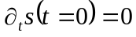, since 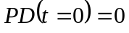, we arrive to 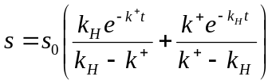, that is, the absorbance will have a bi-exponential decay under the assumed conditions. The figures below show very good fit to single exponential decay for the absorbance, meaning that either 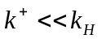(absorbance dominated by NADPH binding) or 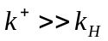(absorbance dominated by the hydride transfer step).

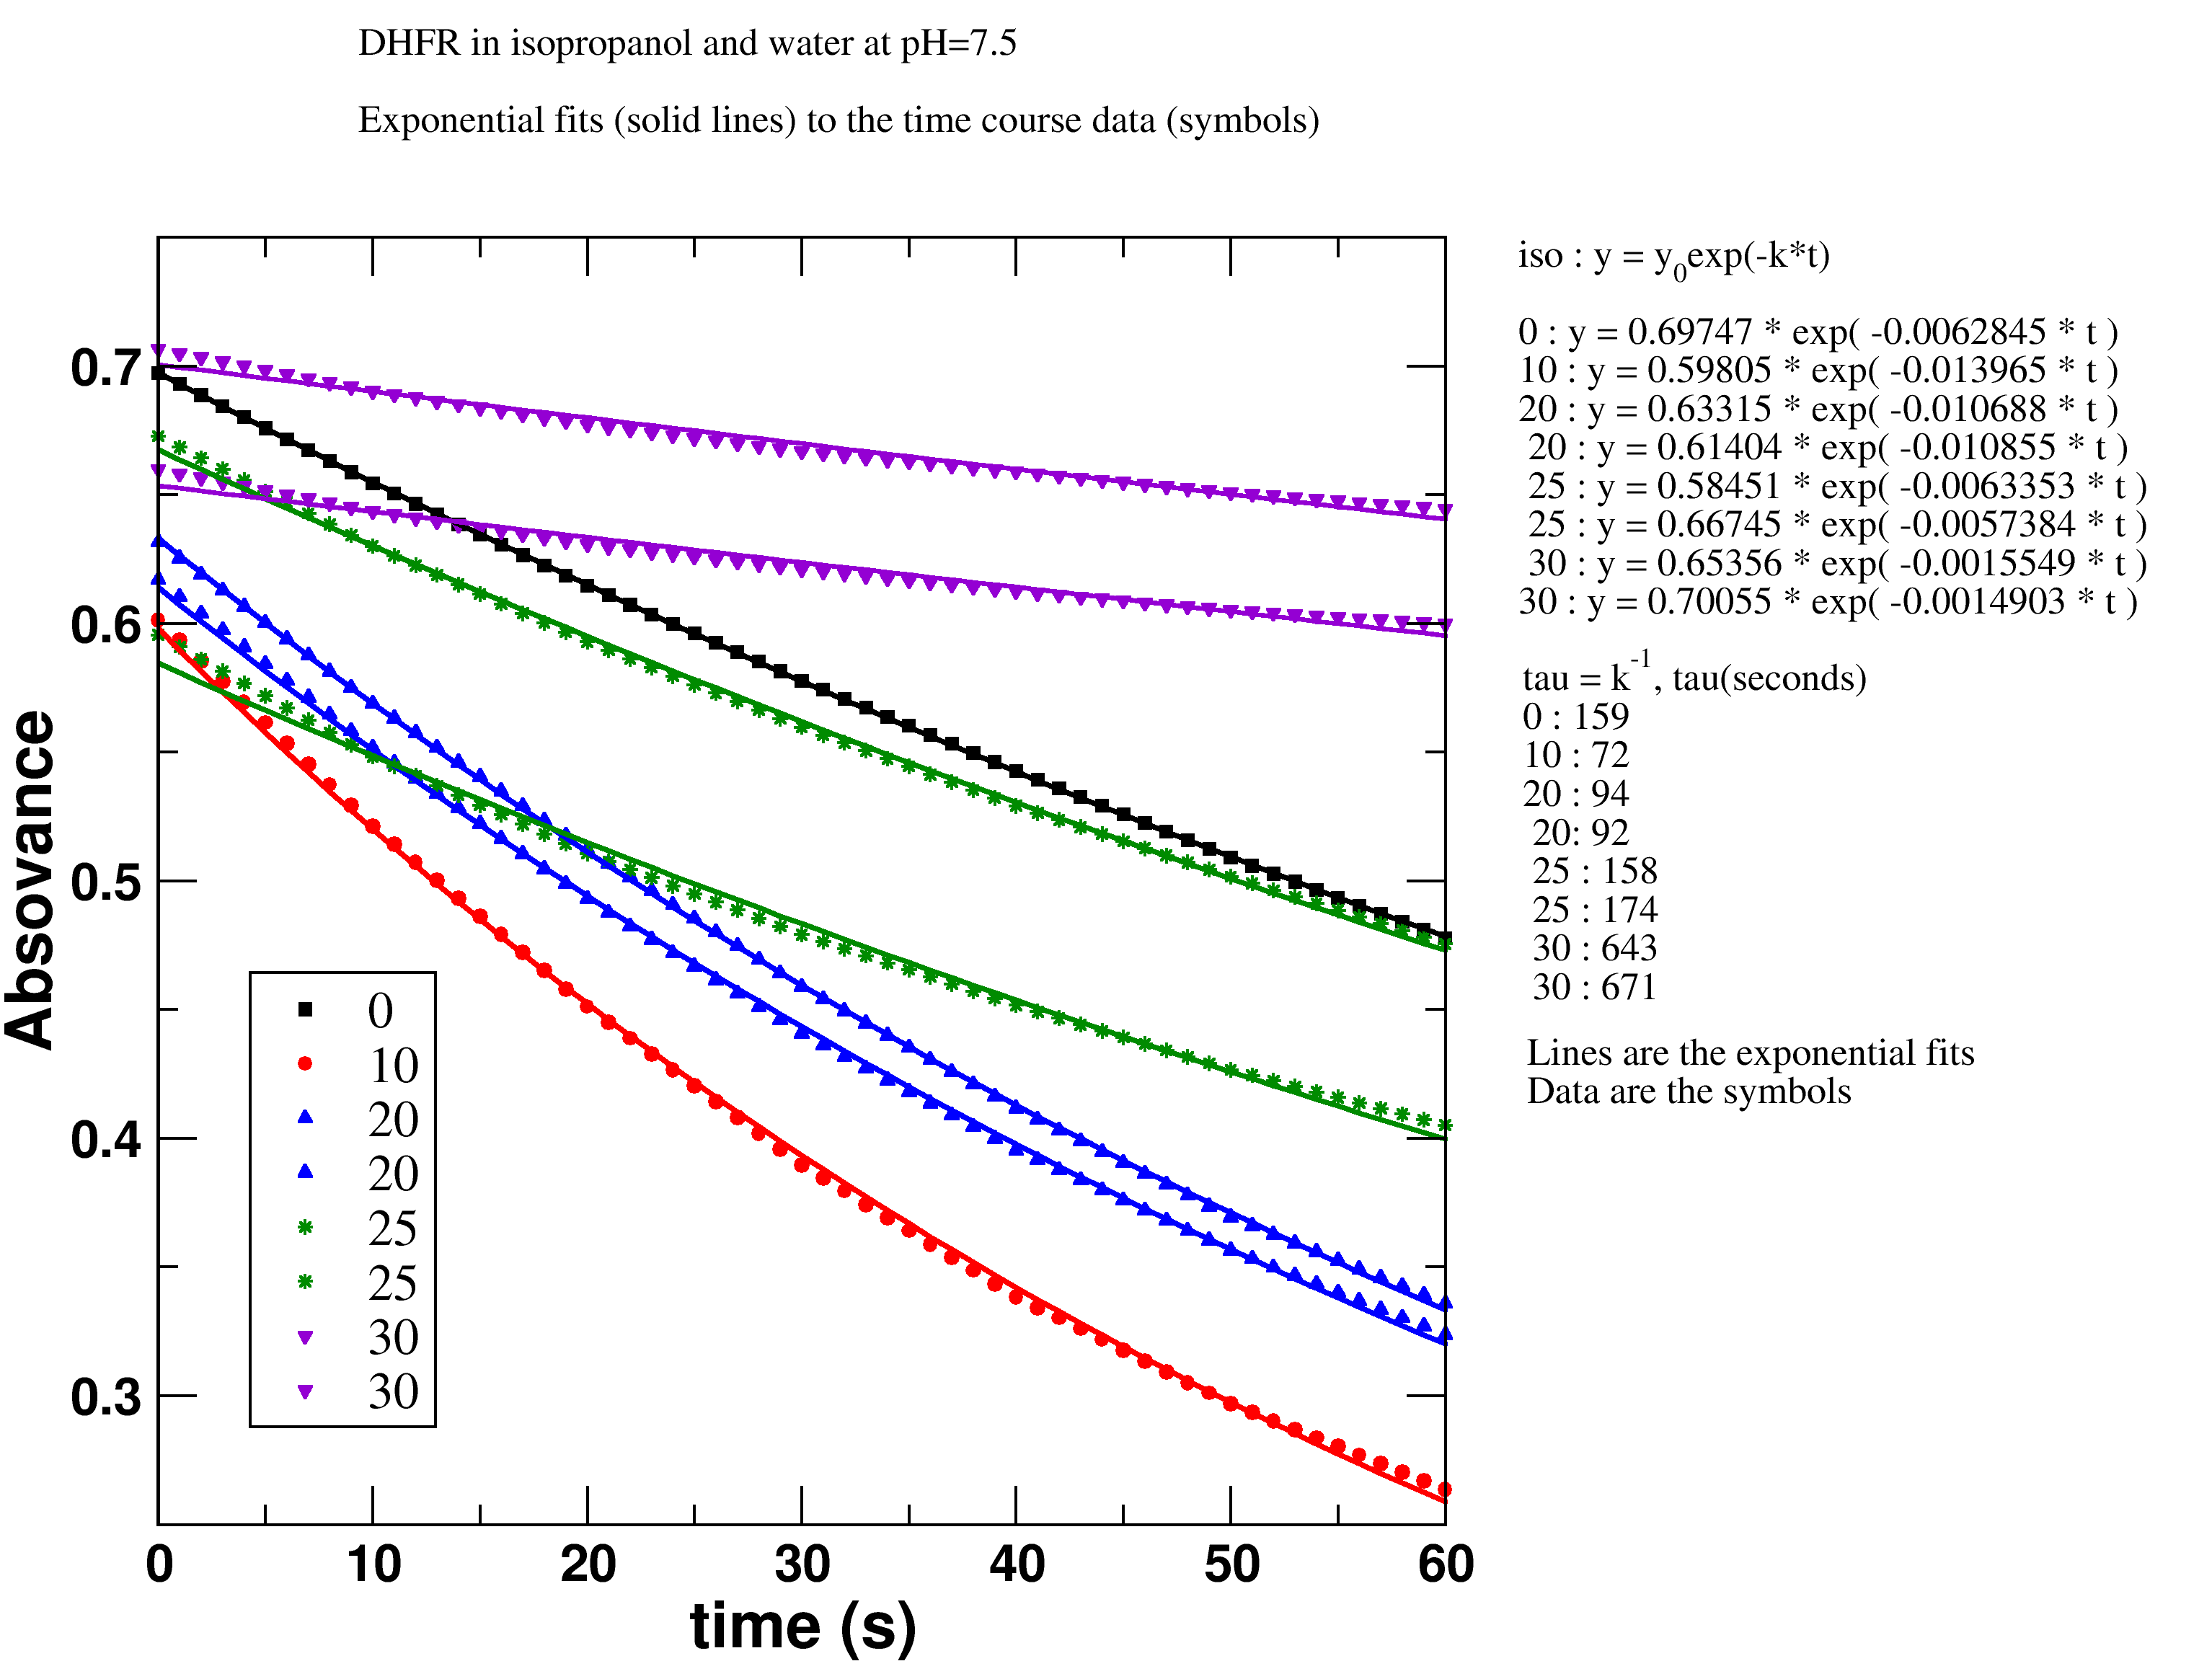
Figure absorbance-decay-in-water. Absorvance decay of NADPH in water and isopropanol and different volume concentrations (points), fitted to single exponential functions (continuous lines).
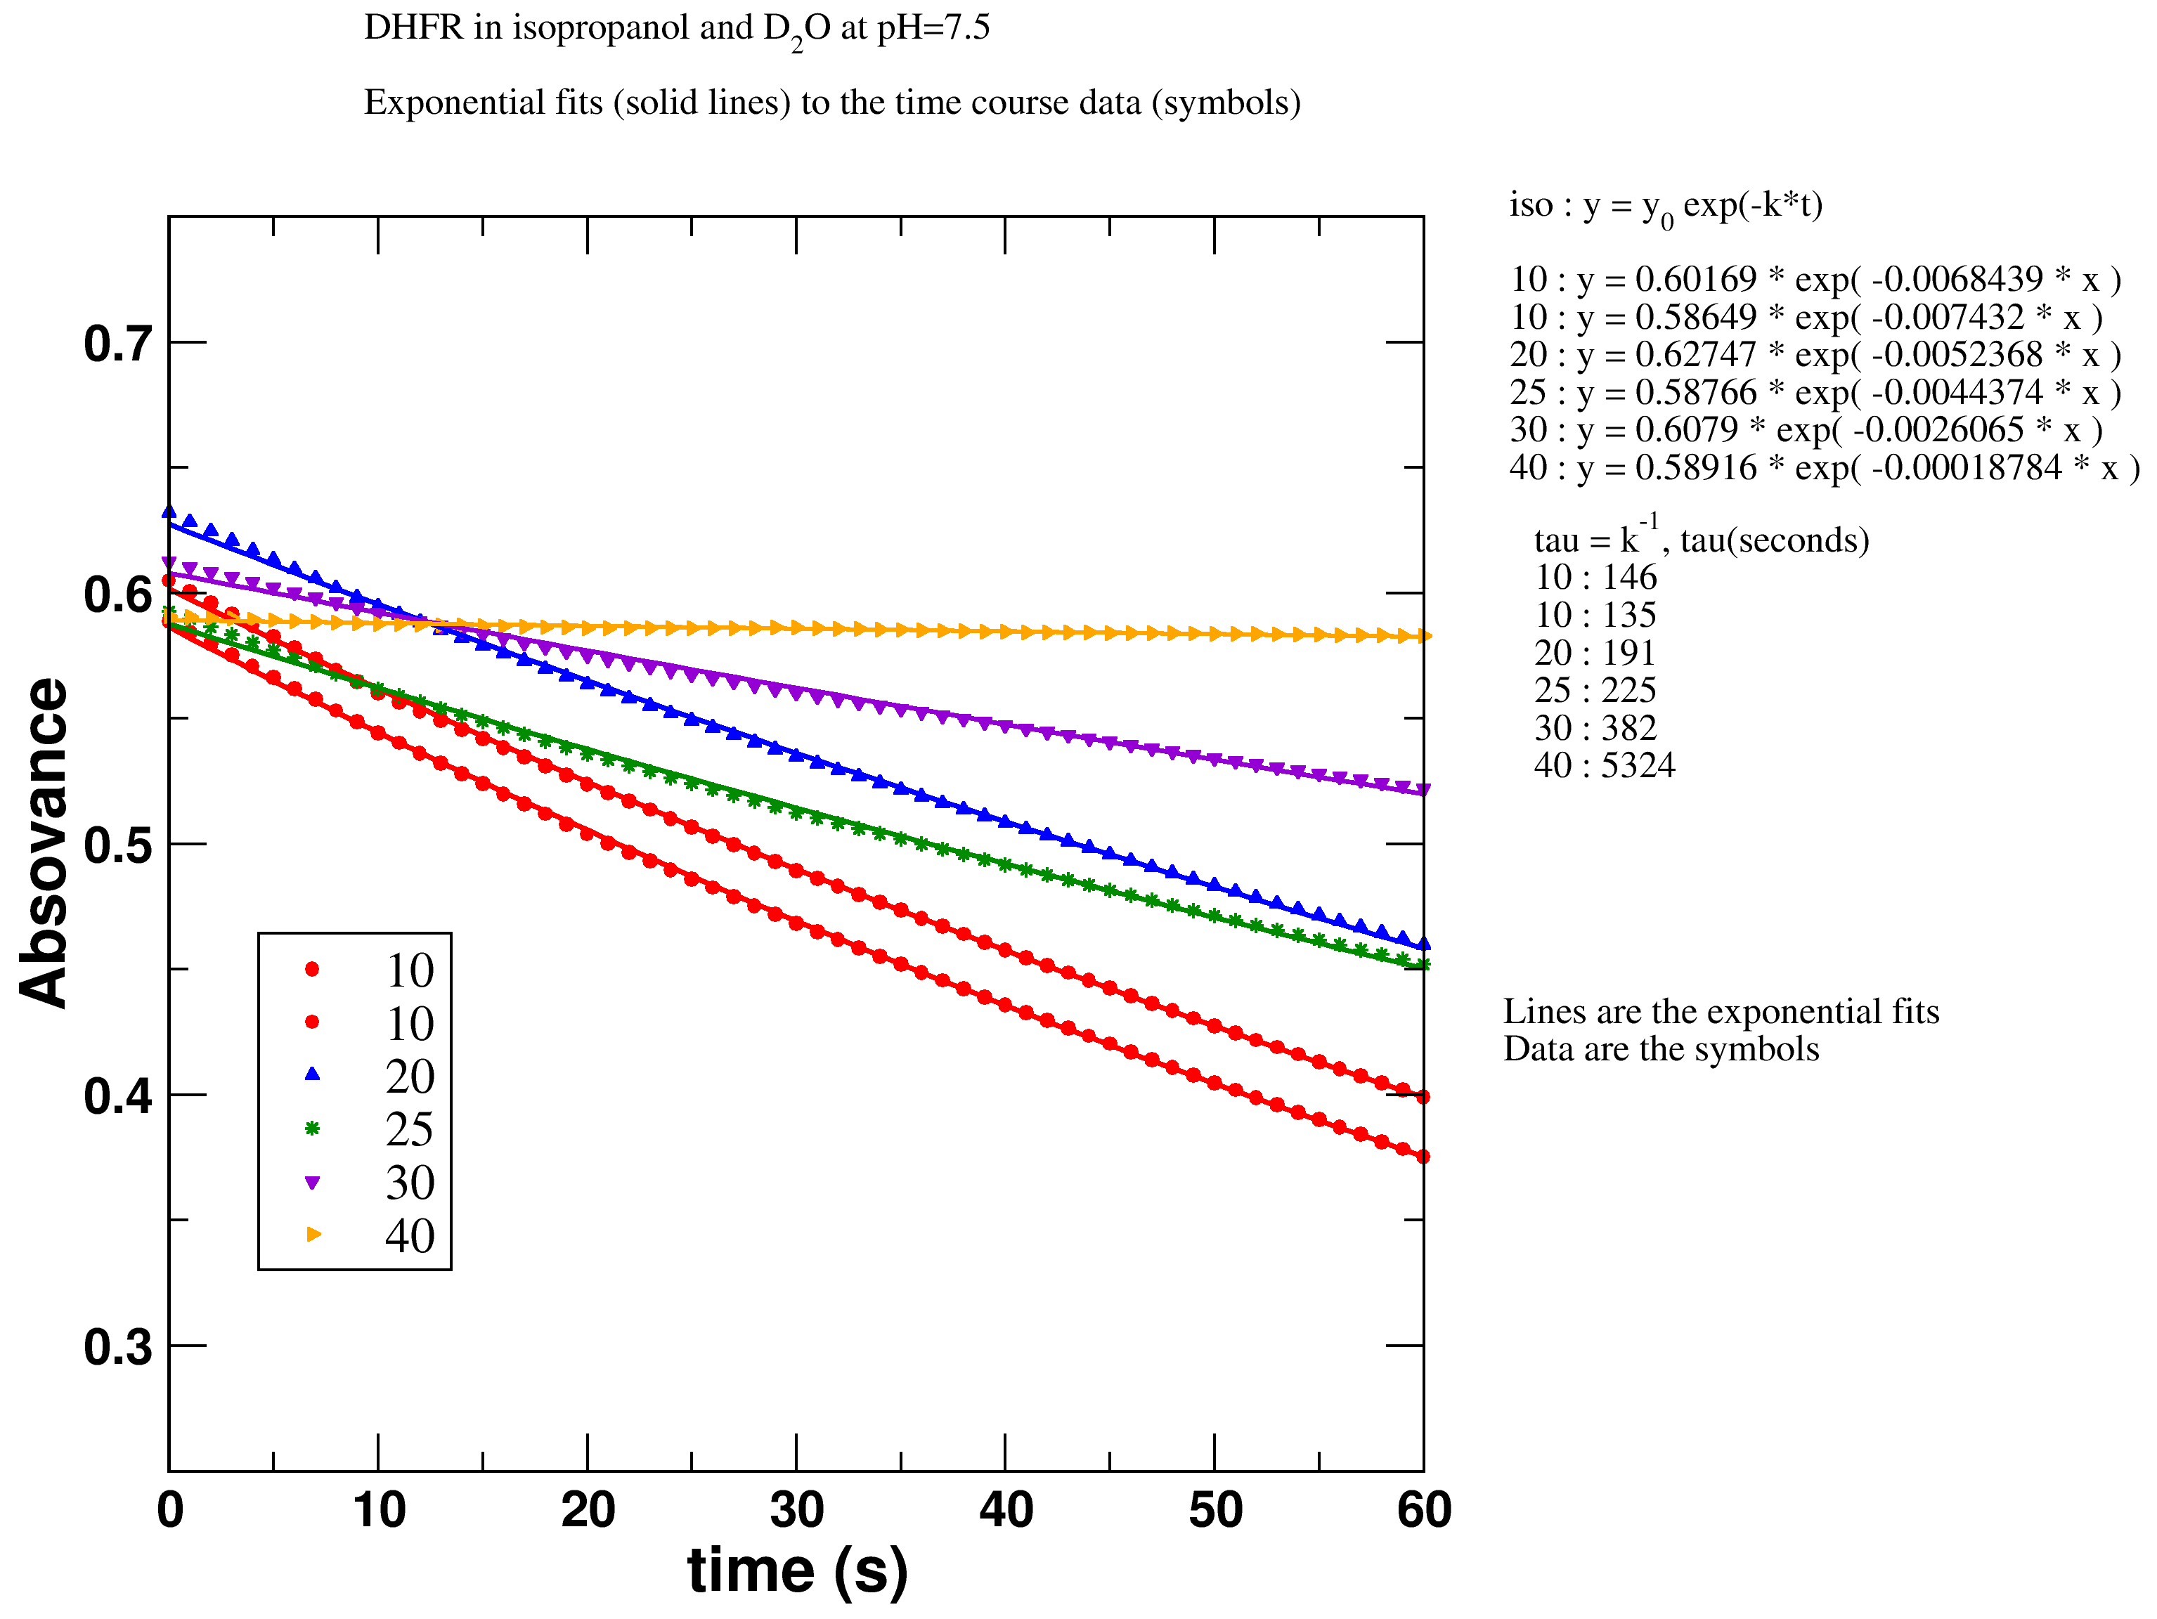
Figure absorbance-decay-in-heavy-water. Absorvance decay of NADPH in deuterated water and isopropanol and different volume concentrations (points), fitted to single exponential functions (continuous lines).
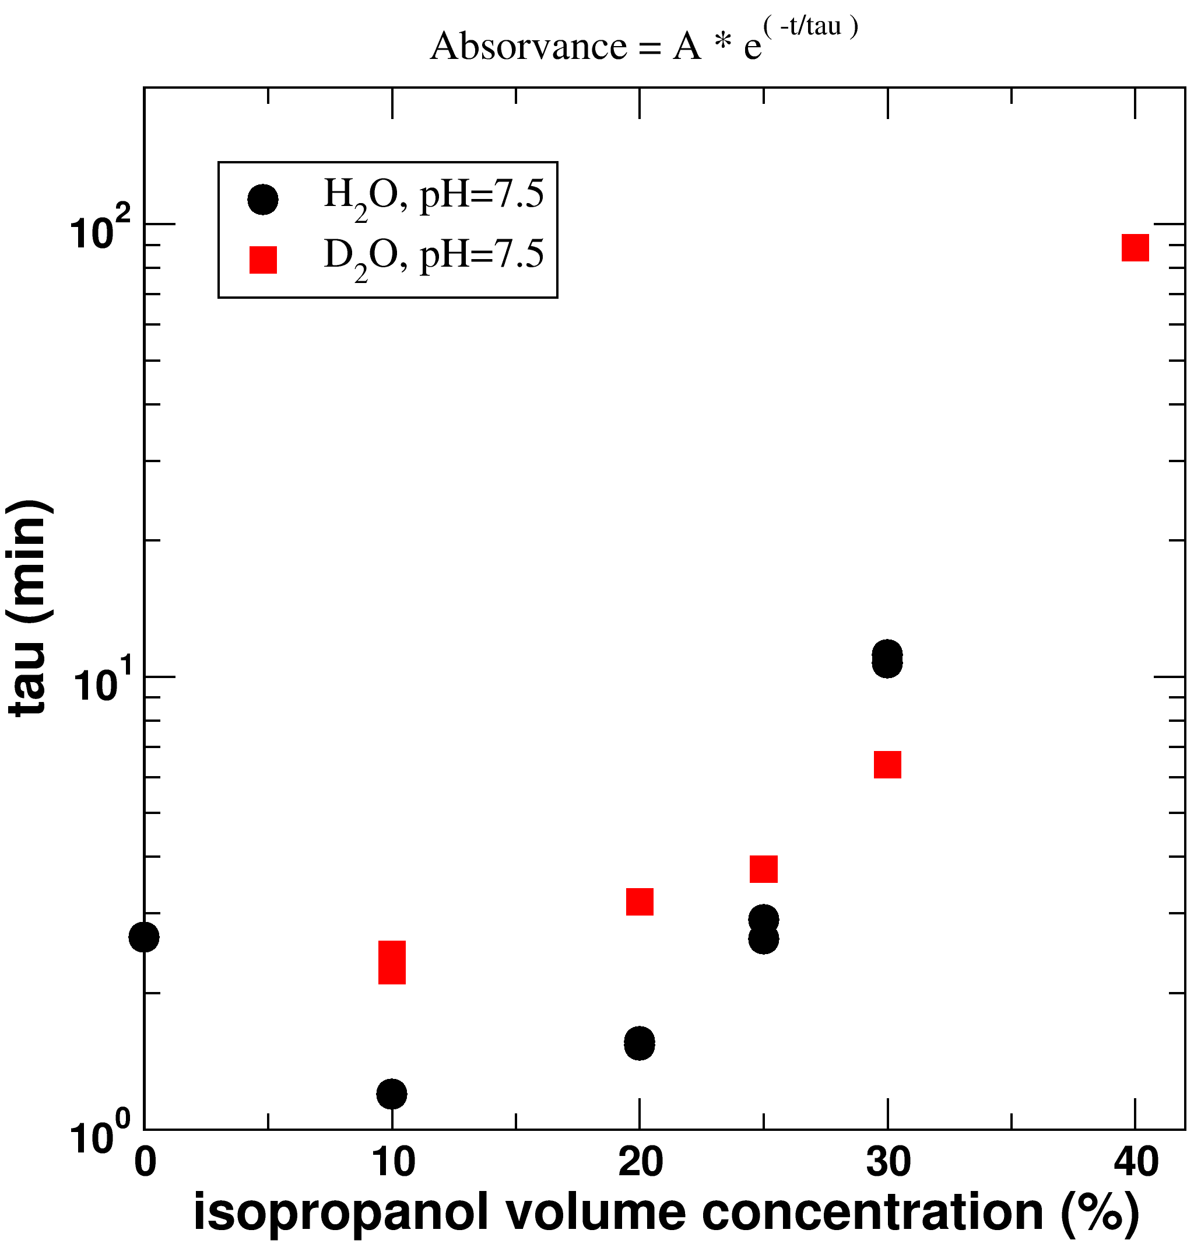
Figure absorvance-decay-lifetime. Decay lifetimes from the absorbance single exponential fittings. Irrespective of whether water or deuterated water is used, the decay lifetime increases with isopropanol concentration, meaning that DHFR becomes increasingly less efficient at transforming NADPH into NADP⁺.
Discussion and Summary

Acknowledgements:

Supporting information:

References
1. Dechene, M., Wink, G., Smith, M., Swartz, P. & Mattos, C. (2009) Proteins-Structure Function and Bioinformatics 76, 861-81.
2. Mattos, C. & Ringe, D. (2001) Curr Opin Struct Biol 11, 761-4.
3. Mattos, C., Bellamacina, C. R., Peisach, E., Pereira, A., Vitkup, D., Petsko, G. A. & Ringe, D. (2006) J Mol Biol 357, 1471-82.
4. Klibanov, A. M. (2003) Current Opinion in Biotechnology 14, 427-431.
5. Halling, P. J. (2004) Philos Trans R Soc Lond B Biol Sci 359, 1287-96; discussion 1296-7, 1323-8.
6. Loveridge, E. J. & Allemann, R. K. (2010) Biochemistry 49, 5390-6.
7. Loveridge, E. J., Tey, L. H. & Allemann, R. K. (2010) J Am Chem Soc 132, 1137-43.
8. Sawaya, M. R. & Kraut, J. (1997) Biochemistry 36, 586-603.
9. Agarwal, P. K., Billeter, S. R., Rajagopalan, P. T. R., Benkovic, S. J. & Hammes-Schiffer, S. (2002) Proceedings of the National Academy of Sciences of the United States of America 99, 2794-2799.
10. Radkiewicz, J. & Brooks, I. C. (2000) J. Am. Chem. Soc. 122, 225-231.
11. Garcia-Viloca, M., Truhlar, D. G. & Gao, J. (2003) Biochemistry 42, 13558-75.
12. Wang, L., Goodey, N. M., Benkovic, S. J. & Kohen, A. (2006) Proc Natl Acad Sci U S A 103, 15753-8.
13. Hammes, G. G. (2002) Biochemistry 41, 8221-8.
14. Zaks, A. & Klibanov, A. M. (1985) Proceedings of the National Academy of Sciences of the United States of America 82, 3192-3196.
15. Martin, M. G. (2006) Fluid Phase Equilibria 248, 50-55.
16. Martinez, L., Andrade, R., Birgin, E. G. & Martinez, J. M. (2009) Journal of Computational Chemistry 30, 2157-2164.
17. Agarwal, P. K. (2004) Proteins 56, 449-63.

