Supporting Information

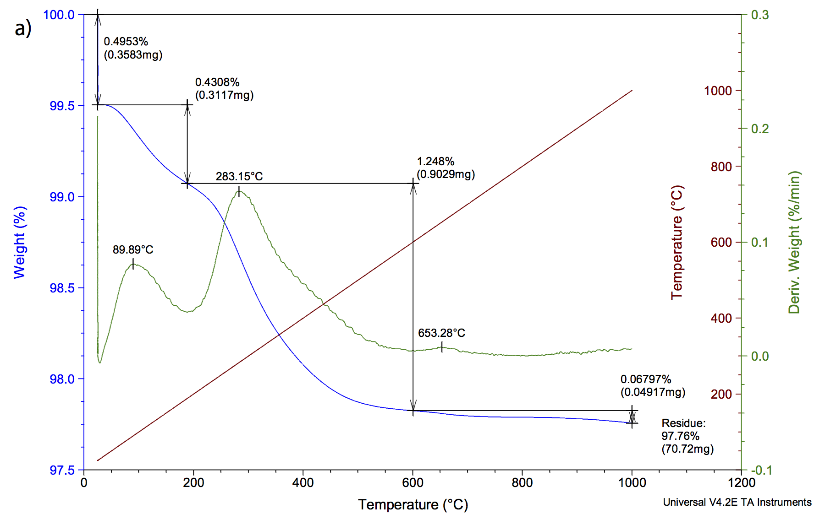
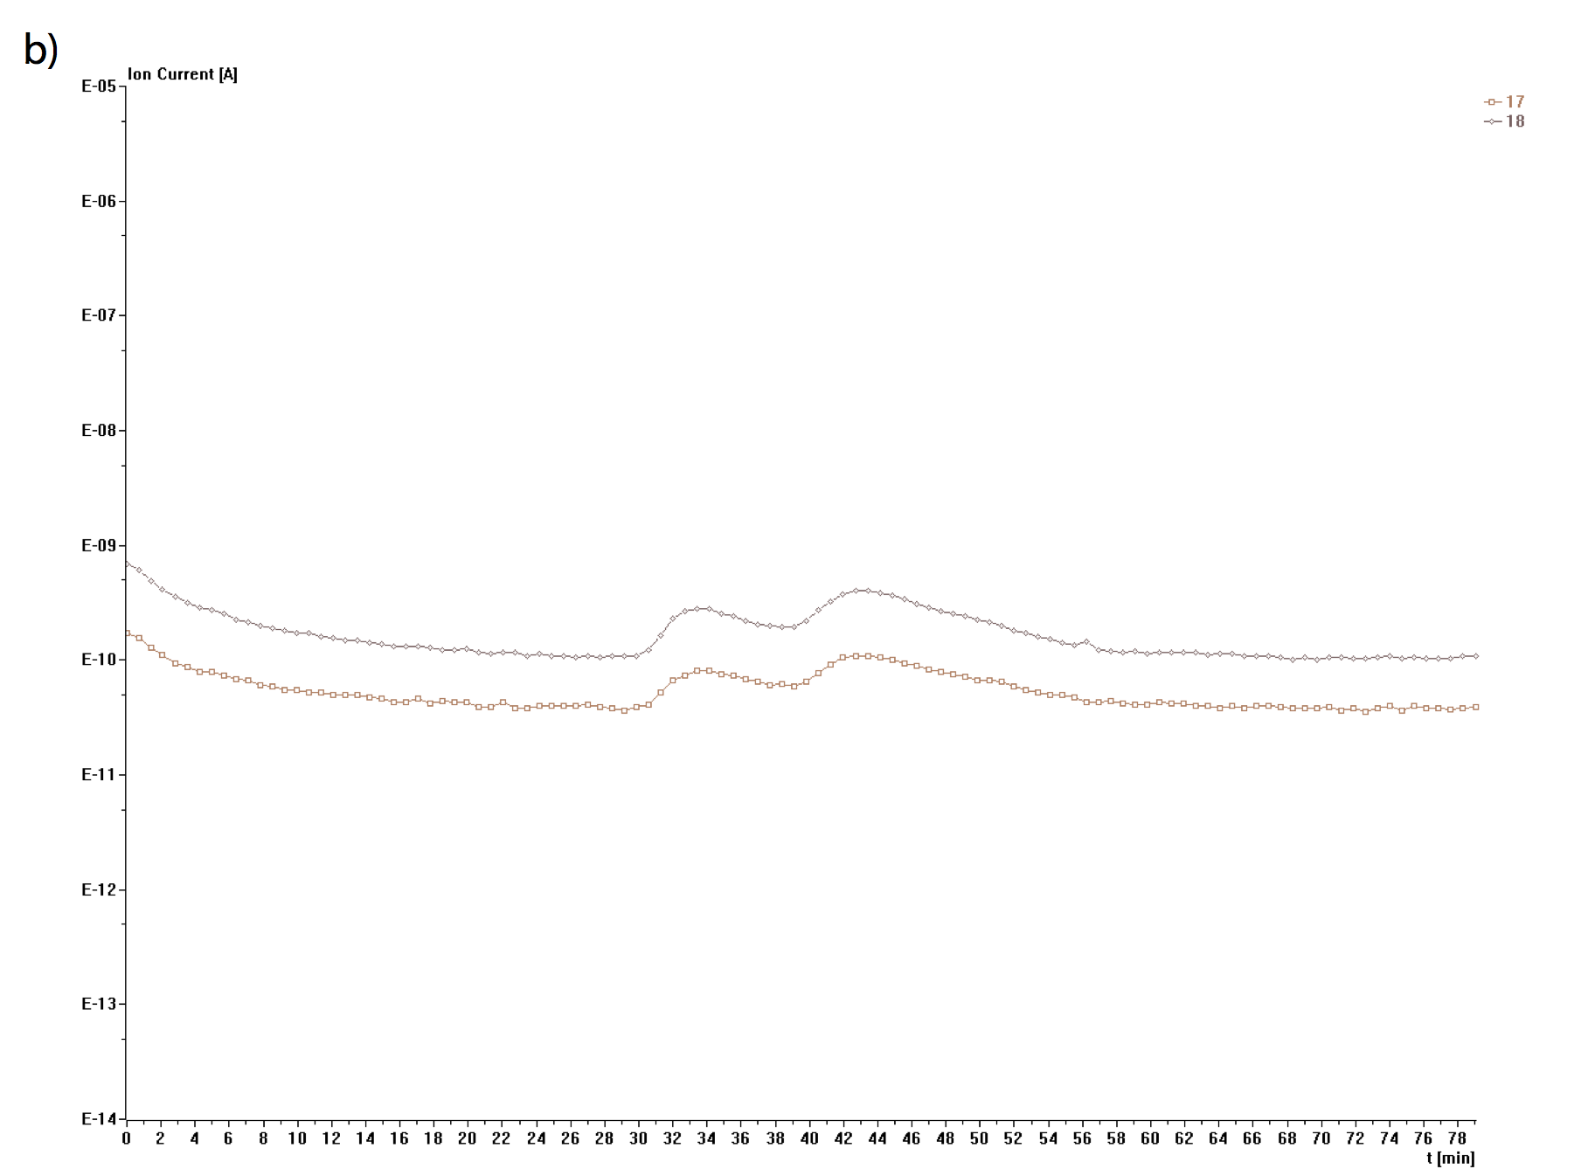

Figure S1. Thermogravimetric Analysis-Mass Spectrometry Data for barite (BaSO₄) nanoparticles exposed to laboratory air. a) Weight of sample as a function of temperature. Two main peaks are observed, occurring at 33.33 min (89.89 °C) and 43.00 min (283.15 °C) with a small peak at 61.57 min. (653 °C). b) MS results, y-axis is m/z values detected evolving from the sample as a function of time. Water (m/z’s 17 and 18) was seen evolving during both weight loss events. No mass fragments were detected from the smaller peak at 61.57 min., indicating water is the dominant volatile species present on these surfaces. Method: The sample was analyzed by a TA Q5000 TGA interfaced to a Pfeiffer Thermostar mass spectrometer by means of a heated capillary transfer line. In this system, the sample was kept isothermal at room temperature for 30 minutes and then heated from room temperature to 1000 °C at 20 °C/min. The capillary transfer line was heated to 195 °C. The Thermostar unit is based on a quadrupole design and the masses scanned ranged from 1-200 amu. The sample gas from the TGA was ionized at 70 eV. The experiment took place in nitrogen with a flow rate of 35 mL/min.

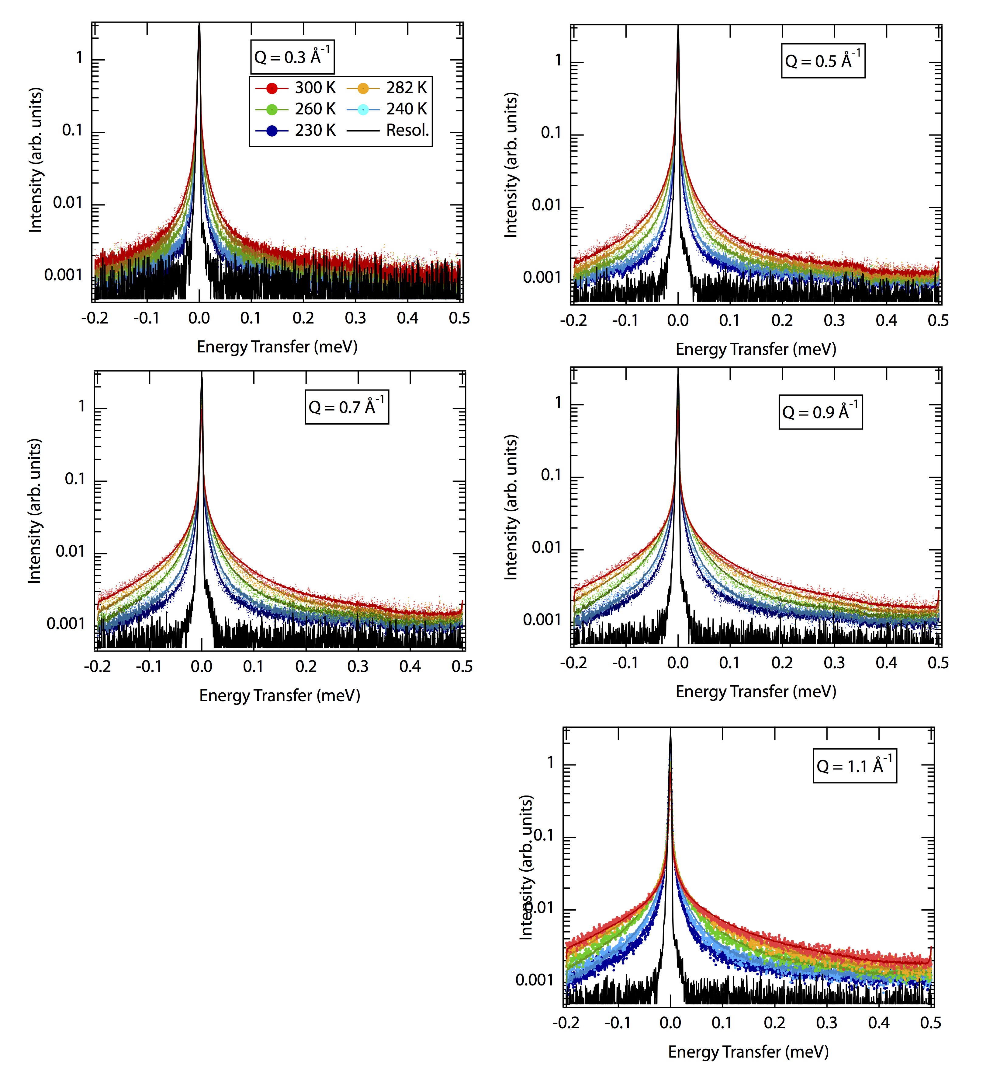
Figure S2. QENS data (points) and fits (lines) as a function of temperature, energy transfer and momentum transfer (Q). The black line is the resolution function. Data is fit to equations 1 & 2 using MD trajectories

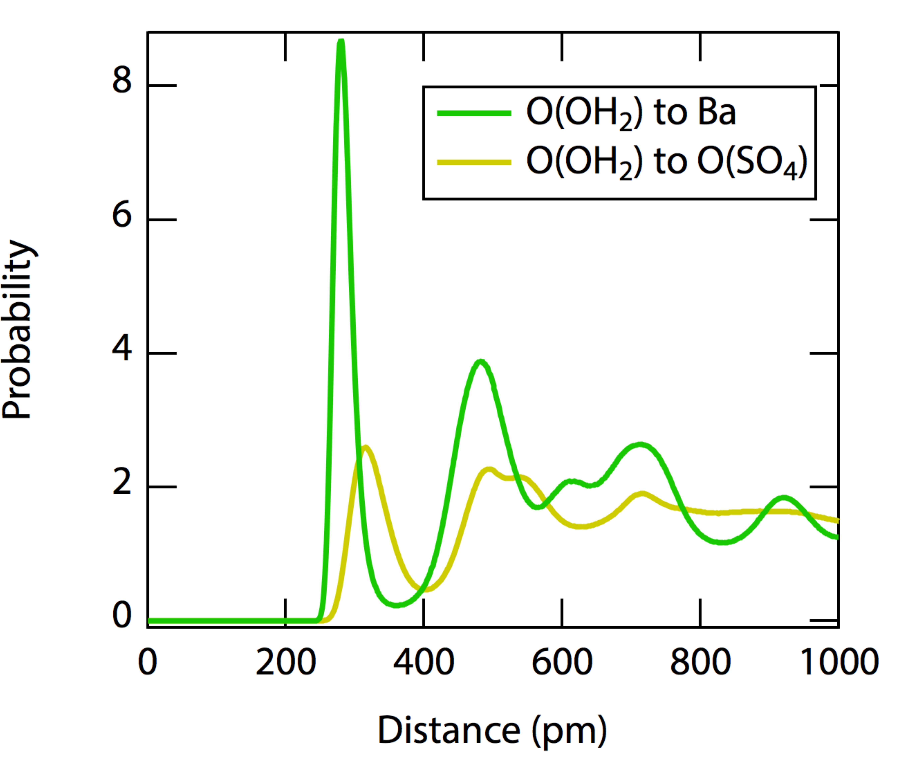

Figure S3. Radial Distribution Functions for oxygen on water to barium (green) and oxygens on sulfate (yellow) surface sites. The minima between first and second shells are located at 360 pm and 400 pm for barium and oxygen on sulfate surface sites, respectively.

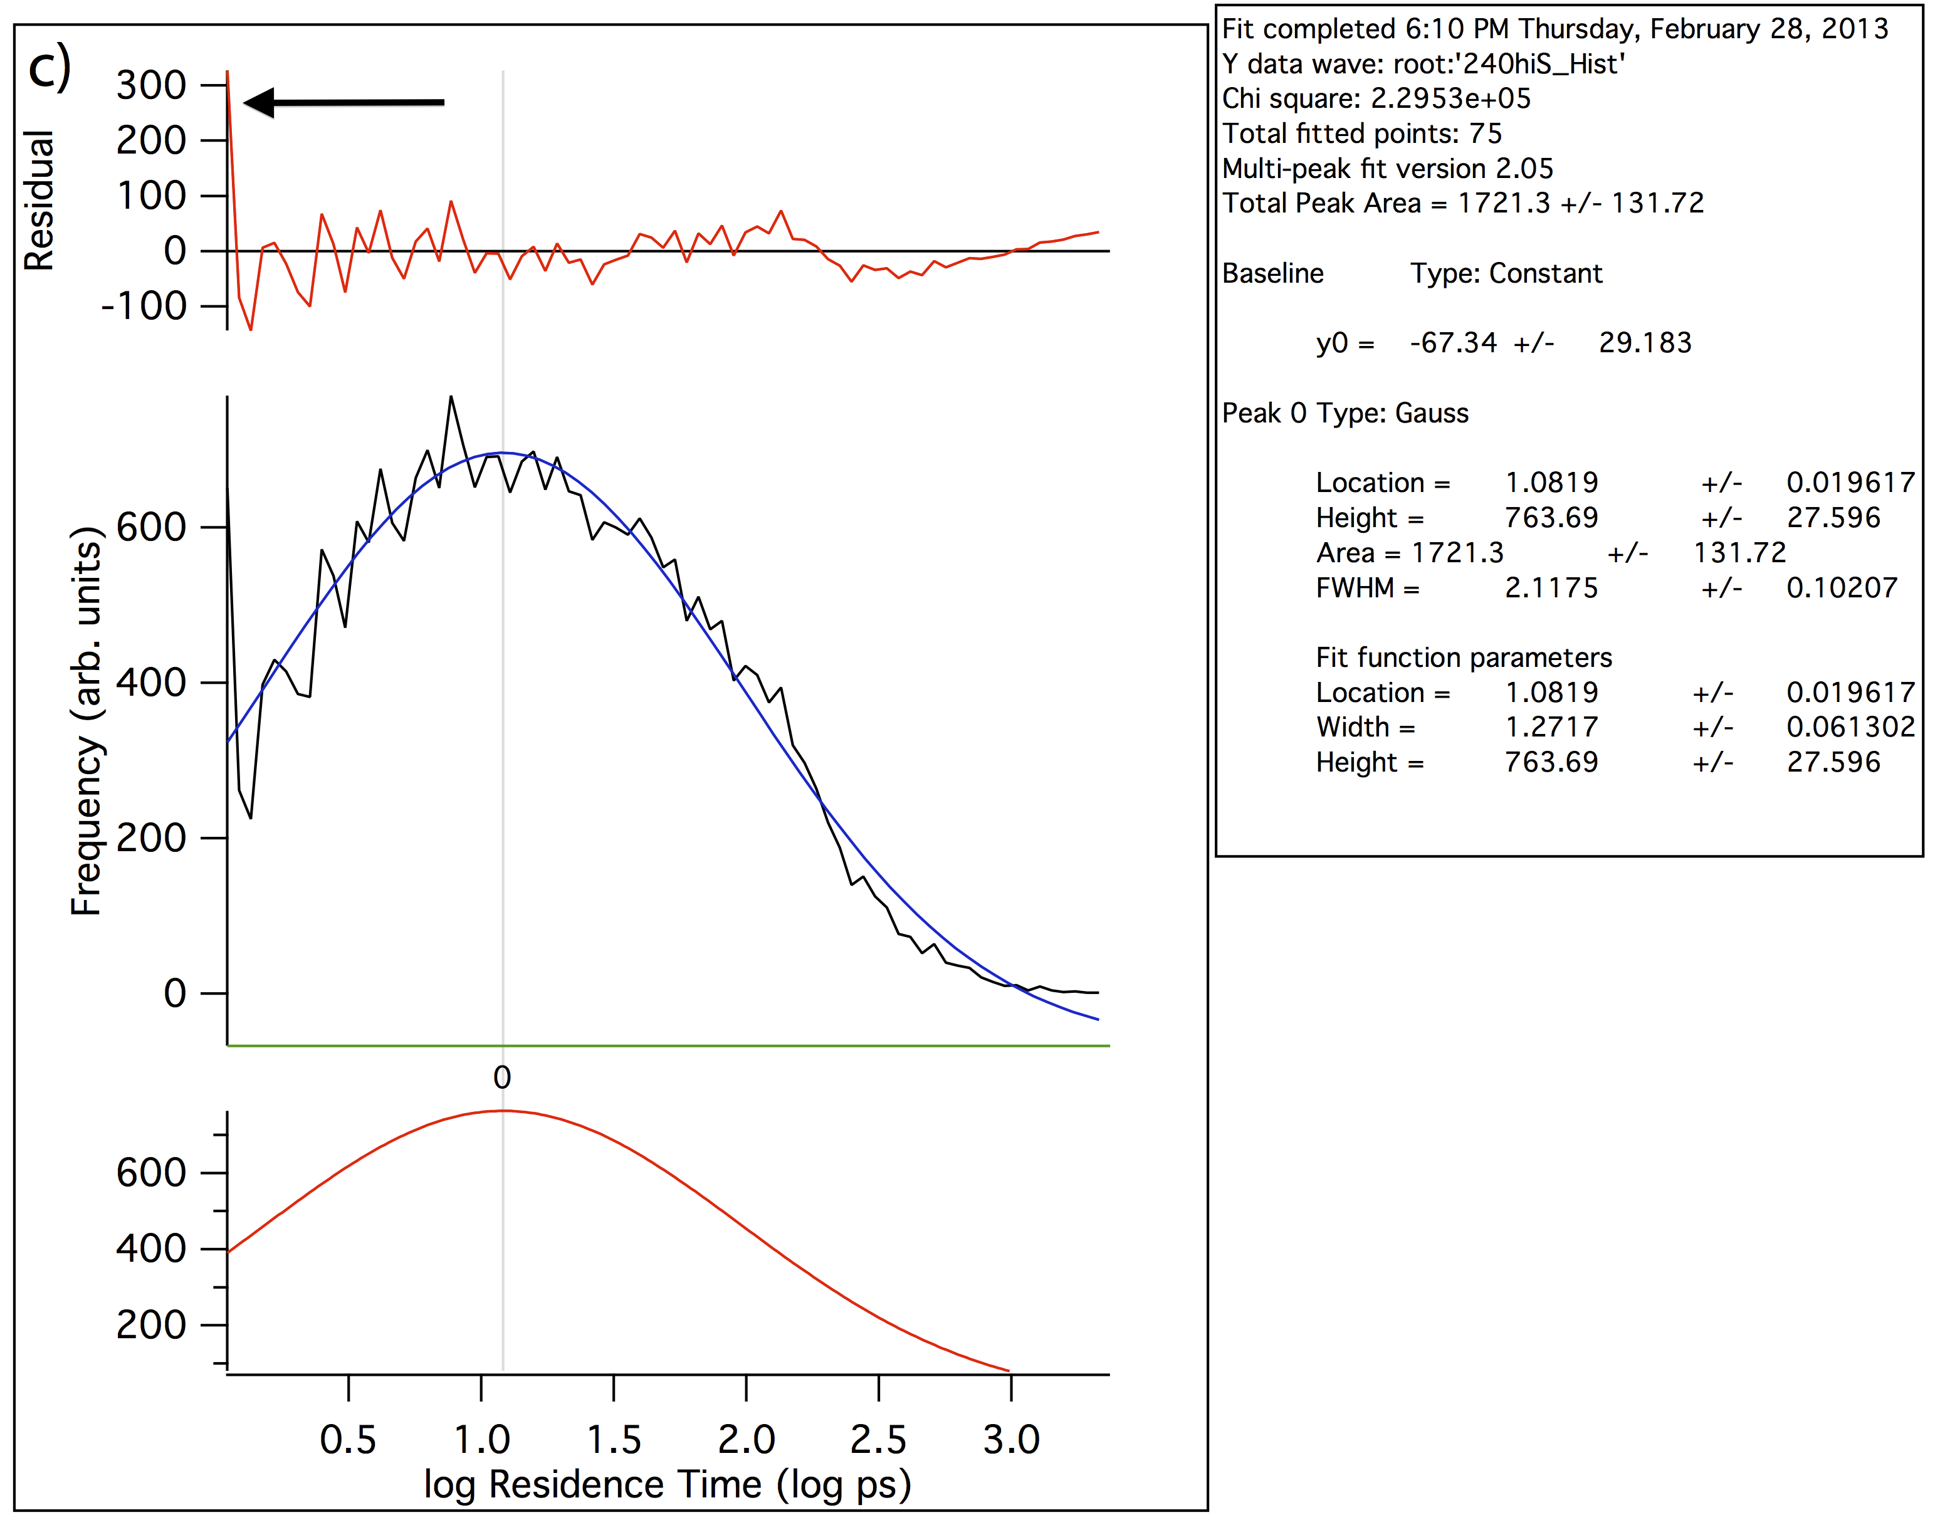

Figure S4. Water exchange on the high sulfate site at 240 K using a 1 ps cutoff for successful exchanges (2 ps are used in Figures 5 & 6). The black arrow on the residual plot denotes the large number of 1 ps exchanges observed without an accompanying distribution, implying these are in fact unsuccessful exchange attempts.

