Wireframe

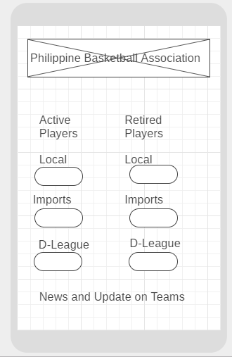

This is the wireframe from my idea of an app that helps any basketball enthusiast know what are the updates and news on drafted players. This app is used by clicking the buttons so that you can see the list of records in every section.

Mockups

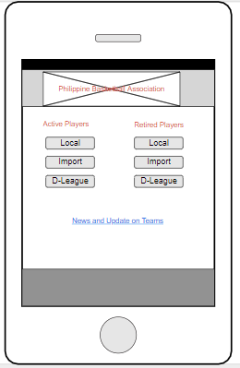

This is the mockup for my app. I used an image to represent the Philippine Basketball Image Logo. I also used colors to indicate what is the section of the list of players that has been active or already retired in the league.

Prototype

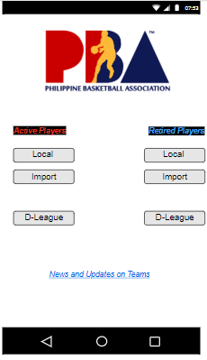

And this is my prototype for my app. It shows the buttons that can be clicked easily and shows up the list of the players which are active player or retired player. You can also see the categories in each button and once it is clicked, it will show you the list of players based on the category that you picked.

Ex. Active > Local > Calvin Abueva

Retired > Import > Norman Black