Git Shared Folder Thing

Josh Brown
CS 499

Vision Statement

Project Goals
- Allow users to share files seamlessly and privately over some kind of network.
- Not rely on a cloud service or centralized server.

Project Scope
- Desktop app with a background service that detects changed files and sends them to other peers.
- Android app similar to the dropbox one. Does not automatically download files to probably space constrained device but able to browse through files and download or share them on command.

High Level Features
- Automatically try to find known peers at known previous locations.
- Peer IP addresses may propagate through the network.
- Automatically recognize, upload, and download files.
- Setting to not download files automatically outside some size range.
- Erase old history so the local git repository doesn’t get too bloated.
- User can cherry pick files to be downloaded or never downloaded.
- Several separate shared folders if needed.

Project Backlog
ID | Description | Points
D01 | Check for changes in one folder inside a git repo and send those to another repo on disk | 8
D02 | Set up some sort of peer registry | 5
D03 | Make queries to known peers | 3
D04 | Interact with peers on a different computer over LAN | 5
D05 | Implement some sort of identity validation | 8
D06 | Ensure data is encrypted on transmission | 8
D07 | Interact with peers over the internet | 3
D08 | Accept a validated connection from a peer at an unknown location | 5
D01a | Create a particularly formatted git repo | 2
D01b | Recognize and log changed files | 1
D01c | Automatically commit and push to a git repo on disk | 2
D01d | Push after negotiating with a peer at localhost | 3
D09 | Make a quick GUI to look at files | 3
D10 | Have GUI program be able to command background service | 5
D11 | Implement useful user commands | 8
A01 | Mock up GUI | 8
A02 | Connect to a peer and query available files | 5
A03 | Download an available file | 2
A04 | “Share” an available file | 5

Sprint 1
ID | Description | Points
D01a | Set up a command line app with JGit | 1 | O
 | Create folders and a git repo | 1 | O
D01b | Query git for changed files | 0.8 | O
 | Identify paths and save to a log file | 0.2 | ~
D01c | Commit changes periodically | 1 | O
 | Push to a repo on disk from config file | 1 | X
D01d | Listen for commands via network | 2 | O
 | Send commands via network | 0.3 | X
 | Implement a peer system on localhost | 0.7 | X
D02 | UUIDs for each peer | 3 | X
 | Save file with UUIDs and addresses | 2 | X
D03 | Implement a query system | 1.5 | X
 | Listen for queries | 1 | X
 | Make queries automatically | 0.5 | X

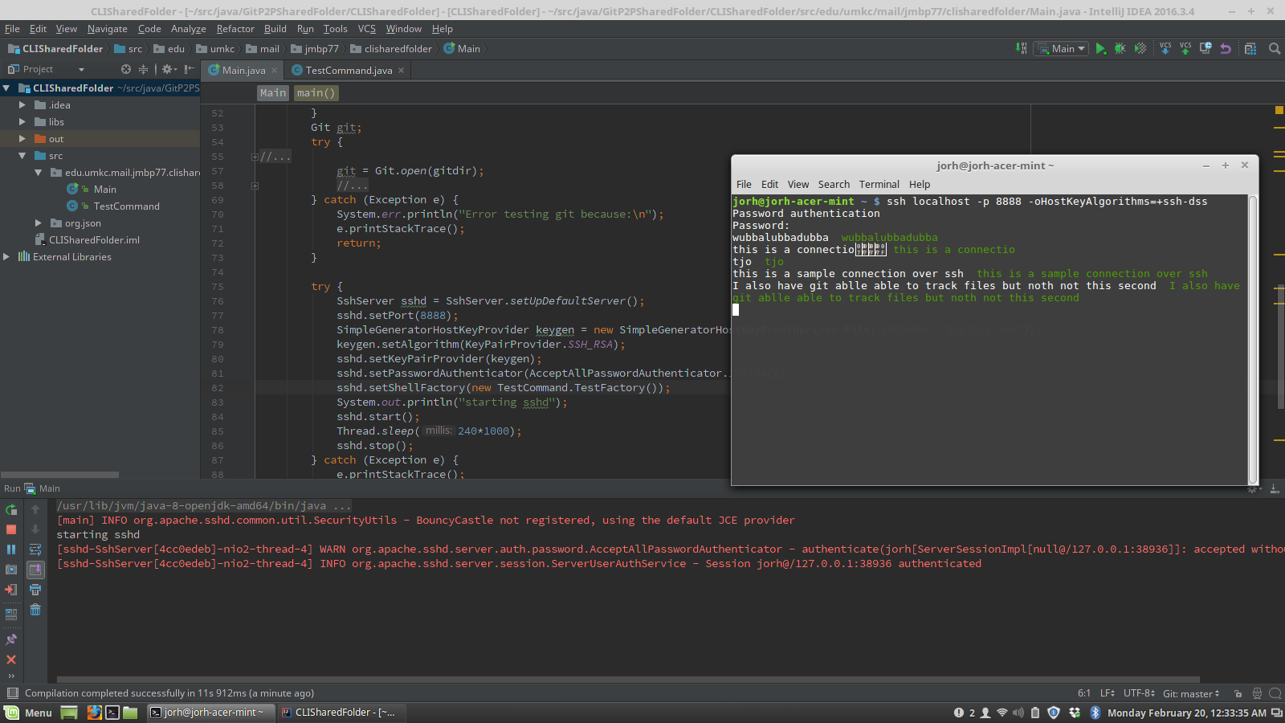
Two way network connection via ssh.

Accomplished in sprint 1:
- Integration of JGit and Apache MINA SSHD for git and ssh protocols.
- Recognize and commit files with git.
- Listen for something via ssh.
- Decided not to push to another repo on disk since it isn’t progress towards the final program
Project Backlog 2
ID | Description | Points
D01 | Check for changes in one folder inside a git repo and send those to another repo on disk | 8
D02 | Set up some sort of peer registry | 5
D03 | Make queries to known peers | 5
D04 | Interact with peers on a different computer over LAN | 3
D05 | Implement some sort of identity validation | 8
D06 | Ensure data is encrypted on transmission | 8
D07 | Interact with peers over the internet | 3
D08 | Accept a validated connection from a peer at an unknown location | 5
D01a | Create a particularly formatted git repo | 2 | O
D01b | Recognize and log changed files | 1 | O
D01c | Automatically commit and push to a git repo on disk | 2 | ~
D01d | Push after negotiating with a peer at localhost | 13
D09 | Make a quick GUI to look at files | 3
D10 | Have GUI program be able to command background service | 5
D11 | Implement useful user commands | 8
A01 | Mock up GUI | 8
A02 | Connect to a peer and query available files | 5
A03 | Download an available file | 2
A04 | “Share” an available file | 5

Sprint 1
ID | Description | Points
D01db | Make some sort of peer system | 1
 | Have two instances connect to each other | 3
D01dc | Have two instances trade info about git | 2
D01dd | Push git info over IP | 5
D02 | UUIDs for peers | 2
 | Save peers with UUID and known addresses | 3
D03 | Implement a query system | 2
 | Listen for queries | 1
 | Make queries automatically | 2
D04 | Interact with a peer over LAN | 3

