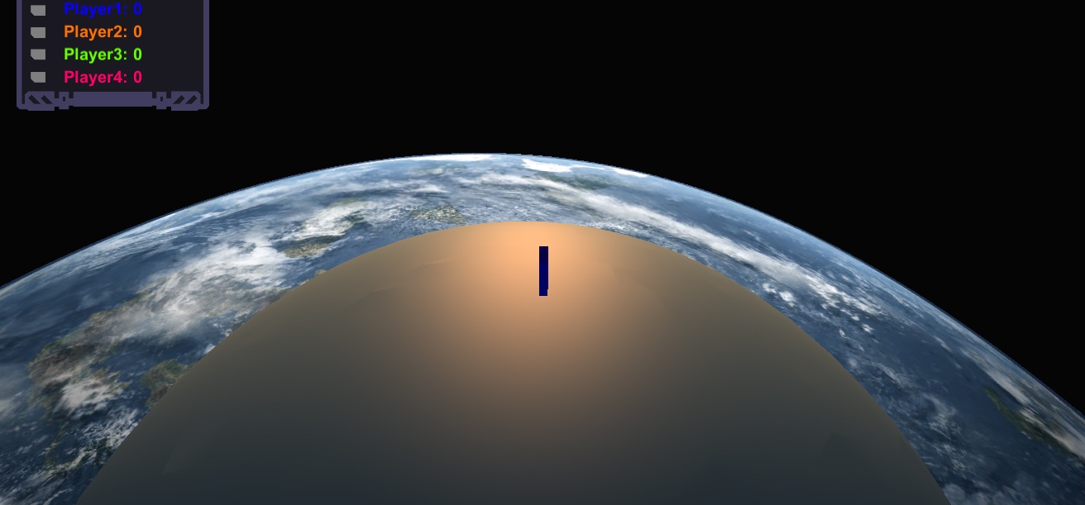

**Compete with your friends in Z3D. Win by blocking your enemies off, the last man standing wins!**

**Z3D**

* **3D levels**
* **Online multiplayer**
* **Awesome soundtrack**

## Description

Z3D is a remake of Achtung die Kurve! Instead of playing in 2D, we can now play in strange planet shaped levels, alone or online!

## Manual

**Controls:** Left/A and right/D keys to move, ESC to quit. Navigate the menu using the mouse.

Choose Singleplayer to explore the level by yourself.  
When you choose Multiplayer, you or one of your friends should start a server. The one who starts a server will see “server” standing in the top right corner.  
When the server is started, the other players will see”Join game” in their menu when they refresh and wait.  
The game begins when the server presses “Start game”.