Jacob Cole, Michael Pittard, Parker Cantu

Dr. Do

CSCE 4444.002

9/23/2015

**Deliverable 2**

**Team: The Textbook Triad**

# 1. Introduction

## 1.1 Purpose:

This document details the functionality required for UNTextbook Finder.

## 1.2 Document Conventions

All functionality detailed in this document is “One” unless specifically noted otherwise.

## 1.3 Intended Audience

The primary audience is Dr. Do and her teaching assistants, as well as anyone peer reviewing our project.

## 1.4 Product Scope

UNTextbook Finder should serve as a tool for any UNT student looking for textbooks and want to find the best price for their books.

## 1.5 Reference

1. Deliverable 1

# 2. Overall Description

## 2.1 Product Functions

**The overall description of UNTextbook Finder functionality was given in Deliverable 1**

* Replace the current method of comparing textbook prices by visiting each site and searching for one book multiple times.
* Provides a convenient way for UNT students to compare textbook prices.
* Provides an easy-to-use interface for the user.
* Enable updating the database at least once a day.

## 2.2 Operating Environment

UNTextbook Finder is developed for use in any web browser supporting javascript.

Code will be developed in python, javascript, and php.

Accessing third party bookstores’ web sites.

# 3. Requirements Specifications

## 3.1 Functional Requirements

* The website will run a script against the UNT Bookstore site.
* Data pulled from the UNT site by the script will be stored in a database.
* The results page will limit the output to the user to one supplier per book for each store.
* Administration levels will be limited to one (1).

## 3.2 Non-functional Requirements

* Data should be relayed to the user within less than 2 seconds.
* Database should be updated once every day.
* The department must be selected before the course.
* This product will be available using any web-browser.
* Minimal user input to ensure stability.
* Code will be well documented in case of future changes .

## 3.3 Interfaces

* Website home page is the search page.
* There will be a separate results page.
* User will search with drop down lists (don’t let user type to reduce error and complexity)
* Each book will display the title, price, store, ISBN, and link

# 4. Architecture

## 4.1 System Architecture

The system follows the client-server model. The user will use the web interface to search for books handled by the server. The server will check the database to see if the requested book exists and give a response.

# 5. UML Documentation

## 5.1 Class Diagram

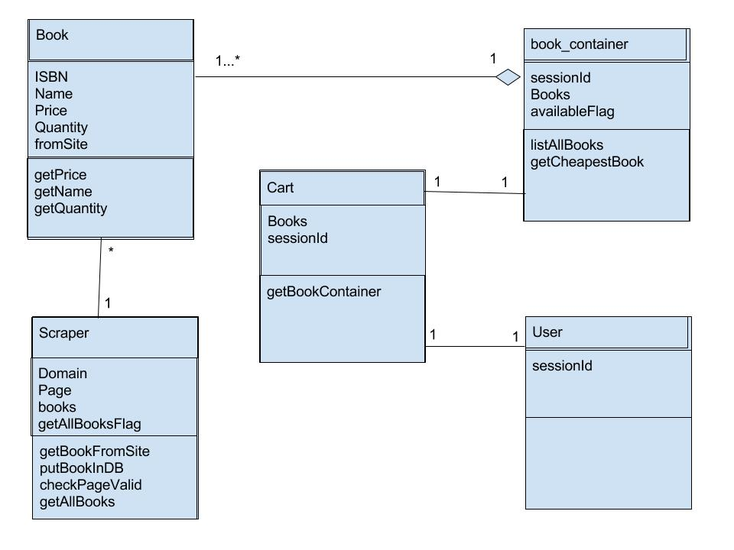

## 

## 5.2 Sequence Diagram

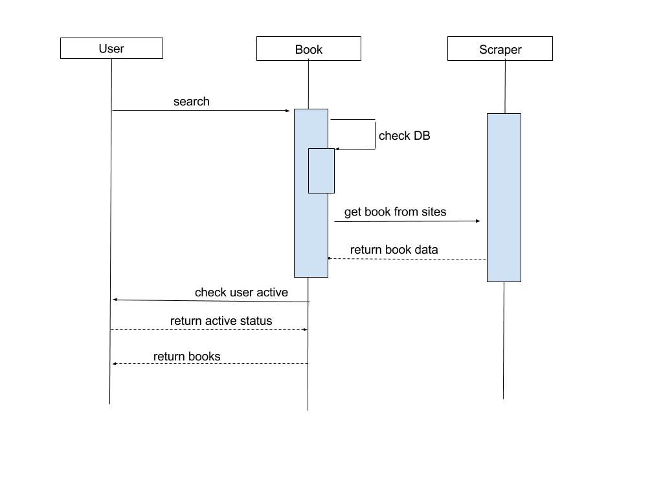

## 5.3 Use Case Diagram

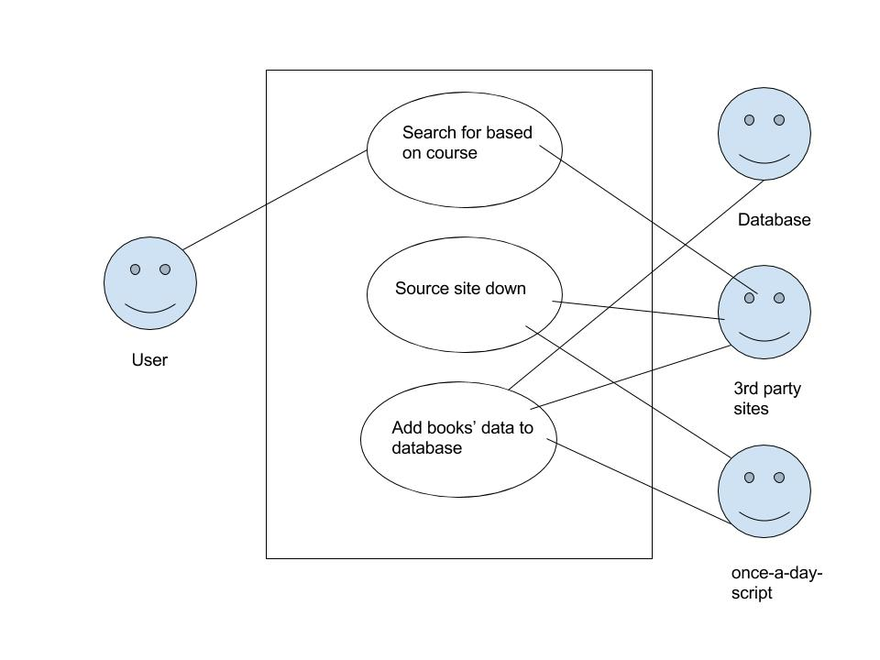

# 6. Testing

## 6.1 Testing Plan

We will do a variation of Unit Testing. All functionality of the website will be tested. The scripts written will also be tested. For example, the correct book will be displayed with all it’s properties.

Website Testing:

* Search page can call script to obtain data
* Results page is called after data is obtained

Scripts Testing:

* Connection to each website is successful
* Obtains all requested data from each website
* UNT Scraper inserts into database successfully

# 7. Updated Processes

## 7.1 Risk Management

Risk management has been reviewed since deliverable 1. The processes for risk mitigation remain the same.

## 7.2 Project Plan

The project is moving forward as discussed in Deliverable 1. Additionally, the MySQL database will be alongside the creation of the script that inserts into the database. That way any adjustments needed for the database can be done at the same time it’s needed for quick testing.

# 8. Project Check-in

## 8.1 Meeting Minutes

720 minutes of meetings

The Textbook Triad

Meeting 1:

Date: 8/28/15

Time: 2:30pm-4:00pm

Location: Discovery Park

Attendees: Jacob Cole, Parker Cantu, Michael Pittard

Discussion: Introductions were made and the group was formed. After a short discussion, Github was chosen to be used for our project repository. The repository was set and, and assignment 1 was completed.

Meeting 2:

Date 9/4/15

Time: 2:30pm-4:00pm

Location: Discovery Park

Attendees: Jacob Cole, Parker Cantu, Michael Pittard

Discussion: The team worked in depth on Deliverable 1. A basic structure of the project proposal was formed. And team planned out how Deliverable 1 was going to be completed.

Meeting 3:

Date 9/6/15

Time: 3:00-6:00pm

Location: Willis Library

Attendees: Jacob Cole, Parker Cantu, Michael Pittard

Discussion: The team worked on the Deliverable 1 paper and powerpoint.

Meeting 4:

Date 9/10/15

Time: 8:00-9:00pm

Location: Skype

Attendees: Jacob Cole, Parker Cantu, Michael Pittard

Discussion: The team finished the powerpoint and went over dry runs of the presentation.

Meeting 5:

Date 9/23/15

Time: 5:00-7:00pm

Location: Skype

Attendees: Jacob Cole, Parker Cantu, Michael Pittard

Discussion: The team worked on deliverable 2.

Meeting 6:

Date 10/2/15

Time: 2:30-3:30pm

Location: Class

Attendees: Jacob Cole, Parker Cantu, Michael Pittard

Discussion: The team worked on deliverable 2.

Meeting 7:

Date 10/4/15

Time: 8:00-10:00pm

Location: Skype

Attendees: Jacob Cole, Parker Cantu, Michael Pittard

Discussion: The team worked on deliverable 2.

## 8.2 Progress Report

Since Deliverable 1, We have finalized the logic for our system. Because the team lives a considerable distance away from each other, we have started to use Skype as the main channel for our meeting. Project development time has been used learning the “ins and outs” of the scrapy framework and discussing the layout of the UI. We have successfully scraped the form element from the UNT bookstore. This form will be used to obtain all the books that are available to search against in our database.