Fordham Law School

Taxation of Business Entities

Professor Jeffrey M. Colón

Fall 2008

Instructions

- The only permitted materials for the exam are: (1) The Kwall casebook, (2) Any version of the IRC and Federal Regulations, (3) your Class Notes and Slides; and (4) a calculator. You are not permitted to use any commercial outline, whether in printed form or stored on your computer, although you can access your notes on your laptop.

- The exam answers must be typed, and please do not retype the questions.

- You must complete and either upload the exam or return it to the registrar within 4 hours of the time you download it. You must return the exam on or before 10 a.m., December 16, 2008.

- You must dispose of any paper copies and delete any electronic copies of the exam.

- The suggested time and relative weighting for grading each question is indicated in brackets at the beginning of each question. The suggested time for the first [___] questions is 5 minutes each. The suggested time for the remaining {---} questions ranges from 10 to 45 minutes. Note, the questions are arranged in order of suggested time.

- For any true-false question, circle the correct response and provide a brief reason for your choice; a citation to the appropriate section of the Code or regulations is fine.

- When asked to describe the tax consequences, give the amount and character of the relevant income, deductions, gains, or losses. Unless specifically requested, do NOT compute tax liability. If necessary, assume that the marginal tax rate for individuals and corporations is 35%, but 15% for the long-term capital gains/qualified dividends of individuals.

- Don’t waste time paraphrasing the Code; an accurate citation is sufficient. Common abbreviations, e.g., FMV, AB, AR, are fine.

- Assume that all taxpayers are U.S. persons and calendar year taxpayers.

- The exam has {______} pages, including the instruction page. Make sure you have them all.

GOOD LUCK!

- [5] What is the main tax difference between operating a business as a partnership/LLC or a C corporation? (Two or three accurate sentences should be sufficient.) Why is that difference generally less relevant for closely held businesses? (One or two accurate sentences should be sufficient.)

- [5] John Jones, a 2009 FLS graduate, forms an LLC, JJ LLC, to operate his tax consulting business after graduation. John is the only member of the LLC. If John makes no elections with respect to the LLC’s tax status, the LLC will be a C corporation.

True False

Reason:

- [5] Assume for purposes of this question that JJ LLC is taxed as a C corporation. John Jones reads on the internet that it may be possible to lower the aggregate taxes paid by him personally and by JJ LLC by splitting his consulting income between income earned in his personal capacity and income earned by JJ LLC. Will splitting his income between his LLC and personally lower Jones’s total aggregate taxes?

Yes No

Reason:

- [10] X, a C corporation, owns (and has owned since formation) all of the stock of Y, a C corporation. X’s basis in Y is $1 million, and Y owns $1 million cash and a building. Y has $1 million of E&Ps. A, an individual, offers to buy all of the stock of Y for either $5 million after Y has distributed the cash or $6 million with no prior distribution. Briefly describe which option X should prefer, why, and note any potential tax risks.

- [15] SCo has been an S Corporation since its inception. It has 3 equal shareholders, Larry, Mike, and Nick. Each shareholder has an AB in its SCo shares of $50,000 and a FMV of $200,000. On March 1, 2008, SCo borrows $250,000 from Bank of America—no shareholder has agreed to be liable for any portion of the loan.

On July 1, 2008, SCo distributes in a nonliquidating distribution to its shareholders a vacant lot in Iowa (they take title as tenants in common). The lot is a capital asset and has been held for 10 years. The lot has an AB of $100,000 and a FMV of $240,000. For 2007, SCo earns $85,000 of gross income from its Iowa farming operations and incurs $15,000 of expenses related to the farming operations.

What are the tax consequences for SCo for 2008?

How much gain, loss, income, or deductions do Larry, Mike, and Nick each have for 2008?

What is their basis in the land?

- [15] C corporation has been owned for 5 years by two unrelated individuals, A and B. A owns 60 shares of C common stock (FMV = $1200; AB = $600). B owns 40 shares of C common stock (FMV= $800; AB = $600). C’s E&Ps are $500 before either of the transactions below.

  - If A sells 30 shares back to C corporation for $600, what are the tax consequences to A (amount and character of any income/loss) and the effect on C corporation’s E&Ps?

  - Same as above, except that A sells 10 shares back to C corporation for property with a FMV of $200 and an AB of $100. What are the tax consequences to A and C (amount and character of any income/loss and basis in the property received) and the effect on C corporation’s E&Ps?

- [20] X, a C corporation, is owned 85% by C, a C corporation, and 15% by A, an individual. (A doesn’t own any stock of C corporation.) C’s basis in its X stock is $85,000 and A’s basis is $40,000. X owns 2 parcels of land, Blackacre and Whiteacre. Blackacre has basis of $50,000, a FMV of $180,000, and is subject to a liability of $10,000; Whiteacre has a basis of $60,000, a FMV of $40,000, and is subject to a liability of $10,000.

X makes a liquidating distribution to C and A of the properties: X distributes Blackacre to C and Whiteacre to A, both subject to the liabilities. (The ratio of the FMV of each property to the total FMV of all properties is 85/100 and 15/100, the same as the relative shareholder interests, so the distribution is proportional to the ownership interests. Both properties were purchased by X for cash.)

What are the tax consequences to C, A, and X? Be sure to address any gain or loss recognized by any party plus the AB of the property in the hands of the shareholders. (Assume that X has $Z (where Z is “exactly enough” dollars) on hand to pay any corporate tax liabilities. In other words, don’t worry about it!)

- [30] A and B each contribute $1,000 to a newly formed general partnership, AB, which borrows $8,000 to finance AB’s operations. The AB PSH agreement provides that A will be allocated 75% of all income, losses, and expenses and B will be allocated 25%. AB satisfies the capital account, liquidating distribution, and deficit restoration tests. In 2008, AB has a net loss of $4,000. Assume that we live in a no-interest world and at the beginning of 2009, the loan balance is still $8,000.
  - What are A’s and B’s basis in AB following the borrowing?
  - How must the $4,000 loss be allocated for 2008?
  - What are A’s and B’s basis in their partnership interests?
  - What are the amounts in A’s and B’s capital accounts at the end of 2008?
  - AB sells the business for $12,000 at the beginning of 2009. What are the payments among the partners after the bank loan is repaid?
  - What if the business is sold for $6,000

- [30] A, B, and C are equal partners in the ABC general partnership. At formation of the ABC partnership, A, B, and C contributed cash, which ABC used to purchase Blueacre, a vacant lot of land held solely for investment purposes. The basis of the land has not been adjusted since it was contributed (as a reminder, land is not depreciable). ABC’s balance sheet as of 1/1/07 is as follows:

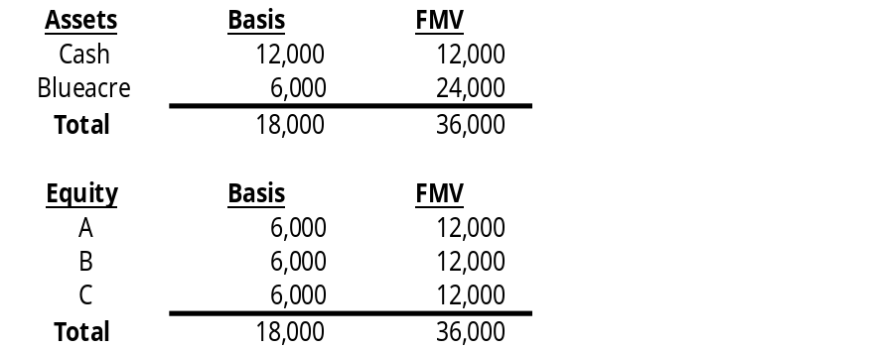

ABC has no debt.

In 2007, ABC makes a liquidating distribution to C of $12,000. Assume that AB has no income or deductions for 2007.

  - What are the tax consequences to A, B, C, and ABC, if ABC does not make a 754 election?

  - What are the tax consequences if ABC makes a 754 election?

  - Would you recommend that ABC make a 754 election? Why or why not?

- [45] On January 1, 2007, Able, Becky, Carl, and David formed a new corporation (Newco) to produce and sell fake iPhones. Newco was authorized to issue a single class of common stock. Able transferred $100,000 in cash to Newco as working capital for 100 Newco shares. Becky transferred an iPhone maker with an AB in her hands of $250,000, a FMV of $450,000, subject to a liability of $300,000, in exchange for $50,000 in cash and 100 Newco shares. (Newco assumes the liability.) Carl transferred to Newco a building in which to house the iPhone maker. The building had an AB in Carl’s hands of $1,200,000 and a FMV of $600,000. Carl received 600 Newco shares. David was named marketing director. In exchange for his promise to render future services to Newco and his personal collection of hundreds of Audrey Hepburn DVDs (FMV = 50; AB = 50,000), he received 100 Newco shares. He believes that if the employees watch the DVDs they will be inspired to design “fabulously fashionable” iPhones. All shares are freely transferable upon receipt.

The new venture proved so profitable that their friend Eric wanted to join in the action as a 50% shareholder. To accomplish this, on July 1, 2007, he transferred a machine for etching images of NASCAR drivers on the iPhones to Newco in exchange for 700 Newco shares and $100,000. The machine had an AB in his hands of $300,000, a FMV of $900,000, and was subject to a liability of $100,000, which Newco assumed.

With regard to Able, Becky, Carl, David, Eric, and Newco, determine only (1) the amount of recognized gain or loss, (2) the amount of any income or deduction, and (3) the basis that each (both the shareholders and Newco) takes in the stock or property received.

Because I’m a nice guy, here’s a table summarizing the contributions:

Person | AB | FMV | Liability | Consideration
Able | 100,000 | 100,000 | 0 | 100 shares
Becky | 250,000 | 450,000 | 300,000 | 100 shares plus 50,000
Carl | 1,200,000 | 600,000 | 0 | 600 shares
David | 50,000 | 50 | 0 | 100 shares
Eric | 300,000 | 900,000 | 100,000 | 700 shares plus 100,000

