I started with the design I made in A5 and 6. This design was supposed to take 800 lbf at the hanger with a safety factor of four. This only accounts for strength as that was the ruling dimensioning requirement other than the member between the pin and the bracket. FEA will likely highlight that as the weakest part because it accounts for both strength and stiffness. Below are pictures of the dimensions.

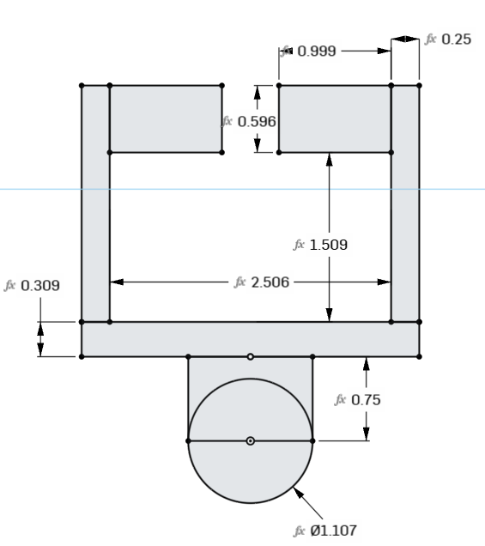

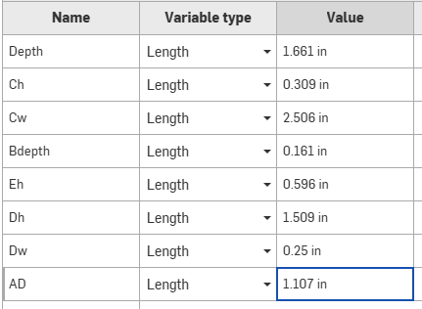

I exported it from onshape as a step file then opened it in fusion. Once in fusion, I switched to the simulation tab and fixed the flanges from the bottom as that is what will be braced against the rail. I applied a load of 800 lbf at the center of the lower pin and clicked solve.

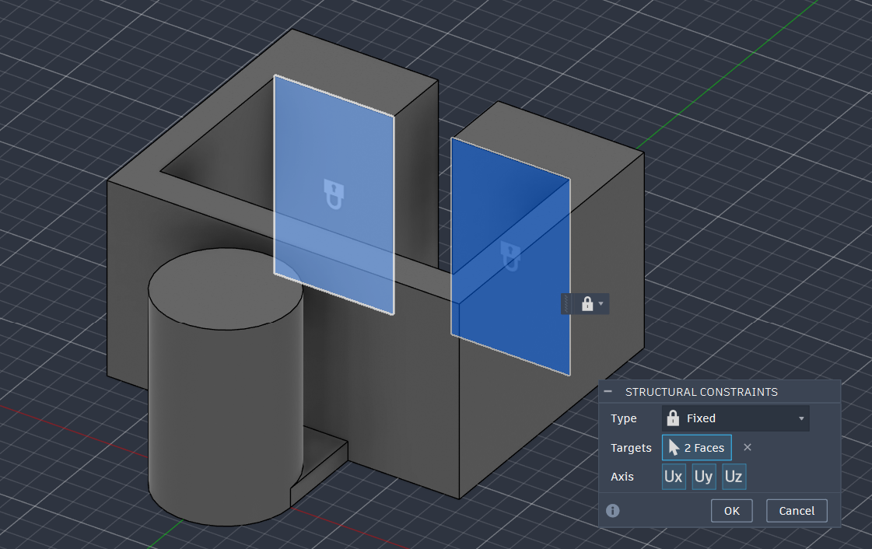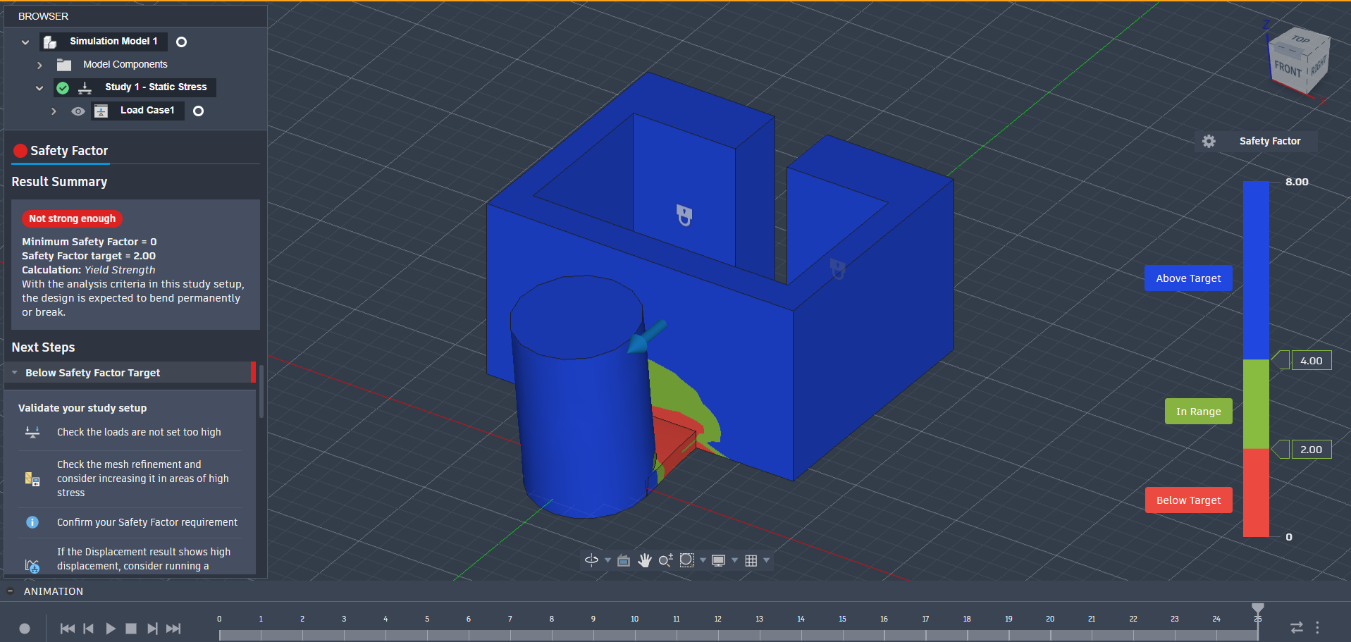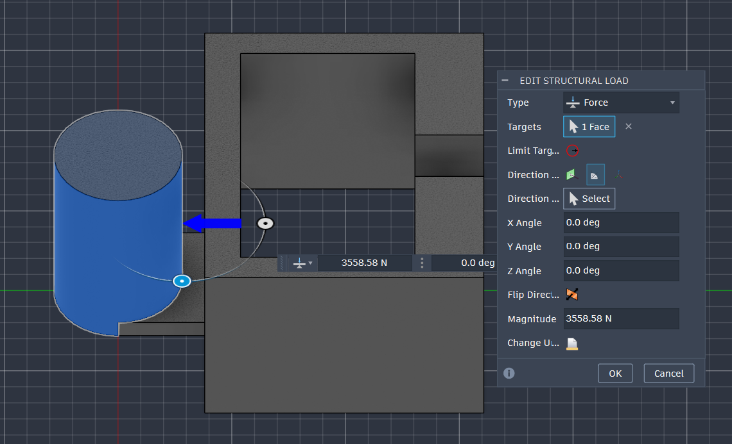

As expected, the member between the pin and bracket was far too weak. It had a safety factor of 0 so it would certainly break. I went back in and thickened it from .1605 inches to .5 inches. I’m thinking that design 2 will get the safety factor to an acceptable level all around and design 3 will cut back down where it's overly built for the 3rd design.

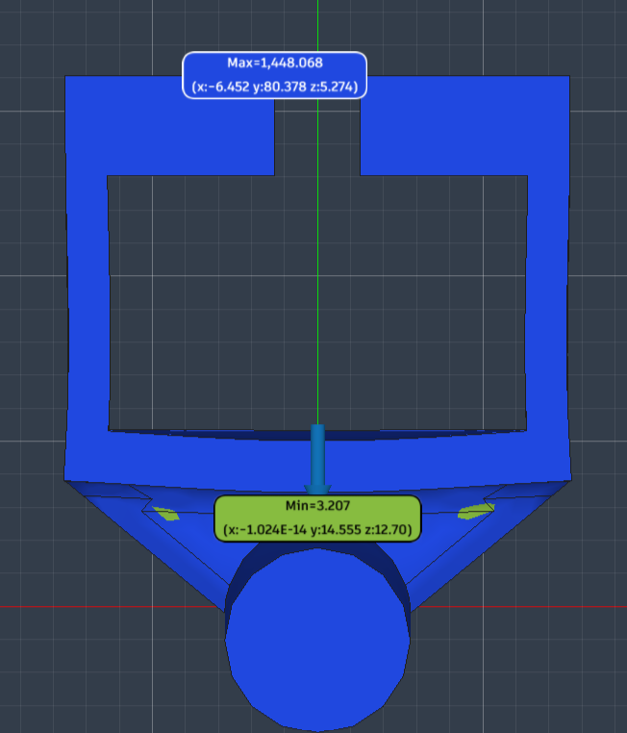

The third design came with a safety factor of 3.207. This is still not as high as I would like it to be but the member is quite large there. I would like to trim down the top portion for the third design. I tried to use a lightening feature to pocket some areas but it ended up being too much for the safety factor to handle. I made member b just a little bit thicker at .625 inches to try to bring the safety factor up to 4.
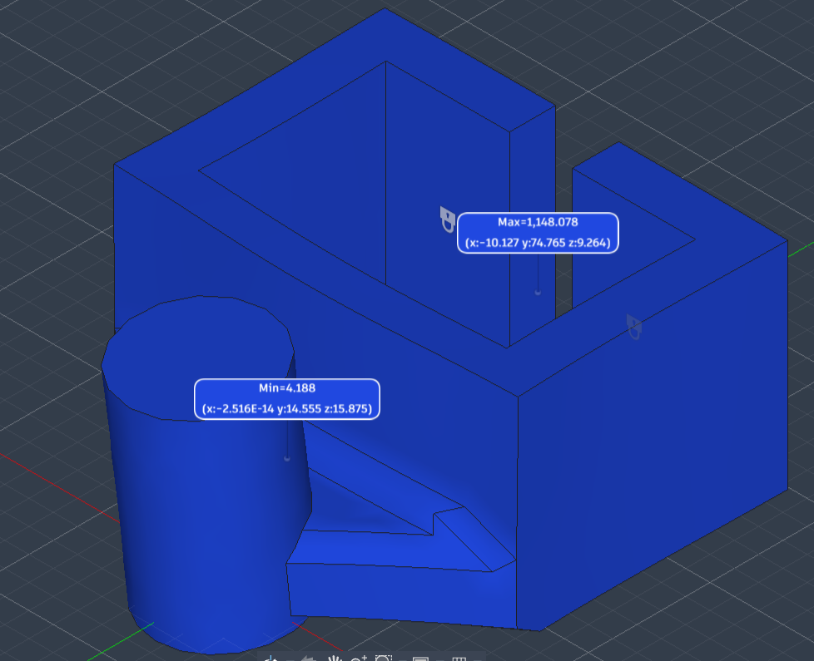

With these changes, we were fully in the clear with a safety factor above 4. I am happy with this design however I did see there was a tab for generative design which would have been neat to compare with for this project. While the part got heavier through every design, I would still consider this optimized for weight as I took mass away from the overbuilt parts and added it to the weaker members.

 | Design 1 | Design II | Design III
Max Stress and location | 763.33 MPA in member B | 77.393 MPA at the top of member B | 59.226 MPA at the top of member B
Max deflection and location | 0.962 mm at the tip of the pin | 0.057 mm at the tip of the pin | 0.039 mm at the tip of the pin
mass | 0.891 kg | 0.95 kg | 1.021 kg
Minimum Safety Factor | Min 0.325 in member B | 3.207 in member B | 4.188 in member B
Number of elements | 7 | 7 | 7

