RAKE MANUAL

TABLE OF CONTENTS

- What is RAKE and how does it work?
- How to start using RAKE
- Using Textpad to build rules and rulesets
- Where to place rule/ruleset within guideline folders/subfolders
- RAKE Legend
- FAQs
- External Resources and Hyperlinks
What is RAKE and how does it work?
- RAKE is a build language based Ruby program.
  - For BSRM purposes, it helps developers build and maintain guidelines.
How to start using RAKE
- Open a new Textpad document within the guideline’s inc folder and name the document with a .gdl extension
Using Textpad to build rules and rulesets
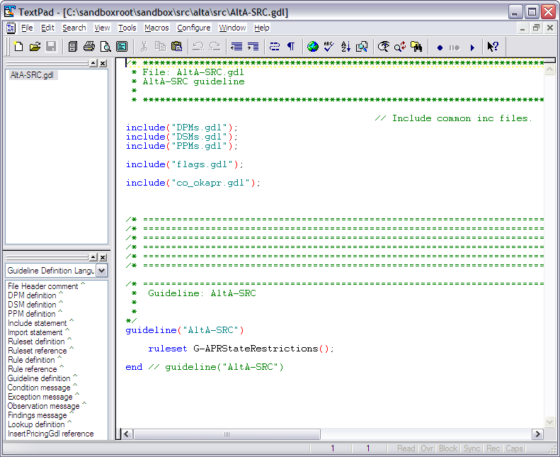
Where to place rule/ruleset within guideline folders/subfolders

- The *.gdl filename needs to be placed in the following places:
RAKE Legend

Clean - Remove any temporary products.
Clobber - Remove any generated files.
Compile - Compile guidelines.
configureProducts - Configure FNMA products.
configurePrograms - Configure FNMA programs.
Deploy - Compile, upload and version guidelines.
Dev - DEV environment
Head - HEAD environment
Install - Install FNMA programs/products and deploy guidelines
Prodbsrm - Prod BSRM environment
Prodecc - Prod ECC environment
Trainbsrm - Training BSRM environment
Trainecc - Training ECC environment
Uatbsrm - UAT BSRM environment
Uatecc - UAT ECC environment
Upload - Upload guidelines to environment
Verbose - Turn on verbose messaging
External Resources and Hyperlinks

- http://del.icio.us/jmcaffee/rake

