OCR
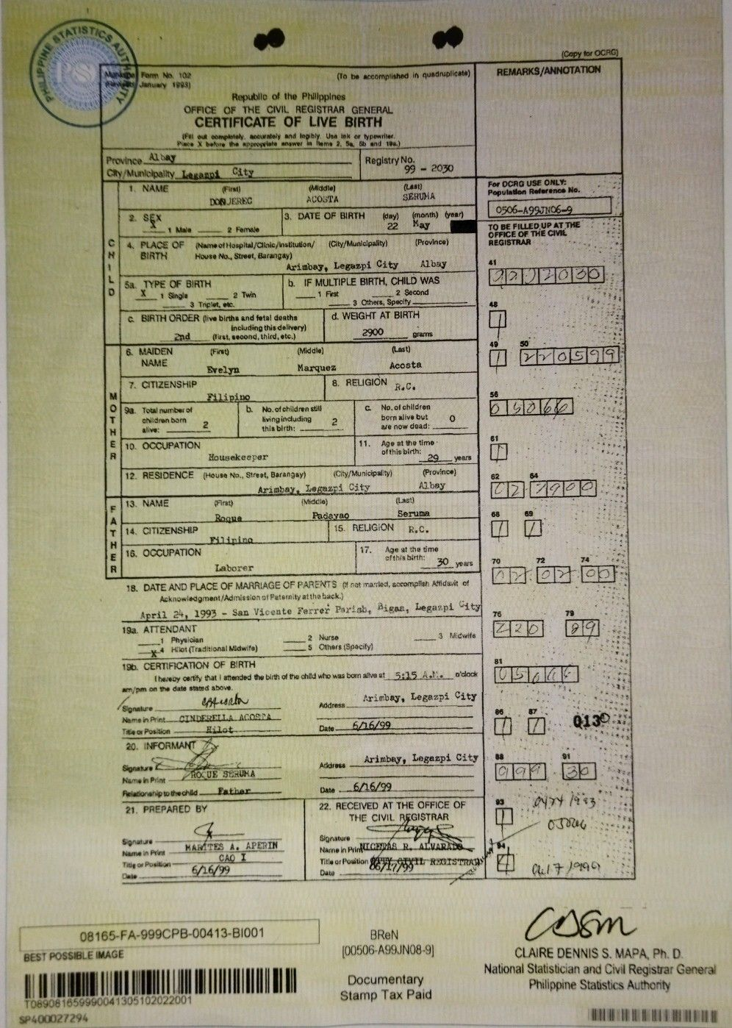
APP: https://pdfsimpli.com
TEXT: NA - MAY BAYAD

APP: https://files-editor.com
TEXT: NA - MAY BAYAD

APP: https://www.onlineocr.net/
TEXT: Not accurate - may bayad din
Pi

his accomplished th nuadrupliceni) RftpUbli() of Iha Philippines OFFICE OF THE CIVIL REGISTRAR GENERAL. CERTIFICATE OF LIVE BIRTH ProOut Ogelelety lettmeley lad krovy Us. in a, typeadiv 1Nrus Were eye eiunrinin *flat in home 2. 5► tie and Sal Province MtaY Registry No. aly/MunicIpalhy Lerampi CitY 99 — 2030
C
H
NAME pen Dos I‘Ret
(,lAlddte) A i.XXiTA
gut? SERUTIA

(copy for °CPO
REMARKS/ANNOTATION
2. SIX
3 DATE OF BIRTH
On) 22
(month) too May
For OCRG USE OILY: Population Regteng No. F0506-A991fliC6,-9
4, PLACE OF BIRTH
Name of Hosptid/Cltoicr Institution/ (Ohi/Municipality) Hone No.. Slot, thunigay) Arimbay. Legazpi City Albany
(PlovInce)
Sa 'EWE OF BIRTH X t Shia 2 Twm . 3 Inc4t.
b. IF
MULTIPLE BIRTH. CHILD WAS I First 2 Second 3 Mac Spec.tu
C. BIRTH ORDER Ova births and final deaths Including this delivery) ___ Pint incont third, etc.)
d. WEIGHT AT BIRTH 2900 _trams
0
E
Ft
S. MAIDEN NAME
(Fab Evelyn
(Middle) Marquez
(Lest) Acosta
CITIZENSHIP
rikipino I8 9a Total numbs( of b. No.olchitdrenstitl Children barn along indadiog 2 she. this birth:
RELIGION
He C.
C. No. ol children born alive but 0 ate now dead:
10 OCCUPATION
Ho tiBakeerer
11.
Age at the time of this birth: year[
A
H
12 RESIDENCE (Noose Na.. 81reeq Batanaso (CityPAusicipalty) (Piovinn) Arietbay, Lagazpi City Al bay
13 NAME p:ifttj IkstKSC:11) 0-11-0 Pad ra Serum•
14 CITIZENSHIP IS RELIGION p.c.
16. OCCUPATION
.71141" it°
17. Laborer
Age et the time sr thls birth: Was
18, DATE AND PLACE OF MARRIAGE CF PARVITS C ^..11 rr.r:lei. ace:WOW A.Mdtein of Acknowledgment/Adfin SiOh of Patsmay at the back.) April 24, 1993 - San Vicente Ferreis Par! nbt Logazpi
19,a. ATTENDANT Phyei.ban .4 Run (TraSmonal 141dwie)
2 Hume 3 M duffle _ S C1heis tSpacity;
it& CERTIFICATION OF BIRTH thanes prey that I rendod the ear Of Tie °Rt.! who was barn aim at 5 at A t o'disoc am/pan on Tel dale Mt! CI above. Mfeditti1/4-1 .4rimbay, Legaspi City Gonave Mains • Hams in Prot Pri4W2171 1. AC00.74 Titod Posarco
Cate 6/1 6/09
20. :NFORMArfr
Myna In Pr` ra ftekt0OnerliptothecNkl

OE WAWA
164 Mbar
21. PREPARED BY
tniernue 14 TES A. APERDI Nerve 01 Pen raper Pueceon FAQ 99 _ . -
Arkkass Arimbay, Logazpi City
0„,, VIVA_
22. RECEIVED AT THE OFFICE OF THE ClViL GISTRAR
SI0natuie Name in IN Tire of Psnition One •

TO BE FILLECSUP AT THE OFFICE OF THE OW. REGISTRAR • •
41
L • "
48

Itt
121210111

61

70

76
74
•
4,
• r

1z-iv H
81

I tor

..■
• „ • .• • ■ • CO3C1. 1114.•• 44 '•i■ • w' '•••1
SI

Oaf,

•r.
08165-FA-999CPB-00413-61001 BEST POSSIBLE IMAGE
II 111111111111111 111111111 1111111111111111111111 III 069081651/490(A I 30t, 10202200 I
seei000mty
BReN (00506-A99JN08-91
Documentary Stamp Tax Paid

CLAIRE DENNIS S. MAP& Ph. D National Statistician and Civil Registrar General Philippine Statistics Authority
111111111111111/1011111

https://pdfhouse.com/pdf-to-ocr?utm_source=bing&utm_medium=cpc&utm_campaign=487340010&utm_term=ocr%20scanner&utm_content=1228155812184627&msclkid=e6a842cfdcdd19f05c3428d4008a7127
NA – MAY BAYAD

Newocr.com
Not accurate

ipeerasecn
4 PLACE OF pramectticspital Ciinia/istnton/ —{City/Municipality) ee,
BIRTH Mowee No., Street, Garengay)

Aviabey, Legaspi City

& BIRTH ORDER (ive birthe and fete! ceethe
including this delivery)
BEd Hirst, aeoond, third, etc.)

Tosa number of “b No. of children stilt Cc No.of children
shidrenborn 5 lvinginctuding 2 born alive out Q
alive: thie Birth: - we now dead:

10. OCCUPATION et . wes

11. Age at he time:

Housekeeper of this birth:

(Province)

12. RESIDENCE (House No., Street, Barangay)

iCity/Municipalty)

in in

§ RELIGION p.c,

Age athe ime
ef this birth:

18. DATE AND PLACE OF MARRIAGE CF PARENTS of ret raved, eocompter: Aitidavit of
Acknowledgment /Admistion st Pater ty atthe back,

April 24, 1993 - San Vacate Ferrer Parist, Aigan, Legazpi vit
19a. ATTENDANT i
1 Phytviclan 2 Nurse 3 acute |
gt Hiot (Traditional Midwife) 5 Cthers (Specity}
19b. CERTIFICATION OF BIRTH
[hereoy cectly Hat | attended the bith of the chtd who was bom atest 5215 Aghie o'clock

Address _ trimbay, L Legazpi City

21. PREPARED BY

sae Pes nad ia semi
we SAD
08165-FA-999CPB-00413-B1001 | BReN CORY
BEST POSSIBLE WAGE [00506-A99JNO8 9} Ne CLARE DENNIS S. MAPA, Ph. D
tional Statistici i
LRAT covey,“ eS

9400027294 ERE

https://www.camscanner.com/webocr
can’t extract docu

https://www.iloveocr.com/
matagal – may limit

ROTATSTICSAL
(Capy for OCRG)
Farm No. 102
(To be accomplished in quadruplicate)
REMARKS/ANNOTATION
January
1983)
Repubilc of the Phillppines
OFFICE OF THE CIVIL REGISTRAR GENERAL
CERTIFICATE OF LIVE BIRTH
(Ful out completaly. aocurataly and Ingibly. Usa ink or typewriter.
Piace X before the appropwiate anawer in fleme 2. Sa. 5b and 19a.
Province
AlDay
Registry No.
Chy/Munioipalty_Leganni
City
99 -2030
1. NAME
(First)
(Middle)
(Last)
For DCRG USE ONLY:
ACOSTA
SERUNA
Population Referencs No.
DONJEREC
(month) (year)
0506-A99JN06-9
2. SEX
3.DATE OF BIRTH
(day)
1 Male
2 Female
22
May
TO BE FILLED UP AT THE
(Province)
OFFICE OF THE CIVIL
PLACE OF
(NameofHospital/Clinic/Institution/
(City/Municipality)
REGISTRAR
BIRTH
House No., Street, Barangay)
Arimbay, Legazpi
City
Albay
22
5a.
TYPE OF BIRTH
. IF MULTIPLE BIRTH, CHILD WAS
.
X 1 Single
2 Twin
1 First
2 Second
3 Tripiet, etc.
3 Others, Specity
c. BIRTH ORDER (ive births and fetal deaths
d. WEIGHT AT BIRTH
including this delivery)
2nd
(fust, second, third, etc.)
2900
grams
6. MAIDEN
(Firnt)
(Middle)
(Last)
50
NAME
Evelyn
Marquez
Acosta
. CITIZENSHIP
8. RELIGION
R.C.
M
Filipino
56
98Total number of
b. No. of children still
c. No. of children
05068
o
children barn
livingindluding
2
born alive but
2
0
H
alive:
this birth:
are now dead:
E
10. OCCUPATION
11.
Age at the time
R
Housekeeper
of this birth:
29
years
12. RESIDENCE
(House No., Street, Barangay)
(City/Municipalty)
(Province)
Albay
62
Arimbay, Legazri City
290
13. NAME
(Firat)
(Midcla)
(Lat)
F
Roqua
Padayao
Seruma
AT
68
14. CITIZENSHIP
15. RELIGION
R.C.
IWa
Filipina
16. OCCUPATION
17.
Age at the time
afthis birth:
30 years
Laborer
70
72
12
02
05
.DATE AND PLACE OF MARRIAGE OF PARENTS f
Acknowledgment/Admission ofPaternity atthe back.
April 24, 1993 - San Vicente Ferrer Pariab, Bigaa, Legazpi Gity
76
19a. ATTENDANT
220
Phyeician
2 Nurse
_3Micwife
4
Hilot (Traitinal Miwi)
5
Others (Spacity)
196. CERTIFICATION OF BIRTH
05C5
81
hy the h the o ws boatv
a/pm on the date stated above.
effscto
Arimbay, Legazpi City
Signature
Address
NemeinPrintCINDERELLA.ACOSTA
Q130
Tile or Position
Hilot
Date 6/16/99
20. INFORMANT
Acdress
Arimbay, Legazpi City
88
91
Signature
Name in Print
ROXUE SERUMA
Relationssip to thechidFather
Date .6/6/99
a4r4 193
21. PREPARED BY
RECEIVED AT THE OFFICE OF
THE CIVIL REGISTRAR
0Jo06
Signature
Signature
Name in Print
MAMTES A. APERIN
Namein PICEAS R. ALVARAD
CAO I
Titlg or Pusllion
Title or Poaition
155 RISTRA
6/26/99
.17)0190
Date
Date
cosm
08165-FA-999CPB-00413-BI001
BReN
[00506-A99JN08-9]
BEST POSSIBLE IMAGE
CLAIRE DENNIS S. MAPA, Ph. D.
National Statistician and Civil Registrar General
Documentary
Philippine Statistics Authority
Stamp Tax Paid
T089081659990041305102022001
SP400027294

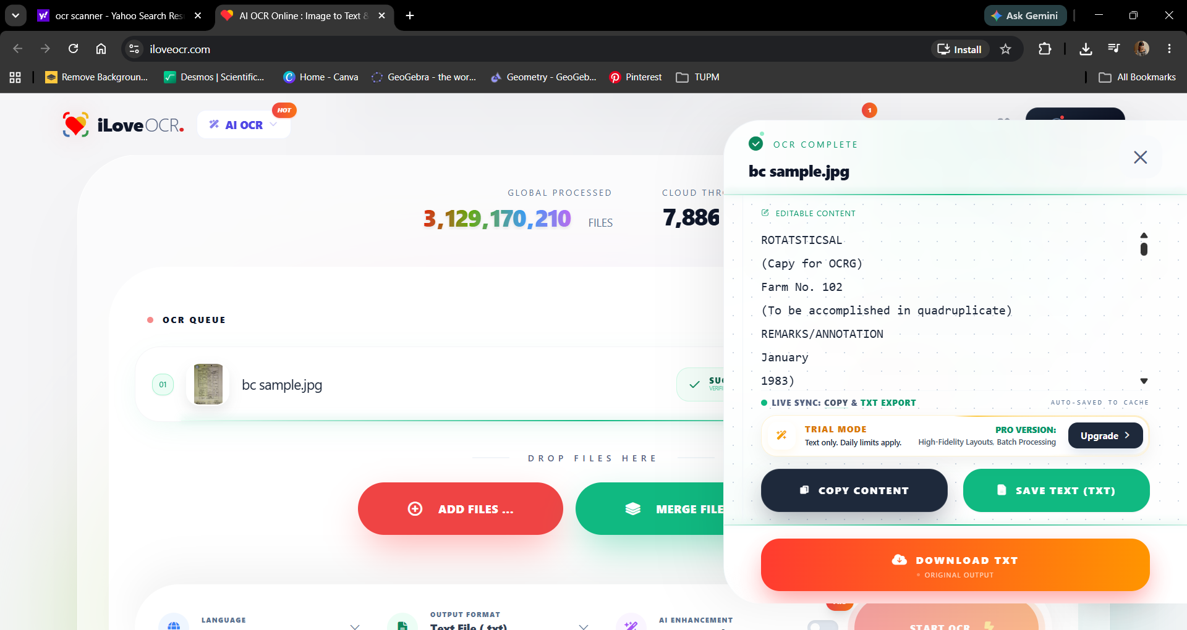

https://pdfaid.com
may bayad – weekly

https://files-editor.com
may bayad

https://www.ilovepdf.com
may bayad yung ocr

https://www.i2ocr.com/
matagal – precise – hindi nakuha yung text sa second column

Republic of the Philippines
OFFICE OF THE CIVIL REGISTRAR GENERAL
CERTIFICATE OF LIVE BIRTH
(To be accomplished in quadruplicate)
(To be accomplished in quadruplicate)
REMARKS/ANNOTATION
(Copy for OCRG)
Province Albay
City/Municipality Legazpi City
Registry No. 99 - 2030
For OCRG USE ONLY:
Population Reference No.
0506-A99JN06-9
1. NAME
(First) DON JEREC
(Middle) ACOSTA
(Last) SERUNA
2. SEX
X 1 Male 2 Female
3. DATE OF BIRTH (day) 22 (month) May (year)
4. PLACE OF BIRTH (Name of Hospital/Clinic/Institution/ House No., Street, Barangay) Arimbay, Legazpi City (City/Municipality) (Province) Albay
5a. TYPE OF BIRTH
X 1 Single 2 Twin 3 Triplet, etc.
b. IF MULTIPLE BIRTH, CHILD WAS
1 First 2 Second 3 Others, Specify
c. BIRTH ORDER (live births and fetal deaths including this delivery) 2nd (first, second, third, etc.)
d. WEIGHT AT BIRTH 2900 grams
6. MAIDEN NAME
(First) Evelyn
(Middle) Marquez
(Last) Acosta
7. CITIZENSHIP Filipino
8. RELIGION R.C.
9a. Total number of children born alive: 2
b. No. of children still living including this birth: 2
c. No. of children born alive but are now dead: 0
10. OCCUPATION Housekeeper
11. Age at the time of this birth: 29 years
12. RESIDENCE (House No., Street, Barangay) Arimbay, Legazpi City (City/Municipality) (Province) Albay
13. NAME
(First) Roque
(Middle) Padayao
(Last) Seruna
14. CITIZENSHIP Filipino
15. RELIGION R.C.
16. OCCUPATION Laborer
17. Age at the time of this birth: 30 years
18. DATE AND PLACE OF MARRIAGE OF PARENTS (If not married, accomplish Affidavit of Acknowledgment/Admission of Paternity at the back.)
April 24, 1993 - San Vicente Ferrer Parish, Bigas, Legazpi City
19a. ATTENDANT
1 Physician 2 Nurse 3 Midwife
X 4 Hilut (Traditional Midwife) 5 Others (Specify)
19b. CERTIFICATION OF BIRTH
I hereby certify that I attended the birth of the child who was born alive at 5:15 A.M. o'clock am/pm on the date stated above.
Signature
Name in Print CINDERELLA ACOSTA
Title or Position Hilut
Address Arimbay, Legazpi City
Date 6/26/99
20. INFORMANT
Signature
Name in Print ROQUE SERUNA
Relationship to the child Father
Address Arimbay, Legazpi City
Date 6/26/99
21. PREPARED BY
Signature
Name in Print MARITES A. APERIN
Title or Position CAO I
Date 6/26/99
22. RECEIVED AT THE OFFICE OF THE CIVIL REGISTRAR
Signature
Name in Print NICEDOR R. ALVARADO
Title or Position CITY CIVIL REGISTRAR
Date 6/26/99
08165-FA-999CPB-00413-BI001
BEST POSSIBLE IMAGE
T089081659990041305102022001
SP400027294
BReN
[00506-A99JN08-9]
Documentary
Stamp Tax Paid
CLAIRE DENNIS S. MAPA, Ph. D.
National Statistician and Civil Registrar General
Philippine Statistics Authority
TO BE FILLED UP AT THE
OFFICE OF THE CIVIL
REGISTRAR
41 0902030
48 1
49 1 270599
50 040666
61 1
62 CD 7900
68 1 1
70 02

https://deepseekocr.io/tools/ocr-scanner
42 seconds – di nadodownload yung extracted text – code binibigay

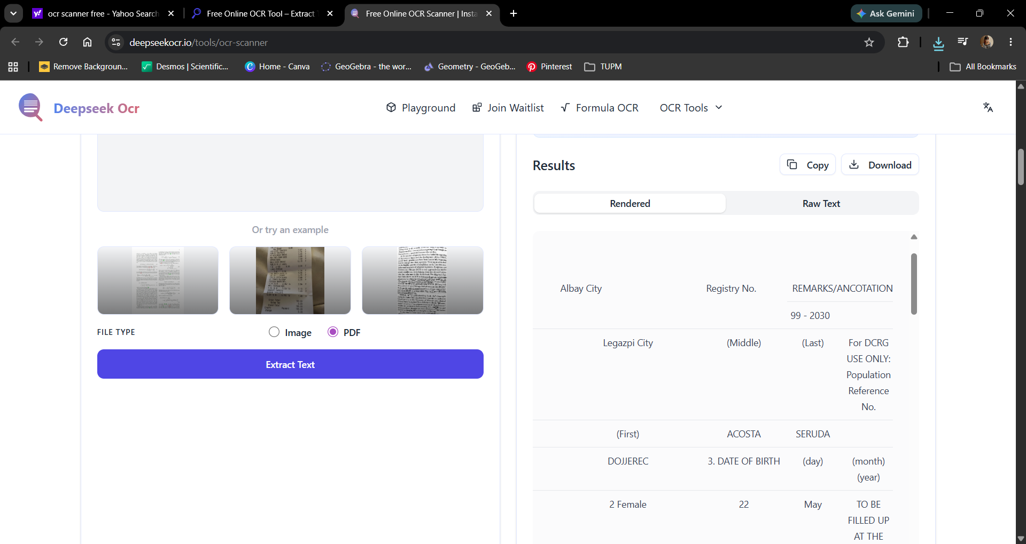

https://pdfguru.com
changed pdf to word

https://pdf.ai/tools/ocr-pdf
convert image to pdf

https://www.freeconvert.com/convert/image-to-text/download
output txt - inaccurate
(0 ba.

Republic of the Philppines
OFFICE OF THE CIVIL REGISTRAR GENERAL
EHIFIGATE OF LIVE BIRTH

pei

accomplished if quadruples)

od)

[3. DATE OF BIRTH

4 PLACE OF Nameotospltl/Cllic/nstiuton/ (Cty/Municipally) (Pravince)
BIRTH House No, Stet, Barangay)

Aeiabey, Legaspi Clty Albay

Gr -z0

Sa TYPE OF BIRTH b IF MULTIPLE BIRTH, CHILD WAS
Pl an re 7 Goren
ee 3 Trgiet ec —— 3 Others, Specty.
© BIRTH ORDER (ive births and fetal deaths d. WEIGHT AT BIRTH
prtwristabon
2d Gu mrteree 290 gum

8 MADEN Fy ede) (ast)

Svelyn Marquez Acosta
7. CITIZENSHIP. 8 RELIGION , o
" xh
Of9a Tom numbecot b. No.ofehidrenstil © No.olchildren
T| ovamavom hingincudig somalvebst O
ME 2 pr p— are now dead
E [10. OCCUPATION 11. Age atthe time
R Hodsvkesrer after: -

2. RESIDENCE (House No. Stest, Barangay) (Clty/Municpaly) (Province)

ofthis birth:

SRATHIALL HAE

DATE AND PLACE OF MARRIAGE OF PARENTS
Acknowledgment/Admission of Petemity atthe back)

April 24, 1993 - San Vi

Laborer | Nid

rioh, Digan, Legarpl Cit;

18a. ATTENDANT
1 Pysien 2 Nurse 3 neces |
gt Fe(msenaimagate) 5 Os Speci)

18. CERTIFICATION OF BIRTH
hucncy cart hat | #tended the birth of ia chid who was bom ave st _ 5:15 AL
n/m 00 he cate sae 3D.

Mame ETI TREE

adock

srinbay, Legazpi City

Adress

Arinbay, Logazpl City

owe EAE Ki

22. RECEIVED AT THE OFFICE OF

08165-FA-999CPB-00413-B1001 |
BEST POSSIBLE IMAGE [00506-A99JNO8-9)

0 ONION oocumertar

656960041305 10202200 Stamp Tax Paid
SPLOO0ZT294

CLAIRE DENNIS S. MAPA, Ph.D.
National Statistician and Civil Registrar General
Philippine Statistics Authority

RCT

