The use of lithic assemblages for the definition of short-term occupations in hunter-gatherer prehistory

Joana Belmiro (ICArEHB, University of Algarve, Faro, Portugal) [nbicho@ualg.pt](mailto:nbicho@ualg.pt)

João Cascalheira (ICArEHB, University of Algarve, Faro, Portugal) [jmcascalheira@ualg.pt](mailto:jmcascalheira@ualg.pt)

2018-07-15

#> # A tibble: 5 x 10  
#> sheet_title author perm version updated sheet_key ws_feed   
#> <chr> <chr> <chr> <chr> <dttm> <chr> <chr>   
#> 1 " ~ " ~ rw new 2018-06-28 17:50:43 1yEZDSew… https:/~  
#> 2 " ~ " ~ rw new 2018-06-24 17:54:02 1Jlhu8rq… https:/~  
#> 3 " B~ " ~ rw new 2018-06-23 13:45:41 1-triJIE… https:/~  
#> 4 " ~ " m~ r new 2017-08-04 11:57:34 1Rxft3H3… https:/~  
#> 5 Mesolithic ~ antle~ r new 2011-06-17 12:45:57 10kR5Os3… https:/~  
#> # ... with 3 more variables: alternate <chr>, self <chr>, alt_key <chr>

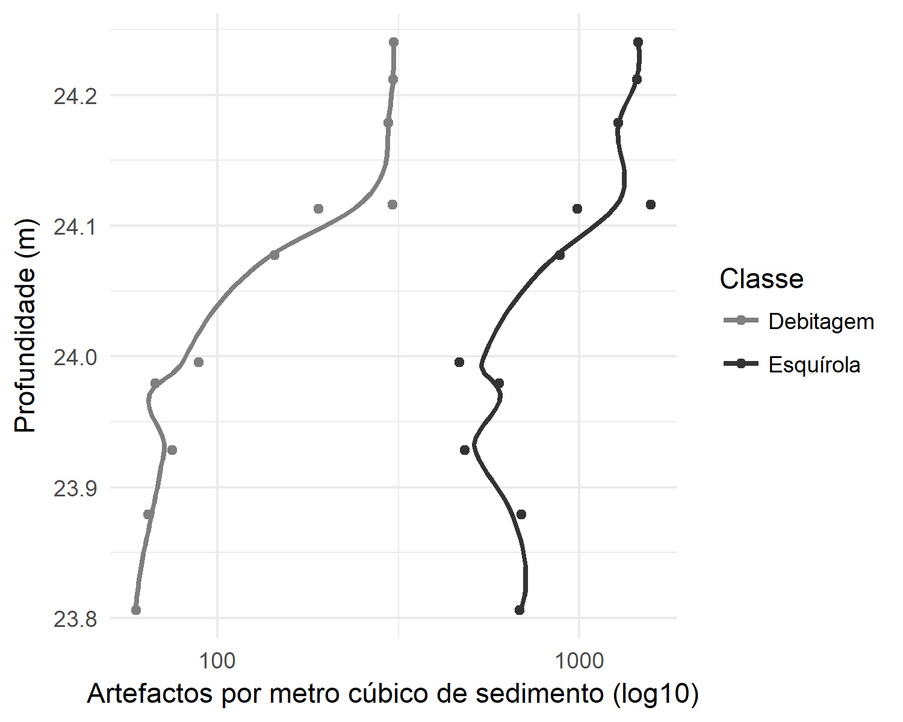

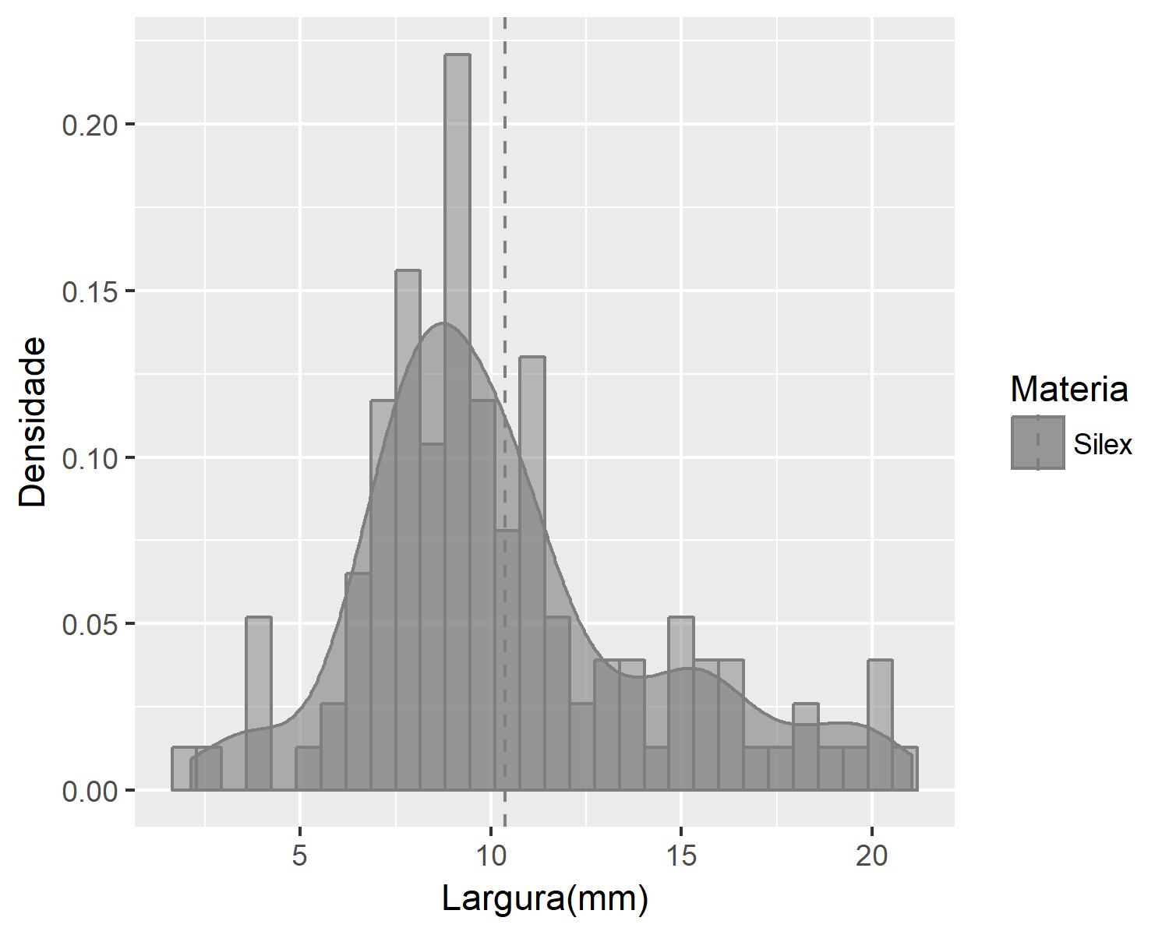

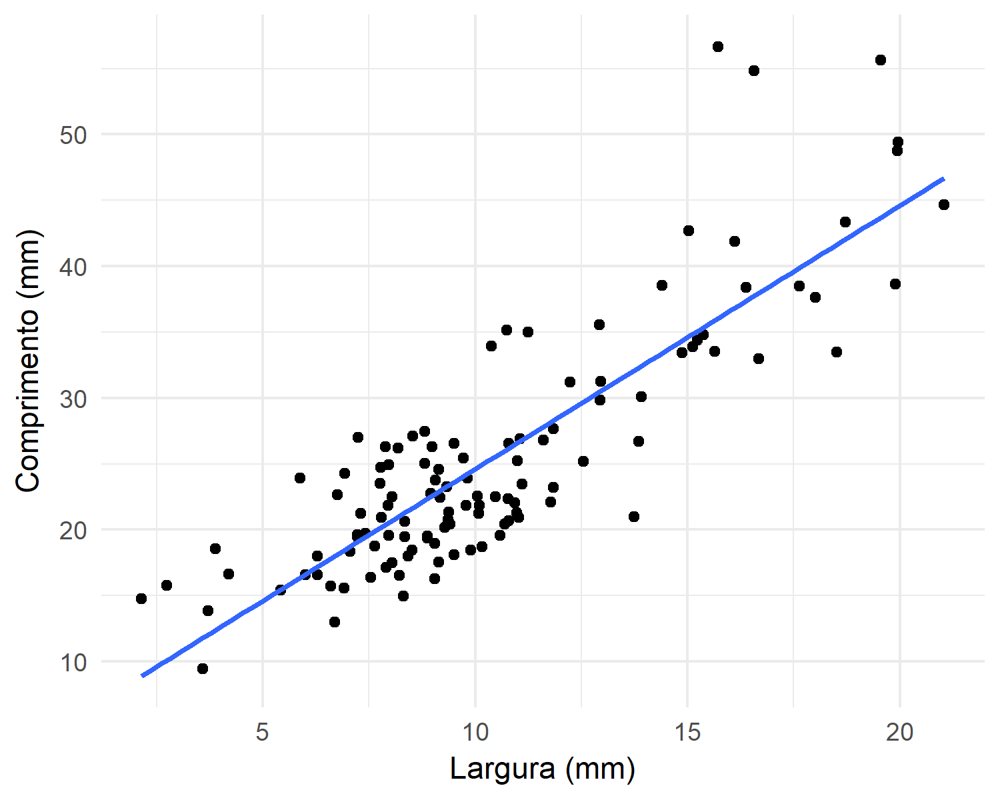

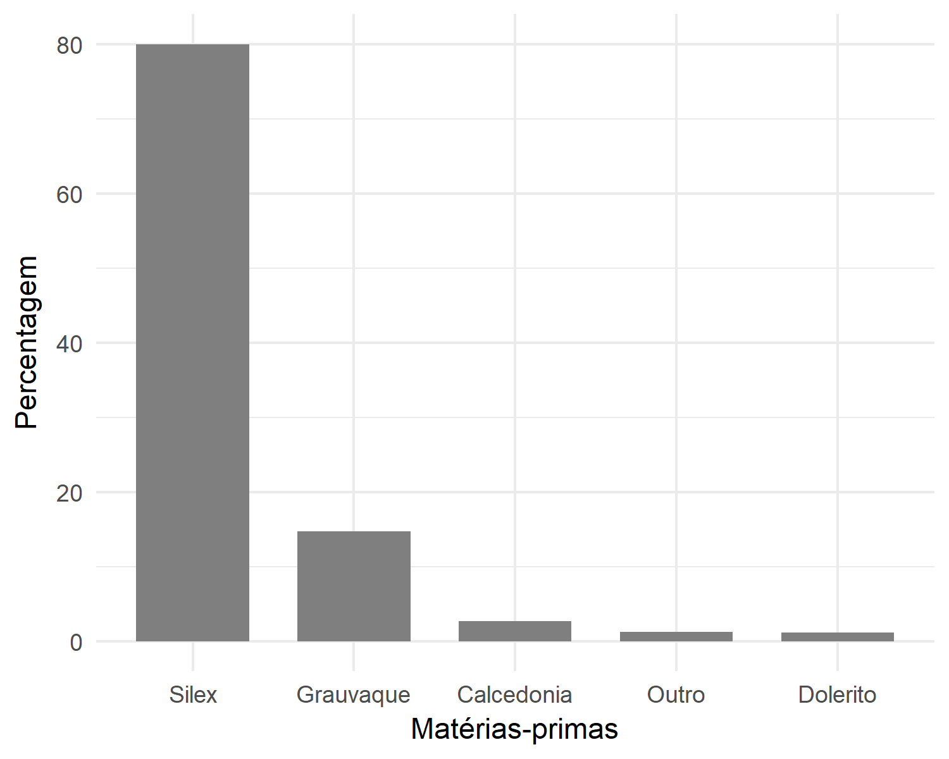

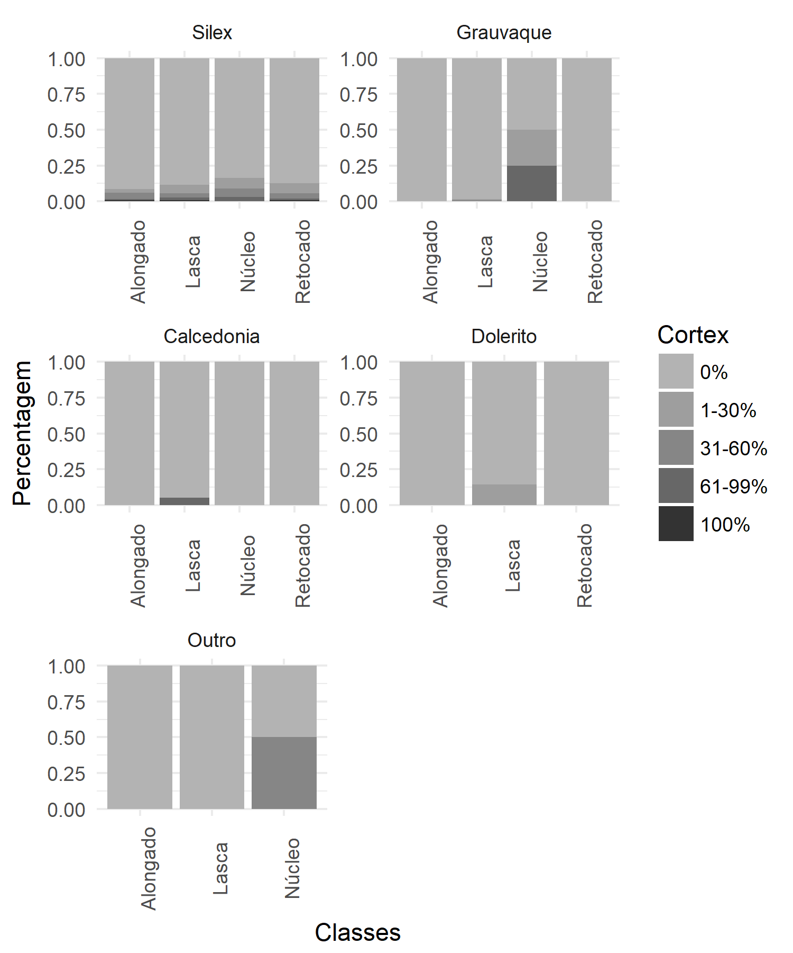

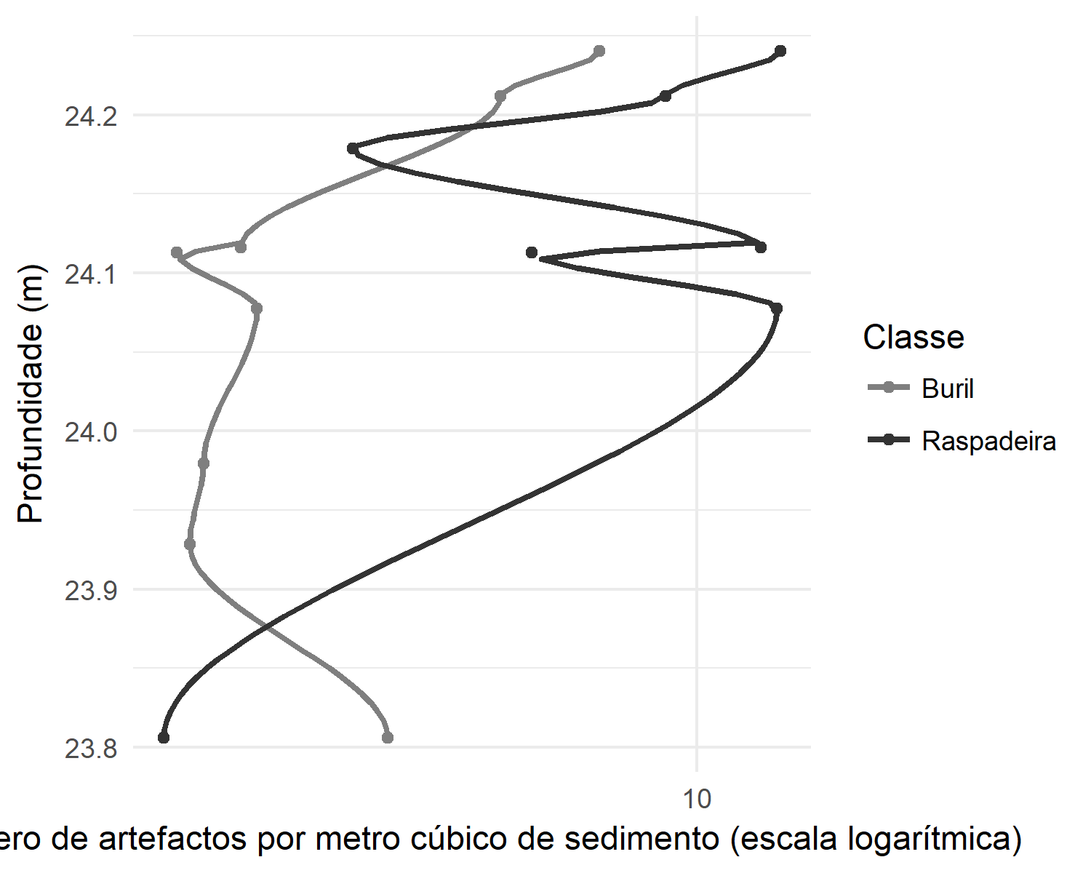

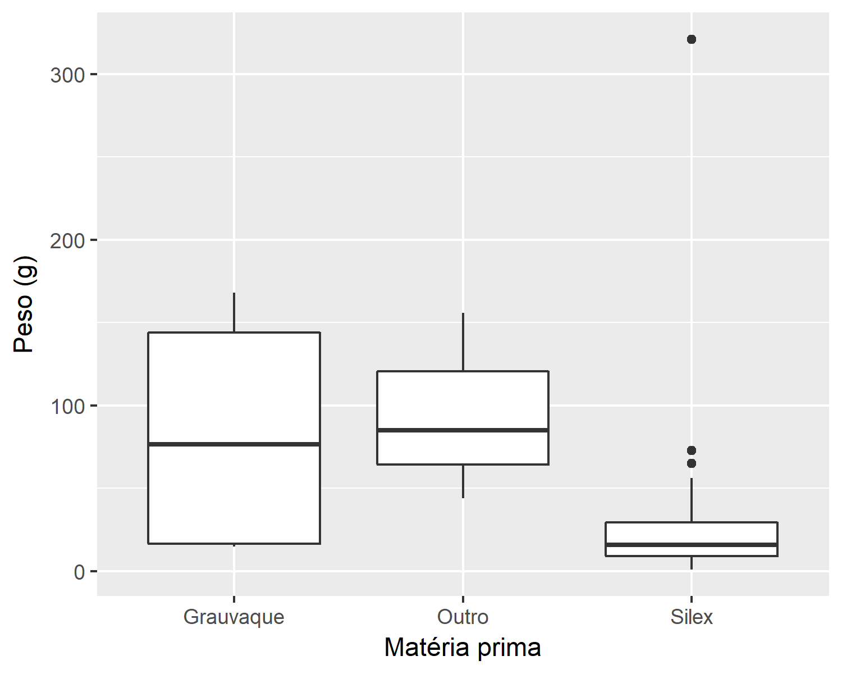

# Introduction

# Background

# Methods

# Results

# Discussion

# Conclusion

# Acknowledgements

##### pagebreak

# References

##### pagebreak

### Colophon

This report was generated on 2018-07-15 17:59:52 using the following computational environment and dependencies:

#> setting value   
#> version R version 3.5.0 (2018-04-23)  
#> system x86_64, mingw32   
#> ui RTerm   
#> language (EN)   
#> collate English_United States.1252   
#> tz Europe/London   
#> date 2018-07-15   
#>   
#> package * version date source   
#> assertthat 0.2.0 2017-04-11 CRAN (R 3.4.4)  
#> backports 1.1.2 2017-12-13 CRAN (R 3.5.0)  
#> base * 3.5.0 2018-04-23 local   
#> bindr 0.1.1 2018-03-13 CRAN (R 3.4.4)  
#> bindrcpp * 0.2.2 2018-03-29 CRAN (R 3.5.0)  
#> bookdown 0.7 2018-02-18 CRAN (R 3.4.4)  
#> broom 0.4.4 2018-03-29 CRAN (R 3.4.4)  
#> cellranger 1.1.0 2016-07-27 CRAN (R 3.4.4)  
#> cli 1.0.0 2017-11-05 CRAN (R 3.4.4)  
#> colorspace 1.3-2 2016-12-14 CRAN (R 3.5.0)  
#> compiler 3.5.0 2018-04-23 local   
#> crayon 1.3.4 2017-09-16 CRAN (R 3.4.4)  
#> curl 3.2 2018-03-28 CRAN (R 3.5.0)  
#> datasets * 3.5.0 2018-04-23 local   
#> devtools 1.13.6 2018-06-27 CRAN (R 3.5.1)  
#> digest 0.6.15 2018-01-28 CRAN (R 3.5.0)  
#> dplyr * 0.7.5 2018-05-19 CRAN (R 3.5.0)  
#> evaluate 0.10.1 2017-06-24 CRAN (R 3.4.4)  
#> forcats * 0.3.0 2018-02-19 CRAN (R 3.4.4)  
#> foreign 0.8-70 2017-11-28 CRAN (R 3.5.0)  
#> ggplot2 * 2.2.1 2016-12-30 CRAN (R 3.4.4)  
#> glue 1.2.0 2017-10-29 CRAN (R 3.5.0)  
#> googlesheets * 0.2.2 2017-05-07 CRAN (R 3.5.0)  
#> graphics * 3.5.0 2018-04-23 local   
#> grDevices * 3.5.0 2018-04-23 local   
#> grid 3.5.0 2018-04-23 local   
#> gtable 0.2.0 2016-02-26 CRAN (R 3.4.4)  
#> haven 1.1.1 2018-01-18 CRAN (R 3.5.0)  
#> hms 0.4.2 2018-03-10 CRAN (R 3.4.4)  
#> htmltools 0.3.6 2017-04-28 CRAN (R 3.5.1)  
#> httr 1.3.1 2017-08-20 CRAN (R 3.4.4)  
#> jsonlite 1.5 2017-06-01 CRAN (R 3.5.0)  
#> knitr 1.20 2018-02-20 CRAN (R 3.4.4)  
#> labeling 0.3 2014-08-23 CRAN (R 3.4.1)  
#> lattice 0.20-35 2017-03-25 CRAN (R 3.5.0)  
#> lazyeval 0.2.1 2017-10-29 CRAN (R 3.5.0)  
#> lubridate 1.7.4 2018-04-11 CRAN (R 3.5.0)  
#> magrittr 1.5 2014-11-22 CRAN (R 3.4.4)  
#> memoise 1.1.0 2017-04-21 CRAN (R 3.4.4)  
#> methods * 3.5.0 2018-04-23 local   
#> mnormt 1.5-5 2016-10-15 CRAN (R 3.5.0)  
#> modelr 0.1.2 2018-05-11 CRAN (R 3.4.4)  
#> munsell 0.5.0 2018-06-12 CRAN (R 3.5.0)  
#> nlme 3.1-137 2018-04-07 CRAN (R 3.5.0)  
#> openssl 1.0.1 2018-03-03 CRAN (R 3.5.0)  
#> parallel 3.5.0 2018-04-23 local   
#> pillar 1.2.3 2018-05-25 CRAN (R 3.5.0)  
#> pkgconfig 2.0.1 2017-03-21 CRAN (R 3.4.4)  
#> plyr * 1.8.4 2016-06-08 CRAN (R 3.5.0)  
#> psych 1.8.4 2018-05-06 CRAN (R 3.4.4)  
#> purrr * 0.2.5 2018-05-29 CRAN (R 3.5.0)  
#> R6 2.2.2 2017-06-17 CRAN (R 3.4.4)  
#> Rcpp 0.12.17 2018-05-18 CRAN (R 3.5.0)  
#> readr * 1.1.1 2017-05-16 CRAN (R 3.5.0)  
#> readxl 1.1.0 2018-04-20 CRAN (R 3.5.0)  
#> reshape2 1.4.3 2017-12-11 CRAN (R 3.5.0)  
#> rlang 0.2.1 2018-05-30 CRAN (R 3.5.0)  
#> rmarkdown 1.10 2018-06-11 CRAN (R 3.5.0)  
#> rprojroot 1.3-2 2018-01-03 CRAN (R 3.4.4)  
#> rstudioapi 0.7 2017-09-07 CRAN (R 3.4.4)  
#> rvest 0.3.2 2016-06-17 CRAN (R 3.4.4)  
#> scales 0.5.0 2017-08-24 CRAN (R 3.5.0)  
#> stats * 3.5.0 2018-04-23 local   
#> stringi 1.1.7 2018-03-12 CRAN (R 3.5.0)  
#> stringr * 1.3.1 2018-05-10 CRAN (R 3.4.4)  
#> tibble * 1.4.2 2018-01-22 CRAN (R 3.5.0)  
#> tidyr * 0.8.1 2018-05-18 CRAN (R 3.5.0)  
#> tidyselect 0.2.4 2018-02-26 CRAN (R 3.5.0)  
#> tidyverse * 1.2.1 2017-11-14 CRAN (R 3.5.0)  
#> tools 3.5.0 2018-04-23 local   
#> utf8 1.1.4 2018-05-24 CRAN (R 3.5.0)  
#> utils * 3.5.0 2018-04-23 local   
#> withr 2.1.2 2018-03-15 CRAN (R 3.4.4)  
#> xfun 0.2 2018-06-16 CRAN (R 3.5.0)  
#> xml2 1.2.0 2018-01-24 CRAN (R 3.5.0)  
#> yaml 2.1.19 2018-05-01 CRAN (R 3.5.1)

The current Git commit details are:

#> Local: master C:/Users/jmcasca/Documents/R_DATA/compendiums/ProtoSolutreanVB  
#> Remote: master @ origin (https://github.com/jmcascalheira/ProtoSolutreanVB.git)  
#> Head: [d72a842] 2018-06-24: plot on artifact densities across stratigraphy