The use of lithic assemblages for the definition of short-term occupations in hunter-gatherer prehistory

Nuno Bicho (ICArEHB, University of Algarve, Faro, Portugal) [nbicho@ualg.pt](mailto:nbicho@ualg.pt)

João Cascalheira (ICArEHB, University of Algarve, Faro, Portugal) [jmcascalheira@ualg.pt](mailto:jmcascalheira@ualg.pt)

2018-06-06

One of the main elements in prehistoric research is the study of settlement patterns. In the last five decades, stemming partially from Binford’s research on the topic, the idea of settlement patterns is based on site typology, including the traditional residential and logistic concepts. Both models of land use and exploitation are certainly marked by the notion of short-term occupation. This concept, used freely by many archaeologists, tends to rely on two main ideas: an occupation lasted a short span of time and resulted in a limited amount of material culture. Our aim, based on our results from various archaeological case studies dated to the Upper Paleolithic of Portugal, is to show that neither idea is necessarily correct: e.g. there may be short-term occupations with the production of large amounts of artifacts, such as lithic workshops; there might be very small collections, such as lithic caches, resulting from short occupations but with very long uses of the site; and most times, both are hardly differentiated within complex palimpsests. Our study shows that the common use of lithic volumetric density and retouch frequency is not always sufficient to differentiate between short and long-term occupations. Also, there are other variables that are more sensitive to indicate the duration of occupation of an archaeological context that should be used in the identification of time length.

# The archaeological use of ‘Short-term occupation’

Prehistoric archaeology has been fighting hard to understand the archaeological record and how it relates to past human evolution and anthropogenic adaptations to the changing environment. The development of actualistic studies (sensu Binford 1981) in the last half century, including such specialized disciplines as Ethnoarchaeology, Geoarchaeology or Zooarchaeology, have greatly helped us to understand, not only the archaeological material culture, but also site formation processes (e.g. Schiffer 1983, 1987) in a wide and very diversified manner. Nevertheless, archaeologists still endure complex problems for the definition of universally used concepts related to past human adaptations. In some cases, however, archaeologists just freely use those concepts without the necessary careful or proper consideration of their meaning and the impact that they might have in further interpretations of the distant past. The concept of ‘short-term occupation’ seems to be such a case. The idea of short-term occupation has been frequently used to succinctly describe site´s or lithic assemblage’s characteristics (e.g. Porraz 2009; Rios-Garaizar 2016; Picin 2017). Most times, it is, in one way or another, related to work on settlement patterns, starting with the classic Binford’ studies on the Nunamiut settlement system and related discussion of site structuring and intra-site spatial organization (e.g. Binford 1978a, 1978b, 1982), as well as on hunter-gatherer mobility research (e.g. Binford 1980; Kuhn 1992; Kelly 1995; Amick 1996; Barton and Riel-Salvatore 2014; Nishiaki and Akazawa 2015).

In 1972, Sahlins (1972) argued that, if given enough time, a small group of foragers can rapidly deplete the resources within a short range from their residential base camp. This basic assumption is fundamental to understand the value of the definition of a short-term occupation for hunter-gatherer research, and more so in the case of the prehistoric archaeological record. As Yellen (1977) stated, the duration of occupation of a group in a specific ecological context will affect both the quantity and nature of the archaeological record visible at a site. The issue, then, is to juggle a series of variables, including duration of occupation and population size, and to make sense of the results, so the concept is clear and used in a meaningful manner.

As Moncel and Rivals (2011) have argued, it is not always easy to make a distinction between long-term and short-term occupations. While ethnographically this distinction might be easy to demonstrate, although most certainly corresponding to a continuum as both Yellen (1977) and Binford (1978a) have shown in their ethnoarchaeological studies, in the archaeological record this task is certainly more complex. There are a set of cultural variables that have a direct impact on the duration of any occupation. The most important are likely to be population size, habitat quality (or in other words, local ecological diversity and carrying capacity), diversity and type of functions at the site. These, unfortunately, cannot be measured directly in the archaeological record and we need proxies that helps us to understand the diversity of each at every single site and even in individual contexts at each site. While in the case of population size there has been attempts to produce numerical formulae to resolve the issue (e.g. Grove 2009), the most common variable used to define the size of a population at a site is the dimension of the site. The measurement of the habitat quality is certainly more problematic and is limited to organic data (i.e., fauna and flora in all possible formats) and raw materials, present at the site. Site diversity and type of functions have traditionally been measured based on, respectively, tool diversity indices, and use-wear and residue analyses. In addition to tool diversity, the presence, quantity, and diversity of habitat features is also commonly used for determining site function (Table 1).

Table 1 Traditional criteria for estimation of duration of occupation

|  |  |  |
| --- | --- | --- |
| Archaeological Variables | Short-term occupation | Long term-occupation |
| Site area | Small | Large |
| Artifact numbers | Small | High |
| Artifact density | Low | High |
| Frequency of retouch | High | Low |
| Tool diversity | Low | High |
| Number of features | Low | High |
| Thickness of Archaeological deposits | Thin | Thick |
| Spatial segregation of activities | Rare | Frequent |

The use of the concept of short-term (and also that of long-term) occupations is directly related, in the archaeological literature, with site typology. Terms such as Residential site, Residential camp, Logistical camp, Base camp, and many others are frequently applied with no particular verified criteria other than the size of the site, or of the dimension and diversity of the artefactual assemblage (e.g. Madsen et al. 2006; Porraz 2009; Crassard et al. 2013; Rios-Garaizar 2016; Bretzke et al. 2017; Terradillos-Bernal et al. 2017). Other studies have furthered improved those concepts, with both descriptions of criteria and their application (e.g. Barton 1990; Dillehay et al. 2011; Nishiaki and Akazawa 2015; Clark and Barton 2017).

In Binford’s seminal framework there are clear definitions of site typology (Binford 1980) that relate to mobility patterns: “For foragers, I recognized two types of site, the residential base camp and the location. Collectors generate at least three additional types of sites by virtue of the logistical character of their procurement strategies. These I have designated the field camp, the station, and the cache.” (Binford 1980: 10).

Another good example of site nomenclature is that of Dillehay et al. (2011) for the foraging-farming transition in the Andes. The authors indicate the presence of a very diverse and expanded site typology (Dillehay et al. 2011: 36-40), defining long-term and short-term base and field camps, processing stations, transitory station/workshops, lithic quarries, earthen mounds, horticultural residences with gardens, permanent residences associated with irrigation, agriculture, hillside villages and special activity locales.

These examples start with a basic assumption that “…the greater the number of generic types of functions a site may serve, the greater the number of possible combinations, and hence the greater the range of inter-site variability…” (Binford 1980: 12). However, as Binford also argued, there is considerable variability in the duration of each stay in each site and the type of mobility pattern present (Binford 1980), and thus each site may have been used for different functions and durations (Binford 1982), with a direct impact on the archaeological visibility of sites and their respective duration cycle. Barton and colleagues (Riel-Salvatore and Barton 2004; Barton and Riel-Salvatore 2014; Clark and Barton 2017), following Binford’s perspective, have argued for a continuum in the use of space and time between residential (Foragers) and logistical (Collectors) patterns, that can be measured in the archaeological record using the relationship between artifact volumetric density and the frequency of retouched tools within each assemblage – named by the authors as the Whole Assemblage Behavioral Index (WABI). The index is expected to show a negative correlation between both variables, reflecting accumulated artifacts deriving from primarily curated to primarily expedient artifact use. Although the authors emphasize that “the terms “expedient” and “curated” do not reflect individual site-occupation events” (Riel-Salvatore and Barton 2007: 62). They also assume that expedient assemblages often accumulate at more intensively occupied sites, while curated assemblages more usually derive from short-term occupations.

In this study, we focus on previous uses of the term short-term occupations and its definitions, and the parent archaeological proxies used to define length of site occupation as well as site type. Using data from various case studies we have been working with over the past 25 years, we critically evaluate the application of the WABI proxy and explore a combination of other potential variables for the definition of occupation duration using commonly available stone tool and context data.

# Materials and Methods

## Case studies

We used in this study a total of 17 stone tool samples from different archaeological contexts, coming from a set of various sites excavated since the late 1980’s: Areeiro I (Bicho 1992, 1993, 1994) Cabeço do Porto Marinho (Bicho 1992, 1994), Carneira II (Bicho 1992, 1993), Picareiro (Bicho et al. 2006), Pinhal da Carneira (Bicho 1992, 1993), and Quinta do Sanguinhal (Bicho 2005) in central Portugal, and Vale Boi (Cascalheira and Bicho 2013, 2015; Bicho et al. 2017b) in southern Portugal. In most cases, only samples were used, instead of whole assemblages, since only those have been published.

Areeiro I (ARI) was excavated in 1987 (Marks et al. 1994). It is located in the Rio Maior area, in a region with the highest concentration of open-air sites in the Portuguese Upper Paleolithic. It was found in sands, as all the Rio Maior sites in the present paper. Excavation was carried out by artificial 10 cm spits and all sediment was screened through a 2 mm mesh. Artifacts are slightly damaged by a modern fire. No habitat features were found at the excavated area (Table 2), but the density of artifacts and the apparent extension of the deposit suggested a medium to long-term residential occupation.

Table 2 Archaeological data based on variables from Table 1

|  |  |  |  |  |  |  |  |  |  |  |  |  |  |  |  |  |  |
| --- | --- | --- | --- | --- | --- | --- | --- | --- | --- | --- | --- | --- | --- | --- | --- | --- | --- |
| Sites | EstimatedArea | DepositThickness | SampledVolume | Artifacts | Cores | Blanks | Chips | RetouchedTools | ToolTypes | Features | LithicDensity | CoreFreq | BlanksFreq | ChipsFreq | RetouchFreq | ToolDiversity | FeaturesFreq |
| AR I | 50 | 0.25 | 0.50 | 2048 | 84 | 890 | 849 | 204 | 38 | 0 | 4096.00 | 0.04 | 0.43 | 0.41 | 0.10 | 2.66 | 0.00 |
| CPM III Trench | 8 | 0.15 | 0.45 | 1487 | 24 | 807 | 529 | 90 | 35 | 1 | 3304.44 | 0.02 | 0.54 | 0.36 | 0.06 | 3.69 | 2.22 |
| CPM I Upper | 70 | 0.35 | 1.40 | 4703 | 217 | 1601 | 1241 | 1481 | 72 | 0 | 3359.29 | 0.05 | 0.34 | 0.26 | 0.31 | 1.87 | 0.00 |
| CPM II Upper | 70 | 0.25 | 1.00 | 2393 | 34 | 1180 | 925 | 187 | 43 | 0 | 2393.00 | 0.01 | 0.49 | 0.39 | 0.08 | 3.14 | 0.00 |
| CPM II Middle | 40 | 0.25 | 1.75 | 2260 | 41 | 1047 | 995 | 120 | 37 | 0 | 1291.43 | 0.02 | 0.46 | 0.44 | 0.05 | 3.38 | 0.00 |
| CPM I Lower | 70 | 0.30 | 2.10 | 1766 | 78 | 843 | 585 | 202 | 45 | 1 | 840.95 | 0.04 | 0.48 | 0.33 | 0.11 | 3.17 | 0.48 |
| CPM III Upper | 60 | 0.25 | 0.75 | 2148 | 90 | 1047 | 699 | 268 | 50 | 0 | 2864.00 | 0.04 | 0.49 | 0.33 | 0.12 | 3.05 | 0.00 |
| CPM III S | 100 | 0.35 | 1.40 | 5179 | 75 | 2597 | 1841 | 382 | 55 | 2 | 3699.29 | 0.01 | 0.50 | 0.36 | 0.07 | 2.81 | 1.43 |
| CPM V | 50 | 0.20 | 1.80 | 2701 | 33 | 1033 | 1397 | 162 | 39 | 0 | 1500.56 | 0.01 | 0.38 | 0.52 | 0.06 | 3.06 | 0.00 |
| CR II | 100 | 0.25 | 1.50 | 2151 | 46 | 1264 | 607 | 171 | 41 | 1 | 1434.00 | 0.02 | 0.59 | 0.28 | 0.08 | 3.14 | 0.67 |
| PC | 100 | 0.25 | 1.00 | 2431 | 29 | 956 | 1148 | 205 | 41 | 0 | 2431.00 | 0.01 | 0.39 | 0.47 | 0.08 | 2.86 | 0.00 |
| QS | 5 | 0.05 | 0.25 | 1438 | 8 | 378 | 975 | 8 | 2 | 0 | 5752.00 | 0.01 | 0.26 | 0.68 | 0.01 | 0.71 | 0.00 |
| VB Shelter 2 | 2 | 0.50 | 1.00 | 54 | 0 | 8 | 13 | 31 | 3 | 0 | 54.00 | 0.00 | 0.15 | 0.24 | 0.57 | 0.54 | 0.00 |
| VB Shelter Z | 8 | 0.15 | 0.90 | 1156 | 22 | 323 | 581 | 33 | 15 | 0 | 1284.44 | 0.02 | 0.28 | 0.50 | 0.03 | 2.61 | 0.00 |
| VB Shelter B | 30 | 0.25 | 6.00 | 12819 | 80 | 2304 | 7867 | 141 | 31 | 1 | 2136.50 | 0.01 | 0.18 | 0.61 | 0.01 | 2.61 | 0.17 |
| Picareiro F/G | 25 | 0.35 | 5.60 | 1954 | 19 | 261 | 1510 | 121 | 43 | 1 | 348.93 | 0.01 | 0.13 | 0.77 | 0.06 | 3.91 | 0.18 |

Cabeço do Porto Marinho (CPM) was excavated between 1987 and 1994 (Bicho 1992; Marks et al. 1994). CPM is one of the largest Portuguese Upper Paleolithic sites with a very long archaeological sequence. There are over 30 different stratigraphical contexts starting with early Gravettian, Proto-Solutrean, Magdalenian, Epipaleolithic, Neolithic and Bronze Age occupations (Bicho 1992; Marks et al. 1994; Zilhão 1997). For this study we used various horizons, known as CPM I Lower, I Upper, II Middle, II Upper, III Upper, III South, III Trench, and V, respectively coming from loci I, II, III and V. All assemblages are dated to the Magdalenian and Epipaleolithic, between c. 20 and 9 ka cal BP. Artifact retrieval resulted from excavation based on artificial 5 or 10 cm spits and all sediment was screened with a 2 mm mesh, but only CMP III trench was fully excavated. Some of those contexts had, at least, an in situ hearth (Bicho 1992). Data from each context is presented in Table 2, but the lithic assemblages have between c. 1500 artifacts (CPM III Trench) and >10 000 artifacts (CPM I Upper), although only the samples studied by Bicho (1992) were used in the present study. With the exception of CPM III Trench, corresponding to a small area around a single hearth, all other contexts were thought to represent middle to long-term occupations, likely residential base camps.

Carneira II (CR II) and Pinhal da Carneira (PC) are sites in the same general pine grove outside Rio Maior city. They are both single layered sites with an average of 20-25 cm thick deposit. There is a hearth in CR II, but no features were found in the small excavated area of PC. Excavation was carried out in 10 cm artificial spits and all sediment was screened with a 2 mm mesh. Both sites are dated to the Epipaleolithic, respectively c. 10.5 and 11.5 cal BP (Bicho 1992, 1994). Lithic assemblages used in this study are samples from the excavated area (Table 2). Both horizons, based on the amount of artifacts, were thought to be middle to long-term occupations, likely residential base camps.

Quinta do Sanguinhal (QS) is a very small open air site, also in the Rio Maior region (Bicho 2005). It is a Gravettian occupation, fully excavated with a total of 6 m2 (although it may have been slightly larger but, when we found the site, the western section had been removed due to construction of a building). The assemblage is composed of c. 1500 artifacts (Table 2) and there are several refittings. No features were found in the excavated area. Based on the lithic assemblage, the occupation was thought to correspond to a single short-term blade production site, with very few tools and cores, with many blades missing from the sequence, as shown by reffiting (Almeida 2000; Bicho 2005).

The cave site of Picareiro is located in central Portugal. The cave was excavated between 1994 and 2001 (PI Nuno Bicho) and a second project started in 2005 and is still underway under the direction of Jonathan Haws. The cave has a very long sequence of more than 9 meters and has archaeological horizons dated from the Middle Paleolithic to the Bronze Age (Bicho et al. 2006; Haws 2012). The lithic assemblage used here dates to the Magdalenian and is associated to a very large hearth (Bicho et al. 2006). This specific occupation was thought to correspond to a meat drying and smoking logistical station. It seems to be a very specialized industry composed mostly of chipage, a few cores, and small backed bladelets (both points such as microgravettes, and simple backed pieces). The sample is close to 2000 artifacts (Table 2).

The site of Vale Boi was discovered in 1998 and excavation started in 2000 (Bicho et al. 2004, 2013). There are four different loci (Terrace, Slope, Rock Shelter and Rock Shelter 2) with archaeological horizons dated to the early Gravettian (Bicho et al. 2015, 2017a), Solutrean and Magdalenian, while one of those loci (VB Terrace) has also Mesolithic and early Neolithic occupations (Carvalho 2007; Bicho 2009). Excavation followed detailed 3D location of artifacts using a Total station and full sediment screening with a 2-3 mm mesh screen.

The oldest assemblage is early Gravettian. It is a particular setting found at the bottom of VB Rock Shelter 2, composed by only 54 artifacts and coming from an area slightly smaller than 2 m2. It likely corresponds to a Gravettian point cache (Bicho et al. 2016), since the large majority of the recovered artifacts are backed pointed bladelets.

The other two assemblages (VB Shelter B and Z) are from the rock shelter locus, respectively dated to the Solutrean and Magdalenian (Mendonça 2009; Cascalheira 2013; Cascalheira and Bicho 2015). No habitat features were found in the small Magdalenian horizon but a small hearth was found in the middle of the excavated area of the VB B Solutrean Layer (Table 2).

## Variables

The literature referenced before indicates as the main archeological variables for the definition of the duration of occupation, artifact and tool density (Barton and Riel-Salvatore 2014; Clark and Barton 2017), expressed as retouch frequency and lithic volumetric density (artifacts per cubic meter). Logistically base camps and short-term camps were recognized by Clark and Barton (2017) based on the correlation of those two variables, producing a table of reference of material correlates of mobility. Short-term camps represent overnight and limited activities of small groups out from logistically base camps or larger groups based on a regular residential moving pattern. The result is a high incidence of retouch but with low lithic volumetric density, high lithic curation, low numbers of cores and debitage, and small archaeological contexts. In contrast, sites with large residential stability, named by those authors as logistically organized base camps, are marked by high lithic densities, low incidence of retouch, high numbers of non-exhausted cores, high numbers of blanks, large sites and what are usually called expedient technologies and assemblages.

There are, however, other variables that have been listed as possibly indicative of duration of occupation. These include site area, number of features, and spatial segregation of activities (e.g. Binford 1980; Dillehay et al. 2011; Nishiaki and Akazawa 2015). In the present study we use all of the above variables, so we can test their usefulness as a measure of time of occupation in archaeological contexts:

* **Site area** - the total area of an occupation visible in the archaeological context. Here we present three cases for each site, all in m2: estimated area of occupation, excavated area, and sampled area of the lithic assemblage used in the study;
* **Thickness of the Deposit** - average thickness of the excavated deposit presented (in meters), where the lithic assemblage and associated features were recovered;
* **Sampled Volume**: Volume of excavated sediments from the sampled area, presented in m3;
* **Number of artifacts** - total number of analyzed artifacts in the lithic sample;
* **Lithic Density** - estimated number of artifacts present in one cubic meter of sediment (following Clark and Barton (2017));
* **Cores** - numbers of cores present in the lithic sample;
* **Core Frequency** - relative frequency of cores in the lithic sample;
* **Blanks** - numbers of blanks (flakes, blades and bladelets) present in the lithic sample;
* **Blank Frequency** - relative frequency of blanks in the lithic sample;
* **Chips** - numbers of chips (artifacts smaller than 1 cm) present in the lithic sample;
* **Chip Frequency** - relative frequency of chips (artifacts smaller than 1 cm) in the lithic sample;
* **Retouched Tools** - total number of artifacts with retouch in the lithic sample;
* **Retouch Frequency** - relative frequency of retouched artifacts in the lithic sample (following Clark and Barton (2017));
* **Tool Types** - number of tool types following the adapted (Bicho 1992; Zilhão 1997) traditional Upper Paleolithic Typology (de Sonneville-Bordes and Perrot 1954, 1955, 1956b, 1956a);
* **Tool diversity** - diversity of tool types within each assemblage, calculated using the Menhinick’s index in which the number of tool types represented is divided by the square root of the total number of retouched tools;
* **Number of Features** - number of features associated to the specific archaeological context from which the lithic assemblage was recovered;
* **Features Frequency** - relative frequency of features for the sampled volume of sediment.

## Statistics

Principal Component Analysis (PCA) is a commonly used technique to extract relevant information from a multivariate dataset and to express this information as a set of few new variables called principal components or dimensions. The usefulness of PCA is that, in a single analytical process, one can indicate relationships between and within variables and cases, suggest general trends in data structure and identify which variables best explain these patterns, compress large percentages of variance from a wide set of variables in a reduced number of factors, and perform this transformation so that the new variables are not correlated and therefore do not present redundant information (Shennan 1997). PCA has had numerous applications in Archaeology (e.g. McPherron 1994; McCall 2006, 2007; Marreiros and Bicho 2013) and is available through most of the statistical software packages.

Here, we applied PCA to our dataset to identify possible correlations between variables that would indicate the existence of patterns that, when compared with a priori information from each of the sites, could possibly be translated into more secure proxies for occupation duration.

All analyses and data processing were accomplished in R (version 3.4.4) (R Core Team 2013). PCA analysis was performed using the FactoMineR package (Lê et al. 2008). Following recent concerns on the reproducibility of archaeological analysis we include the entire R code used for all the analysis and visualizations contained in this paper in our supplemental online material (SOM) at <https://dx.doi.org/10.17605/OSF.IO/AWYVF>. To produce those files we followed the procedures described by Marwick et al. (2017) for the creation of research compendiums to enhance the reproducibility of research. The files provided contain all the raw data used in our analysis as well as a custom R package (Wickham 2015) holding the code use for all analysis and to produce all tables and figures. To enable maximum re-use, our code is released under the MIT license, our data as CC-0, and our figures as CC-BY, (for more information see Marwick 2016).

# Results

Looking at the traditional criteria for estimation of duration of occupation listed in Table 1, the results are, in some cases, different from what we expected based on the field interpretations for each context. Results are presented in Table 2. Site area is relatively low for all loci, ranging from just a few square meters to 50-70 m2, with just a few locations reaching close to 100 m2. Deposit thickness is also fairly low, between 5 and 35 cm thick, but mostly around 20 to 25 cm. Most sites present a medium to high Lithic Density, while Retouch Frequency is, in most cases, very low (less than 1%). Tool Diversity, with very few exceptions, such as CPM III Trench and VB Shelter 2, with ratios close to 0.4, tend to be medium to low with several results lower than 0.2. Features are mostly absent and in the cases that are present are small hearths. The exceptions are CPM IIIS with a possible stone pavement and a hearth, and Picareiro F/G layer with the presence of a very large hearth (over 2 meters in diameter) made of large limestone slabs and clearly object of carefully cleaning and reuse.

Those seven criteria tend to suggest that under traditional classifications, although not without doubts, most of the case studies would be classified as long-term base camp occupations, such as ARI, CPM III Trench, CMP II Upper, CPM II Middle, CMPS IIIS and QS. On the contrary, VB Shelter 2 and CPM III Upper, seem to be the only two contexts that would be unequivocally classified as short-term occupations. In the other nine cases, the criteria do not seem to help to define the duration of the occupation.

This empirical classification is only partially in agreement with the evidence available from previous studies on the lithic and general archaeological context of each site.

When we plot lithic volumetric density against retouch frequency, following Clark and Barton (2017) index, the results are generically as expected (Figure 1). The correlation displayed between both variables is negative, with most of the sites concentrated in the lower right side of the graph, suggesting the presence of a majority of contexts with expedient organization of the lithic technology, and thus, most likely corresponding to long-term base camps. The opposite corner of the chart (upper left) is populated by a single isolated context, VB Shelter 2, which, according to previous interpretations, is in fact a short-term logistical stone tool cache. More interesting, though, is the location of a set of three contexts (QS, VB Shelter Z and Picareiro F/G) towards the bottom right of the chart, for which previous lithic analysis and context characterization suggested the presence of short-term occupations.

This pattern seems to suggest that the WABI approach is viable but may be insufficient to accurately identify the whole range of short-term occupations possibly present in the context of logistical settlement systems. To address this problem, we applied a multivariate approach to the same assemblages, by including a larger set of variables that have been considered significantly related to mobility patterns and, consequently, with the duration and nature of each occupation.

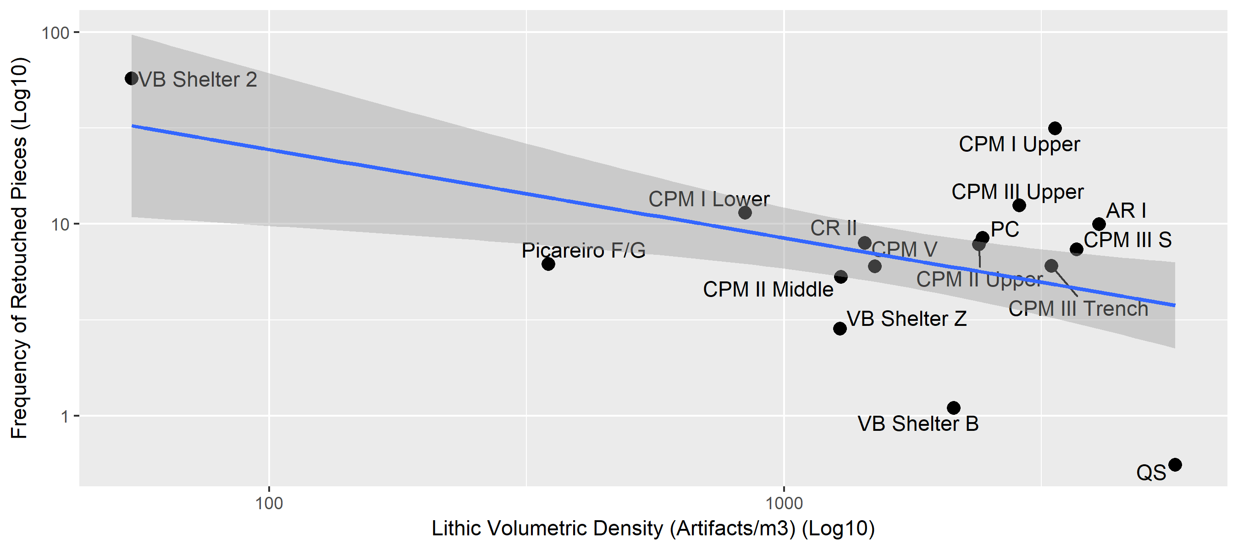

Figure 1 Whole Assemblage Behavioral Index

As a result, running PCA with the enlarged set of criteria provides a slightly different perspective on the WABI patterns. Four of the calculated PCA dimensions present eigenvalues higher than 1, explaining more than 87% of dataset variability (Table 3). Dimensions 1 and 2, alone, explain over 58% of the variability.

Table 3 Eigen values and percentage of variance for each dimension of PCA

|  |  |  |  |
| --- | --- | --- | --- |
|  | eigenvalue | variance.percent | cumulative.variance.percent |
| Dim.1 | 2.764 | 34.555 | 34.555 |
| Dim.2 | 1.940 | 24.252 | 58.808 |
| Dim.3 | 1.246 | 15.578 | 74.386 |
| Dim.4 | 1.076 | 13.455 | 87.841 |
| Dim.5 | 0.607 | 7.582 | 95.422 |
| Dim.6 | 0.256 | 3.202 | 98.624 |
| Dim.7 | 0.084 | 1.052 | 99.676 |
| Dim.8 | 0.026 | 0.324 | 100.000 |

Figure 2 clearly show that a total of three variables with contributions larger than the expected average cut off value are in the origin of the compression represented by Dimension 1: Blank Frequency (c. 32%), site Estimated Area (c. 19%), and Core Frequency (c. 13%). Dimension 2 is mostly explained by Retouch Frequency (c. 42%), Chip Frequency (c. 32%), and Tool Diversity (c. 15%). Finally, Dimensions 3 and 4 are largely explained by a single variable, that in the first case is Lithic Density (c. 72%) and in the second Features Frequency (c. 60%).

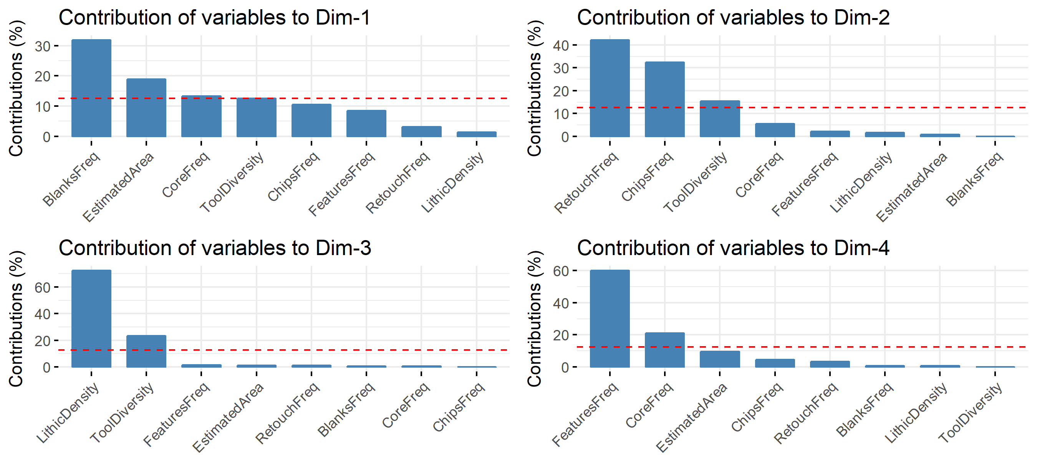

Figure 2 Contribution of variables for each of the four relevant PCA dimensions

When plotted into bi-dimensional correlation plots (Figure 3), Dimension 1 is clearly marked by a positive correlation between all the relevant variables, while Dimension 2 is mostly marked by a negative correlation between Retouch Frequency and the other two major contributors: Chip Frequency and Tool Diversity.

In the case of Dimensions 3 and 4, correlations seem to be less marked, mostly due to the low contribution of many variables. However, it is still noteworthy the negative correlation between Lithic Density and Tool Diversity, on the one hand, and the negative correlation between Features Frequency and Core Frequency, on the other hand.

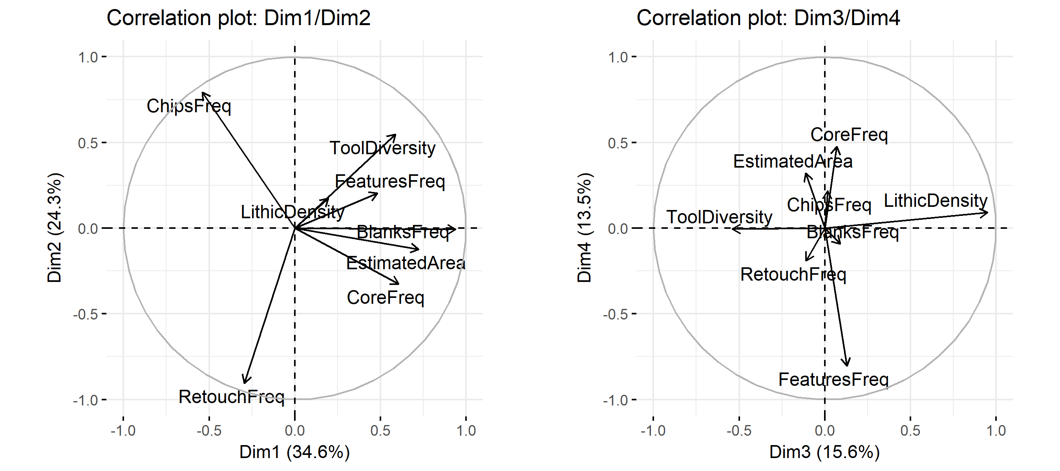

Figure 3 Correlation plots of variables for each of the four relevant PCA dimensions

Figures 4 and 5 present the biplot charts of each pair of PCA dimensions, representing, in a single space, the association between variables and cases. The location of contexts using the first two dimensions (Table 4) seems to confirm the WABI results (Figure 1) by (1) isolating VB Shelter 2 from the remaining group due to a very high frequency of retouched tools and low numbers of every other variable, but also (2) by separating the cluster of sites – Picareiro F/G, QS, VB Shelter Z, and VB Shelter B – whose locations in the WABI plot were outside the 80% confidence interval based on all the remaining sites. The relevant outcome, though, is that these contexts appear now associated with larger values of Chip Frequency and low values of all the remaining variables, and not clearly associated with expedient base camps as suggested by the WABI. The use and relevance of Chip Frequency in this analysis might raise some concerns due to the possible influence of preservation conditions and post-depositional processes affecting each context. For this reason, during our exploratory analysis we recalculate the PCA without using Chip Frequency, and results came out essentially the same in terms of the location of contexts within each dimension (although we do not present the outcomes of these extra-analysis, they can be confirmed by using the code provided in our SOM materials).

Overall, the combination of Dimensions 1 and 2 seems to provide a more detailed separation between contexts with shorter and longer occupations than with WABI. The division between contexts is not as much explained by lithic volumetric density, as it is by the frequencies of the three different technological classes (chips, blanks and cores) used, as well as by the diversity of retouched tools types.

The association between contexts and variables across Dimension 3 and 4 is more difficult to interpret, given that only a small number of variables offers significant explanatory power. Yet, it is rather clear, once again, that Lithic Density is not, by itself or in conjunction with Retouch Frequency, a consistent proxy for duration of occupation. The location of QS in the far right extreme of Figure 4, associated with high values of lithic volumetric density and low frequency of retouched tools clearly corroborates this idea.

Table 4 PCA coordinates for the archaeological contexts

|  |  |  |  |  |
| --- | --- | --- | --- | --- |
|  | Dim.1 | Dim.2 | Dim.3 | Dim.4 |
| AR I | 0.79 | -0.29 | 1.14 | 1.15 |
| CPM III Trench | 1.62 | 1.09 | 0.65 | -2.99 |
| CPM I Upper | 0.49 | -2.44 | 0.86 | 1.01 |
| CPM II Upper | 0.75 | 0.15 | -0.24 | 0.32 |
| CPM II Middle | 0.26 | 0.50 | -0.90 | 0.23 |
| CPM I Lower | 1.63 | -0.74 | -0.98 | 0.47 |
| CPM III Upper | 1.38 | -0.73 | 0.18 | 0.99 |
| CPM III S | 1.91 | 0.27 | 0.88 | -1.16 |
| CPM V | -0.38 | 0.72 | -0.71 | 0.30 |
| CR II | 2.17 | -0.39 | -0.69 | -0.28 |
| PC | 0.38 | 0.29 | -0.23 | 0.71 |
| QS | -2.48 | 1.17 | 3.12 | 0.32 |
| VB Shelter 2 | -3.42 | -3.68 | -0.65 | -1.55 |
| VB Shelter Z | -1.29 | 0.60 | -0.48 | 0.20 |
| VB Shelter B | -1.81 | 1.38 | -0.10 | 0.08 |
| Picareiro F/G | -2.02 | 2.12 | -1.85 | 0.21 |

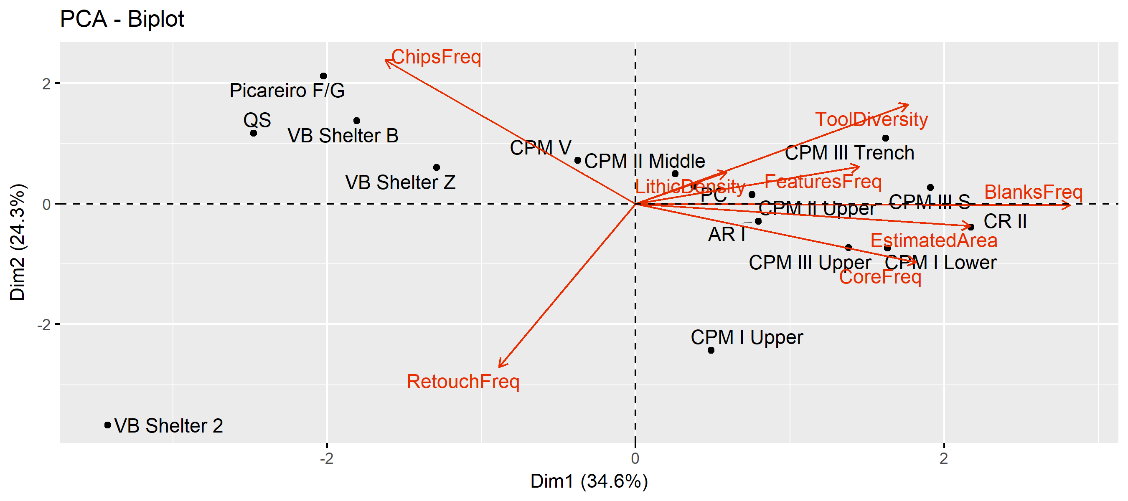

Figure 4 PCA Biplot for Dimensions 1 and 2

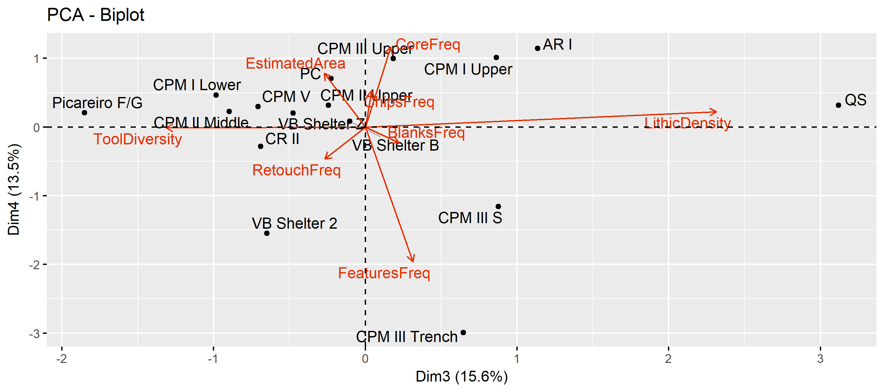

Figure 5 PCA Biplot for Dimensions 3 and 4

# Discussion

The results of our analysis indicate that, unlike what is specified by Clark and Barton (2017), patterns revealed by the inverse relationship between retouch frequency and lithic volumetric density are not always consistent with specific durations of site occupation. Assemblages classified under the traditional concepts of expedient and curated technologies may not necessarily be associated with the time spent at a specific site by human groups.

The best example in this regard are the results obtained for the context of QS. This is a fully excavated context, for which a detailed refitting analysis (Almeida 2000) revealed that a small number of cobbles were exploited for the production of elongated products, and that while the artifact sample is dominated by cortical flakes, cores, and several maintenance elements, a great number of produced blades and bladelets seem to have been exported (Bicho 2005). All these characteristics, together with its location directly on top of a flint source, indicate that QS was a knapping workshop context, used for a short period of time, and most certainly within a logistically organized settlement system. As in this case, sites whose primary functionality was raw material provisioning and served as knapping workshops will certainly present all the characteristics expected from expedient lithic assemblages: low incidence of retouched pieces, high number of blanks, few exhausted cores, among others. Most of these sites, however, were occupied during short periods of time. In these cases, an index calculated based on retouch frequency is impractical to determine occupation length, with retouched tools being imported in small numbers, and onsite retouched debitage products exported to other locations.

Similarly, sites which were occupied as field camps, using Binford’s terminology that define these as “temporary operational center[s] for task groups […], where a task group sleeps, eats, and otherwise maintains itself while away from the residential base” (Binford 1980: 10), can be associated with both expedient or curated assemblages, depending on a complex set of particularities, of which availability of usable raw materials is a central one. The differences introduced by Kuhn’s (1995) concepts of “provisioning of places” and “provisioning of individuals” are fundamental in this regard, distinguishing between strategies in which groups supply themselves from immediately available resources and make tools on the spot, or they anticipate their needs by transporting raw material blocks or already produced tools (Porraz 2009). This seems to be the case with the VB Shelter B context. Although occupying a fairly small area of the site, a very large diversity of chert raw materials (Pereira et al. 2016), low presence of cores and blanks, and high frequency of knapping residues (Cascalheira 2010, 2013), indicate that this context was probably used multiple times as a temporary field camp, where the complex combination of in situ knapping and retooling activities, resulted in a rather typical expedient assemblage. Thus, expedient behaviors are not conditioned by the amount of time spent in a site, but as detailed by Nelson (1991) on the location of activities close to raw material sources (or stockpiling), the lack of time stress in tool manufacture, and the regular use of sites that allow people to take advantage of abundant, predictable, resources.

It is undeniable that the significant negative correlation between retouch frequency and lithic volumetric density can be a viable approach to look for the average technological options made within each context under study (see e.g. Villaverde et al. 1998; Riel-Salvatore and Barton 2004, 2007; Sandgathe 2005; Barton et al. 2013; Clark and Barton 2017). However, although the formula might excel at separating curated vs. expedient approaches, it cannot be always equated with a clear division between short-term logistic and long-term residential sites.

Also problematic in our opinion, is the dichotomy of “curated technologies = residential mobility” vs “expedient technologies = logistical mobility” as presented by, for example, Riel-Salvatore (2010). The case of VB Shelter 2, previously classified as a Gravettian point cache (Bicho et al. 2016), and whose location both in the WABI plot and in the PCA biplots revealed a highly curated assemblage, is particularly relevant in this context. Although rare in the Eurasian Paleolithic archaeological record (but see e.g. Aubry et al. 2003; Tabarev et al. 2013 for other examples), based on the ethnographic record cache contexts are thought to be “common components of a logistical strategy in that successful procurement of resources by relatively small groups for relatively large groups generally means large bulk” (Binford 1980: 12). It is true, though, that in the context of the classification of occupation duration, lithic caches offer an additional classificatory problem, since site use of these contexts can be classified as either a very short occupation (when the cache is placed at the specified location and picked up when needed), or as long-term occupations if considering the total amount of time that the cache is in use. Either way, a context like VB Shelter 2 is unlikely to be associated with a residential mobility strategy, possibly representing the shorter and more curated type of assemblages of a logistical system. From a different perspective, accepting that significant time investment (both in tool manufacture and use life) is an essential component in characterizing reliable assemblages (sensu Bleed 1986), frequently associated with high levels of curation, then the VB Shelter 2 does not seem to fit at all in that category. The set of small retouched and unretouched bladelets more plausibly fit a maintainable type of system, that in the WABI calculation are associated with residential settlement systems. This particular contradiction mirrors the strong debate carried over the years about the factors explaining the curated/expedient dichotomy (see Vaquero and Romagnoli 2017 for a comprehensive review), and their repercussive implications for settlement interpretation.

Although the set of variables used in our analysis seem to show a clearer pattern related to the organization of lithic technology and its possible association with the duration of occupation, there are a series of caveats that are still noteworthy in this context. Perhaps the most important and more relevant one is the influence of repetition of occupations in a single context, independently of its duration. The truth is that, in most cases, it is particularly difficult, if not impossible, to separate two or more occupations in an archaeological palimpsest. It is likely that is not fundamentally important if the various occupations of a site have similar durations and functions – the final result in terms of a lithic assemblage will likely not change, at least in what concerns the variables considered here. The only exception is lithic volumetric density, but we have demonstrated that this is not a particularly helpful variable to separate short-term from long-term occupations, since it can vary both in terms of the intensity of lithic exploitation but also with the rather problematic sedimentation rates at the different contexts (Barton and Clark 1993; Farrand 2001; Stein et al. 2003; Riel-Salvatore and Barton 2004).

The problem raises when an archaeological palimpsest is the formation of diverse temporal and functional occupations through time (Moncel and Rivals 2011). This situation will profoundly alter variables such as the relation of chip-core/blank frequencies, as well as the diversity of tools present across the sequence. Since the presence and frequency of features has a small weight, the only other variable that may help on this context is that of the occupation area. Regrettably, the area of an archaeological context can also be affected by a partial overlapping of two different occupations, thus extending the range of artifact dispersion and material use at a single site. It seems that a particularly interesting, but still underutilized (Goldberg and Aldeias 2018), way to deal with this issue is that of contextualizing common macroscopic archaeological data with the characterization of site formation processes based on micromorphological analyses of sediments, where by virtue of microscopic view various time slices of occupation can be separated in a given sampled area (with the inherent problems related to sample size present in each case). Lithic refitting might be another way to test the occurrence of several short-term occupation in one specific context, but very specific preservation conditions are needed for this to occur, such as in the outstanding case of Abric Romani (see Carbonell (2012) and featured articles). On the other hand, when organic preservation is good enough, specific types of analyses of faunal remains of anthropogenic origin can be used to estimate duration of occupation. Those are, however, most times limited to the definition of seasonal vs. all year-round occupations (see e.g. Manne 2014; Rivals et al. 2009a; b).

# Conclusion

The present study focused on the use and application of the label “short-term occupation”. We used a diverse group of variables, based on different methods, to determine the relative length of occupation of a set of 16 archaeological contexts, all dated to the Upper Paleolithic, and all located in westernmost region of Iberia.

Drawing upon previous approaches to the relationship between lithics and settlement, our study suggests that retouch frequency and lithic volumetric density are not as sensitive as argued for the distinction of settlement systems and site occupancy modalities. Instead, when used in conjunction, those variables most likely represent technological aspects within a very diverse time frames of duration of occupations. A multivariate approach to our data revealed that other variables, such as the frequency of chips, blanks and cores, or the diversity of retouched tools, are more sensitive and more appropriate to distinguish between short-term and long-term occupations and its association with strategies of lithic technology organization (i.e., curated vs. expedient).

We also note that, like all the dichotomous classification systems used to organize the archaeological record, categorizing archaeological contexts as either short or long-term occupations is an oversimplification of past complex reality. Paleolithic assemblages are most of the times time-average constituents of sets of multiple and complex occupations. When detectable, such as in the cases of some of the contexts used in our analysis, short-term occupations are rather challenging to integrate with long-term ones and, with both, to build a wider, consistent, and more pertinent portrait.

# Acknowledgements

We would like to thank Andrea Picin for inviting us to the SAA symposium on Short-term Occupations, held in Vancouver, Canada in 2017, and the two anonymous reviewers whose comentaries and suggestions helped to improve the final version of this paper.

We also would like to thank Fundação para Ciência e Tecnologia, for financial support on various projects, including UID/ARQ/04211/2013 and PTDC/EPH-ARQ/4998/2012.

The sites in the Rio Maior region (ArI, CRII, CPM, PC and QS) were all excavated under Anthony Marks’ US National Science Foundation grant “The Prehistory of Portugal” #8803789, as well as with his direct supervision and participation.

##### pagebreak

# References

Almeida F (2000) The terminal Gravettian of Portuguese estremadura: Technological variability of the lithic industries. PhD Thesis, Southern Methodist University

Amick DS (1996) Regional patterns of Folsom mobility and land use in the American Southwest. World Archaeology 27:411–426. doi: [https://doi.org/10.1080/00438243.1996.9980317](https://doi.org/https://doi.org/10.1080/00438243.1996.9980317)

Aubry T, Peyrouse J-B, Walter B (2003) Les feuilles de laurier de Volgu (Saône-et-Loire): Une énigme en partie résolue? PALEO Revue d’archéologie préhistorique 15:251–254

Barton CM (1990) Stone Tools and Paleolithic Settlement in the Iberian Peninsula. Proceedings of the Prehistoric Society 56:15–32. doi: [10.1017/S0079497X00005004](https://doi.org/10.1017/S0079497X00005004)

Barton CM, Clark GA (1993) Cultural and natural formation processes in late Quaternary cave and rockshelter sites of western Europe and the Near East. In: Goldberg P, Nash DT, Petraglia MD (eds) Formation Processes in Archaeological Context. Prehistory Press, Madison, WI., pp 33–52

Barton CM, Riel-Salvatore J (2014) The formation of lithic assemblages. Journal of Archaeological Science 46:334–352. doi: [10.1016/j.jas.2014.03.031](https://doi.org/10.1016/j.jas.2014.03.031)

Barton CM, Villaverde V, Zilhão J et al (2013) In glacial environments beyond glacial terrains: Human eco-dynamics in late Pleistocene Mediterranean Iberia. Quaternary International 318:53–68. doi: [10.1016/j.quaint.2013.05.007](https://doi.org/10.1016/j.quaint.2013.05.007)

Bicho N (1994) The End of the Paleolithic and the Mesolithic in Portuga. Current Anthropology 35:664–674

Bicho N (2005) The extinction of Neanderthals and the emergence of the Upper Paleolithic in Portugal. Promontoria 3:173–228

Bicho N (1993) Late Glacial prehistory of central and southern Portugal. Antiquity 67:761–775

Bicho N (1992) Technological change in the final upper paleolithic of Rio Maior, Portuguese Estremadura. PhD thesis, Southern Methodist University.

Bicho N (2009) On the edge: Early Holocene adaptations in Southwestern Iberia. Journal of Anthropological Research 65:185–206

Bicho N, Cascalheira J, Gonçalves C (2017a) Early Upper Paleolithic colonization across Europe: Time and mode of the Gravettian diffusion. PLoS One 12:e0178506

Bicho N, Cascalheira J, Marreiros J, Pereira T (2017b) Rapid climatic events and long term cultural change: The case of the Portuguese Upper Paleolithic. Quaternary International 428:3–16

Bicho N, Haws J, Hockett B (2006) Two sides of the same coin—rocks, bones and site function of Picareiro Cave, central Portugal. Journal of Anthropological Archaeology 25:485–499. doi: [10.1016/j.jaa.2006.03.009](https://doi.org/10.1016/j.jaa.2006.03.009)

Bicho N, Manne T, Marreiros J et al (2013) The ecodynamics of the first modern humans in Southwestern Iberia: The case of Vale Boi, Portugal. Quaternary International 318:102–116. doi: [10.1016/j.quaint.2013.06.029](https://doi.org/10.1016/j.quaint.2013.06.029)

Bicho N, Marreiros J, Cascalheira J et al (2015) Bayesian modeling and the chronology of the Portuguese Gravettian. Quaternary International 359-360:499–509. doi: [10.1016/j.quaint.2014.04.040](https://doi.org/10.1016/j.quaint.2014.04.040)

Bicho N, Marreiros J, Cascalheira J, Raja M (2016) An Early Gravettian Point Cache from Vale Boi: Implications for the Arrival of Anatomically Modern Humans to Southern Iberia. Paper presented at 81st Annual Meeting of the Society for American Archaeology

Bicho N, Stiner MC, Lindly J (2004) Shell ornaments, bone tools and long distance connections in the Upper Paleolithic of Southern Portugal. In: Otte M (ed) La Spiritualité - Actes du colloque International de Liège. Études et Recherches Archéologiques de l’Université de Liège, Liège, pp 71–80

Binford LR (1981) Bones: Ancient men and modern myths. Academic Press, New York

Binford LR (1978a) Dimensional analysis of behavior and site structure: Learning from an Eskimo hunting stand. American Antiquity 43:330–361

Binford LR (1978b) Nunamiut ethnoarchaeology. Academic Press, New York

Binford LR (1982) The archaeology of place. Journal of Anthropological Archaeology 1:5–31

Binford LR (1980) Willow smoke and dogs’ tails: Hunter-gatherer settlement systems and archaeological site formation. American Antiquity 4–20

Bleed P (1986) The optimal design of hunting weapons: Maintainability or reliability. American Antiquity 51:737–747

Bretzke K, Kandel AW, Conard NJ (2017) The Middle Paleolithic sequence of Wadi Mushkuna Rockshelter and its implications for hominin settlement dynamics in western Syria. Quaternary International 435:106–114

Carbonell E (ed) (2012) High resolution archaeology and Neanderthal behavior : Time and space in Level J of Abric Romaní (Capellades, Spain) /. Springer, Dordrecht, Netherlands

Carvalho AF (2007) A neolitização do Portugal meridional: Os exemplos do Maciço calcário estremenho e do Algarve ocidental. PhD thesis, Universidade do Algarve

Cascalheira J (2013) A influência mediterrânica nas redes sociais do Solutrense final peninsular. Unpublished Ph.D. thesis, Universidade do Algarve

Cascalheira J (2010) Tecnologia lítica do abrigo Solutrense de Vale Boi. UNIARQ, Lisbon

Cascalheira J, Bicho N (2015) On the Chronological Structure of the Solutrean in Southern Iberia. PLoS One 10:e0137308. doi: [10.1371/journal.pone.0137308](https://doi.org/10.1371/journal.pone.0137308)

Cascalheira J, Bicho N (2013) Hunter–gatherer ecodynamics and the impact of the Heinrich event 2 in Central and Southern Portugal. Quaternary International 318:117–127. doi: [10.1016/j.quaint.2013.05.039](https://doi.org/10.1016/j.quaint.2013.05.039)

Clark GA, Barton CM (2017) Lithics, landscapes & la Longue-durée – Curation & expediency as expressions of forager mobility. Quaternary International 450:137–149. doi: [10.1016/j.quaint.2016.08.002](https://doi.org/10.1016/j.quaint.2016.08.002)

Crassard R, Petraglia MD, Drake NA et al (2013) Middle Palaeolithic and Neolithic Occupations around Mundafan Palaeolake, Saudi Arabia: Implications for Climate Change and Human Dispersals. PLoS One 8:e69665. doi: [10.1371/journal.pone.0069665](https://doi.org/10.1371/journal.pone.0069665)

Dillehay T, Stackelbeck K, Rossen J, Maggard G (2011) Research History, Methods, and Site Types. In: Dillehay TD (ed) From foraging to farming in the Andes: New perspectives on food production and social organization. Cambridge University Press, Cambridge, pp 29–41

Farrand WR (2001) Sediments and stratigraphy in rockshelters and caves: A personal perspective on principles and pragmatics. Geoarchaeology 16:537–557

Goldberg P, Aldeias V (2018) Why does (archaeological) micromorphology have such little traction in (geo) archaeology? Archaeological and Anthropological Sciences 10:269–278

Grove M (2009) Hunter–gatherer movement patterns: Causes and constraints. Journal of Anthropological Archaeology 28:222–233. doi: [10.1016/j.jaa.2009.01.003](https://doi.org/10.1016/j.jaa.2009.01.003)

Haws JA (2012) Paleolithic socionatural relationships during MIS 3 and 2 in central Portugal. Quaternary International 264:61–77. doi: [10.1016/j.quaint.2011.10.003](https://doi.org/10.1016/j.quaint.2011.10.003)

Kelly RL (1995) The foraging spectrum. Smithsonian Institution Press, Washington DC

Kuhn SL (1992) On planning and curated technologies in the Middle Paleolithic. Journal of Anthropological Research 48:185–214

Kuhn SL (1995) Mousterian Lithic Technology. Princeton University Press

Lê S, Josse J, Husson F (2008) FactoMineR: An R package for multivariate analysis. Journal of statistical software 25:1–18

Madsen DB, Haizhou M, Brantingham PJ et al (2006) The late Upper Paleolithic occupation of the northern Tibetan Plateau margin. Journal of Archaeological Science 33:1433–1444

Manne T (2014) Early Upper Paleolithic bone processing and insights into small-scale storage of fats at Vale Boi, southern Iberia. Journal of Archaeological Science 43:111–123. doi: [10.1016/j.jas.2013.12.003](https://doi.org/10.1016/j.jas.2013.12.003)

Marks AE, Bieho N, Zilhão J, Reid Ferring C (1994) Upper Pleistocene prehistory in Portuguese Estremadura: Results of preliminary research. Journal of Field Archaeology 21:53–68

Marreiros J, Bicho N (2013) Lithic technology variability and human ecodynamics during the Early Gravettian of Southern Iberian Peninsula. Quaternary International 318:90–101. doi: [10.1016/j.quaint.2013.05.008](https://doi.org/10.1016/j.quaint.2013.05.008)

Marwick B (2016) Computational Reproducibility in Archaeological Research: Basic Principles and a Case Study of Their Implementation. Journal of Archaeological Method and Theory 24:424–450. doi: [10.1007/s10816-015-9272-9](https://doi.org/10.1007/s10816-015-9272-9)

Marwick B, Boettiger C, Mullen L (2017) Packaging data analytical work reproducibly using R (and friends). The American Statistician 0–0. doi: [10.1080/00031305.2017.1375986](https://doi.org/10.1080/00031305.2017.1375986)

McCall GS (2007) Behavioral ecological models of lithic technological change during the later Middle Stone Age of South Africa. Journal of Archaeological Science 34:1738–1751. doi: [10.1016/j.jas.2006.12.015](https://doi.org/10.1016/j.jas.2006.12.015)

McCall GS (2006) Multivariate perspectives on change and continuity in the Middle Stone Age lithics from Klasies River Mouth, South Africa. Journal of Human Evolution 51:429–39. doi: [10.1016/j.jhevol.2006.06.003](https://doi.org/10.1016/j.jhevol.2006.06.003)

McPherron SP (1994) A reduction model for variability in Acheulian biface morphology. PhD Thesis, University of Pennsylvania

Mendonça CI da S (2009) A tecnologia lítica no Tardiglaciar do Algarve. PhD thesis

Moncel M-H, Rivals F (2011) On the question of short-term neanderthal site occupations: Payre, France (MIS 8-7), and Taubach/Weimar, Germany (MIS 5). Journal of Anthropological Research 67:47–75. doi: [10.3998/jar.0521004.0067.104](https://doi.org/10.3998/jar.0521004.0067.104)

Nelson MC (1991) The study of technological organization. Archaeological method and theory 3:57–100

Nishiaki Y, Akazawa T (2015) Patterning of the early Middle Paleolithic occupations at Douara Cave and its implications for settlement dynamics in the Palmyra basin, Syria. L’Anthropologie 119:519–541

Pereira T, Bicho N, Cascalheira J et al (2016) Territory and abiotic resources between 33 and 15.6 ka at Vale Boi (SW Portugal). Quaternary International 412, Part A:124–134. doi: [http://dx.doi.org/10.1016/j.quaint.2015.08.071](https://doi.org/http://dx.doi.org/10.1016/j.quaint.2015.08.071)

Picin A (2017) Short-term occupations at the lakeshore: A technological reassessment of the open–air site Königsaue (Germany). Quartär 63:7–32. doi: [10.7485/QU63_1](https://doi.org/10.7485/QU63_1)

Porraz G (2009) Middle Paleolithic mobile toolkits in shortterm human occupations: Two case studies. Eurasian Prehistory 6:33–55

R Core Team (2013) R: A Language and Environment for Statistical Computing. R Foundation for Statistical Computing, Vienna, Austria

Riel-Salvatore J (2010) A Niche Construction Perspective on the Middle–Upper Paleolithic Transition in Italy. Journal of Archaeological Method and Theory 17:323–355. doi: [10.1007/s10816-010-9093-9](https://doi.org/10.1007/s10816-010-9093-9)

Riel-Salvatore J, Barton CM (2004) Late Pleistocene technology, economic behavior, and land-use dynamics in southern Italy. American Antiquity 69:257–274

Riel-Salvatore J, Barton CM (2007) New quantitative perspectives on the Middle-Upper Paleolithic transition: The view from the northern Mediterranean. BAR International Series 1620:61

Rios-Garaizar J (2016) Early Middle Palaeolithic occupations at Ventalaperra cave (Cantabrian Region, Northern Iberian Peninsula). Journal of Lithic Studies 3:161–183

Rivals F, Moncel M-H, Patou-Mathis M (2009a) Seasonality and intra-site variation of Neanderthal occupations in the Middle Palaeolithic locality of Payre (Ardèche, France) using dental wear analyses. Journal of Archaeological Science 36:1070–1078. doi: [10.1016/j.jas.2008.12.009](https://doi.org/10.1016/j.jas.2008.12.009)

Rivals F, Schulz E, Kaiser TM (2009b) A new application of dental wear analyses: Estimation of duration of hominid occupations in archaeological localities. Journal of Human Evolution 56:329–339. doi: [10.1016/j.jhevol.2008.11.005](https://doi.org/10.1016/j.jhevol.2008.11.005)

Sahlins M (1972) Stone age economics. Aldine-Atherton, Chicago

Sandgathe DM (2005) Examining the Levallois reduction strategy from a design theory point of view. John; Erica Hedges

Schiffer MB (1983) Toward the identification of formation processes. American Antiquity 48:675–706

Schiffer MB (1987) Formation processes of the archaeological record. University of New Mexico Press, Albuquerque, New Mexico

Shennan S (1997) Quantifying archaeology. University of Iowa Press

Stein JK, Deo JN, Phillips LS (2003) Big Sites—Short Time: Accumulation Rates in Archaeological Sites. Journal of Archaeological Science 30:297–316. doi: [10.1006/jasc.2002.0838](https://doi.org/10.1006/jasc.2002.0838)

Tabarev AV, Gillam JC, Kanomata Y, Gunchinsuren B (2013) A Paleolithic cache at tolbor (Northern Mongolia). Archaeology, Ethnology and Anthropology of Eurasia 41:14–21

Terradillos-Bernal M, Fernández-Lomana JCD, Pardo J-FJ et al (2017) San Quirce (Palencia, Spain). A Neanderthal open air campsite with short term-occupation patterns. Quaternary International 435:115–128. doi: [10.1016/j.quaint.2015.09.082](https://doi.org/10.1016/j.quaint.2015.09.082)

Vaquero M, Romagnoli F (2017) Searching for Lazy People: The Significance of Expedient Behavior in the Interpretation of Paleolithic Assemblages. Journal of Archaeological Method and Theory 25:1–34. doi: [10.1007/s10816-017-9339-x](https://doi.org/10.1007/s10816-017-9339-x)

Villaverde V, Aura JE, Barton CM (1998) The Upper Paleolithic in Mediterranean Spain: A review of current evidence. Journal of World Prehistory 12:121–198

Wickham H (2015) R packages: Organize, test, document, and share your code. O’Reilly Media, Inc., Sebastopol, CA

Yellen JE (1977) Archaeological approaches to the present: Models for reconstructing the past. Academic Press, New York

Zilhão J (1997) O Paleolítico Superior da Estremadura portuguesa. Colibri, Lisbon

##### pagebreak

### Colophon

This report was generated on 2018-06-06 11:55:03 using the following computational environment and dependencies:

#> setting value   
#> version R version 3.4.4 (2018-03-15)  
#> system x86_64, mingw32   
#> ui RTerm   
#> language (EN)   
#> collate English_United States.1252   
#> tz Europe/London   
#> date 2018-06-06   
#>   
#> package * version date source   
#> assertthat 0.2.0 2017-04-11 CRAN (R 3.4.4)  
#> backports 1.1.2 2017-12-13 CRAN (R 3.4.3)  
#> base * 3.4.4 2018-03-15 local   
#> bindr 0.1.1 2018-03-13 CRAN (R 3.4.4)  
#> bindrcpp 0.2.2 2018-03-29 CRAN (R 3.4.4)  
#> bookdown 0.7 2018-02-18 CRAN (R 3.4.4)  
#> cluster 2.0.6 2017-03-10 CRAN (R 3.4.4)  
#> colorspace 1.3-2 2016-12-14 CRAN (R 3.4.4)  
#> compiler 3.4.4 2018-03-15 local   
#> cowplot 0.9.2 2017-12-17 CRAN (R 3.4.4)  
#> datasets * 3.4.4 2018-03-15 local   
#> devtools 1.13.5 2018-02-18 CRAN (R 3.4.3)  
#> digest 0.6.15 2018-01-28 CRAN (R 3.4.3)  
#> dplyr * 0.7.5 2018-05-19 CRAN (R 3.4.4)  
#> evaluate 0.10.1 2017-06-24 CRAN (R 3.4.4)  
#> factoextra * 1.0.5 2017-08-22 CRAN (R 3.4.4)  
#> FactoMineR * 1.41 2018-05-04 CRAN (R 3.4.4)  
#> flashClust 1.01-2 2012-08-21 CRAN (R 3.4.1)  
#> ggplot2 * 2.2.1 2016-12-30 CRAN (R 3.4.4)  
#> ggpubr * 0.1.6 2017-11-14 CRAN (R 3.4.4)  
#> ggrepel * 0.8.0 2018-05-09 CRAN (R 3.4.4)  
#> glue 1.2.0 2017-10-29 CRAN (R 3.4.4)  
#> graphics * 3.4.4 2018-03-15 local   
#> grDevices * 3.4.4 2018-03-15 local   
#> grid 3.4.4 2018-03-15 local   
#> gtable 0.2.0 2016-02-26 CRAN (R 3.4.4)  
#> highr 0.6 2016-05-09 CRAN (R 3.4.4)  
#> hms 0.4.2 2018-03-10 CRAN (R 3.4.4)  
#> htmltools 0.3.6 2017-04-28 CRAN (R 3.4.4)  
#> knitr 1.20 2018-02-20 CRAN (R 3.4.4)  
#> labeling 0.3 2014-08-23 CRAN (R 3.4.1)  
#> lattice 0.20-35 2017-03-25 CRAN (R 3.4.4)  
#> lazyeval 0.2.1 2017-10-29 CRAN (R 3.4.4)  
#> leaps 3.0 2017-01-10 CRAN (R 3.4.4)  
#> magrittr * 1.5 2014-11-22 CRAN (R 3.4.4)  
#> MASS 7.3-49 2018-02-23 CRAN (R 3.4.4)  
#> memoise 1.1.0 2017-04-21 CRAN (R 3.4.4)  
#> methods * 3.4.4 2018-03-15 local   
#> munsell 0.4.3 2016-02-13 CRAN (R 3.4.4)  
#> pillar 1.2.1 2018-02-27 CRAN (R 3.4.4)  
#> pkgconfig 2.0.1 2017-03-21 CRAN (R 3.4.4)  
#> plyr 1.8.4 2016-06-08 CRAN (R 3.4.4)  
#> purrr 0.2.4 2017-10-18 CRAN (R 3.4.4)  
#> R6 2.2.2 2017-06-17 CRAN (R 3.4.4)  
#> Rcpp 0.12.17 2018-05-18 CRAN (R 3.4.4)  
#> readr 1.1.1 2017-05-16 CRAN (R 3.4.4)  
#> rlang 0.2.0 2018-02-20 CRAN (R 3.4.4)  
#> rmarkdown 1.9 2018-03-01 CRAN (R 3.4.4)  
#> rprojroot 1.3-2 2018-01-03 CRAN (R 3.4.4)  
#> scales 0.5.0 2017-08-24 CRAN (R 3.4.4)  
#> scatterplot3d 0.3-41 2018-03-14 CRAN (R 3.4.4)  
#> stats * 3.4.4 2018-03-15 local   
#> stringi 1.1.7 2018-03-12 CRAN (R 3.4.4)  
#> stringr 1.3.1 2018-05-10 CRAN (R 3.4.4)  
#> tibble 1.4.2 2018-01-22 CRAN (R 3.4.4)  
#> tidyselect 0.2.4 2018-02-26 CRAN (R 3.4.4)  
#> tools 3.4.4 2018-03-15 local   
#> utils * 3.4.4 2018-03-15 local   
#> withr 2.1.2 2018-03-15 CRAN (R 3.4.4)  
#> xfun 0.1 2018-01-22 CRAN (R 3.4.4)  
#> yaml 2.1.19 2018-05-01 CRAN (R 3.4.4)

The current Git commit details are:

#> Local: master C:/Users/jmcasca/Documents/R_DATA/compendiums/ShortTermOccupations/  
#> Remote: master @ origin (https://github.com/jmcascalheira/ShortTermOccupations.git)  
#> Head: [88d8eab] 2018-06-05: final revision