**Dublin Bill Management Company – Visuals**

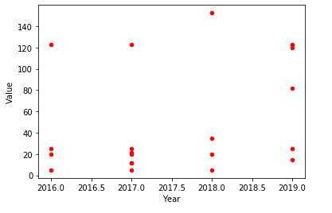

Chart 1: Scatter graph showing the breakdown of bill amounts versus the year of the bill.

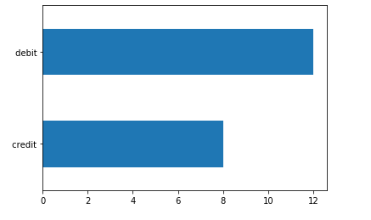

Chart 2: Bar chart showing the breakdown of bill types. Of the twenty bills in the system, twelve are debits and eight are credits.

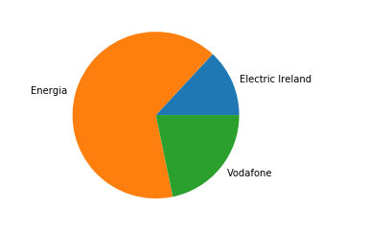

Chart 3: Pie chart showing the breakdown of companies.

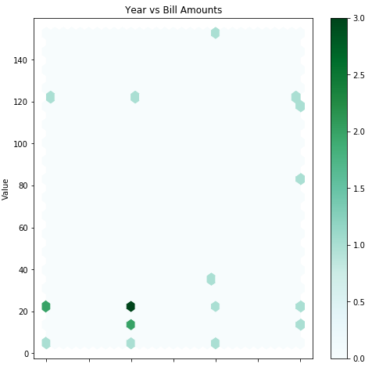

Chart 4: Hexbin plot showing the breakdown of bill amounts versus the year of the bill.