Jonathan McCaffrey

CSCI 380

November 11, 2018

Writeup for Week 13 Assignment

For my project I am building a very basic task management system which has lists and cards which can be moved to different columns. This is the type of tool used by many Agile and SCRUM projects in the software industry and building a tool like this gives me some interesting opportunities on the front-end with the drag-and-drop user interface.

I created several tables for this such as cards, comments, lists and users with an ERD as shown below. I used IntelliJ IDE to create these tables and run my SQL commands instead of PHP MyAdmin.

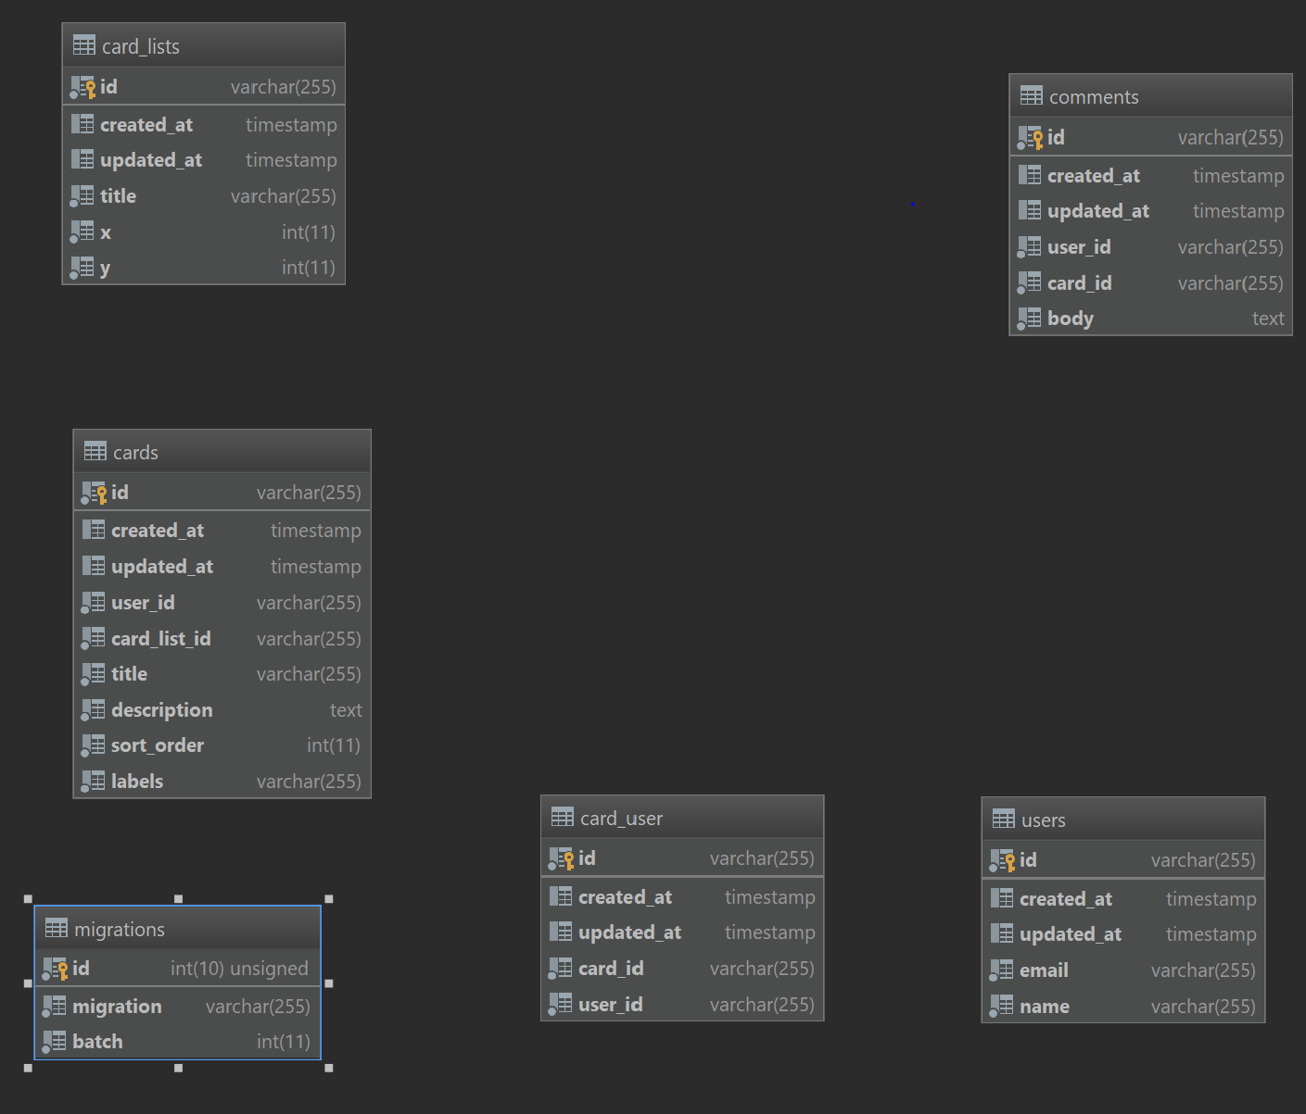



Since this is a class project, I opted to use a non-password protected login system to make it as easy as possible for you to review. The system will simply take whatever username and email combo you have and create a user if necessary, in the database.

Users can create, delete and move lists which hold cards. Lists would be categories like “Todo” and “Done”, where as cards can represent tasks like “Create Database Tables” or “Fix bug #234”. Each card can have comments on it.

Once cards are created, they can be dragged from one list to another or deleted all together.