# Calix P. Alstone IV

## Wizard 2 TopShelf13

CLASS & LEVEL PLAYER NAME

## Eladrin (Variant) Urban Bounty Hunter 300

CHARACTER NAME

Saving Throw Modifiers

Advantage against being charmed

**SAVING THROWS**

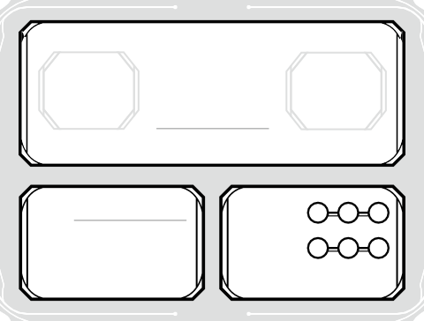

Max HP

12

**Current HP**

Temp HP

--

**HIT POINTS**

Total 2d6

SUCCESSES

FAILURES

HIT DICE

DEATH SAVES

|  |  |  |
| --- | --- | --- |
|  | +1 | Strength |
| +4 | Dexterity |
| +1 | Constitution |
| • | +5 | Intelligence |
| • | +3 | Wisdom |
|  | +1 | Charisma |

RACE

BACKGROUND

EXPERIENCE POINTS

=== ACTIONS ===



**STRENGTH**

+1

13

**DEXTERITY**

+4

18

**CONSTITUTION**

+

**INTELLIGENCE**

+3

17

**WISDOM**

+1

13

**CHARISMA**

+1

13



+4 Acrobatics DEX

+1 Insight WIS

+1 Intimidation CHA

+3 Investigation INT

+1 Medicine WIS

+3

P +3

Nature INT

Perception WIS

P +3

+1

Performance CHA

Persuasion CHA

+3 Religion INT

+4 Sleight of Hand DEX

P +6

+1

Stealth DEX

Survival WIS

**SKILLS**

Standard Actions

Attack, Cast a Spell, Dash, Disengage, Dodge, Help, Hide, Ready, Search, Use an Object, Opportunity Attack, Grapple, Shove, Improvise, Two-Weapon Fighting, Interact with an Object

=== BONUS ACTIONS ===

Bladesong • 2 / Long Rest

2 times per long rest, you can use a bonus action to start a Bladesong, which lasts for 1 minute and grants you the following benefits:

You gain a +3 bonus to your AC, your walking speed increases by 10 ft., you have advantage on Acrobatics checks, and you gain a +3 bonus to any CON saving

throw you make to maintain your concentration on a spell.



**ARMOR**

+4

**INITIATIVE**

16

**CLASS**

Immunities - Magical Sleep

**DEFENSES**

+2

**PROFICIENCY BONUS**

**ABILITY SAVE DC**

30 ft. (Walking)

**SPEED**

**INSPIRATION**

=== ARMOR ===

Light Armor

=== WEAPONS ===

Crossbow, Light, Dagger, Dart, Longbow, Longsword, Quarterstaff, Scimitar, Shortbow, Shortsword, Sling

=== TOOLS ===

Lyre, Thieves' Tools

=== LANGUAGES ===

Common, Elvish

**PROFICIENCIES & LANGUAGES**

|  |  |  |  |
| --- | --- | --- | --- |
| 1 +1 Animal Handling WIS | | | |
|  | P | +5 | Arcana INT |
| 13 |  | +1 | Athletics STR |
|  | P | +3 | Deception CHA |
|  | P | +5 | History INT |

It ends early if you are incapacitated, if you don medium or heavy armor or a shield, or if you use two hands to make an attack with a weapon. You can also dismiss the Bladesong at any time you choose (no action required).

=== SPECIAL ===

Arcane Recovery • 1 / Long Rest

Once per day when you finish a short rest, you can choose expended spell slots to recover - up to a combined level of 1, and none of the slots can be 6th level or higher.

**ACTIONS**



13

PASSIVE WISDOM (PERCEPTION)

11

PASSIVE WISDOM (INSIGHT)

13

PASSIVE INTELLIGENCE (INVESTIGATION)

Darkvision 60 ft.

**SENSES**

TM & © 2018 Wizards of the Coast LLC. ©2018 D&D Beyond | All Rights Reserved. Permission is granted to photo copy this document for personal use.

NAME

Scimitar

HIT

+6

DAMAGE/TYPE

1d6+4 Slashing

NOTES

Martial, Finesse, Light, Booming Blade: Thunder, 1d8 Thunder, Green-Flame Blade: Fire, 3 Fire

Scimitar

+6

1d6+4 Slashing

Martial, Finesse, Light, Booming Blade: Thunder, 1d8 Thunder, Green-Flame Blade: Fire, 3 Fire

Fire Bolt

+5

1d10 Fire

V/S

Unarmed Strike

+3

2 Bludgeoning

**WEAPON ATTACKS & CANTRIPS**

# Calix P. Alstone IV

## Wizard 2 TopShelf13

CLASS & LEVEL PLAYER NAME

## Eladrin (Variant) Urban Bounty Hunter 300

CHARACTER NAME

RACE

BACKGROUND

EXPERIENCE POINTS

=== WIZARD FEATURES ===

* Hit Points • PHB 113
* Proficiencies • PHB 113
* Spellcasting • PHB 114

You can cast prepared wizard spells using INT as your spellcasting modifier (Spell DC 13, Spell Attack +5) and wizard spells in your spellbook as rituals if they have the ritual tag. You can use an arcane focus as a spellcasting focus.

* Arcane Recovery • PHB 115

Once per day when you finish a short rest, you can choose expended spell slots to recover - up to a combined level of 1, and none of the slots can be 6th level or higher.

| 1 / Long Rest • Special

* Arcane Tradition • PHB 115

| Bladesinging

* Training in War and Song • SCAG

You gain proficiency with light armor, one type of one-handed melee weapon of your choice, and the Performance skill if you don’t already have it.

* Bladesong • SCAG

2 times per long rest, you can use a bonus action to start a Bladesong, which lasts for 1 minute and grants you the following benefits:

You gain a +3 bonus to your AC, your walking speed increases by 10 ft., you have advantage on Acrobatics checks, and you gain a +3 bonus to any CON saving throw you make to maintain your concentration on a spell.

It ends early if you are incapacitated, if you don medium or heavy armor or a shield, or if you use two hands to make an attack with a weapon. You can also dismiss the Bladesong at any time you choose (no action required).

| 2 / Long Rest • 1 Bonus Action

=== ELADRIN (VARIANT) RACIAL TRAITS ===

* Darkvision • BR 23

You can see in darkness (shades of gray) up to 60 ft.

* Keen Senses • BR 23

You have proficiency in the Perception skill.

* Fey Ancestry • BR 23

You have advantage on saves against being charmed, and magic can’t put you to sleep.

* Trance • BR 23

You don't need to sleep, but meditate semiconsciously for 4 hours a day. While meditating, you can dream after a fashion; such dreams are actually mental exercises that have become reflexive through years of practice. After resting in this way, you gain the same benefit that a human does from 8 hours of sleep.

* Elf Weapon Training • DMG

You have proficiency with the longsword, shortsword, shortbow, and longbow.

* Fey Step • DMG

Once per short rest, you can cast the misty step spell.



**FEATURES & TRAITS**



PP

|  |  |  |  |  |  |  |  |
| --- | --- | --- | --- | --- | --- | --- | --- |
|  | | NAME | QTY | WEIGHT | NAME | QTY | WEIGHT |
| CP | 45 | Studded Leather | 1 | 13 lb. |  |  |  |
|  |  | Scimitar | 1 | 3 lb. |  |  |  |
| SP | 26 | Scimitar | 1 | 3 lb. |  |  |  |
|  |  | Backpack | 1 | 5 lb. |  |  |  |
| EP | 0 | Spellbook | 1 | 3 lb. |  |  |  |
|  |  | Clothing, cold weather | 1 | 5 lb. |  |  |  |
| GP | 104 | gem stone 10gp | 6 | -- |  |  |  |
|  |  | Scimitar | 1 | 3 lb. |  |  |  |

|  |  |  |  |
| --- | --- | --- | --- |
| 0 | gem stone 10gp | 6 | -- |
| WEIGHT CARRIED  35 lb. |  |  |  |
| ENCUMBERED |  |  | ATTUNED MAGIC ITEMS QTY WEIGHT |
| 0 lb. |  |  |  |
| PUSH/DRAG/LIFT |  |  |  |
| 0 lb. |  |  |  |
|  |  |  | **EQUIPMENT** |

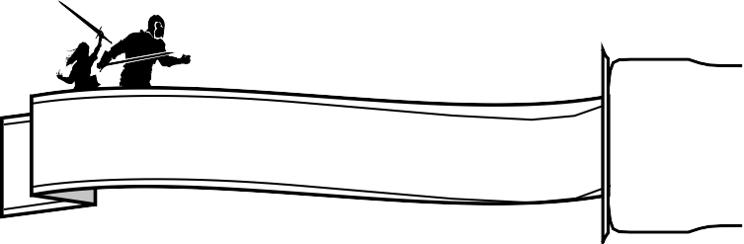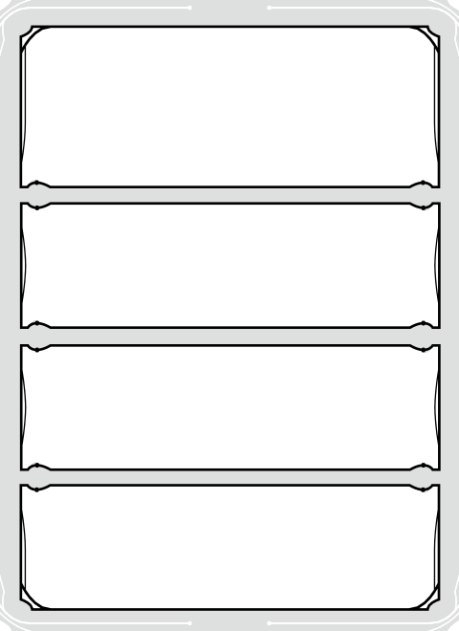

Calix P. Alstone IV

CHARACTER NAME

Male

GENDER

Lawful Neutral

ALIGNMENT

88

AGE

FAITH

Medium

SIZE

Tan/dark r

SKIN

6' 170

HEIGHT WEIGHT

Burnt Orange Short/Medium

EYES HAIR

=== Allies ===

Icarus The Familiar Owl

[https://www.dndbeyond.com/monsters/16974-owl](http://www.dndbeyond.com/monsters/16974-owl)

I am always calm, no matter what the situation. I never raise my voice or let my emotions control me.

I always have a plan for what to do

PERSONALITY TRAITS

People. I’m loyal to my friends, not to any ideals, and everyone else can take a trip down the Styx for all I

IDEALS

BONDS

Always references bounty hunting.

**CHARACTER APPEARANCE**

**ALLIES & ORGANIZATIONS**

FLAWS

**ADDITIONAL NOTES**

Alston Enterprises in Bryn Shander

**CHARACTER BACKSTORY**

## Wizard



+5

13

INT

SPELL SAVE DC

SPELLCASTING

CLASS

SPELL ATTACK BONUS

SPELLCASTING ABILITY

|  |  |  |  |  |  |  |  |  |  |
| --- | --- | --- | --- | --- | --- | --- | --- | --- | --- |
| PREP | SPELL NAME | SOURCE | SAVE/ATK | TIME | RANGE | COMP | DURATION | PAGE REF | NOTES |
|  | === CANTRIPS === | (At Will) |  |  |  |  |  |  |  |
| O | Booming Blade | Wizard | +5 | 1A | Self/5 ft. Sphere | S,M | 1 round | SCAG 142 | D: 1Rnd, 5 ft. Sphere, S/M |
| O | Fire Bolt | Wizard | +5 | 1A | 120 ft. | V,S | Instantaneous | PHB 242 | V/S |
| O | Green-Flame Blade | Wizard | +5 | 1A | Self/5 ft. Sphere | S,M | Instantaneous | SCAG 142 | 5 ft. Sphere, S/M |
|  | === 1st LEVEL === | 3 Slots OOO |  |  |  |  |  |  |  |
| O | Charm Person | Wizard | WIS 13 | 1A | 30 ft. | V,S | 1 hour | PHB 221 | D: 1h, V/S |
| O | Shield | Wizard | -- | 1R | Self | V,S | 1 round | PHB 275 | D: 1Rnd, V/S |
| O | Catapult | Wizard | DEX 13 | 1A | 60 ft. | S | Instantaneous | EE 150 | S |
| O | Absorb Elements | Wizard | -- | 1R | Self | S | 1 round | EE 150 | D: 1Rnd, S |
| O | Alarm [R] | Wizard | -- | 11m | 30 ft. | V,S,M | 8 hours | PHB 211 | D: 8h, V/S/M |
| O | Burning Hands | Wizard | DEX 13 | 1A | Self/15 ft. Cone | V,S | Instantaneous | PHB 220 | 15 ft. Cone, V/S |
| O | Color Spray | Wizard | -- | 1A | Self/15 ft. Cone | V,S,M | 1 round | PHB 222 | D: 1Rnd, 15 ft. Cone, V/S/M |
| O | Comprehend Languages [R] | Wizard | -- | 1A + 10m | Self | V,S,M | 1 hour | PHB 224 | D: 1h, V/S/M |
| O | Detect Magic [R]<C> | Wizard | -- | 1A + 10m | Self/30 ft. Sphere | V,S | Concentration, up to 10 minutes | PHB 231 | D: 10m, 30 ft. Sphere, V/S |
| O | Disguise Self | Wizard | -- | 1A | Self | V,S | 1 hour | PHB 233 | D: 1h, V/S |
| O | Earth Tremor | Wizard | DEX 13 | 1A | 10 ft. | V,S | Instantaneous | EE 155 | V/S |
| O | Expeditious Retreat <C> | Wizard | -- | 1BA | Self | V,S | Concentration, up to 10 minutes | PHB 238 | D: 10m, V/S |
| O | False Life | Wizard | -- | 1A | Self | V,S,M | 1 hour | PHB 239 | D: 1h, V/S/M |
| O | Feather Fall | Wizard | -- | 1R | 60 ft. | V,M | 1 minute | PHB 239 | D: 1m, V/M |
| O | Find Familiar [R] | Wizard | -- | 1h | 10 ft. | V,S,M | Instantaneous | PHB 240 | V/S/M |
| O | Floating Disk [R] | Wizard | -- | 1A + 10m | 30 ft. | V,S,M | 1 hour | PHB | D: 1h, V/S/M |
| O | Fog Cloud <C> | Wizard | -- | 1A | 120 ft./20 ft. Sphere | V,S | Concentration, up to 1 hour | PHB 243 | D: 1h, 20 ft. Sphere, V/S |
| O | Frost Fingers | Wizard | CON 13 | 1A | Self/15 ft. Cone | V,S | Instantaneous | IDRotF 318 | 15 ft. Cone, V/S |
| O | Grease | Wizard | DEX 13 | 1A | 60 ft./10 ft. Square | V,S,M | 1 minute | PHB 246 | D: 1m, 10 ft. Square, V/S/M |
| O | Hideous Laughter <C> | Wizard | WIS 13 | 1A | 30 ft. | V,S,M | Concentration, up to 1 minute | PHB | D: 1m, V/S/M |
| O | Ice Knife | Wizard | DEX 13 / +5 | 1A | 60 ft./5 ft. Sphere | S,M | Instantaneous | EE 157 | 5 ft. Sphere, S/M |
| O | Identify [R] | Wizard | -- | 11m | Touch | V,S,M | Instantaneous | PHB 252 | V/S/M |
| O | Illusory Script [R] | Wizard | -- | 11m | Touch | S,M | 10 days | PHB 252 | D: 10d, S/M |
| O | Jump | Wizard | -- | 1A | Touch | V,S,M | 1 minute | PHB 254 | D: 1m, V/S/M |
| O | Longstrider | Wizard | -- | 1A | Touch | V,S,M | 1 hour | PHB 256 | D: 1h, V/S/M |
| O | Mage Armor | Wizard | -- | 1A | Touch | V,S,M | 8 hours | PHB 256 | D: 8h, V/S/M |
| O | Magic Missile | Wizard | -- | 1A | 120 ft. | V,S | Instantaneous | PHB 257 | V/S |
| O | Protection from Evil and Good <C> | Wizard | -- | 1A | Touch | V,S,M | Concentration, up to 10 minutes | PHB 270 | D: 10m, V/S/M |
| O | Silent Image <C> | Wizard | -- | 1A | 60 ft./15 ft. Cube | V,S,M | Concentration, up to 10 minutes | PHB 276 | D: 10m, 15 ft. Cube, V/S/M |
| O | Sleep | Wizard | -- | 1A | 90 ft./20 ft. Sphere | V,S,M | 1 minute | PHB 276 | D: 1m, 20 ft. Sphere, V/S/M |
| O | Thunderwave | Wizard | CON 13 | 1A | Self/15 ft. Cube | V,S | Instantaneous | PHB 282 | 15 ft. Cube, V/S |
| O | Unseen Servant [R] | Wizard | -- | 1A + 10m | 60 ft. | V,S,M | 1 hour | PHB 284 | D: 1h, V/S/M |
| O | Snare | Wizard | DEX 13 | 1m | Touch | S,M | 8 hours | XGtE 165 | D: 8h, S/M |
| O | Tasha's Caustic Brew <C> | Wizard | DEX 13 | 1A | Self/30 ft. Line | V,S,M | Concentration, up to 1 minute | TCoE 115 | D: 1m, 30 ft. Line, V/S/M |
| O | Tasha’s Hideous Laughter <C> | Wizard | WIS 13 | 1A | 30 ft. | V,S,M | Concentration, up to 1 minute | PHB 280 | D: 1m, V/S/M |
| O | Tenser’s Floating Disk [R] | Wizard | -- | 1A + 10m | 30 ft. | V,S,M | 1 hour | PHB 282 | D: 1h, V/S/M |
| O | Witch Bolt <C> | Wizard | +5 | 1A | 30 ft. | V,S,M | Concentration, up to 1 minute | PHB 289 | D: 1m, V/S/M |
| O | Ray of Sickness | Wizard | CON 13 / +5 | 1A | 60 ft. | V,S | Instantaneous | PHB 271 | V/S |
| O | Chromatic Orb | Wizard | +5 | 1A | 90 ft. | V,S,M | Instantaneous | PHB 221 | V/S/M |
| O | Cause Fear <C> | Wizard | WIS 13 | 1A | 60 ft. | V | Concentration, up to 1 minute | XGtE 151 | D: 1m, V |
|  | === 2nd LEVEL === |  |  |  |  |  |  |  |  |
| O | Misty Step | Fey Step | -- | 1BA | Self | V | Instantaneous | PHB 260 | 1/SR, V |

**SPELLS**