

Windows User Instructions

Tasks

Account creation 2

Login 5

View measure results 6

Filter measure results by patient demographics 9

Filter measure results by provider characteristics 11

Change the reporting period 12

View measure parameters 14

View the patient list 16

View a single patient 22

Manually exclude patients from a patient list 24

Manage practice: Provider list 26

Add a new provider 27

Edit an existing provider 28

Logout 29

Account Creation

* Complete the installation instructions
* After rebooting your system, go to the Start Menu and find the popHealth folder. There will be two items in the folder. One is a shortcut to the popHealth login on your web browser.
* Click on the popHealth icon
* Click on the “Create new account” hyperlink

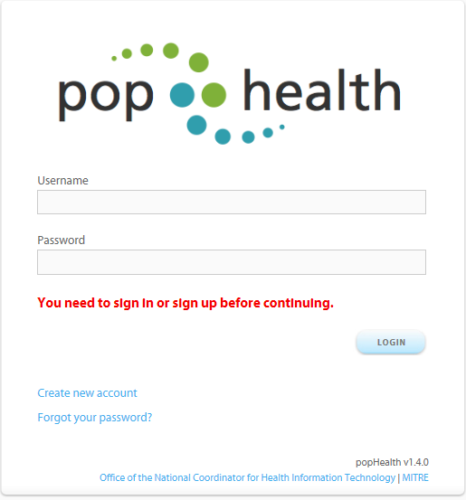

* Type your information in the blank form provided (see the example below)

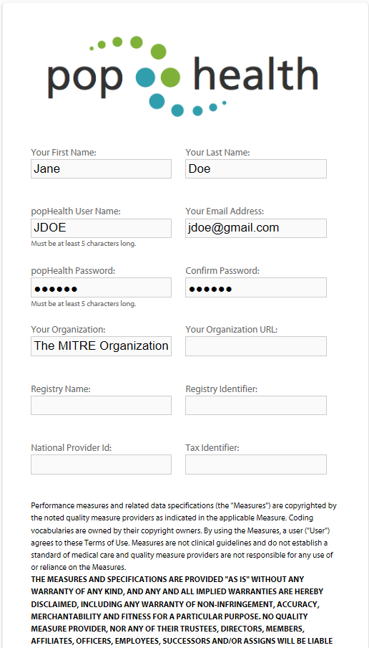

* Scroll to the bottom of the form and check box next to the “I agree to the Terms and Conditions of use” statement
* Click the on the “create” button

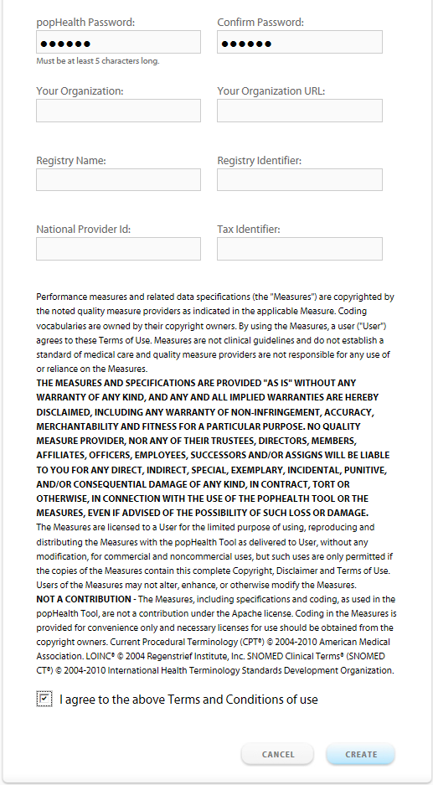

Login

* Type in your user name and password
* Click the “login” button



View Measure Results

* After you login, you will be taken to the following page

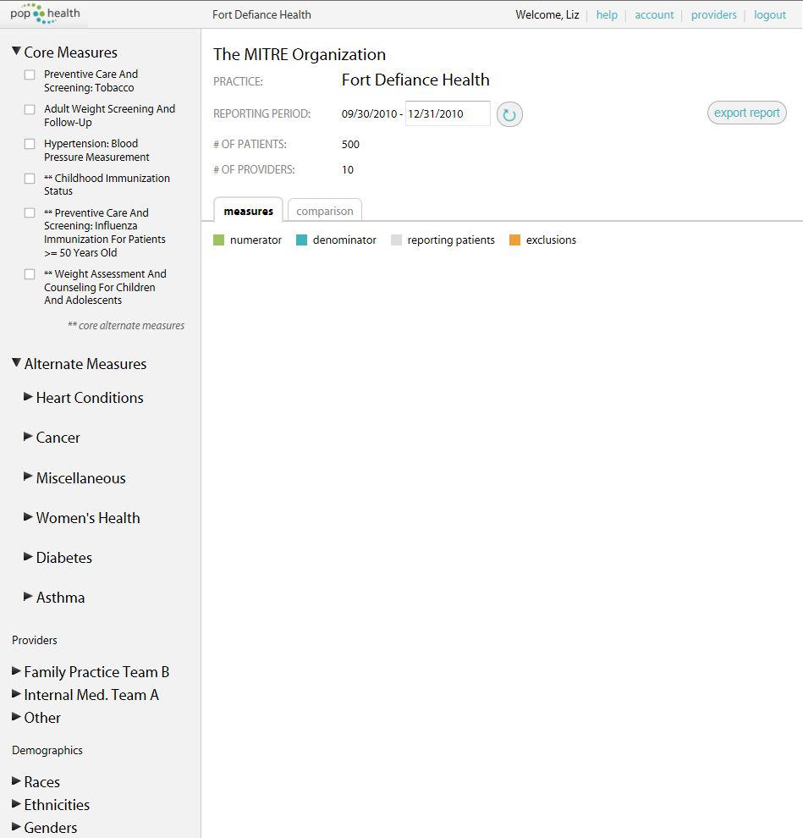

* You can select measures by checking the box next to the name of the measure
* You can expand the full list of measures by clicking the next to the measure name
* The indicates that the full list is expanded
* The measure results will populate the center of the screen. Please note that the measures will indicate that they are queued (as seen for the adult weight screening and follow-up measure) when the measure is calculating the results

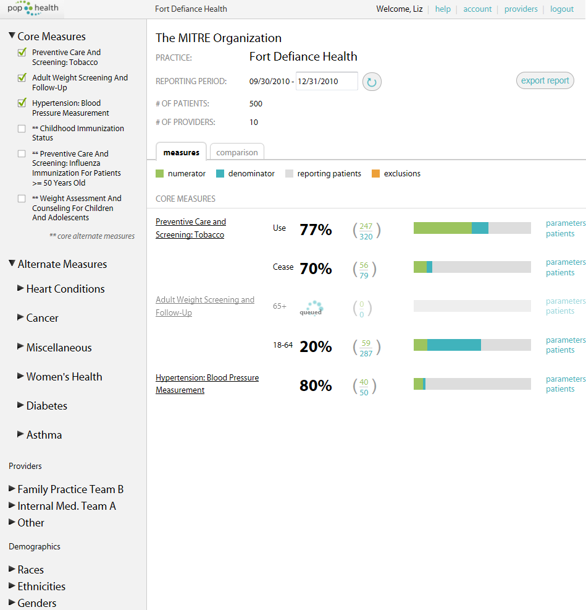

* The following screenshot is an example of how the measure results will appear in the center of the screen

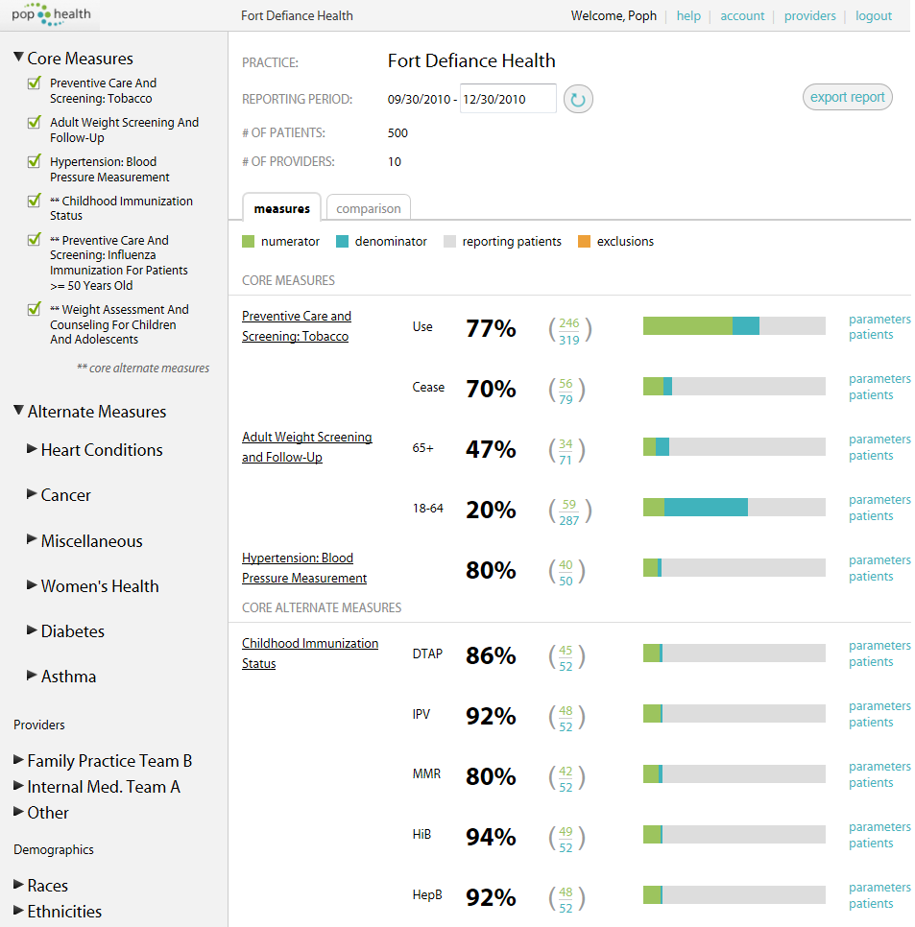

# Filter Measure Results by Patient Demographics

* Users can expand the list of demographic filters for race, ethnicity, gender and language by clicking on the next to the filter name

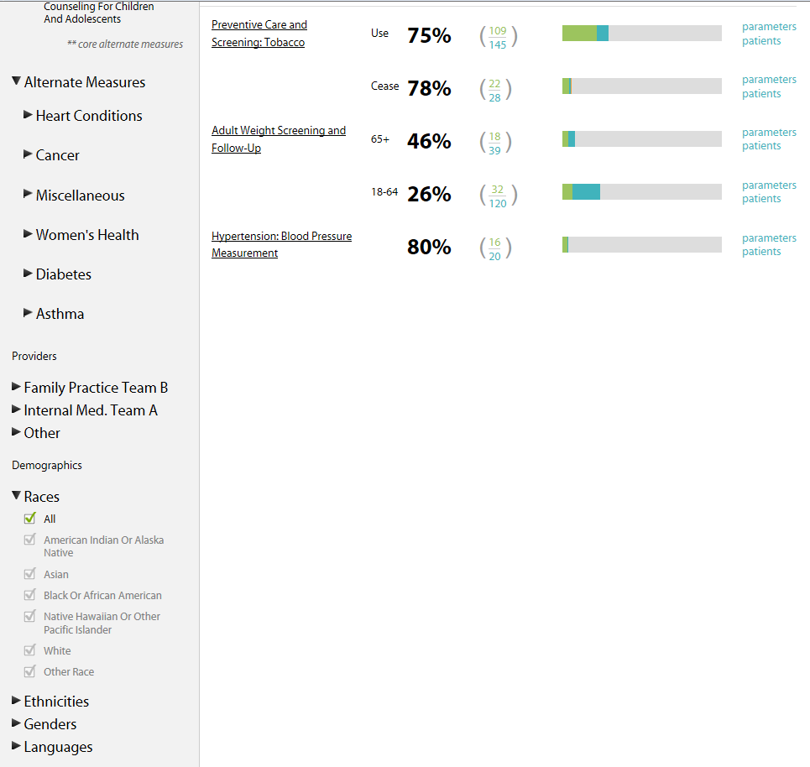

* A indicates the filter is fully expanded
* Users can check the box next to the filters they want to apply to the measure results. For example, the following filter will return results for patients of any races, who are Hispanic or Latino, male, and who speak any language.

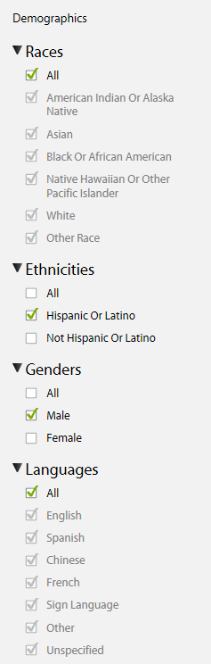

# Filter Measure Results by Provider Characteristics

* Users can select entire teams of providers or single providers by checking the boxes in the provider filters

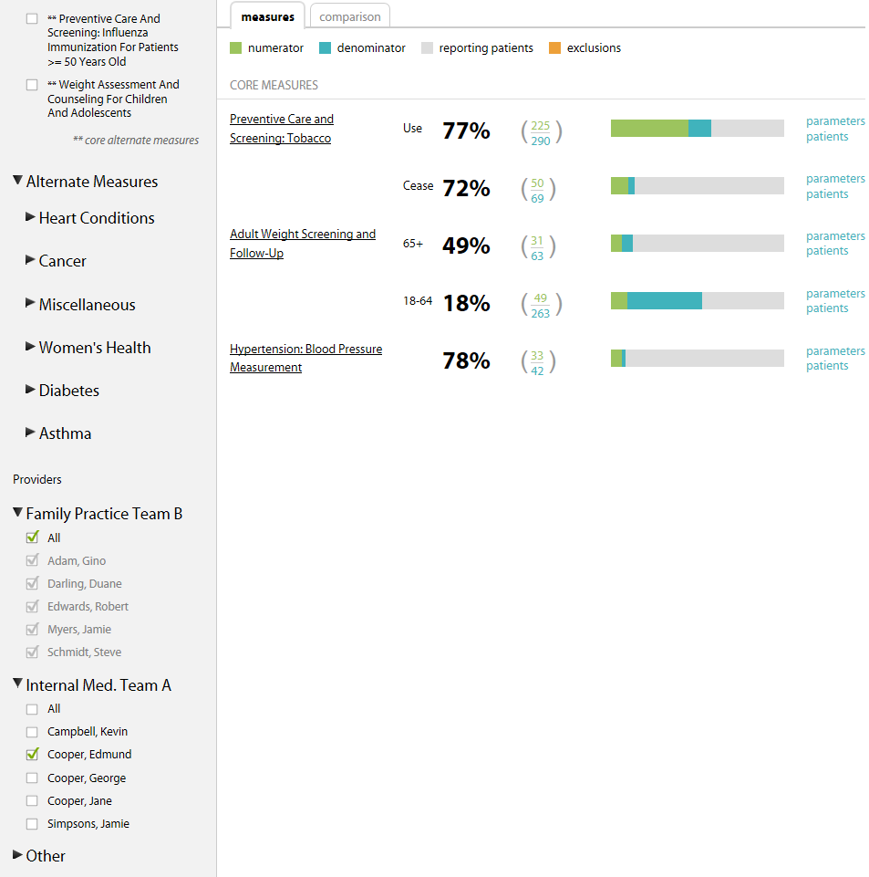

# Change the Reporting Period

* You can edit the end date of the reporting period
* Click on the text box with the old date and select a new date from the calendar

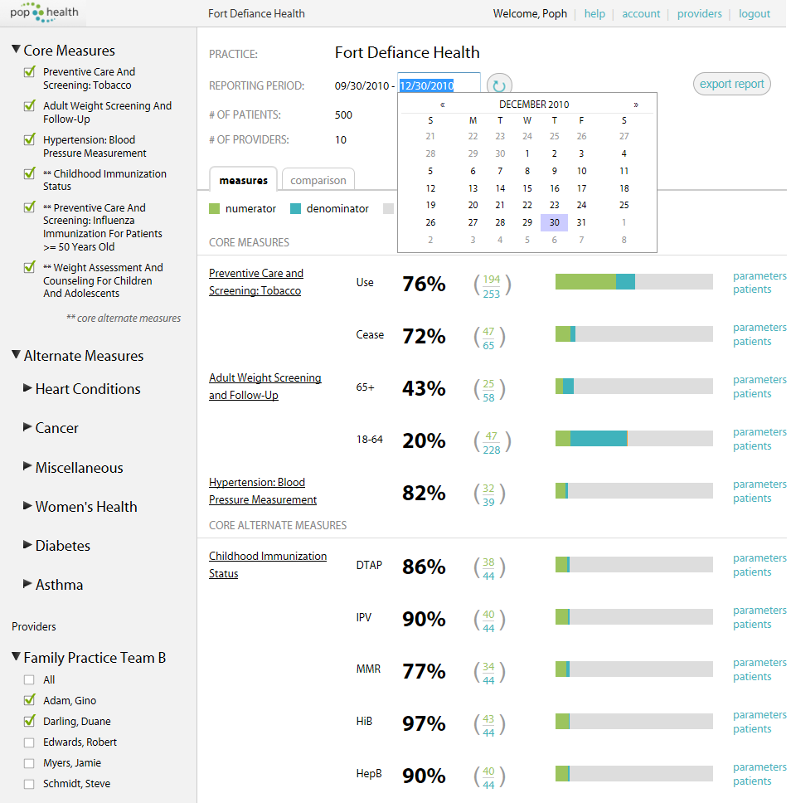

* Click on the refresh button to the right of the text box

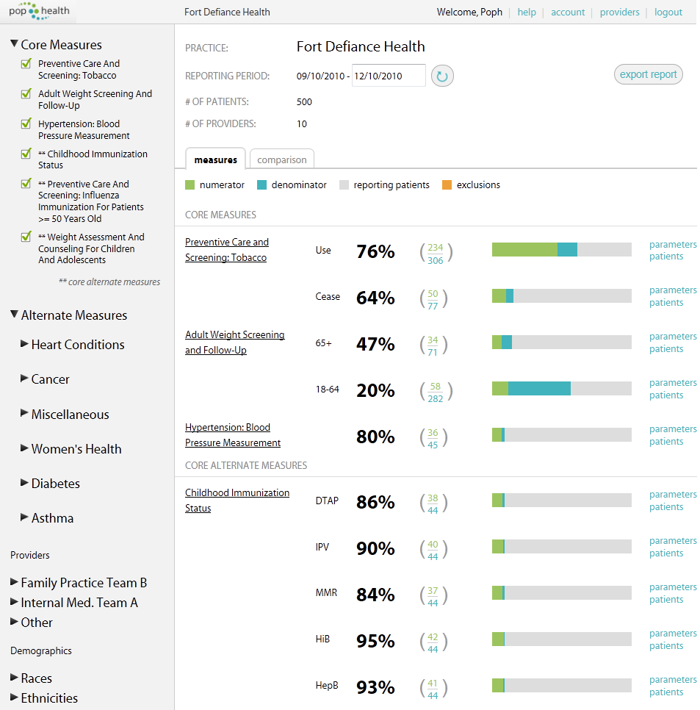

View Measure Parameters

* There are two options to view the measure parameters
* Option 1: Click on the “parameters” hyperlink from the homepage



* Option 2: Click on the name of the measure



* Then click on the “parameters” button from the measure page

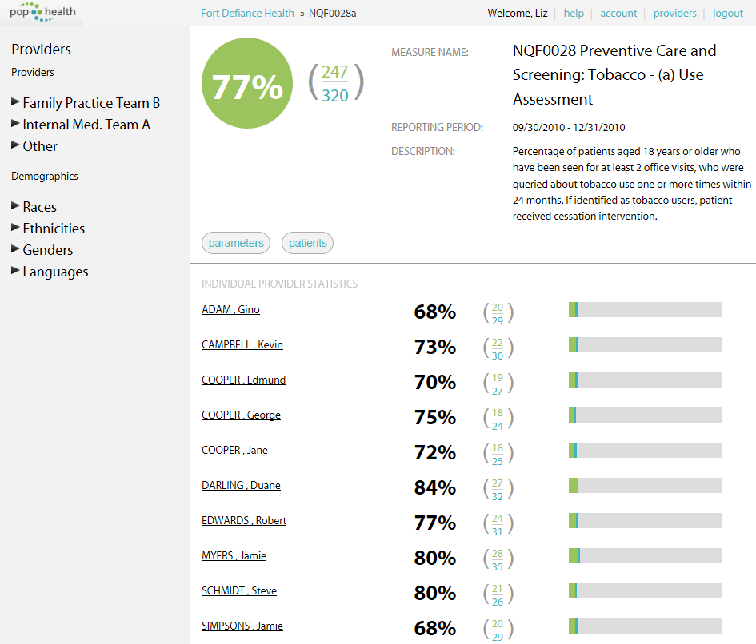

* The following screen shot is the parameter view of a measure

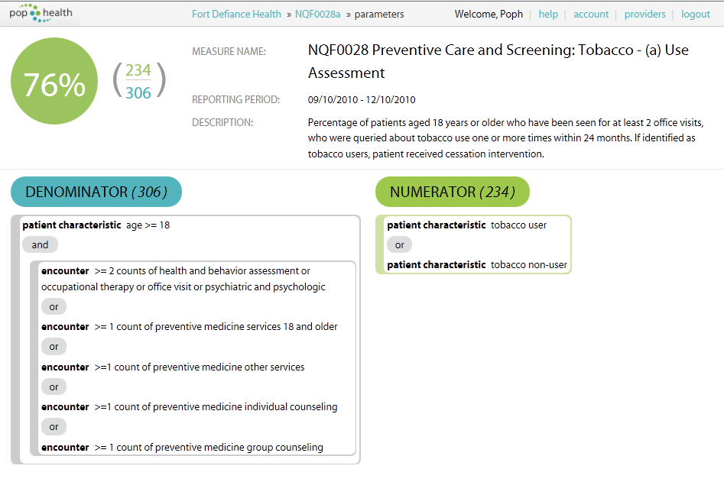

View the Patient List

* There are two options to view the patient list
* Option 1: Click on the “patients” hyperlink from the homepage.



* Option 2: Click on the name of the measure



* Then click on the “patients” button from the measure page



* Both options will take you to a list of patients for a specific measure.
* This list allows you to view all the patients that are considered in the denominator for the measure
* Users can select any of the colored blocks named: numerator, denominator, outliers or exclusions to view the list of patients for those four categories.

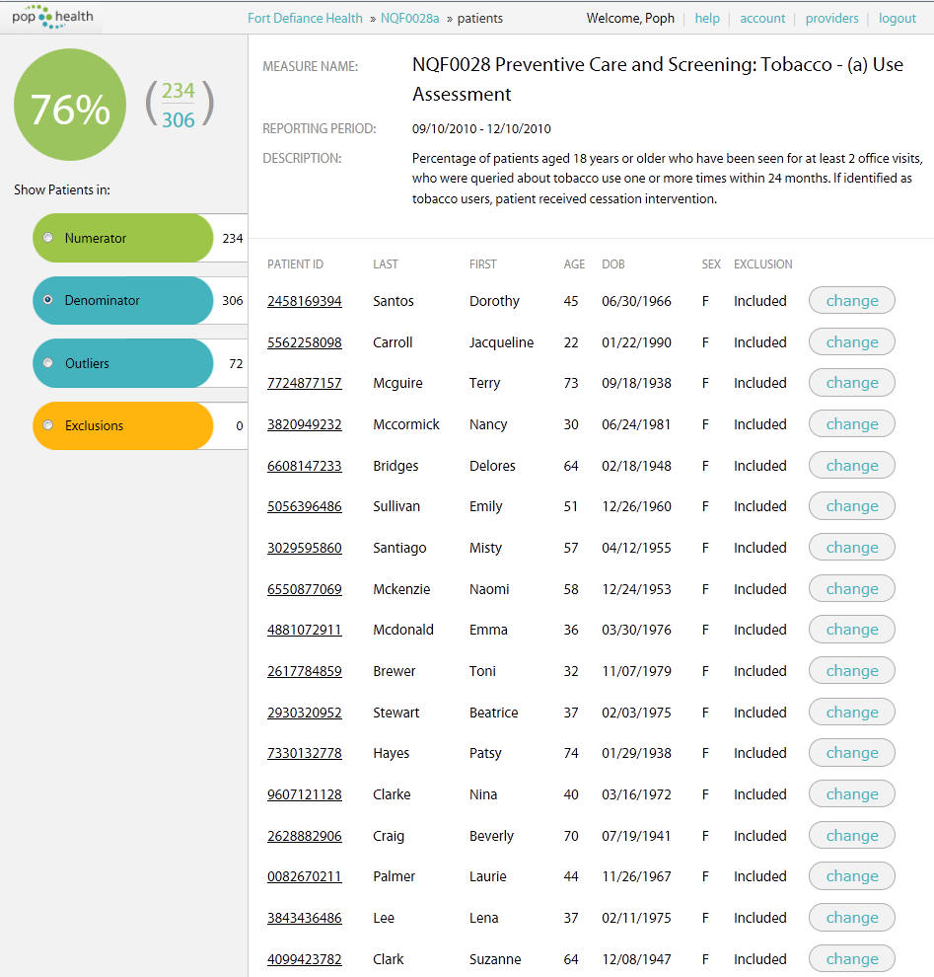

# View a Single Patient

* Users can click on the patient ID to view the information for one patient

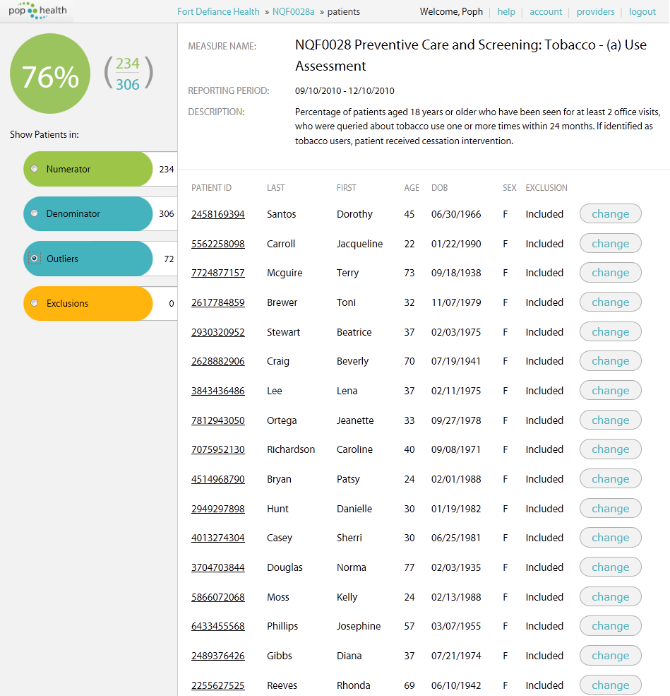

* Users can view the patient information on the “patient view” page

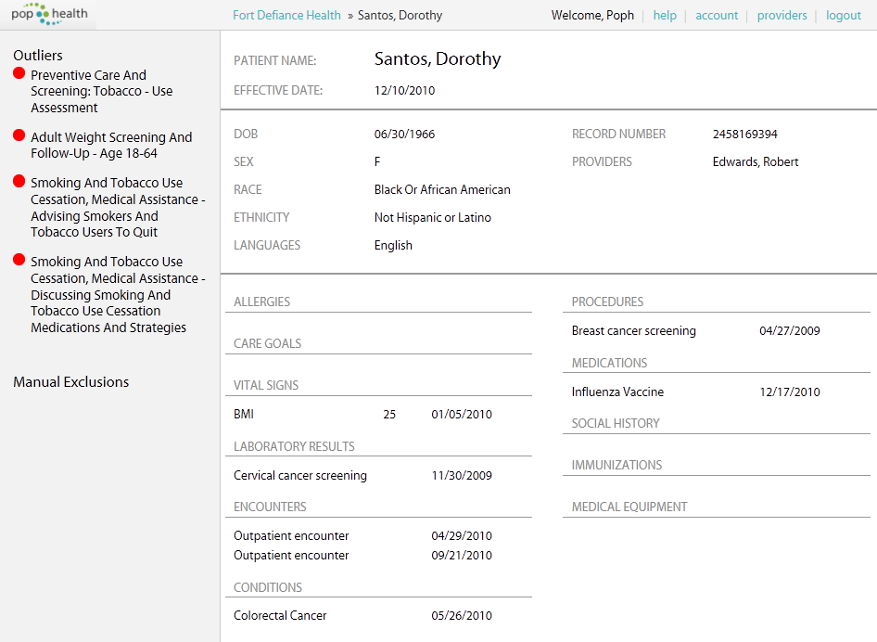

Manually Exclude Patients from a Patient List

* Select the patient list of a measure
* For example, you can view the list of patients that are considered outliers
* Click the “change” button to exclude the patient from this list



* Type in the rational for exclusion
* Click the “update” button

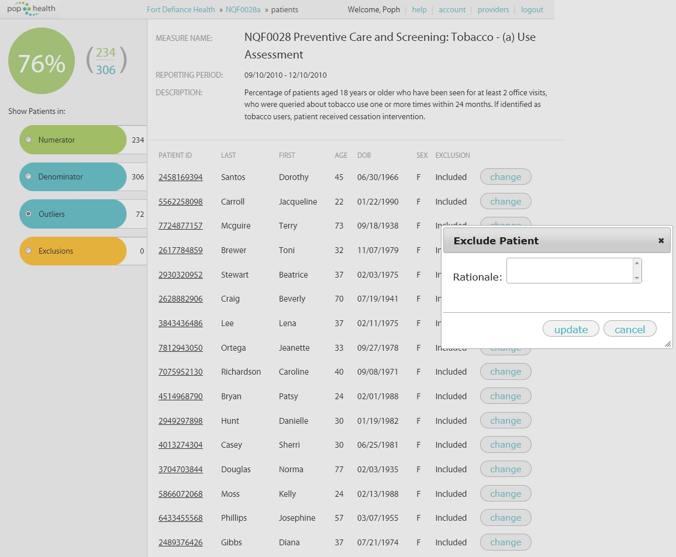

Manage Practice: Provider List

* Click the “providers” hyperlink from the tool bar at the top of any page



# Add a New Provider

* Fill in the text boxes and then click the “save” button

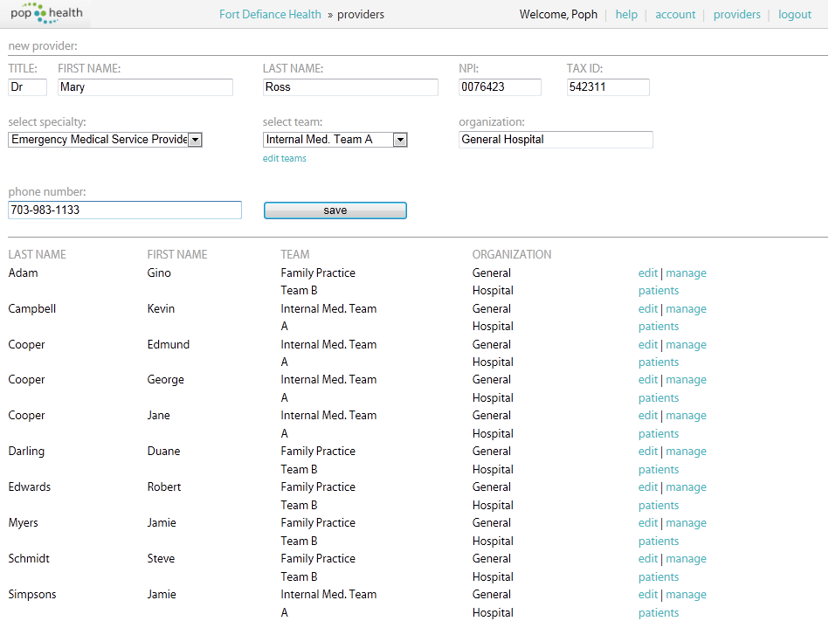

# Edit an Existing Provider

* Select the “edit” hyperlink and the provider’s information will automatically populate the text boxes
* Edit the information in the text boxes and then click the “save” button

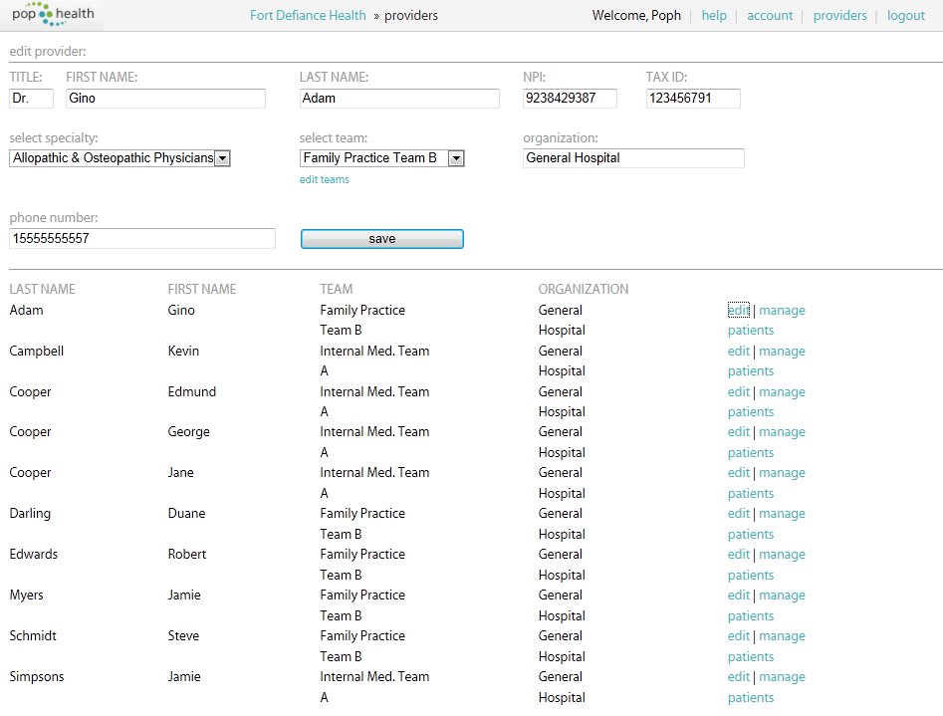

Logout of popHealth

* Click the “logout” hyperlink



* Users will see this screenshot when they are logged out

