John McCormack  
Assignment #1  
2/4/2015

1. Invert.py

The only function in this file is “inverse_image.” This function opens an image, then parses over each pixels and inverts it. The Python Image Library is used to open and the file and obtain the pixel information. The image is then saved as a new file.

The input image is:

The output image is:

1. ExtractCoins.py

There are four functions:

binarize: This function converts the image into a two color image.

expandCircle: Once a circle is identified, this function can be used to expand the circle. It starts from the point identified and searches all its neighbors for valid parts of the circle. It uses a breadth first search and appends possible circle points to a list.

findCircle: This function is used to find the circles themselves. It then calls expandCircle.

averagePixel: This function is used to smooth over stray noise areas.

The input image is:

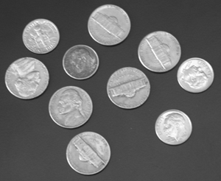

The output image is:

