John McCormack  
Assignment #3  
3/18/2015

spatialfilters.py

This program creates an "image processing" object. When the object is instantiated, it is loaded into python and padded. The methods are then able to apply filters to the image through different method calls. All but the median filter uses a private method called "__iterator" to handle applying the filter across the image. Some methods have optional parameters to call different variations of the same filter. This is mentioned in the comments of the code.

The output image for all the sets was:



The linear smoothing could be applied normally, or weighted, depending on the parameters included in the method call.

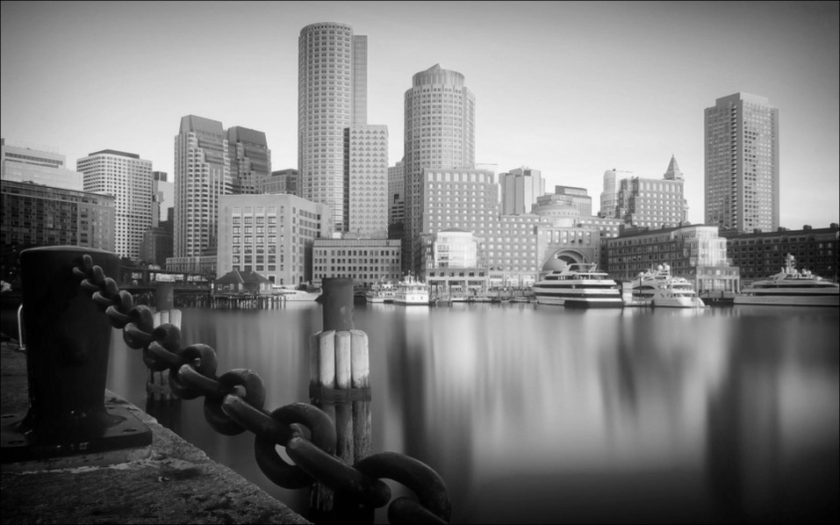

Linear

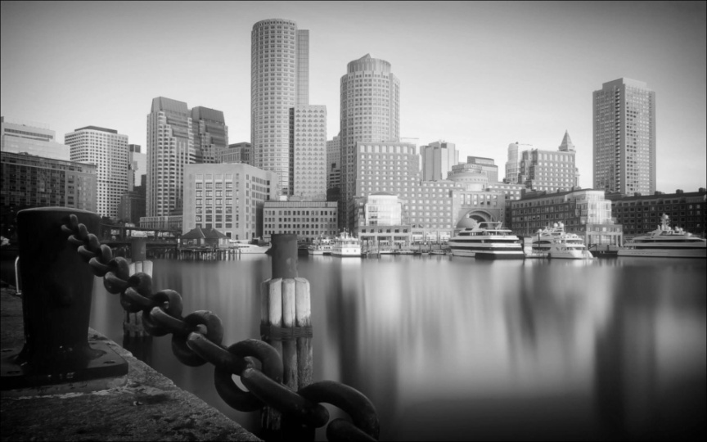

Weighted

The Gaussian blur has a similar effect. It is possible to change the variance of the gaussian to change the output.

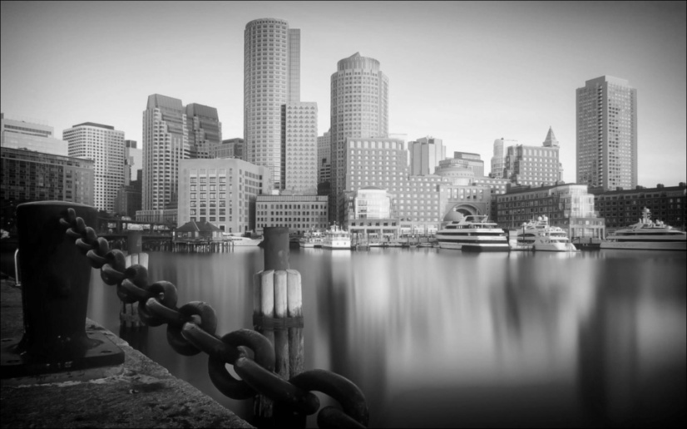

Gaussian

Using the Laplacian method call, either a laplacian or isotropic image could be generated. These images needed to be scaled in order to be seen accurately.

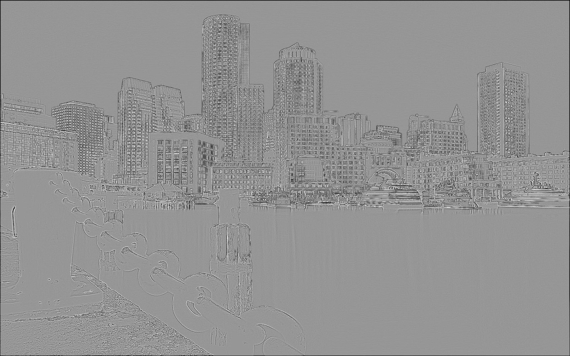

Isotropic

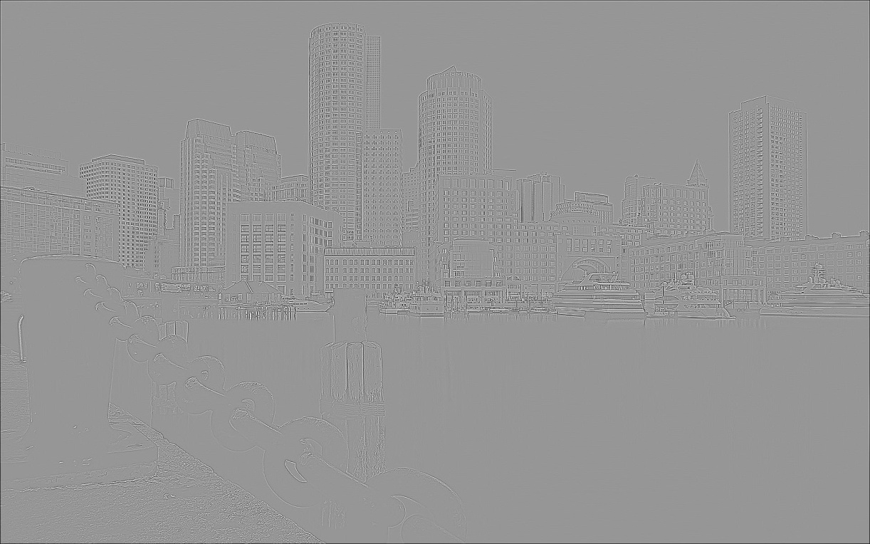

Laplacian

The first derivate or Sobel filter can then be found. This method can perform an X only, Y only, X then Y, or Y then X, depending on the parameters passed to the method. The one then the other filters require two passes through the iterator method.

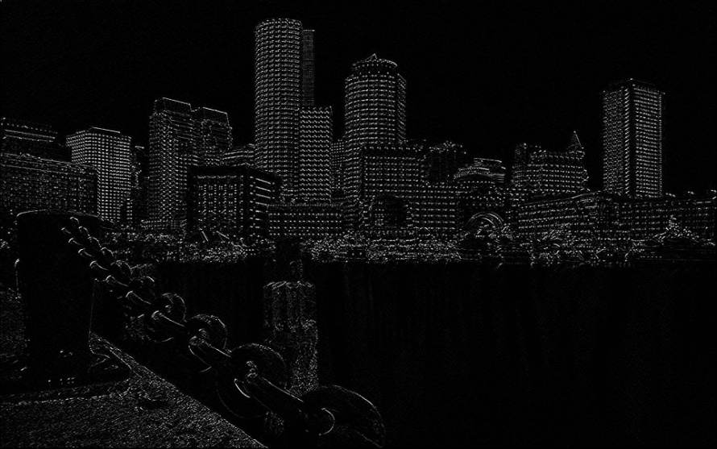

X Only

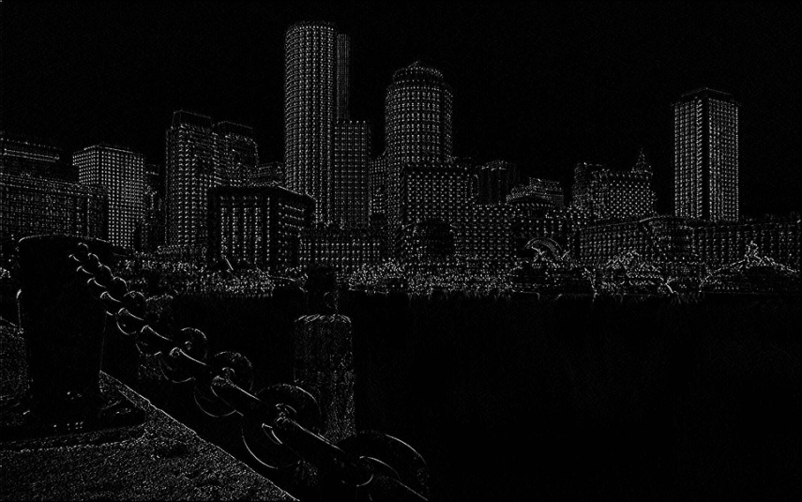

Y only

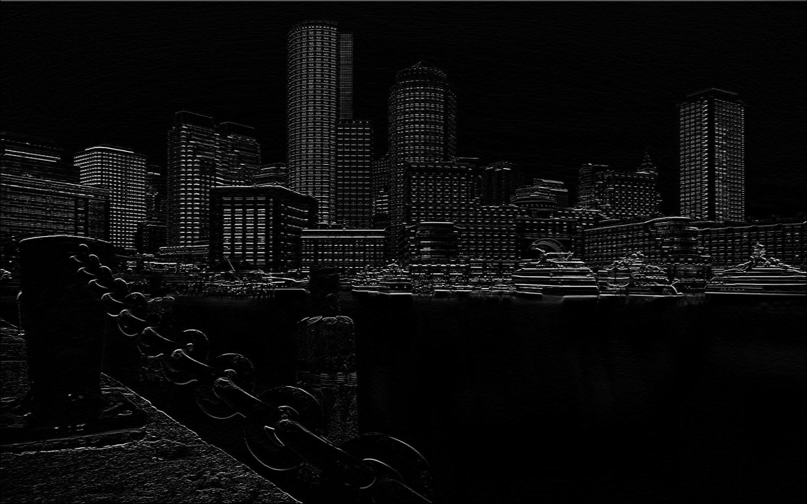

X then Y

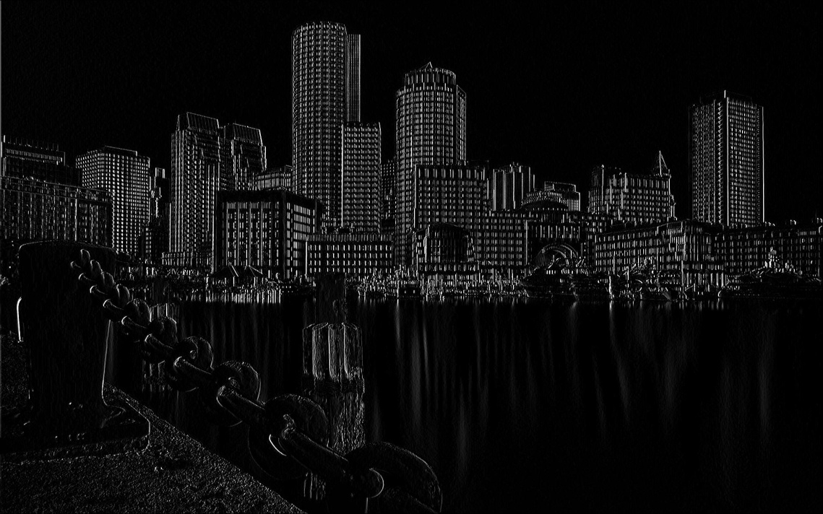

Y then X

Additional:

If you look through the included files, there is an image called "weird effect." While getting the iterator working properly with the filters I managed to create the file. If the image is zoomed into, and out of, dots appear, disappear, and rearrange. I think it may be some sort of aliasing issue. I tried it on 3 different screens and it did it every time. It's pretty neat to look at and I thought you may enjoy it. Since I use git for my assignments I saved the code that generated it.