John McCormack  
Assignment #4  
4/1/2015  
  
dft.py  
  
 This program is used to create a discrete fourier transform and the inverse. An object is instantiated with the image path and an optional name which is appended to the output file name. The two main methods are then takeDFT and takeIDFT. TakeDFT takes no parameters, takeIDFT takes a tag that can be used to indicate whether both plots, just the phase, or just the power is to be used to reconstruct the image. Two 16 x 16 pixel images were used to account for the extremely long time it takes to run a DFT. Two images that were 256 x 256 were also used. Their plots are in the folder as well, but they were initially run with an error in the phase plot. Taking all the plots took around 4 hours (about 20-30 minutes per plot). Due to time constraints it was not possible to redo the plot in time for the report.

The DFT images are shown below. The FFT Discussion follows after the images.

C:\Users\John\ImageProcessing\Homework4\BWSkull.jpgC:\Users\John\ImageProcessing\Homework4\sword.png

The two images, a skull icon and a sword icon.

C:\Users\John\ImageProcessing\Homework4\elephantdftPower.jpgC:\Users\John\ImageProcessing\Homework4\elephantPhase.jpg

The Power Plot (Left) and Phase Plot (Right) of the Skull Image

C:\Users\John\ImageProcessing\Homework4\elephantidftImagenone.jpgC:\Users\John\ImageProcessing\Homework4\BWSkull.jpg

The Original Image(Right) And the IDFT Image(Left) of the skull icon. Some color and detail were lost.

C:\Users\John\ImageProcessing\Homework4\elephantidftImagephase.jpgC:\Users\John\ImageProcessing\Homework4\elephantidftImagepower.jpg

Reconstructing the image with just the Phase (Right) and Power(Left)

C:\Users\John\ImageProcessing\Homework4\sheepdftPower.jpgC:\Users\John\ImageProcessing\Homework4\sheepPhase.jpg

The Power(Right) And Phase(Left) of the sword

C:\Users\John\ImageProcessing\Homework4\sheepidftImagenone.jpgC:\Users\John\ImageProcessing\Homework4\sword.png

The IDFT(Right) and the Original Image(Left)

C:\Users\John\ImageProcessing\Homework4\sheepidftImagephase.jpgC:\Users\John\ImageProcessing\Homework4\sheepidftImagepower.jpg

The IDFT with just the Phase(Left) and Power(Right)

C:\Users\John\ImageProcessing\Homework4\SwitchedPhase1idftImagenone.jpgC:\Users\John\ImageProcessing\Homework4\SwitchedPhase2idftImagenone.jpg

The Skull Power with Sword Phase(Right) and the reverse(Left)

Using only one of the two plots, the phase or the power, created images that were barely recognizable. However, using the two together made it possible to clearly see the original image. There was some loss, which may be due to the need to scale the images to be displayed. Also, when returning from the frequency domain, the imaginary part of the complex number needs to be cut, meaning some data is being lost. Crossing the spectrum and power plots from the two images lead to interesting results. The outline of whichever power plot was used is still able to be seen, but the finer details are completely lost with the incorrect phase.

FFT vs DFT:

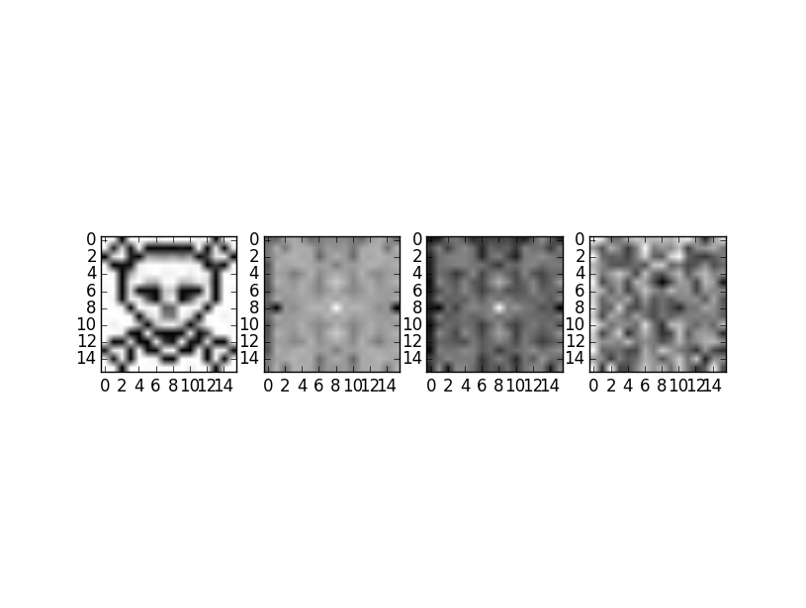

The figure above compares the FFT to the DFT. The FFT is taken from the OpenCV Documentation. The first image on the right is the original image. The next is the power spectrum from the FFT. Next to that is the power spectrum from the DFT. The image on the farthest right is the difference between them. Unfortunately, the difference showed far more error than was expected. This may indicate there is an error in my code. However, physically examining the two plots shows that there is significant similarities between the two plots. The contrast is certainly off between the two. There may be a difference in scaling that is causing the error as well. It is also possible that this particular FFT uses a different method of converting the image from the complex domain into the real domain. The speed test on the 16 x 16 image did not show much difference between the two plots. However, when the DFT Was run on a 256 x 256 image it took about 30 minutes per image to fully render. With the FFT it took around 15-30 seconds to create the image. An extremely dramatic difference in time.