7. Generate a sampled sinusoid with the following data: 1
% Class: ECE 580, Digital Signal Processing
% Assignment: Lab 1, Problem 7
% Author: Jonathan Gohl, Electrical Engineering M.S.E. Student
% University of Michigan Dearborn, Electrical and Computer Engineering
% email address: jrgohl@umich.edu
% Author: Joshua McCready, Electrical Engineering M.S.E. Student
% University of Michigan Dearborn, Electrical and Computer Engineering
% email address: jmccread@umich.edu
% June 2018; Last revision: 03-June-2018
set(groot, 'defaultAxesTickLabelInterpreter','latex'); set(groot, 'defaultLegendInterpreter','latex');

7. Generate a sampled sinusoid with the following data:
¤ Signal frequency = 0.25 kHz, ¤ Sampling frequency = 16 kHz, ¤ Inial phase = 45 degrees, ¤ Starting time = 0 sec., ¤ Amplitude = 10, ¤ Ending time = 10 msec
dT = 1/(16*1000);
t = 0:dT:10e-3;
n = 1:size(t,2);
x = 10*sin(2*pi*0.25*1000*t+pi/4);
fig = figure(1);
subplot(2,1,1)
plot(t*1000, x, 'LineWidth', 2);
ax = gca;
ax.XLabel.String = 'Time (mS)';
ax.YLabel.String = '10sin(2\pi25000t + \pi/4)';
ax.XLabel.FontSize = 14;
ax.YLabel.FontSize = 14;
title('Lab Assignment 1, Problem 7', 'FontSize', 16, 'FontWeight', 'bold');
subplot(2,1,2)
stem(n,x, 'LineWidth', 2);
ax = gca;
ax.XLabel.String = 'Sample Index (n)';
ax.XLabel.FontSize = 14;
ax.YLabel.String = '10sin(2\pi25000t + \pi/4)';
ax.YLabel.FontSize = 14;
axis([min(n), 161, -10, 10])
saveas(fig, 'Prob7', 'png');
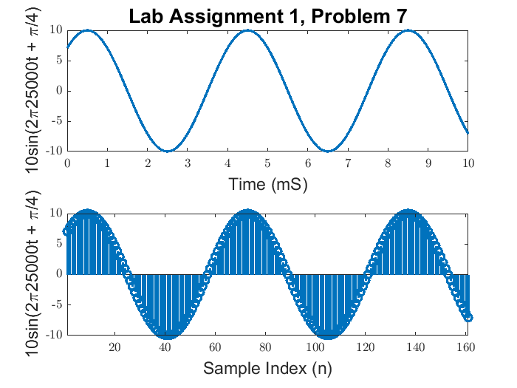
Published with MATLAB® R2017a

