Table of Contents 1
Create signals 1
Do inverse Z transforms for part a - d; 2
Filter Coeffiecent Setup 3
Part (a) x(n) = delta(n) 3
Part (b) x(n) = u(n-3) 4
Part (c) x(n) = u(n)u(-n+21) 6
Part (d) ramp(n)-ramp(n-23) 7
% Class: ECE 580, Digital Signal Processing
% Assignment: Lab Assignment 2, Problem 1
% Author: Jonathan Gohl, Electrical Engineering M.S.E. Student
% University of Michigan Dearborn, Electrical and Computer Engineering
% email address: jrgohl@umich.edu
% Author: Joshua McCready, Electrical Engineering M.S.E. Student
% University of Michigan Dearborn, Electrical and Computer Engineering
% email address: jmccread@umich.edu
% Month Year; Last revision: 21-June-2018
set(groot, 'defaultAxesTickLabelInterpreter','latex'); set(groot, 'defaultLegendInterpreter','latex');

Table of Contents
- Create Signals
- Do inverse Z transforms for part a - d;
- Filter Coeffiecent Setup
- Part (a) x(n) = delta(n)
- Part (b) x(n) = u(n-3)
- Part (c) x(n) = u(n)u(-n+23)
- Part (d) ramp(n)-ramp(n-23)
close all
clear all

Create signals
delta = @(n) n == 0; % Impulse function operating on n.
u = @(n) n >= 0; % Step starting from 0, operating on n
pulse =@(n, l) u(n) - u(n -l); %Impulse train of lenth l, starting from 0,
ramp =@(n) n.*(n>=0); %Ramp starting from 0
% Question 1
% Consider the dierence equation given as follows:
% y(n) = 0.75y(n - 1) - x(n) + 4/3 * x(n-1), n>= 0
% Find and plot x(n) and y(n) and hence find the energy of y(n) for the
% following cases

Do inverse Z transforms for part a - d;
syms z
% Part a
H = (4/3 - z)/(z-0.75); % H(Z) = Y(Z)/X(Z)
Xa = 1;
disp('y(n) part a:')
ya = iztrans(H*Xa)
% Part b
Xb = z^(-3)*z/(z-1);
disp('y(n) part b:')
yb = iztrans(H*Xb)
% Part c
Xc = z/(z-1)-z^(-22)*z/(z-1);
disp('y(n) part c:')
yc = iztrans(H*Xc)
% Part d
Xd = z/(z-1)^2-z^(-23)*z/(z-1)^2;
disp('y(n) part d:')
yd = iztrans(H*Xd)
y(n) part a:
ya =
(7*(3/4)^n)/9 - (16*kroneckerDelta(n, 0))/9
y(n) part b:
yb =
(76*kroneckerDelta(n - 1, 0))/27 + (16*kroneckerDelta(n - 2, 0))/9 - (448*(3/4)^n)/81 + (340*kroneckerDelta(n, 0))/81 + 4/3
y(n) part c:
yc =
(122925634893649*(3/4)^n)/94143178827 - (7682634256828*kroneckerDelta(n - 2, 0))/10460353203 - (1919496302740*kroneckerDelta(n - 3, 0))/3486784401 - (479486655196*kroneckerDelta(n - 4, 0))/1162261467 - (119742523636*kroneckerDelta(n - 5, 0))/387420489 - (29892584188*kroneckerDelta(n - 6, 0))/129140163 - (7458797140*kroneckerDelta(n - 7, 0))/43046721 - (1859916316*kroneckerDelta(n - 8, 0))/14348907 - (463384756*kroneckerDelta(n - 9, 0))/4782969 - (115314748*kroneckerDelta(n - 10, 0))/1594323 - (28651540*kroneckerDelta(n - 11, 0))/531441 - (7103836*kroneckerDelta(n - 12, 0))/177147 - (1756276*kroneckerDelta(n - 13, 0))/59049 - (432508*kroneckerDelta(n - 14, 0))/19683 - (105940*kroneckerDelta(n - 15, 0))/6561 - (25756*kroneckerDelta(n - 16, 0))/2187 - (6196*kroneckerDelta(n - 17, 0))/729 - (1468*kroneckerDelta(n - 18, 0))/243 - (340*kroneckerDelta(n - 19, 0))/81 - (76*kroneckerDelta(n - 20, 0))/27 - (16*kroneckerDelta(n - 21, 0))/9 - (30744484164916*kroneckerDelta(n - 1, 0))/31381059609 \\\r\n- (123019778072476*kroneckerDelta(n, 0))/94143178827
y(n) part d:
yd =
(488941006329004*kroneckerDelta(n - 1, 0))/94143178827 + (121973742752176*kroneckerDelta(n - 2, 0))/31381059609 + (30409752862420*kroneckerDelta(n - 3, 0))/10460353203 + (7575706201864*kroneckerDelta(n - 4, 0))/3486784401 + (1885403299708*kroneckerDelta(n - 5, 0))/1162261467 + (468638881504*kroneckerDelta(n - 6, 0))/387420489 + (116298785956*kroneckerDelta(n - 7, 0))/129140163 + (28802067256*kroneckerDelta(n - 8, 0))/43046721 + (7114423372*kroneckerDelta(n - 9, 0))/14348907 + (1751502352*kroneckerDelta(n - 10, 0))/4782969 + (429372532*kroneckerDelta(n - 11, 0))/1594323 + (104685928*kroneckerDelta(n - 12, 0))/531441 + (25344796*kroneckerDelta(n - 13, 0))/177147 + (6080320*kroneckerDelta(n - 14, 0))/59049 + (1441348*kroneckerDelta(n - 15, 0))/19683 + (336280*kroneckerDelta(n - 16, 0))/6561 + (76780*kroneckerDelta(n - 17, 0))/2187 + (17008*kroneckerDelta(n - 18, 0))/729 + (3604*kroneckerDelta(n - 19, 0))/243 + (712*kroneckerDelta(n - 20, 0))/81 + (124*kroneckerDelta(n - 21, 0))/27 + (16*\\\r\nkroneckerDelta(n - 22, 0))/9 - (1967688827967436*(3/4)^n)/282429536481 + (1959027655515352*kroneckerDelta(n, 0))/282429536481 + 92/3

Filter Coeffiecent Setup
Choose n such that signal length allows transient to to die off
a = [1, -0.75];
b = [-1, 4/3];

Part (a) x(n) = delta(n)
n = 0:100;
x = delta(n);
y = filter(b,a,x);
Ey = sum(y.^2) % Finite energy <-> x is absolutely summable
% Plotting
fig = figure('units','normalized','outerposition',[0 0 0.95 0.95])
subplot(2,1,1)
stem(n(1:end), x(1:end), 'LineWidth', 2);
ax = gca;
ax.YLabel.String = 'x(n) = \delta(n)';
ax.XLabel.FontSize = 14;
ax.YLabel.FontSize = 14;
title('Lab Assignment 2, Problem 1 (a): Impulse Repsonse', 'FontSize', 16, 'FontWeight', 'bold');
subplot(2,1,2)
stem(n(1:end),y(1:end), 'LineWidth', 2);
hold on;
stem(n, 4/3*0.75.^(n-1).*u(n-1)-0.75.^n);
hold off;
ax = gca;
ax.XLabel.String = 'Sample Index (n)';
ax.XLabel.FontSize = 14;
ax.YLabel.String = 'y(n)=0.75y(n-1)-x(n)+4/3x(n-1)';
ax.YLabel.FontSize = 14;
legend('Filter Result', 'Inv. Z Transform Result');
%axis([min(n), max(n), -10, 10])
saveas(fig, 'Prob1a', 'png');
Ey =
1.7778
fig =
Figure (1) with properties:
Number: 1
Name: ''
Color: [0.9400 0.9400 0.9400]
Position: [0.0047 0.0083 0.9406 0.9065]
Units: 'normalized'
Use GET to show all properties
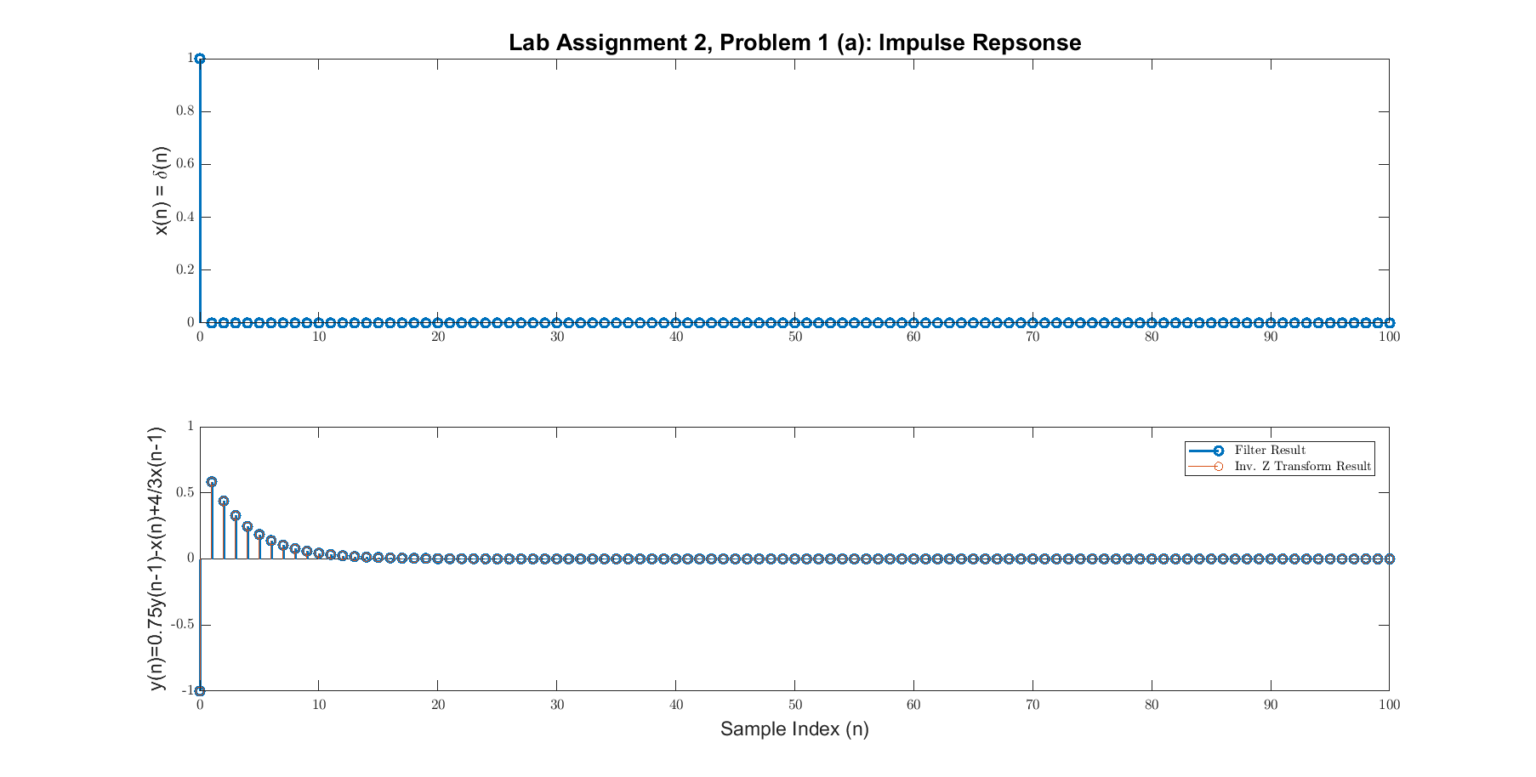

Part (b) x(n) = u(n-3)
n = 0:100;
x = u(n-3);
y = filter(b,a,x);
Ey = sum(y.^2); % infinite energy <-> x is NOT absolutely summable
disp('In part b, x(n) is infinite duration and not absolutely summable, it follows that y(n) is a power signal');
% Plotting
fig = figure('units','normalized','outerposition',[0 0 0.95 0.95])
subplot(2,1,1)
stem(n(1:end), x(1:end), 'LineWidth', 2);
ax = gca;
ax.YLabel.String = 'x(n)=u(n-3)';
ax.XLabel.FontSize = 14;
ax.YLabel.FontSize = 14;
title('Lab Assignment 2, Problem 1 (b): Shifted Step Repsonse', 'FontSize', 16, 'FontWeight', 'bold');
subplot(2,1,2)
stem(n(1:end),y(1:end), 'LineWidth', 2);
hold on;
%stem(n, (1.33333 - 2.33333*(0.75).^(n-3)).*u(n-3));
stem(n, u(n-3).*(4/3-1.75*0.75.^(n-1-3))) ;
hold off;
ax = gca;
ax.XLabel.String = 'Sample Index (n)';
ax.XLabel.FontSize = 14;
ax.YLabel.String = 'y(n)=0.75y(n-1)-x(n)+4/3x(n-1)';
ax.YLabel.FontSize = 14;
legend('Filter Result', 'Inv. Z Transform Result');
%axis([min(n), max(n), -10, 10])
saveas(fig, 'Prob1b', 'png');
In part b, x(n) is infinite duration and not absolutely summable, it follows that y(n) is a power signal
fig =
Figure (2) with properties:
Number: 2
Name: ''
Color: [0.9400 0.9400 0.9400]
Position: [0.0047 0.0083 0.9406 0.9065]
Units: 'normalized'
Use GET to show all properties
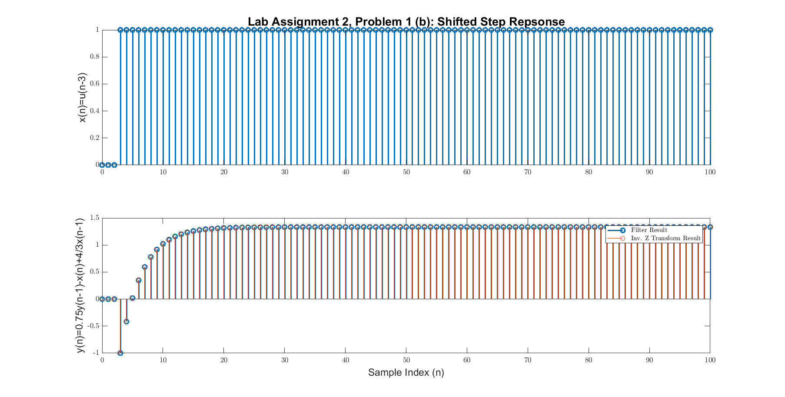

Part (c) x(n) = u(n)u(-n+21)
n = 0:100;
x = u(n).*u(-n+21);
y = filter(b,a,x);
Ey = sum(y.^2) % finite energy <-> x is absolutely summable
% Plotting
fig = figure('units','normalized','outerposition',[0 0 0.95 0.95])
subplot(2,1,1)
stem(n(1:end), x(1:end), 'LineWidth', 2);
ax = gca;
ax.YLabel.String = 'x(n)=u(n)u(-n+21)';
ax.XLabel.FontSize = 14;
ax.YLabel.FontSize = 14;
title('Lab Assignment 2, Problem 1 (c): Response to input', 'FontSize', 16, 'FontWeight', 'bold');
subplot(2,1,2)
stem(n(1:end),y(1:end), 'LineWidth', 2);
hold on;
stem(n, u(n).*(4/3-1.75*0.75.^(n-1))- u(n-22).*(4/3-1.75*0.75.^(n-1-22)));
hold off;
ax = gca;
legend('Filter Result', 'Inv. Z Transform Result');
ax.XLabel.String = 'Sample Index (n)';
ax.XLabel.FontSize = 14;
ax.YLabel.String = 'y(n)=0.75y(n-1)-x(n)+4/3x(n-1)';
ax.YLabel.FontSize = 14;
%axis([min(n), max(n), -10, 10])
saveas(fig, 'Prob1c', 'png');
Ey =
39.1111
fig =
Figure (3) with properties:
Number: 3
Name: ''
Color: [0.9400 0.9400 0.9400]
Position: [0.0047 0.0083 0.9406 0.9065]
Units: 'normalized'
Use GET to show all properties
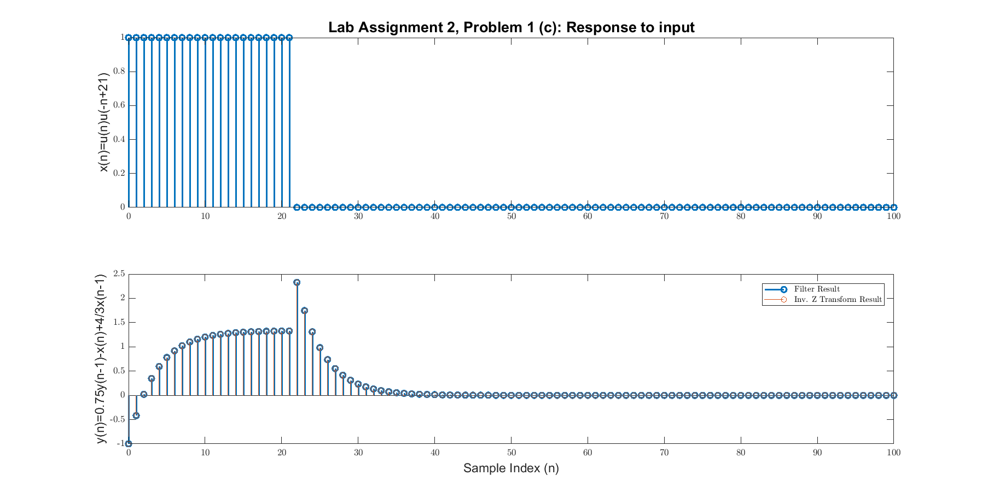

Part (d) ramp(n)-ramp(n-23)
n = 0:200;
x = ramp(n)-ramp(n-23);
y = filter(b,a,x);
Ey = sum(y.^2); % Infinite energy <-> x is NOT absolutely summable
disp('In part d, x(n) is infinite duration and not absolutely summable, it follows that y(n) is a power signal');
% Plotting
fig = figure('units','normalized','outerposition',[0 0 0.95 0.95])
subplot(2,1,1)
stem(n(1:end), x(1:end), 'LineWidth', 2);
ax = gca;
ax.YLabel.String = 'x(n)=r(n)-r(n-23)';
ax.XLabel.FontSize = 14;
ax.YLabel.FontSize = 14;
title('Lab Assignment 2, Problem 1 (d): Response to input', 'FontSize', 16, 'FontWeight', 'bold');
subplot(2,1,2)
stem(n(1:end),y(1:end), 'LineWidth', 2);
hold on;
stem(n, (4/3*(n-1)-8+7*(0.75).^(n-1)).*u(n-1)...
-(4/3*(n-24)-8+7*(0.75).^(n-24)).*u(n-24));
hold off;
ax = gca;
ax.XLabel.String = 'Sample Index (n)';
ax.XLabel.FontSize = 14;
ax.YLabel.String = 'y(n)=0.75y(n-1)-x(n)+4/3x(n-1)';
ax.YLabel.FontSize = 14;
%axis([min(n), max(n), -10, 10])
saveas(fig, 'Prob1d', 'png');
In part d, x(n) is infinite duration and not absolutely summable, it follows that y(n) is a power signal
fig =
Figure (4) with properties:
Number: 4
Name: ''
Color: [0.9400 0.9400 0.9400]
Position: [0.0047 0.0083 0.9406 0.9065]
Units: 'normalized'
Use GET to show all properties
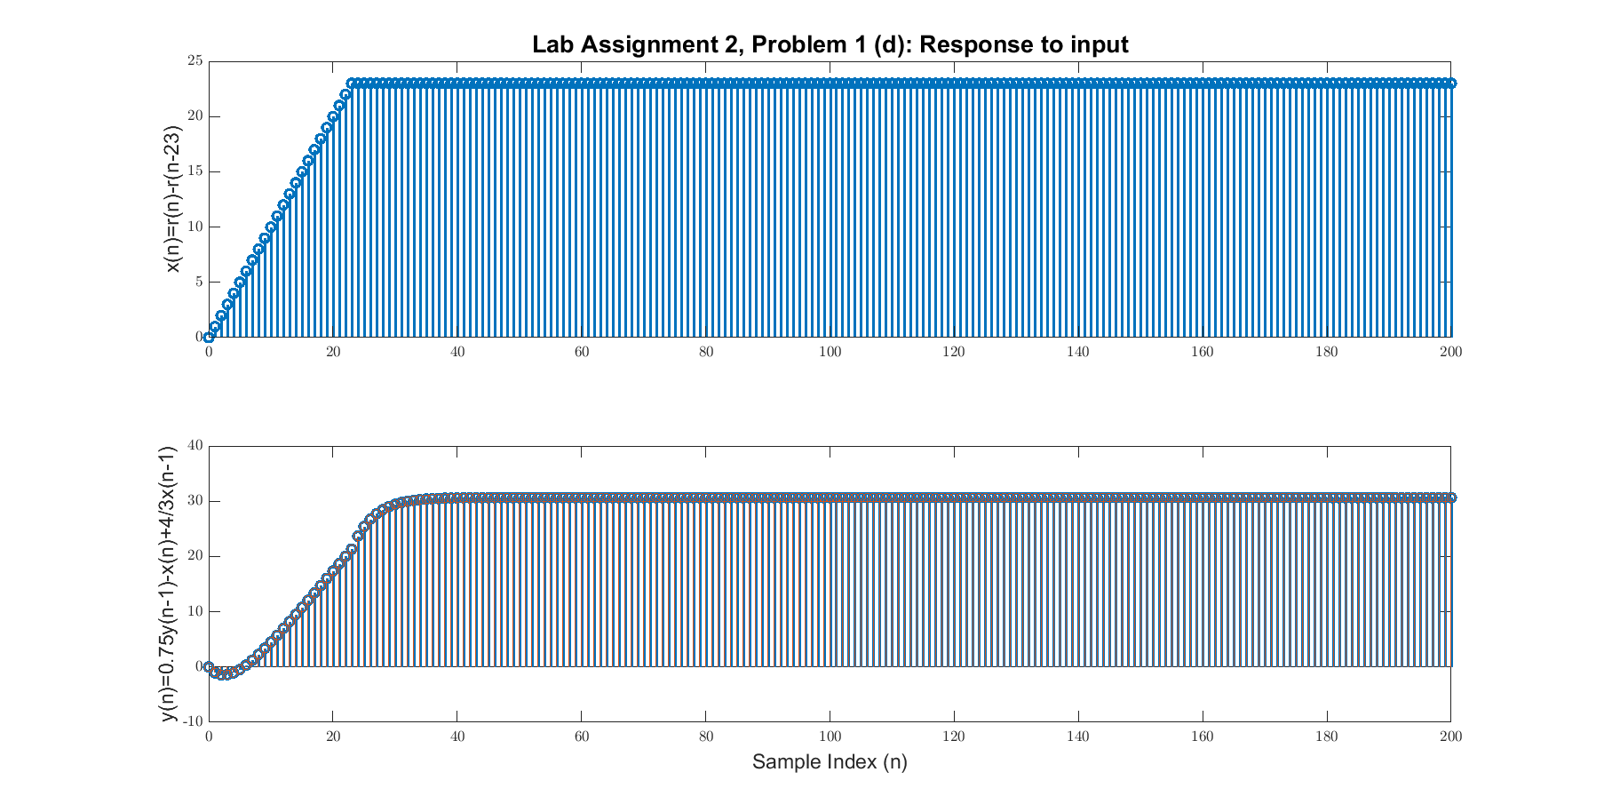
Published with MATLAB® R2017a

