Table of Contents 1
Filter Coeffiecent Setup 1
Create signals 1
Part (a) Create Block Diagram 2
Part (b) 2
Part (c) unit step response 3
Part d 5
Part d. Print out all the computed energies 6
% Class: ECE 580, Digital Signal Processing
% Assignment: Lab Assignment 2, Problem 3
% Author: Jonathan Gohl, Electrical Engineering M.S.E. Student
% University of Michigan Dearborn, Electrical and Computer Engineering
% email address: jrgohl@umich.edu
% Author: Joshua McCready, Electrical Engineering M.S.E. Student
% University of Michigan Dearborn, Electrical and Computer Engineering
% email address: jmccread@umich.edu
% Month Year; Last revision: 21-June-2018
close all
clear all
% Problem 3:
% y(n) = 0.75y(n-2)+x(n)+2x(n-1)-x(n-2)

Table of Contents
- Create Signals
- Filter Coeffiecent Setup
- Part (a) Block Diagram
- Part (b) Impulse Response
- Part (c) Step Response
- Part (d) Convulved Pulse Response
- Part (e) Energy of Signals

Filter Coeffiecent Setup
n = 0:100; % Choose n such that signal length allows transient to to die off
a = [1 0 -0.75];
b = [1, 2, -1];

Create signals
delta = @(n) n == 0; % Impulse function operating on n.
u = @(n) n >= 0; % Step starting from 0, operating on n
pulse =@(n, l) u(n) - u(n -l); %Impulse train of lenth l, starting from 0,
ramp =@(n) n.*(n>=0); %Ramp starting from 0

Part (a) Create Block Diagram
%print -dpng -block_diagram block_diagram.png
syms z

Part (b)
Y(Z)*(1 -0.75z^-2) = X(Z)(1 + 2z^-1 -z^-2) Y(Z)(z^2 - 0.75) = X(Z)(z^2+2z-1)
H = (z^2+2*z-1)/(z^2-0.75);
Delta = 1;
Y_b = Delta*H;
Y_b = partfrac(Y_b, z);
y_b_n = iztrans(Y_b)
%simplify(y_b_n, n)
disp('The response is called the impulse response.');
x = delta(n);
y = filter(b,a,x);
Ey_b = sum(y.^2)
y_analytic = 4/3*delta(n) + (1-1/(4*3^.5)).*sqrt(3/4).^(n-1)...
+(1+1/(4*3^.5)).*(-sqrt(3/4)).^(n-1);
%Ey_a = sum(y.^2); % Finite energy <-> x is absolutely summable
fig = figure('units','normalized','outerposition',[0 0 0.95 0.95])
subplot(2,1,1)
stem(n(1:end), x(1:end), 'LineWidth', 2);
ax = gca;
ax.YLabel.String = 'x(n)=\delta(n)';
ax.XLabel.FontSize = 14;
ax.YLabel.FontSize = 14;
title('Lab Assignment 2, Problem 3 (b): Impulse Response', 'FontSize', 16, 'FontWeight', 'bold');
subplot(2,1,2)
stem(n(1:end),y(1:end), 'LineWidth', 2);
hold on;
stem(n,y_analytic)
hold off;
ax = gca;
legend('impz', 'analytic');
ax.XLabel.String = 'Sample Index (n)';
ax.XLabel.FontSize = 14;
ax.YLabel.String = 'y(n)';
ax.YLabel.FontSize = 14;
%axis([min(n), max(n), -10, 10])
saveas(fig, 'Prob3b', 'png');
y_b_n =
(4*kroneckerDelta(n, 0))/3 + (3^(1/2)*(4*3^(1/2) - 1)*(3^(1/2)/2)^(n - 1))/12 + (3^(1/2)*(4*3^(1/2) + 1)*(-3^(1/2)/2)^(n - 1))/12
The response is called the impulse response.
Ey_b =
10.2857
fig =
Figure (1) with properties:
Number: 1
Name: ''
Color: [0.9400 0.9400 0.9400]
Position: [0.0047 0.0083 0.9406 0.9065]
Units: 'normalized'
Use GET to show all properties
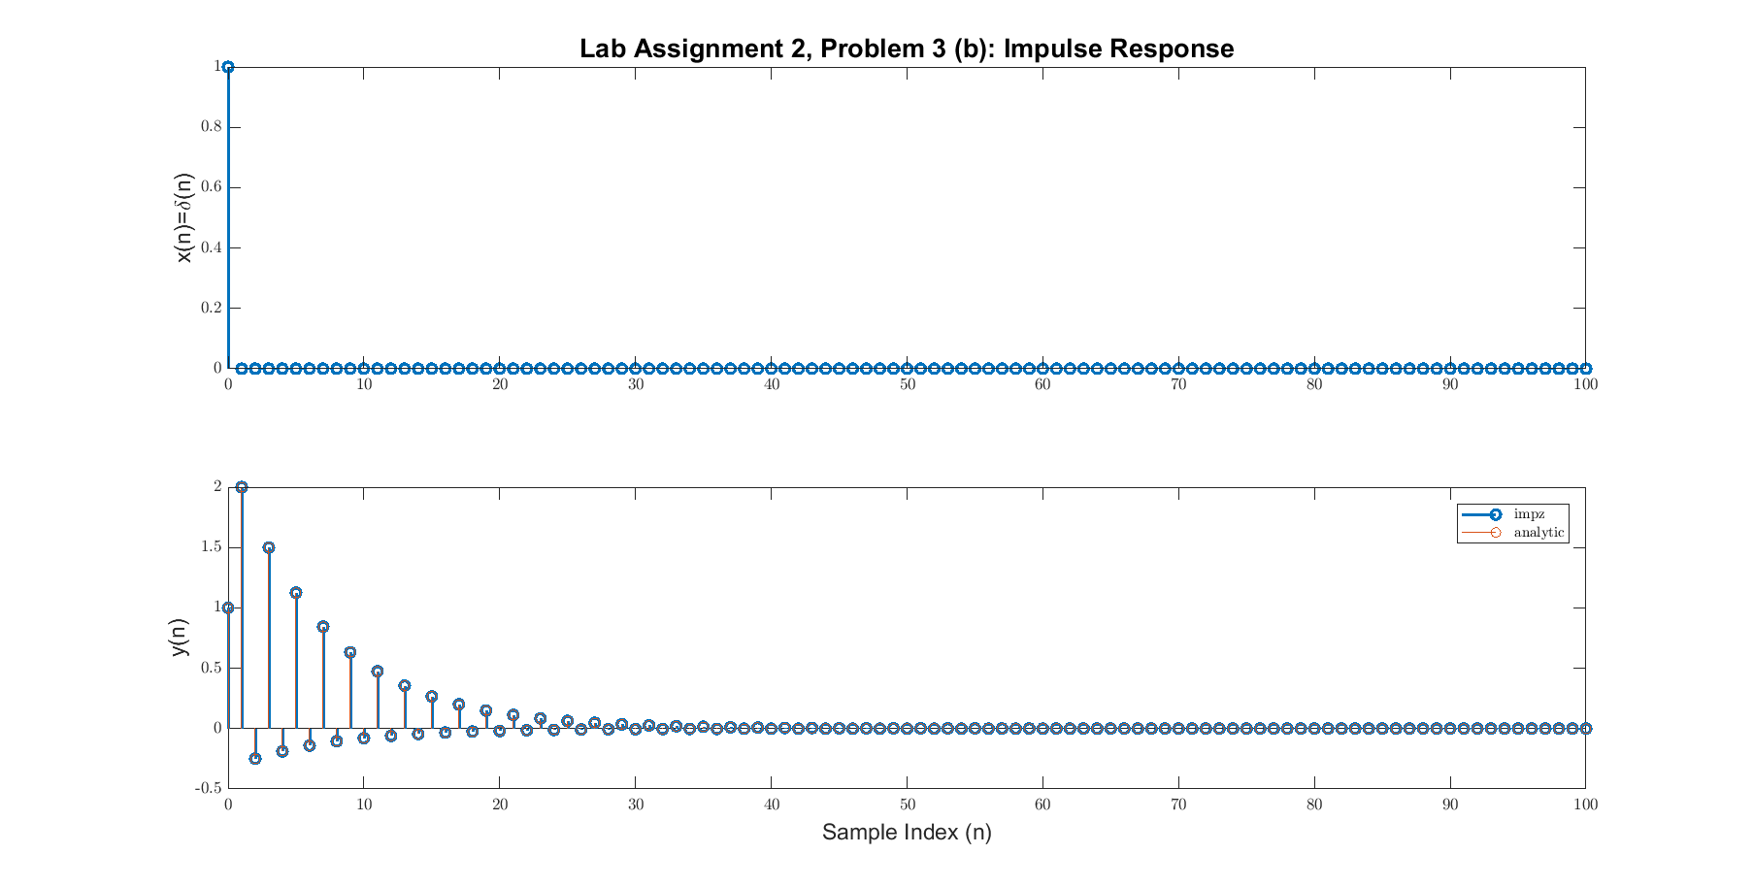

Part (c) unit step response
Step = z/(z-1);
Y_c = Step*H;
Y_c = partfrac(Y_c, z);
y_c_n = iztrans(Y_c)
x = u(n);
y = filter(b,a,x);
Ey_c = sum(y.^2);
y_analytic = 8 - ((5/2+ 7*sqrt(3)/4)*sqrt(3/4).^(n-1) + (5/2 -7*sqrt(3)/4)*(-sqrt(3/4)).^(n-1));
%Ey_a = sum(y.^2); % Finite energy <-> x is absolutely summable
fig = figure('units','normalized','outerposition',[0 0 0.95 0.95])
subplot(2,1,1)
stem(n, x, 'LineWidth', 2);
ax = gca;
ax.YLabel.String = 'x(n)= u(n)';
ax.XLabel.FontSize = 14;
ax.YLabel.FontSize = 14;
title('Lab Assignment 2, Problem 3 (c): Step Response', 'FontSize', 16, 'FontWeight', 'bold');
subplot(2,1,2)
stem(n(1:end),y(1:end), 'LineWidth', 2);
hold on;
stem(n,y_analytic)
hold off;
ax = gca;
legend('impz', 'analytic');
ax.XLabel.String = 'Sample Index (n)';
ax.XLabel.FontSize = 14;
ax.YLabel.String = 'y(n)';
ax.YLabel.FontSize = 14;
%axis([min(n), max(n), -10, 10])
saveas(fig, 'Prob3c', 'png');
y_c_n =
8 - (3^(1/2)*(10*3^(1/2) + 21)*(3^(1/2)/2)^(n - 1))/12 - (3^(1/2)*(10*3^(1/2) - 21)*(-3^(1/2)/2)^(n - 1))/12
fig =
Figure (2) with properties:
Number: 2
Name: ''
Color: [0.9400 0.9400 0.9400]
Position: [0.0047 0.0083 0.9406 0.9065]
Units: 'normalized'
Use GET to show all properties
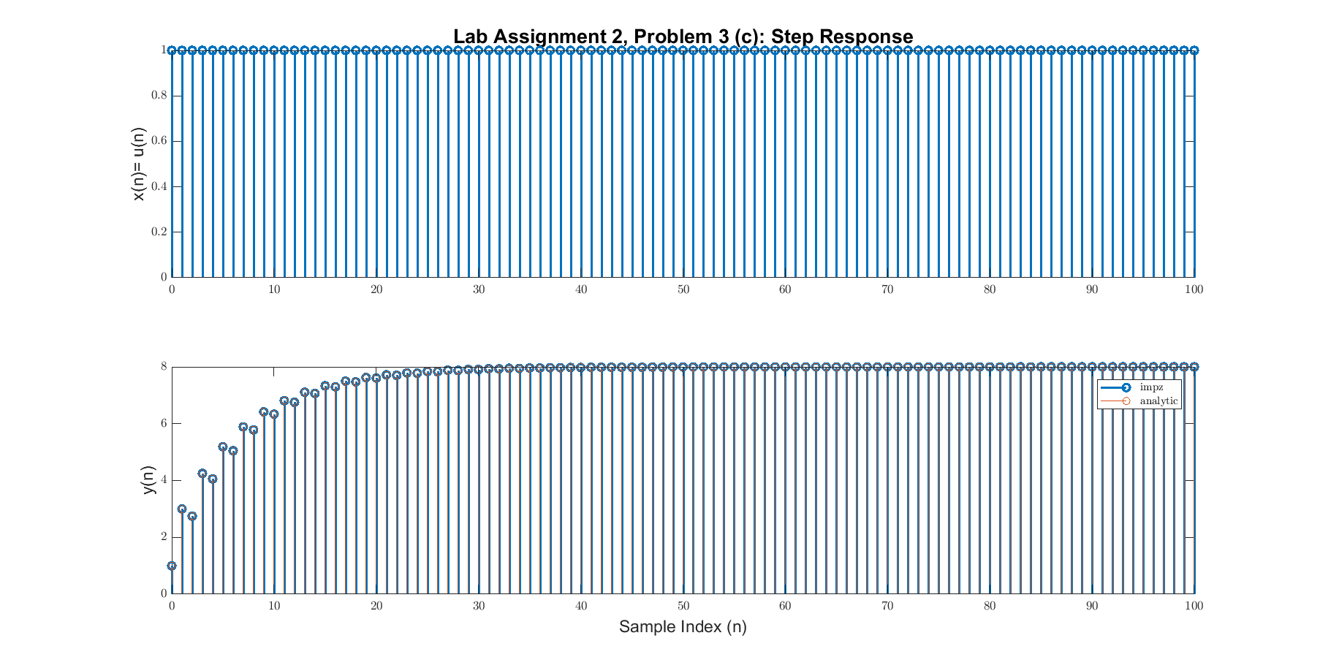

Part d
Step = z/(z-1);
Xzd = (Step*z^-2 - Step*z^-7)*(Step-Step*z^-10);
Y_d = Xzd*H;
Y_d = partfrac(Y_d, z);
y_d_n = iztrans(Y_d);
x = conv(pulse(n-2,5),pulse(n,10));
x = x(1:101);
y = filter(b,a,x);
Ey_d = sum(y.^2)
%y_analytic = 8 - ((5/2+ 7*sqrt(3)/4)*sqrt(3/4).^(n-1) + (5/2 -7*sqrt(3)/4)*(-sqrt(3/4)).^(n-1));
%Ey_a = sum(y.^2); % Finite energy <-> x is absolutely summable
fig = figure('units','normalized','outerposition',[0 0 0.95 0.95]);
subplot(2,1,1)
stem(n, x, 'LineWidth', 2);
ax = gca;
ax.YLabel.String = 'x(n)= p_{5}(n-2)*p_{10}(10)';
ax.XLabel.FontSize = 14;
ax.YLabel.FontSize = 14;
title('Lab Assignment 2, Problem 3 (d): Convolved Pulse Response', 'FontSize', 16, 'FontWeight', 'bold');
subplot(2,1,2)
stem(n(1:end),y(1:end), 'LineWidth', 2);
hold on;
%stem(n,y_analytic)
hold off;
ax = gca;
legend('impz', 'analytic');
ax.XLabel.String = 'Sample Index (n)';
ax.XLabel.FontSize = 14;
ax.YLabel.String = 'y(n)';
ax.YLabel.FontSize = 14;
%axis([min(n), max(n), -10, 10])
saveas(fig, 'Prob3d', 'png');
Ey_d =
7.4080e+03
Warning: Ignoring extra legend entries.
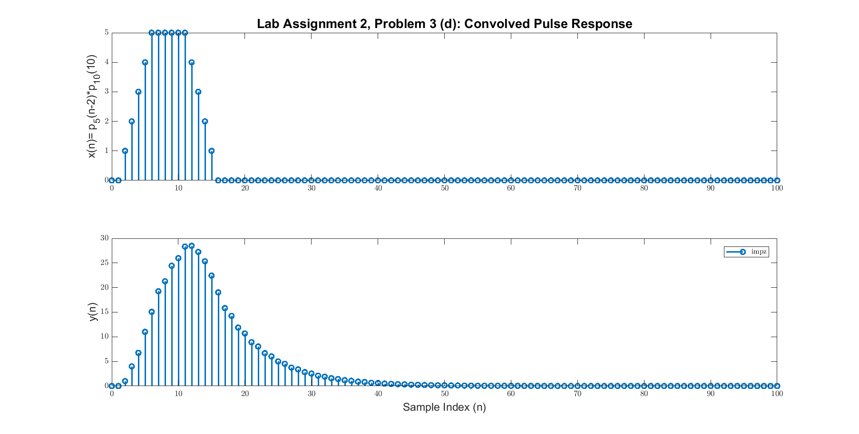

Part d. Print out all the computed energies
Ey_b
Ey_c
Ey_d
Ey_b =
10.2857
Ey_c =
5.8651e+03
Ey_d =
7.4080e+03
Published with MATLAB® R2017a

