Table of Contents 1
Create signals 1
Setup 1
Part (a) Magnitude and Phase Response 2
Part (b) System response to x(n) = 8sin(w1*n-pi/3)*cos(w2*n-pi/4)*u(n) 2
Part c - Find the steady state output of the system 4
Part d: Steady State and Transient Periods 6
Part e: Plot magnitude spectra of input and output 6
% Class: ECE 580, Digital Signal Processing
% Assignment: Lab Assignment 2, Problem 5
% Author: Jonathan Gohl, Electrical Engineering M.S.E. Student
% University of Michigan Dearborn, Electrical and Computer Engineering
% email address: jrgohl@umich.edu
% Author: Joshua McCready, Electrical Engineering M.S.E. Student
% University of Michigan Dearborn, Electrical and Computer Engineering
% email address: jmccread@umich.edu
% Last revision: 21-June-2018
set(groot, 'defaultAxesTickLabelInterpreter','latex'); set(groot, 'defaultLegendInterpreter','latex');

Table of Contents
- Create Signals
- Set up filter
- Part a: Magnitude and Phase Response
- Part b: System Response to Input
- Part c: Steady State and Transient
- Part d: Steady State and Transient Periods
- Pard e: Spectra of Input and Output
close all
clear

Create signals
delta = @(n) n == 0; % Impulse function operating on n.
u = @(n) n >= 0; % Step starting from 0, operating on n
pulse =@(n, l) u(n) - u(n -l); %Impulse train of lenth l, starting from 0,
ramp =@(n) n.*(n>=0); %Ramp starting from 0

Setup
y(n) - 0.9051y(n-1) -0.598y(n-2) -0.29y(n-3) - 0.1958y(n-4) = 0.207x(n) +0.413x(n-2) + 0.207x(n-4) Filter coeffiencent setup
a = [1, -0.9051, 0.598, -0.29, 0.1958];
b = [0.207, 0, 0.413, 0, 0.207];

Part (a) Magnitude and Phase Response
use the filt function to create
%h = filt(b,a);
figure('units','normalized','outerposition',[0 0 0.95 0.95], 'Visible', 'off')
[FResp,W] = freqz(b,a, 10e5);
freqz(b,a, 10e5)
ax = gca;
title('Gain and Phase Response of y(n) - 0.9051y(n-1) +0.598y(n-2) -0.29y(n-3) + 0.1958y(n-4) = 0.207x(n) +0.413x(n-2) + 0.207x(n-4)')
saveas(figure(1), 'Prob5a', 'png');
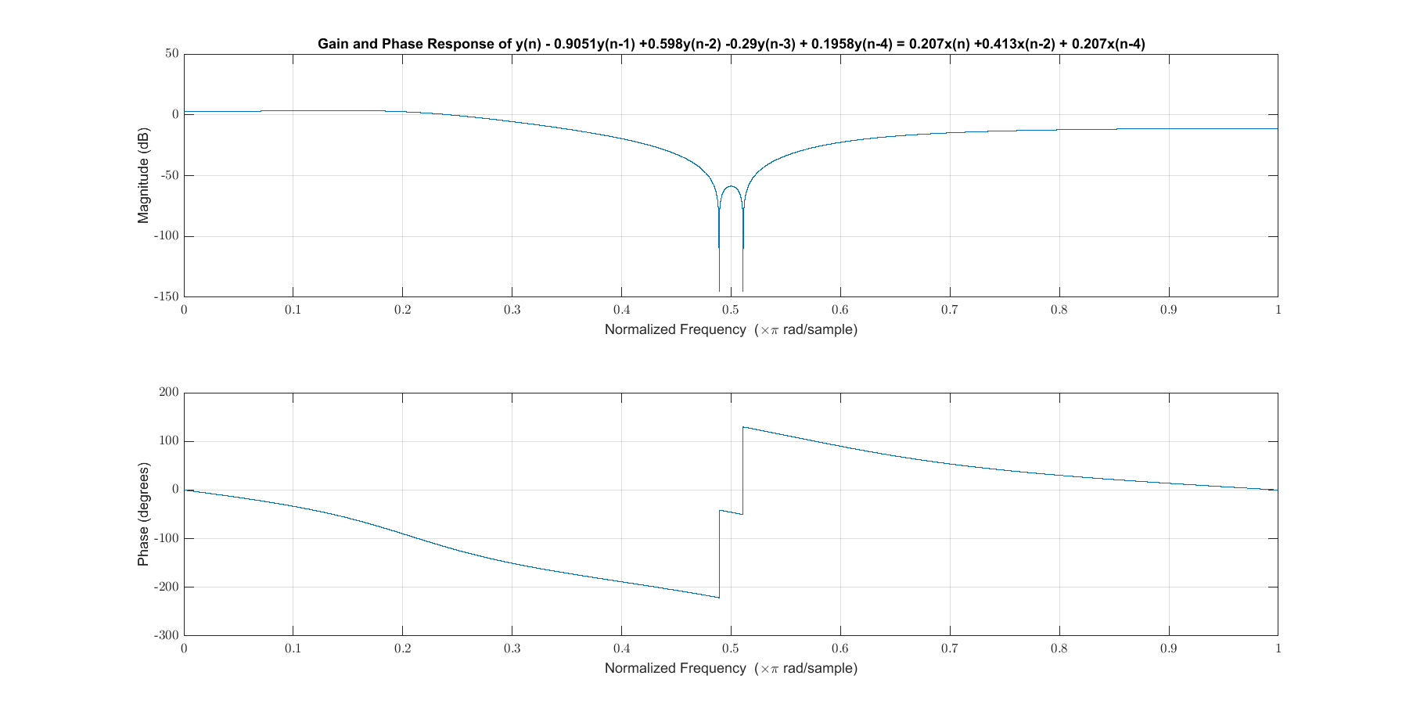

Part (b) System response to x(n) = 8sin(w1*n-pi/3)*cos(w2*n-pi/4)*u(n)
n = 0:100;
w1 = 0.25*pi;
w2 = 0.45*pi;
A = w1*n-pi/3;
B = w2*n-pi/4;
% We can re-write the input functiont using a product identities
% sin(A)cos(B) = 0.5*(sin(A+B) +sin(A-B)
x0 = 8*sin(w1*n-pi/3).*cos(w2*n-pi/4).*u(n);
x1 = 4*(sin(A+B)+sin(A-B)).*u(n);
x2 = 4*(cos(A+B+pi/2) +cos(A-B+pi/2)).*u(n);
figure
stem(n,x0, 'r', 'LineWidth', 2); hold on
stem(n,x1, 'b', 'LineWidth', 1); hold on
legend('given', 'sin sum');
x = x0;
y = filter(b,a, x);
fig = figure('units','normalized','outerposition',[0 0 0.95 0.95], 'Visible', 'on');
subplot(2,1,1)
stem(n, x, 'LineWidth', 2);
ax = gca;
ax.YLabel.String = 'x(n) = 8sin(w1*n-pi/3)*cos(w2*n-pi/4)*u(n)';
ax.XLabel.FontSize = 14;
ax.YLabel.FontSize = 14;
title('Lab Assignment 2, Problem 5 (b): Response to input', 'FontSize', 16, 'FontWeight', 'bold');
subplot(2,1,2)
stem(n,y, 'LineWidth', 2);
ax = gca;
ax.XLabel.String = 'Sample Index (n)';
ax.XLabel.FontSize = 14;
ax.YLabel.String = 'y(n)';
ax.YLabel.FontSize = 14;
%axis([min(n), max(n), -10, 10])
saveas(fig, 'Prob5b', 'png');
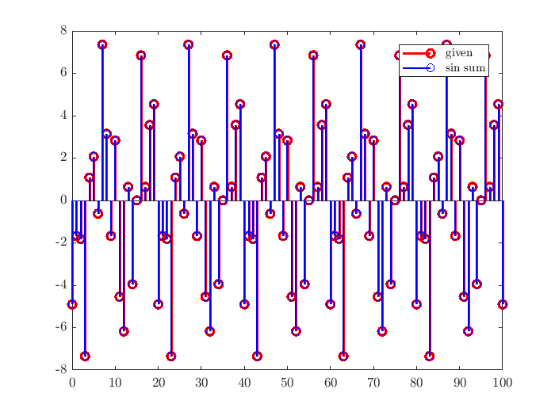
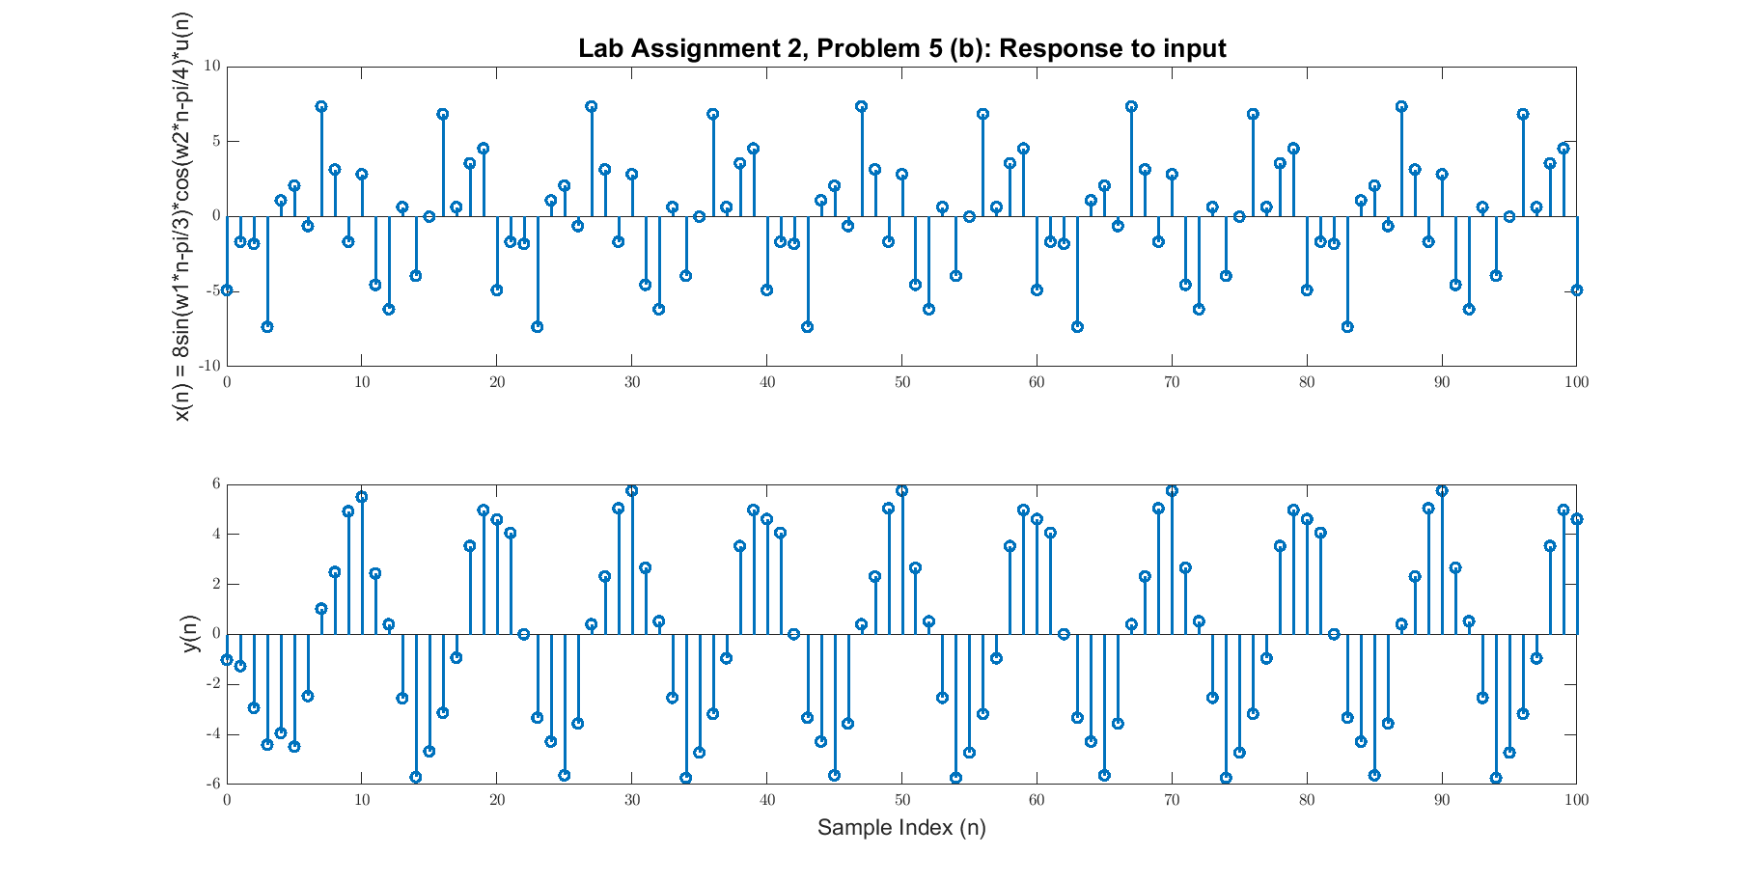

Part c - Find the steady state output of the system
in order to find the transient response, we will first find the steady state response
% Find the indicies of W for the two input frequencies of x (0.2 and 0.7):
I_p2pi = find(W == 0.2*pi); % Index for FResp value for 0.2pi
I_p7pi = find(W == 0.7*pi); % Index for FResp value for 0.7pi
% Use the fact that for steady state: y_ss = A|H(jw)|cos(wn+B+<H(jw))
% for x = Acos(wn+B).
y_ss = 4*(abs(FResp(I_p7pi))*sin(A+B+ angle(FResp(I_p7pi)))...
-abs(FResp(I_p2pi))*sin(A-B + angle(FResp(I_p2pi))));
fig = figure('units','normalized','outerposition',[0 0 0.95 0.95], 'Visible', 'on');
y_tr = y-y_ss;
subplot(2,1,1)
stem(n, y_ss, 'LineWidth', 2);
ax = gca;
ax.YLabel.String = 'y(n) (steady state)';
ax.XLabel.FontSize = 14;
ax.YLabel.FontSize = 14;
title('Lab Assignment 2, Problem 5 (c): Steady State and Transient', 'FontSize', 16, 'FontWeight', 'bold');
subplot(2,1,2)
stem(n,(y-y_ss) , 'LineWidth', 2);
ax = gca;
ax.XLabel.String = 'Sample Index (n)';
ax.XLabel.FontSize = 14;
ax.YLabel.String = 'y(n) (transient)';
ax.YLabel.FontSize = 14;
%axis([min(n), max(n), -10, 10])
saveas(fig, 'Prob5c', 'png');
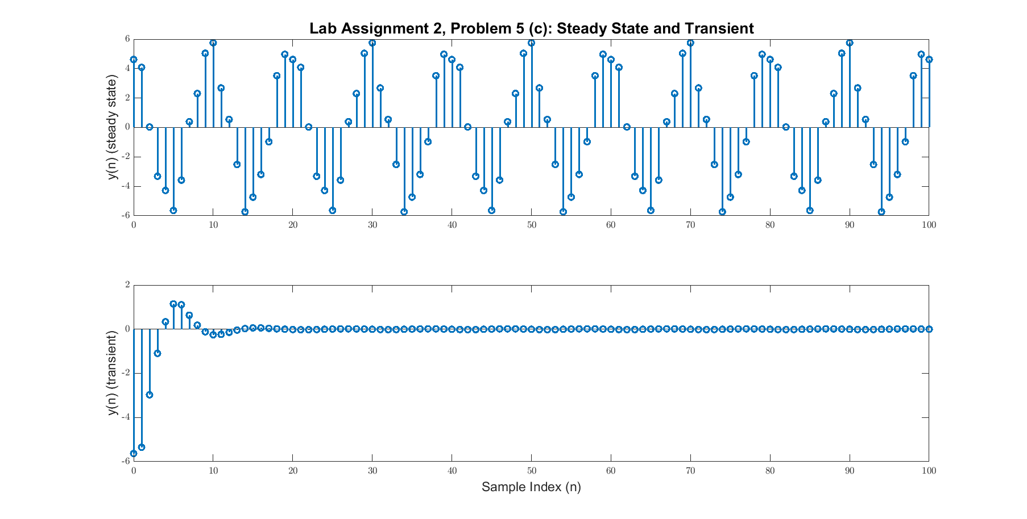

Part d: Steady State and Transient Periods
Lets consider that the energy of the transient response after it has "died" must be less than 0.05 of the total.
E_tr = sum(y_tr.^2); % calculate energy
E_tr_cum = cumsum(y_tr.^2); % calculate cumulative sum of energy
E_tr_cum_per = E_tr_cum/E_tr; % calculate decimal percentage
I_dead = find(1-E_tr_cum_per <= 0.05); % use find to see when <=5% energy remains
I_dead(1) % First sample to reach steady state
ans =
4

Part e: Plot magnitude spectra of input and output
fig = figure('units','normalized','outerposition',[0 0 0.95 0.95], 'Visible', 'on');
%plot first half of DFT (normalised frequency)
Y_mags = abs(fft(y));
num_bins = length(Y_mags);
stem([0:1/(num_bins/2 -1):1], Y_mags(1:num_bins/2), 'LineWidth',2),grid on;
hold on;
X_mags = abs(fft(x));
num_bins = length(X_mags);
stem([0:1/(num_bins/2 -1):1], X_mags(1:num_bins/2), 'LineWidth', 1)
title('Magnitude spectrum of Input and Output');
xlabel('Normalized frequency (\pi rads/sample)');
ylabel('Magnitude');
legend('Output y', 'Input x');
saveas(fig, 'Prob5e', 'png');
Warning: Integer operands are required for colon operator when used as index
Warning: Integer operands are required for colon operator when used as index
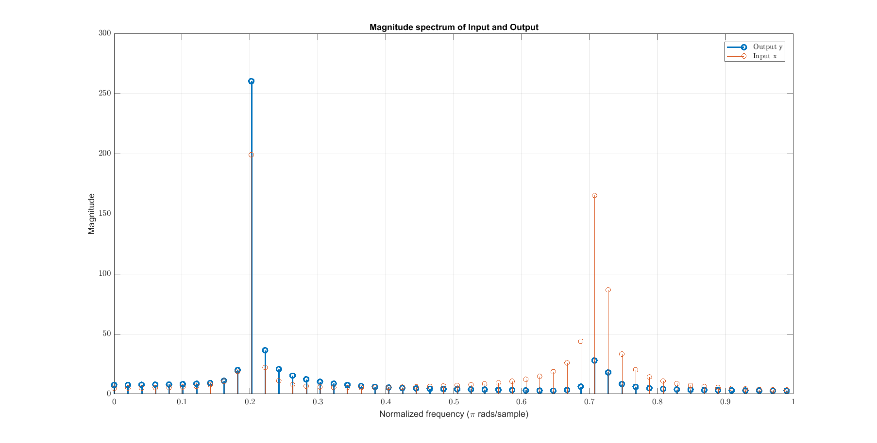
Published with MATLAB® R2017a

