

Parsley Version 2.0

User Guide

**Copyright © 2016 PTC Inc. and/or Its Subsidiary Companies. All Rights Reserved.**

User and training guides and related documentation from PTC Inc. and its subsidiary companies (collectively “PTC”) are subject to the copyright laws of the United States and other countries and are provided under a license agreement that restricts copying, disclosure, and use of such documentation. PTC hereby grants to the licensed software user the right to make copies in printed form of this documentation if provided on software media, but only for internal/personal use and in accordance with the license agreement under which the applicable software is licensed. Any copy made shall include the PTC copyright notice and any other proprietary notice provided by PTC. Training materials may not be copied without the express written consent of PTC. This documentation may not be disclosed, transferred, modified, or reduced to any form, including electronic media, or transmitted or made publicly available by any means without the prior written consent of PTC and no authorization is granted to make copies for such purposes.

Information described herein is furnished for general information only, is subject to change without notice, and should not be construed as a warranty or commitment by PTC. PTC assumes no responsibility or liability for any errors or inaccuracies that may appear in this document.

The software described in this document is provided under written license agreement, contains valuable trade secrets and proprietary information, and is protected by the copyright laws of the United States and other countries. It may not be copied or distributed in any form or medium, disclosed to third parties, or used in any manner not provided for in the software licenses agreement except with written prior approval from PTC.

UNAUTHORIZED USE OF SOFTWARE OR ITS DOCUMENTATION CAN RESULT IN CIVIL DAMAGES AND CRIMINAL PROSECUTION. PTC regards software piracy as the crime it is, and we view offenders accordingly. We do not tolerate the piracy of PTC software products, and we pursue (both civilly and criminally) those who do so using all legal means available, including public and private surveillance resources. As part of these efforts, PTC uses data monitoring and scouring technologies to obtain and transmit data on users of illegal copies of our software. This data collection is not performed on users of legally licensed software from PTC and its authorized distributors. If you are using an illegal copy of our software and do not consent to the collection and transmission of such data (including to the United States), cease using the illegal version, and contact PTC to obtain a legally licensed copy.

**Important Copyright, Trademark, Patent, and Licensing Information:** See the About Box, or copyright notice, of your PTC software.

**UNITED STATES GOVERNMENT RESTRICTED RIGHTS LEGEND**

This document and the software described herein are Commercial Computer Documentation and Software, pursuant to FAR 12.212(a)-(b) (OCT’95) or DFARS 227.7202-1(a) and 227.7202-3(a) (JUN’95), and are provided to the US Government under a limited commercial license only. For procurements predating the above clauses, use, duplication, or disclosure by the Government is subject to the restrictions set forth in subparagraph (c)(1)(ii) of the Rights in Technical Data and Computer Software Clause at DFARS 252.227-7013 (OCT’88) or Commercial Computer Software-Restricted Rights at FAR 52.227-19(c)(1)-(2) (JUN’87), as applicable. 01012015

**PTC Inc., 140 Kendrick Street, Needham, MA 02494 USA**



Software Change Log 3

Introduction and Installation 3

About the Parsley 3

Installing the Parsley Extension 3

Configuration and Usage 5

Configuration 5

Usage 5

[Known Limitations and] Compatibility 5

Document Revision History 5

# Software Change Log

|  |  |  |
| --- | --- | --- |
| Version | Release Date | Changes |
| 2.0.0 | 1/23/2017 | Initial Release |
| 2.0.7 | 1/23/2017 | * Fixed date parsing * Allow for CSV parsing without datashape if the file has headers |

# Introduction and Installation

Extensibility is a core aspect of the architecture and design of ThingWorx. Partners, third parties, and general ThingWorx users can easily add new functionality into the system, seamlessly. Extensions can be in the form of Service (function/method) Libraries, Connector Templates, Widgets, and more.

This document provides installation and usage instructions for the Parsley Extension.

## About Parsley

Parsley aims to allow you to parse CSV files, JSON Objects, and JSON Arrays into InfoTables as painlessly as possible.

The Parsley Extension for ThingWorx provides a Parsley Resource with the following services:

* ParseJSON
* ParseCSV.

This extension utilizes the Thingworx 6.6.5 SDK.

## Installing the Parsley Extension

|  |  |
| --- | --- |
| 1. From a web browser, launch ThingWorx. 2. Log into ThingWorx as an administrator. |  |
| 1. Go to **Import/Export > Import**. |  |
| 1. Click Choose File and select Parsley_ExtensionPackage.zip 2. Click **Import**.  Note: If an **Import Successful** message does not display, contact your ThingWorx System Administrator. | Note: |
| 1. Click **Yes** to refresh Composer after importing the final extension. |  |
| 1. Confirm that the Extension has been imported properly. Check the Application Log for potential problems. |  |
|  |  |

## Usage

The Parsley Extension can be used by invoking any one of the following services through the Snippets tab when creating a new Service on any ThingWorx entity:

* ParseJSON
* ParseCSV

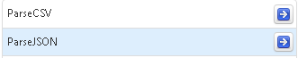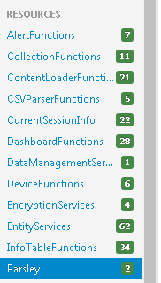

These services can be used to parse a JSON object or CSV file directly into an InfoTable result.

**ParseCSV**

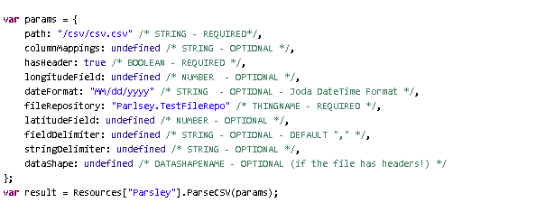

**Result**

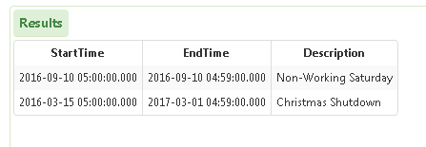

**ParseJSON**

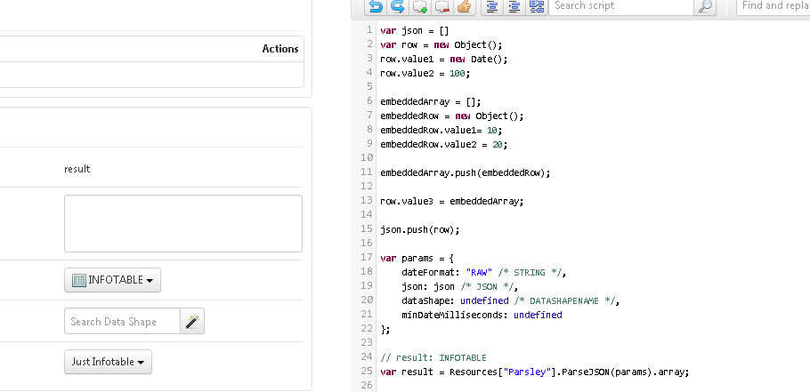

**Result**

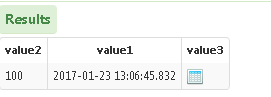

# Compatibility

This extension was tested for compatibility with the following ThingWorx Platform version(s) and Operating System(s):

|  |  |
| --- | --- |
| ThingWorx Platform Version | ThingWorx 6.6.5 |
| OS | Windows 7, Service Pack 1 |

# Document Revision History

|  |  |  |
| --- | --- | --- |
| Revision Date | Version | Description of Change |
| January 23, 2017 | 1.1 | Initial Draft |