Jason McGough
Senior Seminar
Fall 2015
Dr. Liszka

Capstone Report

The original concept for the Generic Digital Character Sheet (GDCS) came about long before I considered what project I would work on for my senior seminar project. Having played tabletop role-playing games since early high school, I have had quite a lot of exposure to them, and created my fair share of characters. But there were always difficulties tracking character information. Perhaps there simply wasn't enough room on the sheet to keep track of everything necessary, or values changed so often that erasure marks would begin to turn into holes through the paper. Today, software seems to be a reasonable solution to these sorts of problems. However, most applications that I could find were designed for specific rule-systems and could not accommodate different versions of the same system. A character sheet application is fairly simple, if confined to a single rpg system. Primary concerns lay in accounting for all the information normally tracked on a character sheet and creating an interface. But players often play across multiple rpg systems, and a truly useful tool to them would be one that can be used across all of their favorite systems, and maybe even new ones they wish to try out. Although, a generic application presents many more problems than one that is tailored to something specific.
Initially, GDCS was planned as a local C# application. However, since I had already been exposed to entire class on C#, I opted to instead implement the project for android. Android development can be done in a few different languages. I have been told Java is fairly similar to C#, and since it runs natively on android, it seemed like an obvious choice. Between learning Java, the tools in the android SDK and interface design for mobile apps, I figured I would have plenty on my plate for a challenging project. Before starting my project, I thought it prudent to familiarize myself with Java, so as to avoid making certain assumptions based on my knowledge of C#. But by the time I had started writing code for the project, I had realized I spent too much time investigating the language and not enough time familiarizing myself with the android development cycle. So, it then turns out that there was a little more to it than I thought. My IDE of choice for development, Android Studio, provided a graphic interface for designing the look of the app. This interface was not very intuitive to use, but XML could be used as an alternative. Lists of usable interface elements and their parameters could easily be found within the IDE, which was a great time saver. And with the help of a few guides found on the internet, I was able to customize the look of some of the elements a little further. The toolbar at the top of GDCS was one such customization. The toolbar was designed as an overlay that could be displayed on any screen used in the app, and stay consistent across each screen. Of all of the features in GDCS, I spent a little too much time with this one. Setting it up as an overlay required changing some configuration files that ended up breaking other parts of the display. The toolbar itself was not a necessary component to the project, and drew away from more critical components to the app. Once completed, I finally moved on to the core of the project.

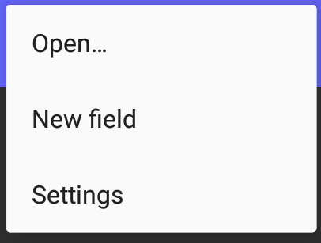

The android SDK itself was fairly easy to pick up on. Starting with a demo “Hello, World” project, I spent some time looking through the auto-generated code. The demo project offered some good examples of what sorts of things belong to functions such as onCreate, as well as insight into the structure of event handlers. The biggest problem I faced was the most important part of the entire project, learning to generate an interface programmatically. While learning the XML to generate elements statically was most certainly useful, it offered little insight into how this could be done with Java. Some parameters could be set directly using an object of the appropriate type and the dot operator. Others were required to be set using a dynamically created parameters object, which could then be passed to the desired object. There did not seem to be an obvious pattern to what had to be set though a parameters object and what could be set directly. The SDK's documentation was helpful here, but was time-consuming to sift through, and had to be visited for each different object type. Even after learning the steps necessary, complicated dynamic structures were difficult to wrap my head around.
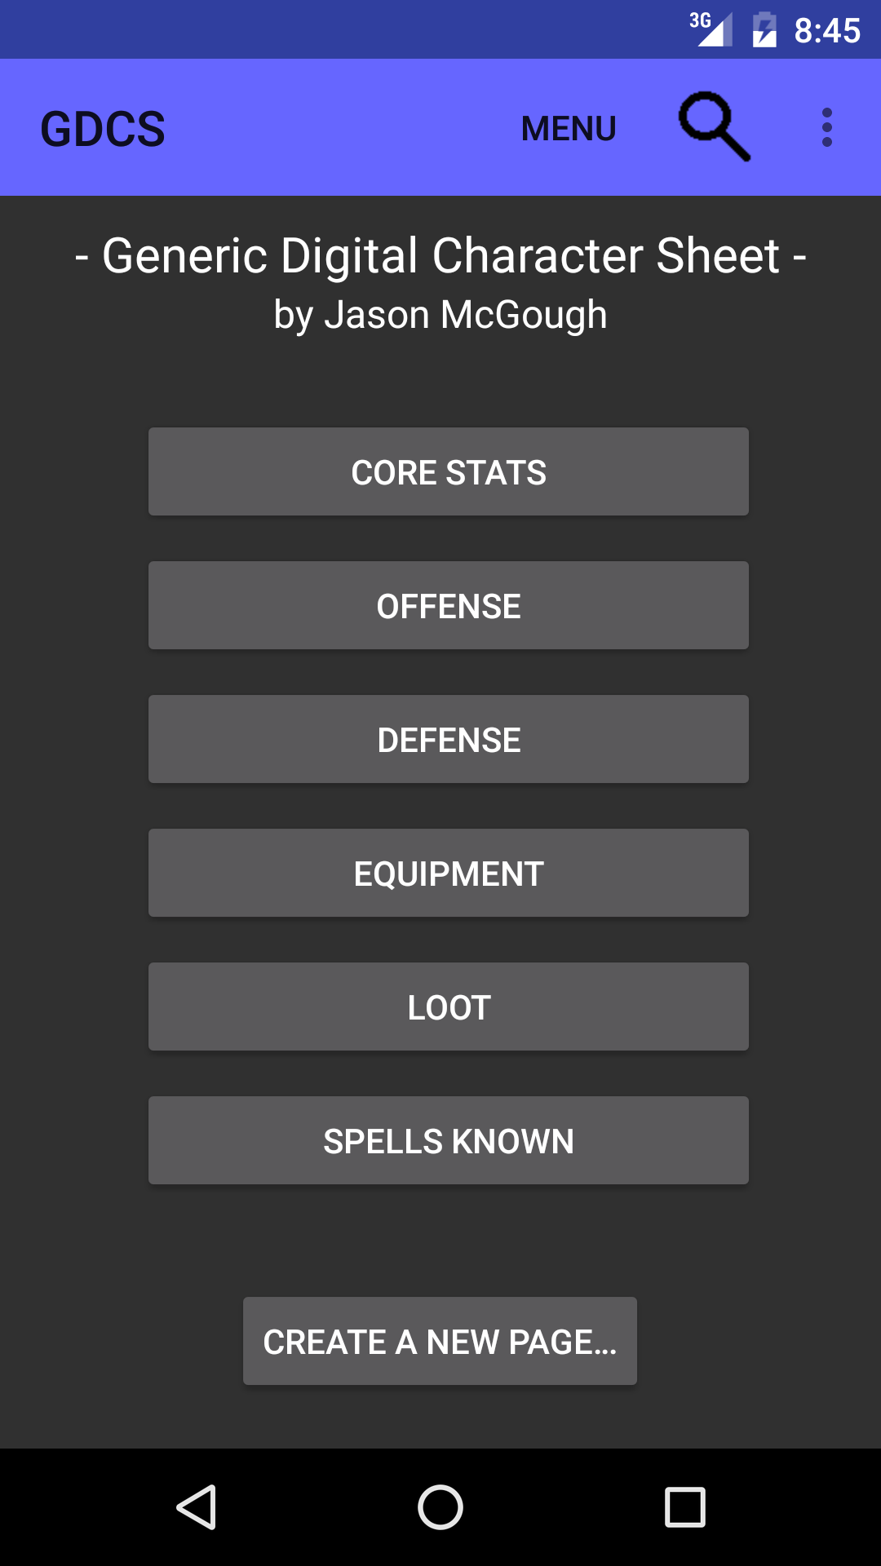
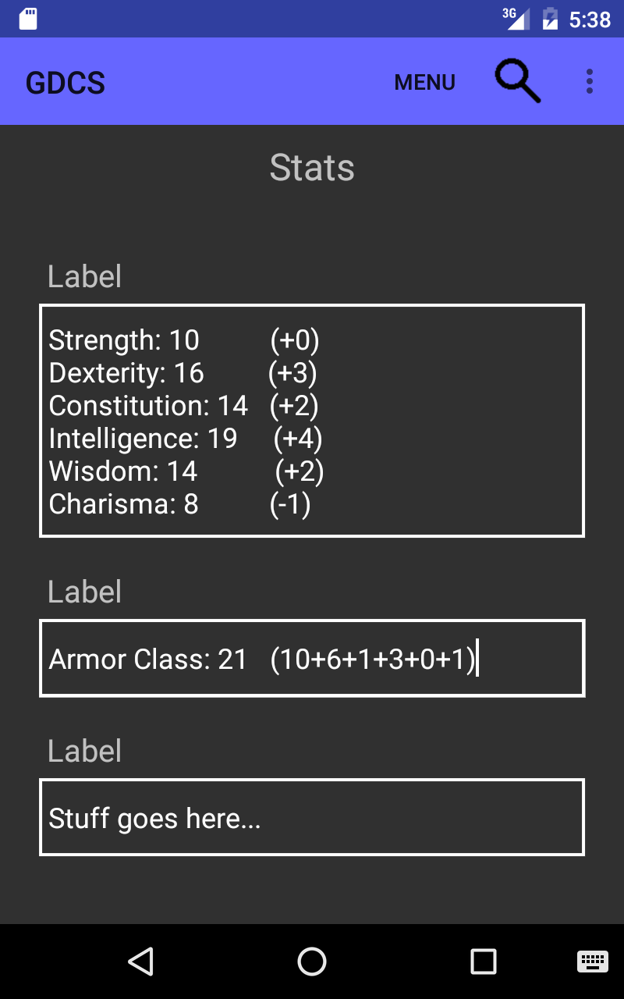

With the ability to generate dynamic content, like buttons and text fields, I moved on to create an interface to enable a user to customize this new content. Dialog prompts were the solution I turned to. These would allow the user to name buttons and select specific content to generate. Dialog boxes were a little tricky, at least in my case, as they became a series of nested event handlers. Nested functions was something completely new to me. However, assumptions on their behavior became an obstacle to me. Variables created in external event handlers could not be altered inside internal ones, and variables created in internal handlers could not be passed back up a level. I never really figured this one out, and had to resort to alternatives that did not have the desired behavior to move forward. I was unable to find any comprehensive guides, that I could understand in relatively short time, for what I wanted. What was important was that the dialog boxes worked, and they enabled content customization. At this point, the core of the project had been completed.
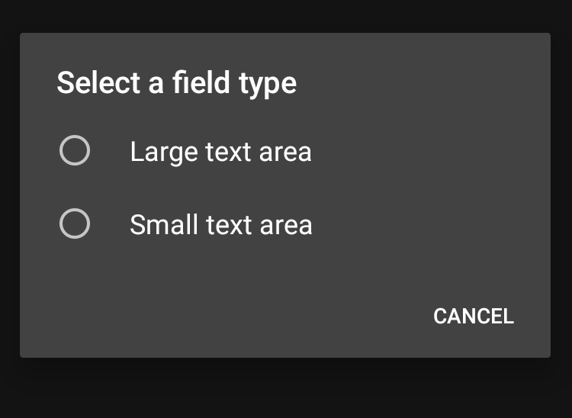
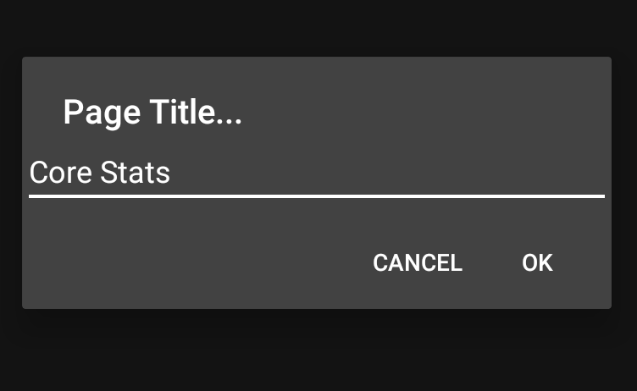

A few planned features for the project had to be abandoned for the time being, for various reasons. Behavior was hard to suss out for some of the interface elements. I had intended for user's to be able to set up a single element in 1 or 2 columns (2 spanning the width of the screen), and as many rows as needed. I tried out several containers, including the table and grid layouts. Tables couldn't quite get the behavior I was looking for (one element in a column spanning multiple rows, but it's horizontal neighbors using more or less rows), and grid behavior was something of a mystery. Ultimately, I used a linear layout for the sake of simplicity. However, I believe that the grid will be able to get me the behavior I want, with a bit more research. Another feature that was cut was the ability to add varying types of content to a page. Ultimately, the time it took to work out the code for programmatically constructing one element was rather long, and visually formatting it was tedious as well. I was surprised at how complex element structures became! Elements created were limited to a small or large editable text area with a generic label attached to it. The most tragic feature to cut was the ability to actually save and recall information in the app when it loses focus or is closed. The app is pretty much useless without this feature, as the user must recreate the character sheet and reenter all of their character's information any time they even minimize the app. I looked into the procedures required to do this, and it seemed reasonable for a known amount of static data. However, the basis of GDCS is that everything besides a basic interface is dynamically generated. This was a big problem that I looked into much too late. It was foolish of me to leave something so important to an app's functionality until near the end of semester.
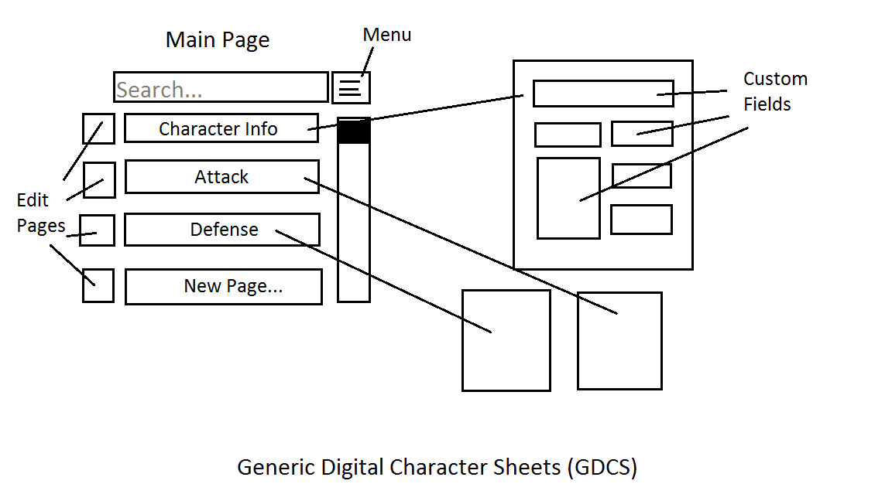
And while disheartening, I still feel like I learned so much. Development of GDCS has exposed me to two familiar, but different programming languages, Java and XML. While clearly useful in android app development, both languages are applicable in a wider range of areas as well. Familiarity with the android SDK itself it extremely valueable, as the mobile device market continues to expand. I also enjoy the process of designing an interface. Not many class project require much of an interface outside of something that runs in the command line. And the opportunity to dedicate the time and energy to work on a personal project like this has been very valuable. I could really get behind the project, and I genuinely feel that GDCS will become something useful to myself and it's users. Development will continue after this semester, perhaps continuing with android, or perhaps my originally intended C#. I don't just want to be able to add some new languages and skills to my resume, I want to be able to put the name of my project on my resume and have it mean something!

