CMP3111M:

Software Engineering

Assignment Item 1

Rebeka Lewis  
Student Number: LEW13388462  
  
17/12/2015

Contents

# Logs -

Sprint Logs -Pair Programming Logs -  
Contribution -

# Program -

Design -Code -

# Critical Reflection -

# References -

# 

Logs

Sprint Logs

Pair Programming Logs

Contribution

Program

Design

* 1. Domain Modelling
  2. Use Case diagram



* 1. Class Diagram



* 1. Sequence Diagram

Code

Connect

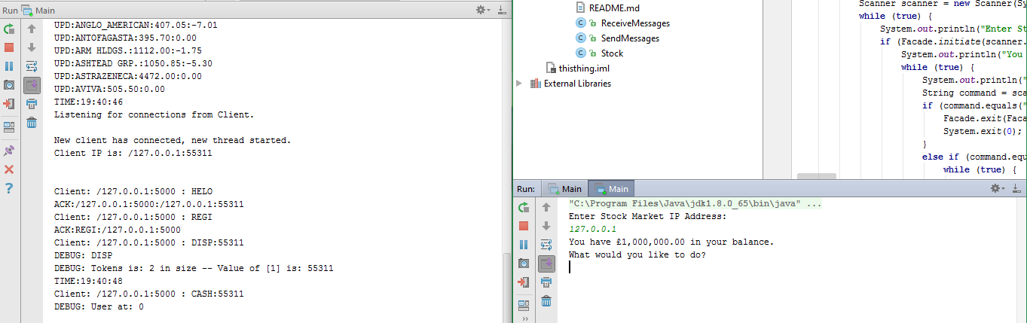

Automated Buying and Selling

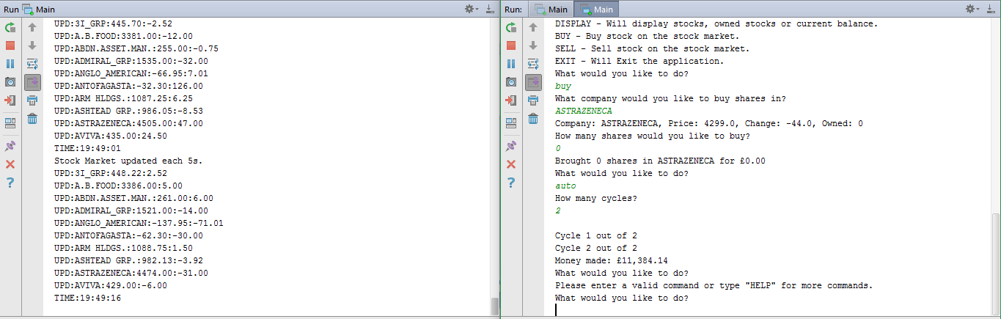

Manual Buying and Selling

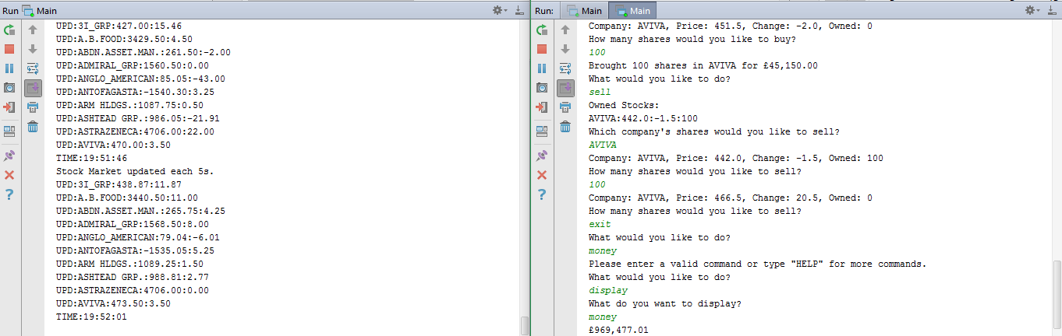

Critical Reflection

References