Leave or remove someone from a group chat

After you join a group chat, you can decide whether you want to remain a member, or leave the group chat. You can also remove people from a group chat.

**Tip:** If you’re considering leaving a group because you’re being inundated by notifications about new messages, you can instead just [turn off notifications](https://support.microsoft.com/en-us/office/manage-notifications-in-teams-1cc31834-5fe5-412b-8edb-43fecc78413d) or [mute the chat](https://support.microsoft.com/en-us/office/hide-unhide-mute-or-pin-a-chat-in-teams-9aee02ef-713d-495b-8a73-9762d8e4b066) from that group.

Leave a group chat

If you decide to leave a group chat in Teams, follow these steps:

1. Select **Chat**  to open the chat list.
2. Find the name of the group you want to leave.
3. Select **More options** More options button > **Leave**.  
     
   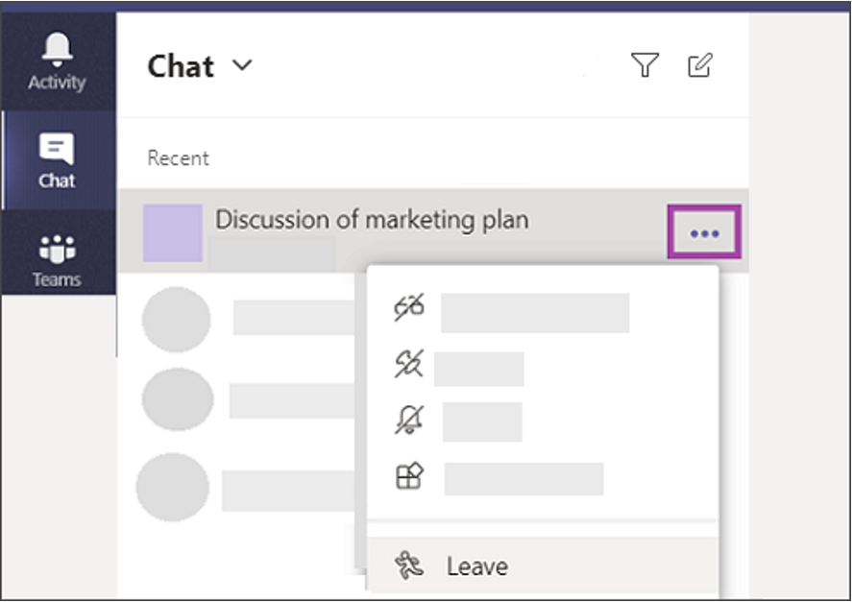  
   If you change your mind, just ask someone to re-invite you to the group.

Remove people from a group chat

**Note:** Your admin will need to turn on this setting to allow members to remove each other from a group chat.

To remove people from a group chat in Teams, follow these steps:

1. Open any group chat of three or more people and go to the top of the chat where it tells you the number of participants.
2. Hover on the number of participants and then hover on the person's name you want to remove.
3. Select the **X** and confirm you want to remove the participant from chat.  
     
   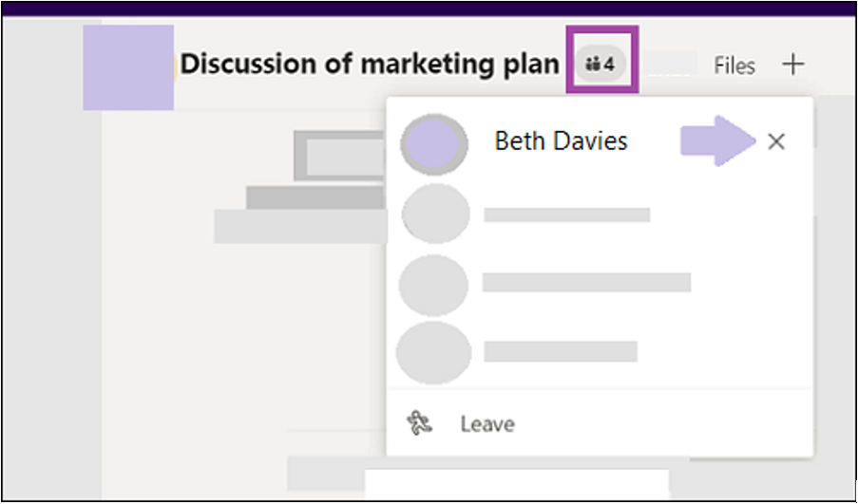  
     
   An update in the chat will inform everyone that you've removed the person.

People removed from a chat will be able to view previous chat history, but won't be able to send new messages, react to messages, and won't be able to view new conversations or files shared by the group.

**Note:** If someone has been removed or decides to leave a group chat, their chat messages are still there in your chat history. Any changes to the chat history can be seen by them, so try to avoid editing these messages.