**Cook et al. 2019: Glacier algae accelerate melting of the south-western Greenland Ice Sheet, The Cryosphere.**

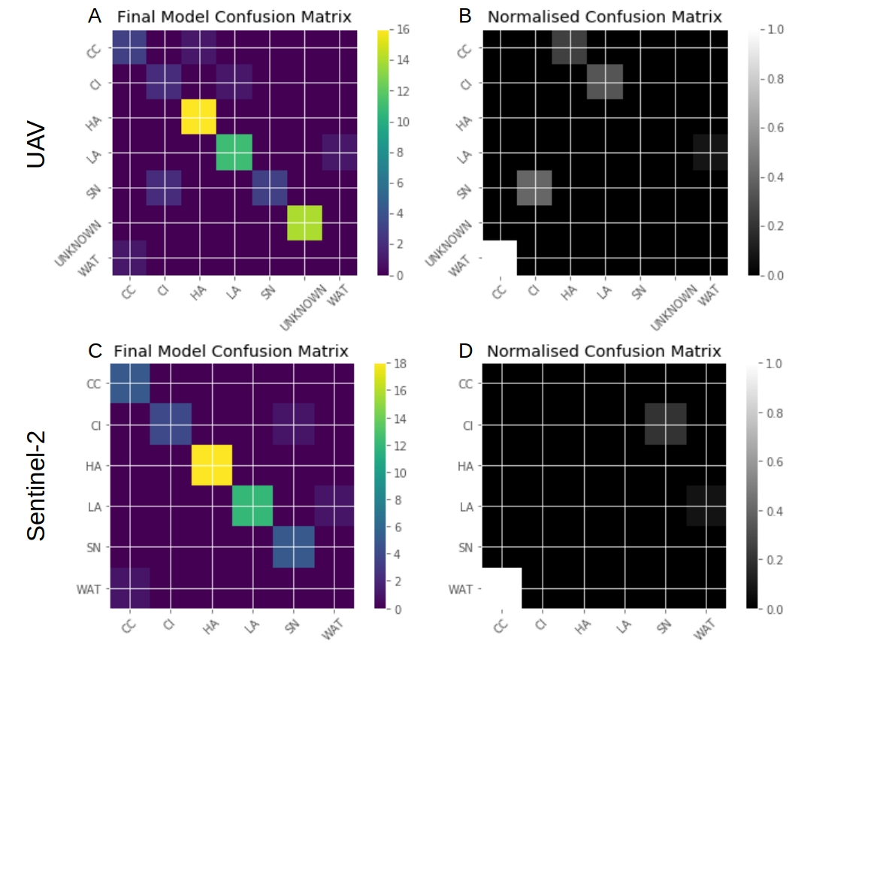**Supp Info 9:**