Supp Info 6:

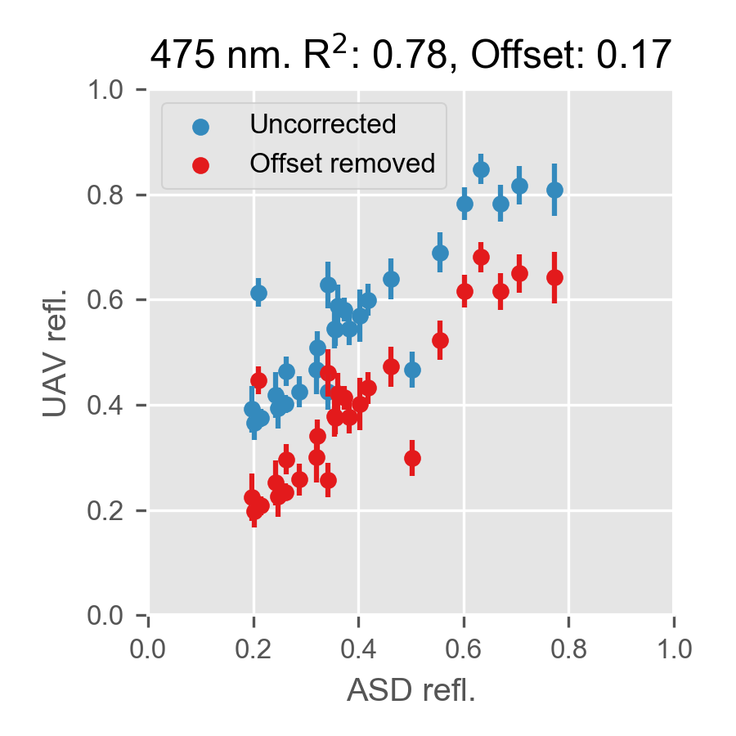
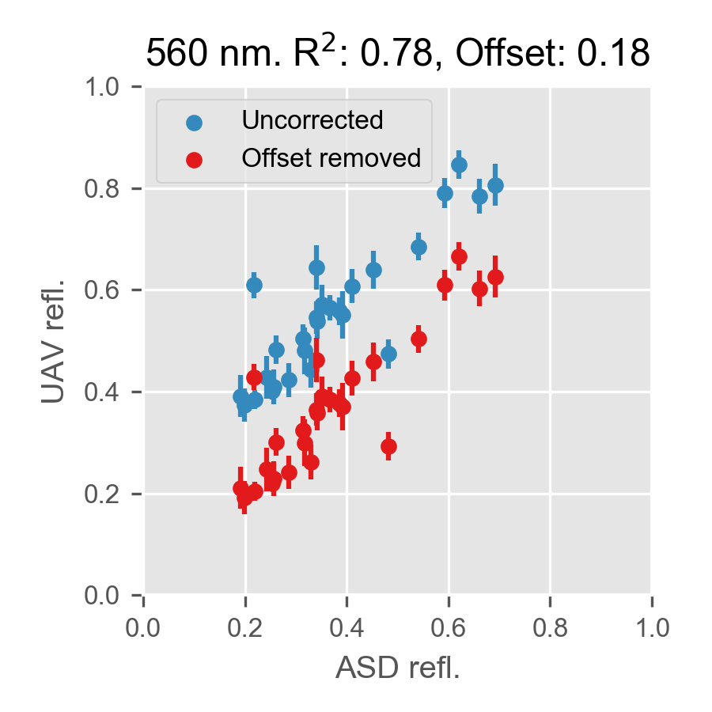
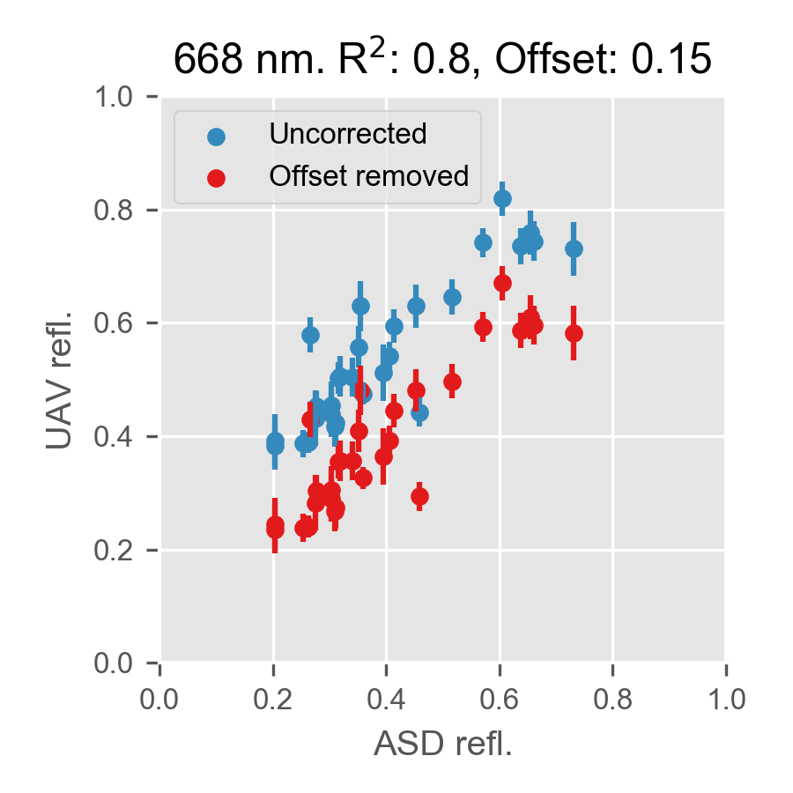
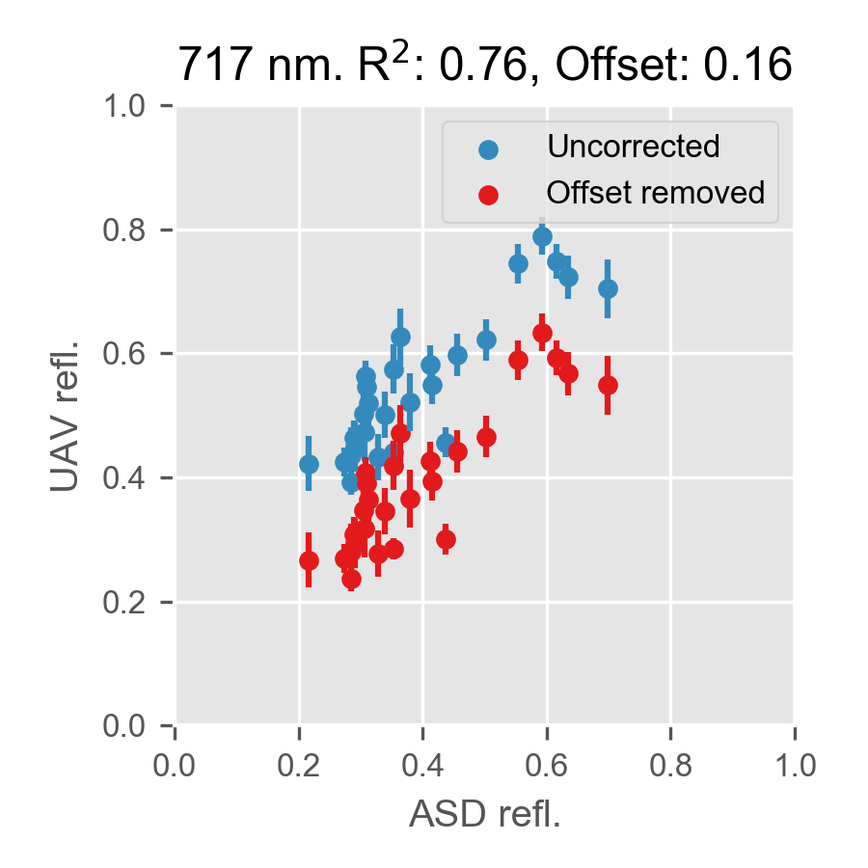
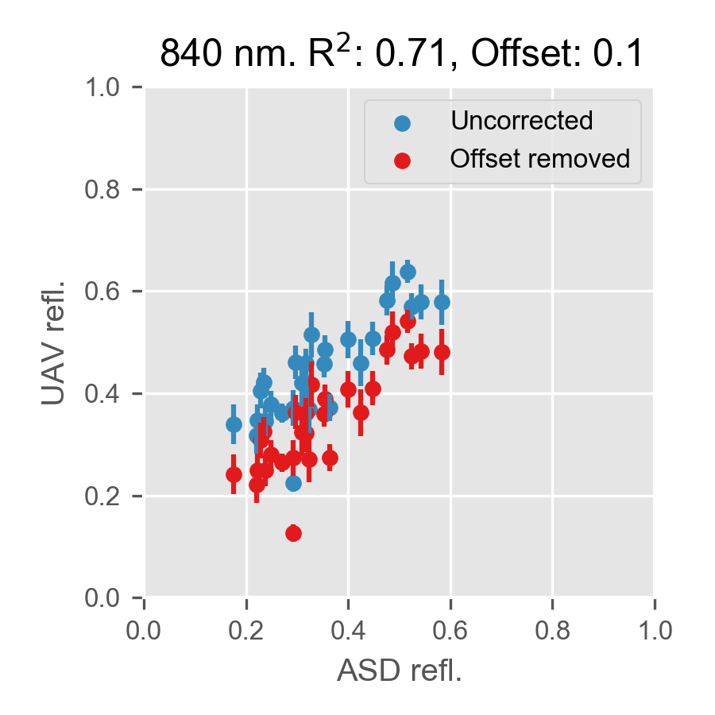
Figure S6.1: UAV reflectance plotted against ASD reflectance for each UAV band, in uncorrected (blue) and corrected (red) form.

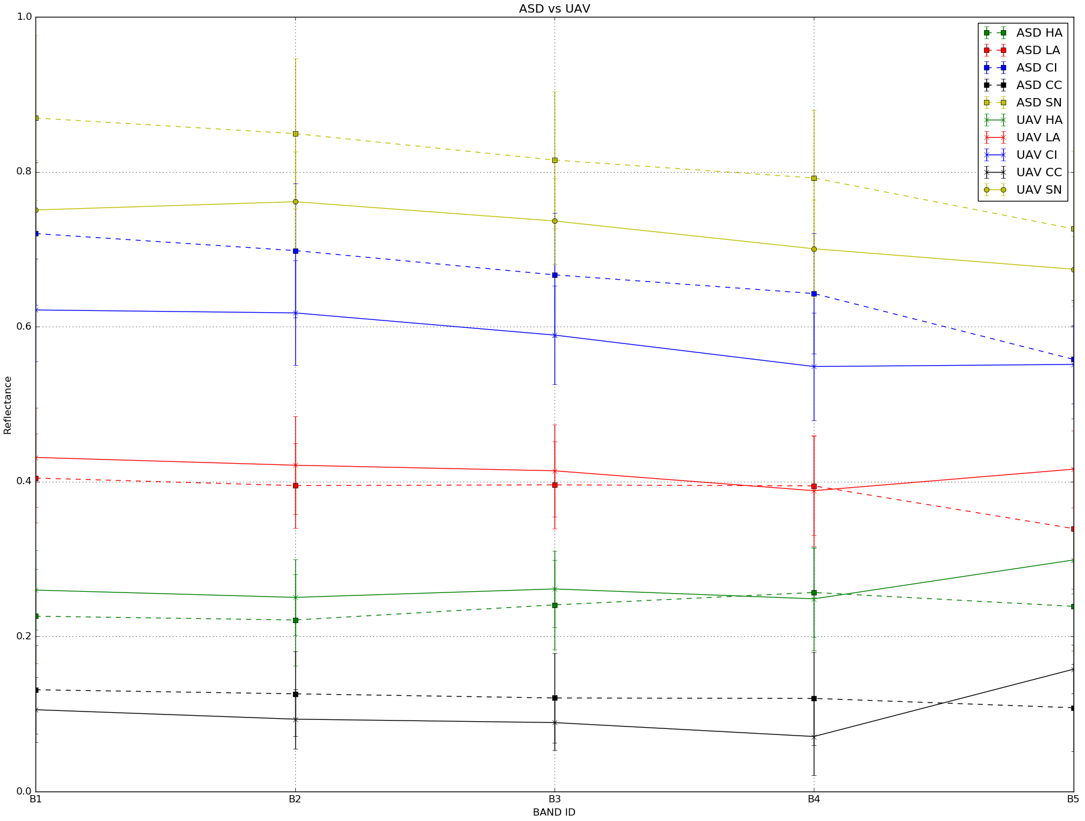
S6.2 Mean reflectance and +/- 1 standard deviation error bars at each spectral band for each surface class for the ASD field spectrometer and the UAV-mounted multispectral camera.

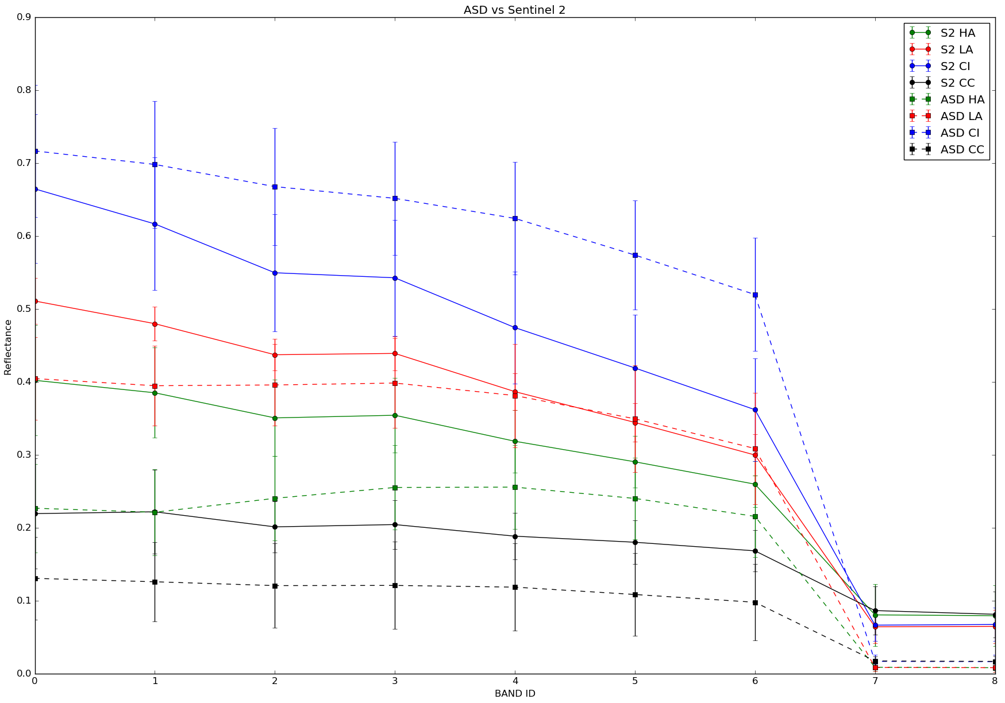

S6.3 Mean reflectance and +/- 1 standard deviation error bars at each spectral band for each surface class for the ASD field spectrometer and Sentinel-2.

