Cook et al. 2019: Glacier algae accelerate melting of the south-western Greenland Ice Sheet, The Cryosphere.
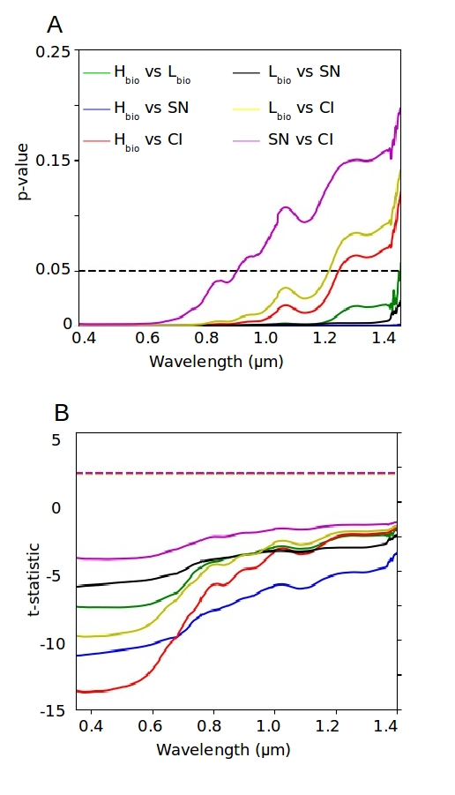
Supp Info 7:

