Joseph Cook
Aberystwyth University
Aberystwyth
Wales
SY23 3DA
joc102@aber.ac.uk

Dear Editors,

we are delighted to submit the revised version of our paper “Glacier algae accelerate melt rates on the south-western Greenland Ice Sheet”. The reviewers made helpful comments and we have reflected deeply on them and made substantial amendments to the study in response. The paper has been restructured, we have repeated and revised our imaginary refractive index retrievals, presented a new sensitivity study for mineral dusts, expanded the introduction and discussion, and revised our method for attributing melting to glacier algae. As a result, we present a much stronger manuscript and hope that the amendments satisfy the reviewers and editors and that this paper will now go forwards to publication.

We thank the editorial team for their patience and for granting us an extension to make these major updates to the paper.

Kind regards,

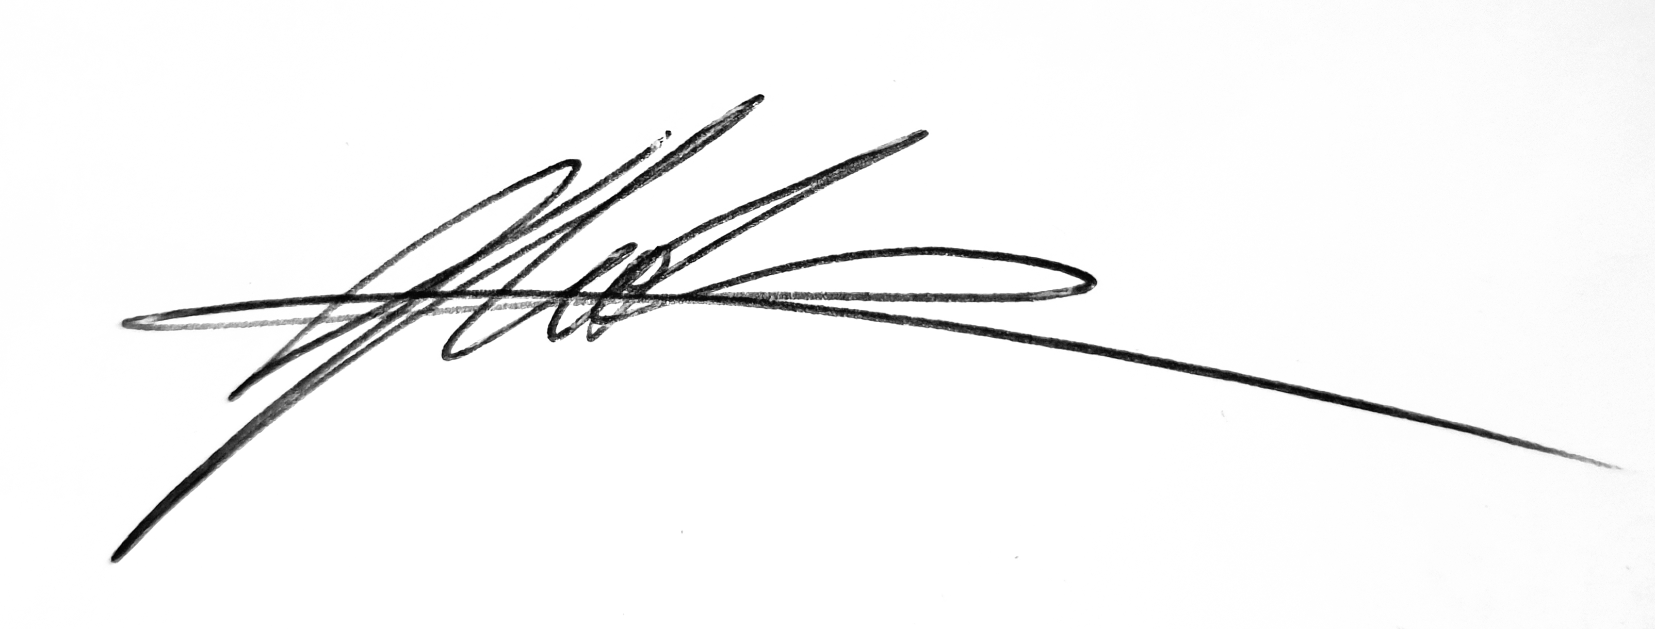

Joseph Cook
(on behalf of all authors)

