The Cryosphere

Cook et al. (2019): Glacier Algae accelerate melt rates on the south-western Greenland Ice Sheet

Revised Supplementary Information

S1: Schematic diagram of the BioSNICAR_GO model structure
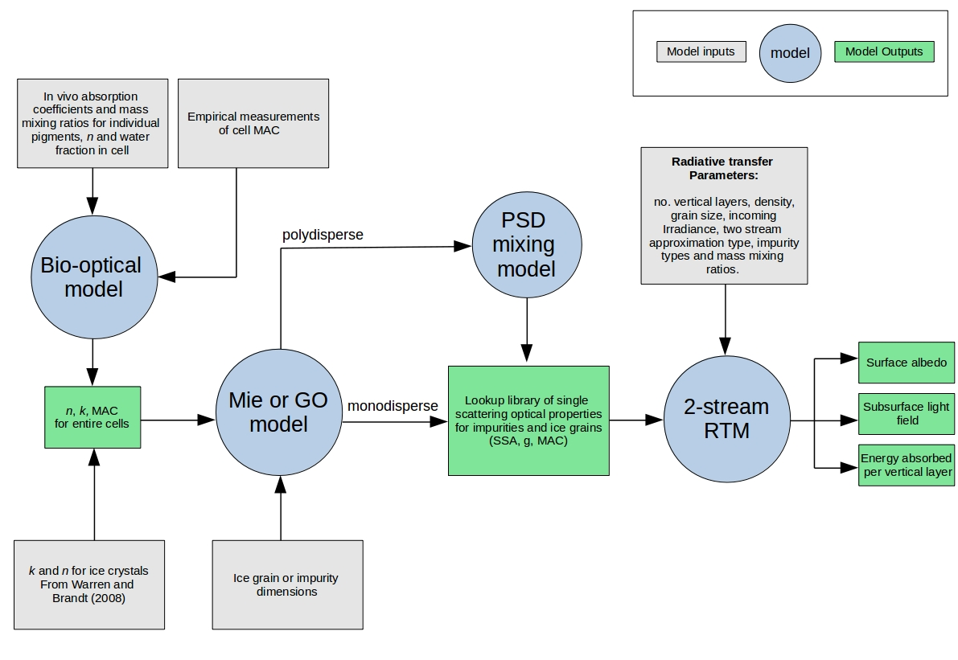

Supp Info 2: Mineral dust sampling and particle size distribution (PSD).

High algal biomass ice samples were collected in sterile sample bags and melted at ambient temperatures (5-10 C). The thawed samples were filtered onto glass fiber filters (0.7 m pore size), from which the solids were removed into a glass jar using a stainless steel spatula. In 50 mL centrifuge tubes, the samples were treated using 30% H₂O₂ (w/w) (Honeywell Fluka™) to remove the organic fraction. The samples (1-2 g) were sonicated (VWR ultrasonic cleaner) in 45 mL of the H₂O₂ treatment for 10 min to disaggregate the material. The samples were left in the H₂O₂ treatment for 48 h, after which they were centrifuged for 10 min at 4000 rpm (Eppendorf centrifuge 5810). The supernatant was removed, and the H₂O₂ solution was replaced. This process was repeated up to ten times until no more organic oxidation was observed. The remaining mineral fraction was washed three times in water (Sartorius arium pro ultrapure water), with centrifugation after each wash.
A 5 mg of H₂O₂-treated sample was suspended in 10 mL of ultrapure water. The sample was sonicated to disaggregate the grains. The suspension was dispersed onto a 0.2 m polycarbonate filter (Sartorius Track-Etch Membrane, 0.2 m). Once dry, a section of each filter was adhered to a stainless steel SEM stub using an adhesive carbon tab. The sample was coated with 8 nm of Ir (Agar high resolution sputter coater). The PSD was determined using a Zeiss Ultra Plus field emission scanning electron microscope (FE-SEM) operated at 20 kV. Automated particle counting software was used to determine the PSD in an area of approximately 1 mm².

Supp Info 3: Schematic diagram of the classification method
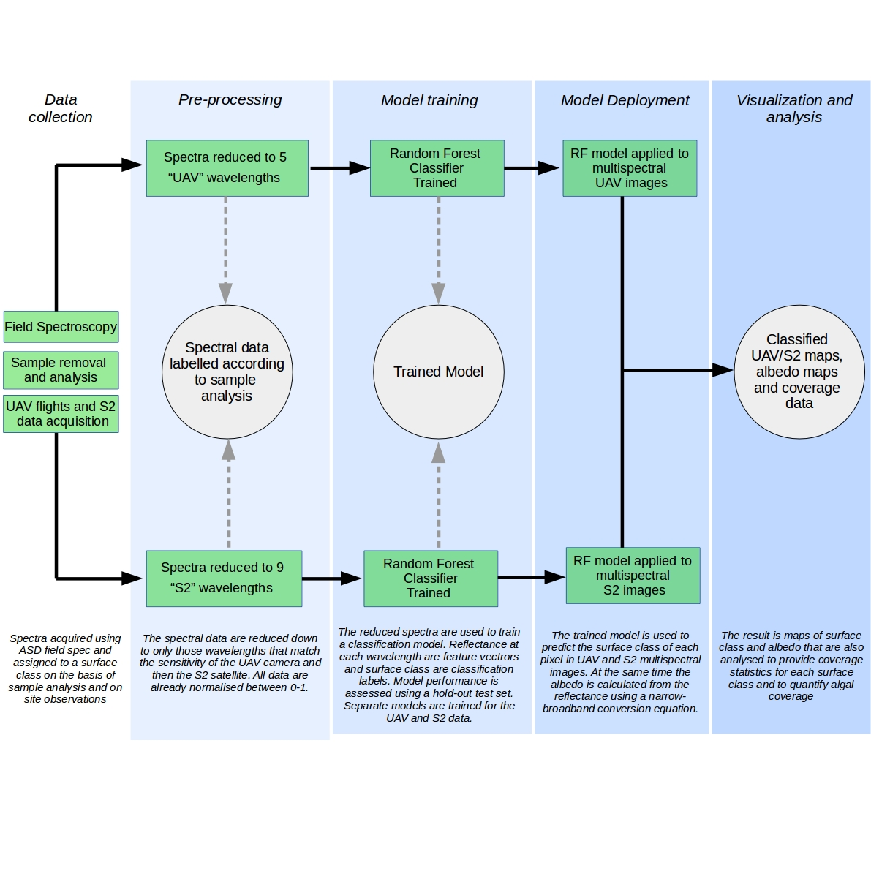

Supp Info 4: A) Performance metrics for supervised classification algorithms on training data using five bands coincident with MicaSense Red-Edge multispectral imagery, plus the final model performance on the test set; B) Performance metrics for supervised classification algorithms on training data using eight bands coincident with Sentinel-2 multispectral imagery, plus the final model performance on the test set.

A:

Model | Accuracy | Precision | Recall | F1 Score
K-Nearest Neighbours | 0.90 | 0.74 | 0.78 | 0.76
Naive-bayes | 0.90 | 0.80 | 0.81 | 0.80
Support Vector Machine | 0.94 | 0.89 | 0.87 | 0.88
Random Forest | 0.99 | 0.99 | 0.95 | 0.97
Ensemble | 0.92 | 0.76 | 0.81 | 0.78
RF performance on test set | 0.90 | 0.91 | 0.90 | 0.90

B:

Model | Accuracy | Precision | Recall | F1 Score
K-Nearest Neighbours | 0.89 | 0.90 | 0.89 | 0.87
Naive-bayes | 0.89 | 0.89 | 0.89 | 0.89
Support Vector Machine | 0.96 | 0.96 | 0.96 | 0.96
Random Forest | 0.99 | 0.99 | 0.99 | 0.99
Ensemble | 0.93 | 0.93 | 0.93 | 0.93
RF performance on test set | 0.92 | 0.93 | 0.92 | 0.93

Supp Info 5: A) Hourly radiative forcing for H_{bio} and L_{bio} ice; B) Mea depth of absorption feature for H_{bio}, L_{bio,} CI and SN sites; C) p-values for spectral Bonferroni-corrected t-tests for albedo between each surface class; D) t-statistics for spectral Bonferroni-corrected t-tests for albedo between each surface class.

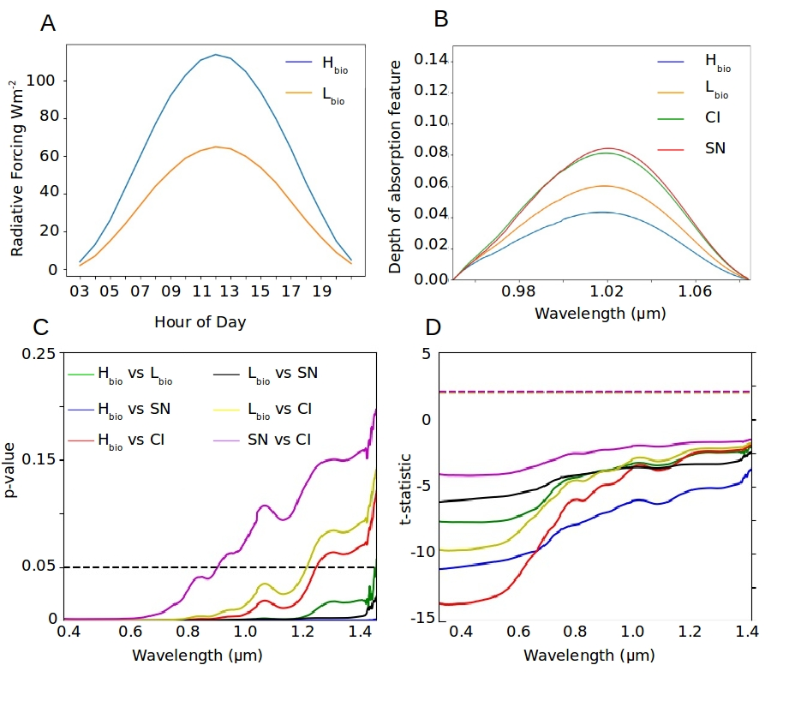

Supp Info 6: Confusion matrices and normalised confusion matrices for the final RF model applied to UAV (A,B) and Sentinel-2 (C,D) multispectral data. Confusion matrices show predicted class on the y-axis and actual class on the x-axis. The score at the intersections shows the frequency of instances – i.e. higher scores along the top-left to bottom-right diagonal indicate a more accurate classifier.

