


STATEMENT OF WORK BETWEEN
Client
And
JMAN Group

1 Introduction to JMAN

JMAN is a Data & Analytics Consultancy with 325 employees across London, Chennai, and New York. Our international team is a unique blend of consulting, data science and technology expertise. We specialise in working with private equity firms, and their portfolio companies across the investment lifecycle from diligence to exit. Over the last year, we have worked on 375+ projects with 100 portfolio companies across 51 funds. The experience we have on both sides of the deal in Diligence and at Exit, with some of the most sophisticated data adopters in private equity, gives us a good understanding of how businesses are evaluated, and what bidders are looking for from data.

2 Business Context

PURE FINANCIAL ADVISORS LLC operates within the financial advisory and wealth management industry, serving clients across the United States. Their primary business offerings include comprehensive financial advisory services and asset management, utilizing a business-to-consumer model. Key stakeholders in this initiative are Jason Carver, Client Engagement Manager, and Lee Equity Partners, the firm’s investment partner.

The current focus centers on enhancing the firm's Lead-to-AUM (L2A) pipeline and customer acquisition cost (CAC) reporting capabilities. PURE seeks to address limited granularity in existing pipeline reporting and the absence of integrated, actionable insights into CAC. Data, technology, and marketing teams are directly involved, with their work supported by platforms such as Salesforce, Tamarac, Azure Blob Storage, Microsoft Fabric, Azure Synapse, Power BI, and, prospectively, QuickBooks.

This initiative is strategically critical to PURE’s growth objectives. By delivering a detailed L2A and CAC data model, integrated reporting suite, and automated data pipelines, PURE aims to empower leadership with deeper visibility into the customer journey, marketing ROI, and pipeline performance. The anticipated solution will position PURE to drive data maturity, support scalable analytics, and make more informed investment decisions in marketing and client acquisition.

3 Overview

PURE FINANCIAL ADVISORS LLC’s data, technology, and marketing teams are actively engaged in pipeline and customer acquisition reporting efforts. These teams coordinate across several established processes to manage, analyze, and report on business pipeline and client acquisition metrics.

The organization’s operational environment features a suite of integrated tools and platforms, including Salesforce, Tamarac, Azure Blob Storage, Microsoft Fabric, Azure Synapse, and Power BI. A Power BI reporting suite currently provides analytics capabilities, drawing data primarily from Salesforce, Tamarac, Azure Blob Storage, and, pending integration, QuickBooks. Microsoft Fabric and Azure Synapse serve as the core data platform infrastructure supporting batch data processing requirements. Integration efforts focus on connecting and ingesting data from QuickBooks, with special attention to assessing data quality for customer acquisition cost (CAC) reporting.

4 Understanding

• Limited granularity in current pipeline reporting and lack of integrated Customer Acquisition Cost (CAC) insights hinder marketing and operational decision-making.
• Existing reporting does not provide detailed visibility into the entire journey from lead generation to assets under management (AUM).
• The current process lacks an automated data ingestion pipeline from QuickBooks, creating gaps in CAC calculation and reporting accuracy.
• Data quality assessment is required to ensure reliable metrics, particularly for CAC reporting.
• Enhanced data models for Lead-to-AUM and CAC are needed to accommodate advanced analytics and more actionable insights.
• Integration with both Salesforce and QuickBooks is mandatory to capture and unify all relevant pipeline and financial data.
• Automation of data ingestion and transformation pipelines is required to support timely, consistent, and scalable reporting.
• The new reporting solution must serve data and technology stakeholders, senior leadership, and marketing teams for improved decision support.

5 Objectives

• Deliver a comprehensive Lead-to-AUM (L2A) and Customer Acquisition Cost (CAC) data model and reporting suite providing granular insights into pipeline performance and marketing ROI.
• Automate data ingestion, transformation, and reporting refresh processes to streamline information flow and improve reporting accuracy.
• Enable leadership to gain a detailed understanding of the customer journey from lead generation to asset conversion, with clear measurement of marketing spend effectiveness.
• Enhance user experience through improved Power BI dashboards featuring precise KPI definitions and intuitive visualizations.
• Strengthen pipeline reporting and customer acquisition cost tracking to support data-driven business decisions.
• Ensure the data platform and reporting capabilities are scalable to accommodate future data sources and evolving reporting needs, with seamless integration to Salesforce, QuickBooks, Tamarac, and Azure Fabric.

6 Deliverables

Throughout the engagement with PURE FINANCIAL ADVISORS LLC, the following key deliverables and artifacts will be provided to ensure a comprehensive and actionable outcome aligned with the project objectives:

1. KPI Book
• Contains detailed definitions for Lead-to-AUM (L2A) and Customer Acquisition Cost (CAC) metrics relevant to pipeline performance and marketing ROI.
• Documents calculation logic, data sources, and associated business rules for all tracked KPIs.
• Provides mapping of KPIs to user personas and use cases.
• Format: Structured Excel workbook and accompanying PDF document, delivered at the conclusion of discovery (Phase 3A).

2. Power BI Mock-ups
• Includes up to 8 detailed view mock-ups illustrating proposed dashboards and visualizations for L2A and CAC reporting.
• Showcases data flows, dashboard layouts, and interactivity features tailored to PURE’s reporting requirements.
• Provides clear representation of KPI displays and user navigation experience.
• Format: PDF slides and Power BI file with annotated screenshots, delivered following requirements confirmation.

3. Data Model Design
• Outlines the conceptual, logical, and physical data models supporting L2A and CAC reporting.
• Details data entities, relationships, data flow diagrams, and integration points with Salesforce, QuickBooks, Tamarac, and Microsoft Fabric.
• Includes specifications for batch data pipelines and transformation logic.
• Format: Visual diagrams (Visio or equivalent) and supporting technical documentation, delivered near the end of the discovery phase.

4. Data Gap Assessment
• Identifies gaps, inconsistencies, and quality issues in existing data sources required for L2A and CAC metrics.
• Recommends remediation actions, priorities, and integration dependencies.
• Assesses impact on reporting accuracy and timelines.
• Format: Written assessment report with supporting summary matrix, delivered as part of discovery outputs.

5. Technical Approach
• Provides a detailed plan for integrating QuickBooks, outlining the end-to-end architecture, required connectors, and data flow design.
• Defines data ingestion, transformation, and refresh cycles for each source system in Microsoft Fabric.
• Includes testing strategy, error handling, and monitoring considerations.
• Format: Technical design document and workflow diagrams, delivered during the latter half of the discovery phase.

6. Phase 3B Implementation Plan
• Details the step-by-step execution roadmap for the build phase, including milestones, resource assignments, dependencies, and estimated timelines.
• Aligns deliverable completion with business priorities and key stakeholder checkpoints.
• Outlines required approvals, staging, and production migration processes.
• Format: Project plan in Microsoft Project (or equivalent) and summary slides, delivered at the end of discovery.

Each deliverable will be iteratively reviewed with PURE FINANCIAL ADVISORS LLC’s leadership and technical teams to ensure alignment with business goals and to incorporate feedback promptly. This structured approach guarantees transparency, accountability, and measurable value throughout the engagement lifecycle.

7 Approach

This engagement will leverage a systematic, data-driven methodology to enhance Pure Financial Advisors LLC’s Lead-to-AUM (L2A) and Customer Acquisition Cost (CAC) reporting capabilities. Our team will partner closely with Pure’s data, technology, and marketing teams to design and implement scalable, automated solutions that deliver granular insights into the pipeline and optimize marketing ROI. The approach prioritizes the integration of critical data sources, development of advanced data models, and delivery of user-centric Power BI dashboards.

The methodology consists of two tightly scoped phases. Each phase is designed to mitigate risks and dependencies, drive rapid, high-impact outcomes, and deliver clear, actionable deliverables—including a detailed KPI Book, Power BI mock-ups, comprehensive data models, and a practical implementation roadmap. Activities are fully aligned to support streamlined data ingestion, robust quality assessments, and accelerated time-to-value.

Phase 3A: Discovery & Design, Duration: 3 weeks, Timeline: Week 1 to Week 3
Summary: This phase establishes project requirements, designs the L2A and CAC data models, and defines key reporting metrics and user experiences.
Activities:
• Conduct stakeholder interviews to capture reporting requirements and success criteria
• Analyze source systems (Salesforce, Tamarac, QuickBooks, Azure Blob Storage) for data structure and quality
• Develop a detailed Data Gap Assessment and document integration dependencies
• Define the L2A and CAC data models, including metric calculation logic and business rules
• Design Power BI reporting mock-ups (up to 8 pages) with clear KPI visualizations
• Produce a KPI Book to standardize metric definitions and governance

Phase 3B: Build & Implementation Planning, Duration: 8–12 weeks, Timeline: Week 4 to Week 15
Summary: This phase focuses on implementing automated data ingestion, data transformation pipelines, and integrating QuickBooks into the reporting ecosystem.
Activities:
• Build automated batch data pipelines in Microsoft Fabric for L2A and CAC reporting
• Integrate QuickBooks data with Salesforce, Tamarac, and Azure platforms
• Validate data quality and completeness across all reporting inputs
• Develop and deploy scalable Power BI dashboards for L2A and CAC insights
• Prepare technical documentation for ongoing data processes and security standards
• Deliver a Phase 3B Implementation Plan outlining support, future scalability, and next steps

Each phase is structured to yield tangible, reviewable deliverables and actionable recommendations. This phased approach ensures that foundational requirements are fully captured and addressed before moving to system implementation, thereby reducing risks and optimizing resource allocation. By working iteratively in partnership with Pure Financial Advisors LLC, we will enable the firm to achieve higher levels of data maturity and empower decision-makers with timely, accurate, and actionable L2A and CAC insights.
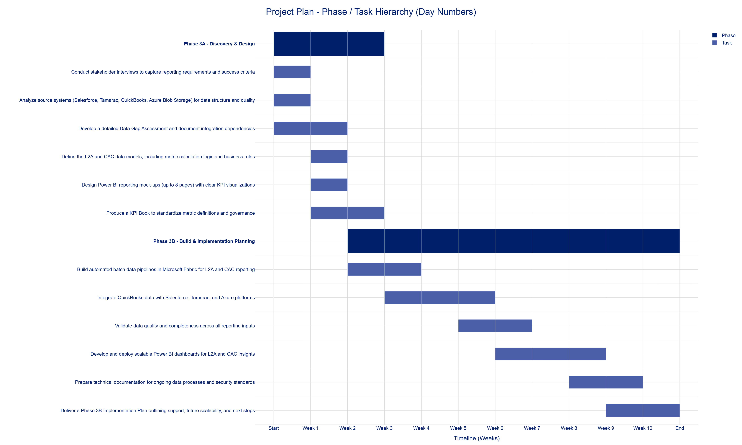
Figure: Project Timeline - Gantt Chart

8 Outcomes

This engagement will empower PURE FINANCIAL ADVISORS LLC with accurate, automated, and granular Lead-to-AUM (L2A) and Customer Acquisition Cost (CAC) reporting. The solution will deliver actionable insights into pipeline performance and marketing ROI, enabling leadership to make data-driven decisions and optimize resource allocation. Success will be measured by improved visibility and refined KPIs, driving greater data maturity and scalable reporting for continued business growth.

Expected Business Outcomes

• Granular Pipeline Visibility: Provide detailed tracking of the lead journey from initial contact to asset conversion, improving understanding of pipeline performance.
• Actionable Marketing ROI Insights: Measure and analyze marketing spend effectiveness using Customer Acquisition Cost KPIs, enabling smarter marketing investments.
• Automated Reporting and Data Flows: Reduce manual effort through automation of data ingestion, transformation, and reporting refresh processes, ensuring timely and accurate insights.
• Enhanced Leadership Decision-Making: Equip stakeholders with clear, Power BI-driven dashboards, offering intuitive visualizations and definitions of key metrics.
• Scalable Data & Reporting Foundation: Establish a robust, future-ready data platform capable of integrating additional sources and supporting Pure’s long-term growth strategies.

9 Business Impact

• Enhanced Financial Transparency: Implementing detailed L2A and CAC reporting will provide PURE FINANCIAL ADVISORS LLC with deep visibility into the effectiveness of their client acquisition funnel and marketing spend, allowing for rapid identification of cost-saving opportunities and underperforming channels.

• Optimized Marketing ROI: Granular data on the journey from lead to AUM and real-time CAC metrics will enable marketing and executive teams to reallocate resources with precision, maximizing returns and reducing wasted spend by up to 20% through targeted optimization.

• Streamlined Operations Through Automation: Automated data ingestion, transformation, and reporting refresh processes will reduce manual reporting efforts across Data, Technology, and Marketing teams, improving operational efficiency and freeing up capacity for high-value analysis.

• Strategic Decision Support: Leadership will benefit from clear, actionable insights into pipeline performance, empowering evidence-based, strategic decisions that drive future growth and increase total assets under management (AUM).

• Scalable Data Foundation: The solution will deliver a future-proof data platform leveraging Microsoft Fabric and Azure Synapse, ensuring scalability to accommodate additional data sources and evolving reporting needs as the organization grows.

By establishing automated, accurate, and actionable L2A and CAC reporting, this initiative positions PURE FINANCIAL ADVISORS LLC to continuously improve marketing investments, strengthen strategic planning, and sustain long-term, scalable business growth.

