The Financial Opportunity Cost of Continued Navy Service
A General Internist Case
James M. Day
September 29, 2026
BUS 620 - Micro and Macro Economics
Individual Research Paper - A Global Challenge, Analyzed

Challenge and approach
The Navy needs to retain physicians without assuming that every civilian salary advantage requires an equivalent bonus. The Government Accountability Office (GAO, 2020) found that military cash compensation trailed civilian medians in 21 of 27 medical and dental specialties reviewed. Its June 2026 update still lists recommendations on replacement costs, retention data, and civilian wages as unimplemented. This continuing information gap supports evaluating compensation more carefully.
The economic question is what a physician gives up by staying. Past medical-school support is a sunk cost; future pay, pension eligibility, and working conditions affect the decision (Frank et al., 2022). This case compares an O-4 general internist leaving at 10 active-service years with remaining to 20. The physician is married, age 37, and stationed in San Diego. Marit Health's (2026) $459,057 local compensation average is a benchmark, not a matched offer. The model treats it as civilian employee cash pay and adds benefits separately. Appendix A specifies all inputs.
Both comparisons use the same O-4 longevity increases and pension base. Cash flows are discounted at 5% real and pension payments at an illustrative 3%. The latter reflects inflation protection, but alternative rates are tested. All amounts are in constant 2026 dollars; reaching retirement eligibility is assumed, not guaranteed.

Results and their meaning
The four-year gross-pay comparison produces a $636,209 present-value civilian advantage, but stops before pension eligibility. Across the full ten years, the gross civilian advantage is $1,349,196, offset by a conditional pension worth $733,228. Thus, staying costs $615,968 on the gross basis. Figure 1 shows this cost falling as retirement approaches, with break-even near 14.3 years. These calculations include longevity increases without promotion; Appendix B makes the annual arithmetic visible.
Taxes and benefits substantially change that comparison. Tax-free housing and subsistence allowances favor Navy pay, while civilian wages face income and payroll taxes. After adding employer retirement contributions and subtracting civilian insurance and health premiums, staying costs $58,419. Break-even moves to 10.9 years. This is a tax-adjusted compensation comparison, not spendable income: retirement contributions are included at face value, and later withdrawal taxes are omitted. Appendix C identifies the tax brackets and simplifications.
Figure 2 then adds retiree health coverage, bringing staying to approximately break-even. A qualifying Navy domicile without state income tax raises its value to $98,456; assumed continuation pay raises it to $114,808. A 5% civilian earnings penalty after military retirement lowers it to $29,072. These are conditional scenarios, not a confidence interval. The near-zero results should not be presented as proof that staying is financially superior.

Policy implications and supporting evidence
The gross and adjusted break-even estimates answer different questions; neither identifies when bonuses cause the largest retention response. The size of their difference motivates testing whether physicians understand total compensation. Workload, deployment, autonomy, and family needs may instead explain departures. Baseline knowledge and exit reasons should determine whether communication or changes to pay and working conditions deserve priority.
Civilian health care provides a practical precedent. NHS Employers (2022, 2025) supplies communication guides and personalized Total Reward Statements covering pay, allowances, and pensions. At United Lincolnshire Hospitals, individual retirement discussions accompanied a broader retention effort; 18 retiring staff returned in its first quarter (NHS Employers, 2020). That uncontrolled experience cannot isolate the effect of education. Randomized military and university experiments show that financial information can change retirement-plan participation, but do not establish a retention effect (Goldin et al., 2020; Duflo & Saez, 2003).
The model remains sensitive to assumptions. Increasing the pension discount rate from 3% to 5% raises the adjusted cost of staying from $58,419 to $234,384. Adding an illustrative 9.3-percentage-point pension state tax raises it to $126,609. The salary benchmark mixes employers and experience levels; promotion, deductions, retirement-account taxation, and separation risk are incompletely modeled. Individual estimates and sensitivity disclosure are essential.

Recommendation and decision rule
The Navy should adapt the NHS statement and communication plan into physician-specific counseling for officers whose obligations end within 12 months. A personalized comparison would show current cash, taxes, special pays, pension eligibility, and civilian offer assumptions. A financial counselor would use the Navy continuation-pay checklist structure (Financial Readiness Program, n.d.) to review obligations and uncertainties, then document unanswered questions. Appendix F provides the adapted materials. Existing Navy career-counseling resources offer instructional examples, although their enlisted focus requires adaptation (MyNavy HR, n.d.).
Randomize commands to enhanced counseling or usual information, balance specialty and service stage, and analyze physicians by assigned group with clustering accounted for. Measure knowledge before counseling and at six months, and actual retention at 24 months. Information can spread among colleagues, supporting command-level assignment. A prospective power calculation should determine the required commands and cohorts; initially test feasibility and comprehension if adequate recruitment is not possible.
Before enrollment, approve proposed expansion criteria: a five-percentage-point retention improvement, a 95% confidence interval excluding zero, and cost per additional physician retained for 24 months below 25% of documented specialty replacement cost. These thresholds are policy judgments, not findings from the cited programs. Include counselor and administrative costs. If knowledge improves without retention, do not expand on awareness alone; use departure reasons to reconsider pay and working conditions. Report inconclusive results without claiming success.

Figure 1 Break-even depends on what is counted
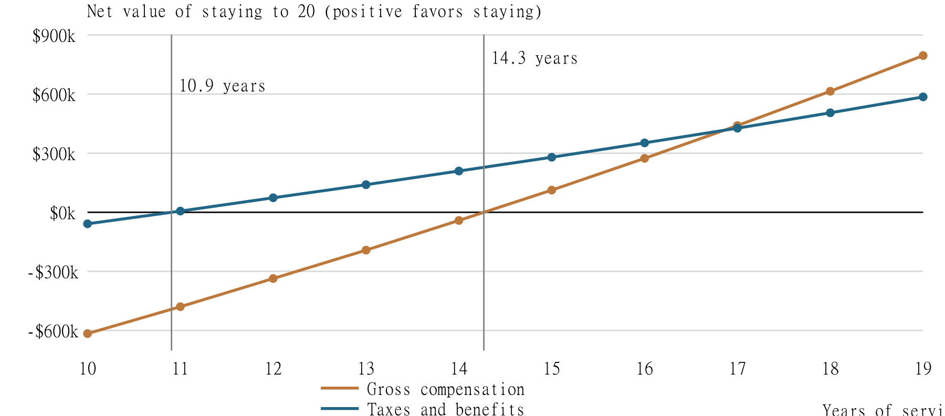
The same O-4 longevity pay and $50,274 annual pension are used on both paths. Pension: 30 payments discounted at 3%; pre-retirement compensation: 5%. The adjusted line excludes retiree health, continuation pay, and later civilian pay differences. Crossings are interpolated, not causal retention estimates. Sources and calculations: Appendices A-D.

Figure 2 Taxes and benefits narrow the difference
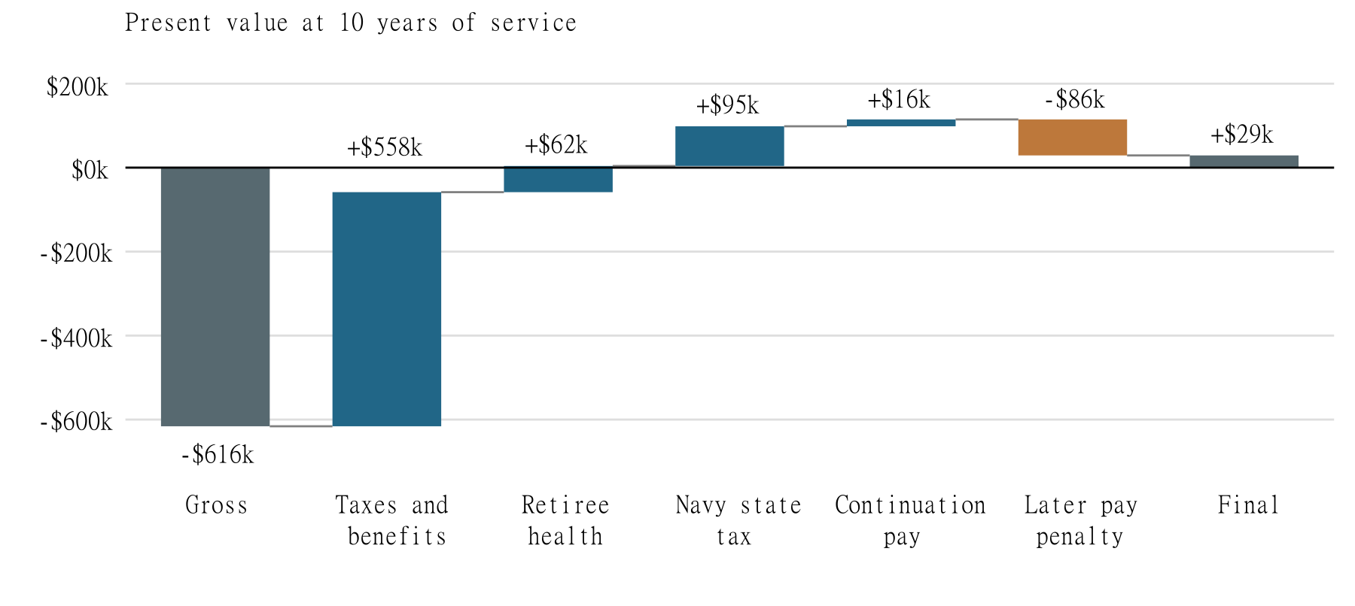
Each step adds to the preceding result. Positive values favor staying. Navy state tax means a qualifying domicile without state income tax during active duty. Later pay penalty means 5% lower civilian pay after military retirement, through age 65. Values are rounded; exact totals and assumptions appear in Appendix D.

References
California Employment Development Department. (2026). Contribution rates and benefit amounts. https://edd.ca.gov/en/Disability/Contribution_Rates_and_Benefit_Amounts
California Franchise Tax Board. (2025a). 2025 California tax rate schedules. https://www.ftb.ca.gov/forms/2025/2025-540-tax-rate-schedules.pdf
California Franchise Tax Board. (2025b). 2025 personal income tax booklet. https://www.ftb.ca.gov/forms/2025/2025-540-booklet.html
Defense Finance and Accounting Service. (2026a). Basic pay for commissioned officers. https://www.dfas.mil/MilitaryMembers/payentitlements/Pay-Tables/Basic-Pay/CO/
Defense Finance and Accounting Service. (2026b). Basic allowance for subsistence. https://www.dfas.mil/militarymembers/payentitlements/Pay-Tables/BAS/
Defense Finance and Accounting Service. (2026c). Medical Corps special pay tables for fiscal year 2026. https://www.dfas.mil/militarymembers/payentitlements/Pay-Tables/HPO4/
Defense Travel Management Office. (n.d.). BAH rate lookup. https://www.travel.dod.mil/Allowances/Basic-Allowance-for-Housing/BAH-Rate-Lookup/
Department of Defense. (2017). Blended Retirement System defined contribution fact sheet. https://militarypay.defense.gov/Portals/3/Documents/BlendedRetirementDocuments/BRSDefinedContributionFactSheet18Aug2017.pdf
Department of Defense. (n.d.). Military retirement. https://militarypay.defense.gov/Pay/Retirement/

References continued
Duflo, E., & Saez, E. (2003). The role of information and social interactions in retirement plan decisions: Evidence from a randomized experiment. The Quarterly Journal of Economics, 118(3), 815-842. https://eml.berkeley.edu/~saez/tdafairQJE.pdf
Financial Readiness Program. (n.d.). Entitlement to continuation pay: Counselor checklist. https://finred.usalearning.gov/assets/downloads/TC%206%20CP%20Counselor%20Checklist%201220E1R1.pdf
Frank, R. H., Bernanke, B. S., Antonovics, K., & Heffetz, O. (2022). Principles of economics: A streamlined approach (4th ed.). McGraw Hill.
Goldin, J., Homonoff, T., Patterson, R. W., & Skimmyhorn, W. L. (2020). How much to save? Decision costs and retirement plan participation (Working Paper No. 27575). National Bureau of Economic Research. https://www.nber.org/papers/w27575
Internal Revenue Service. (2025a). Tax inflation adjustments for tax year 2026 (IR-2025-103). https://www.irs.gov/newsroom/irs-releases-tax-inflation-adjustments-for-tax-year-2026-including-amendments-from-the-one-big-beautiful-bill
Internal Revenue Service. (2025b). COLA increases for dollar limitations on benefits and contributions. https://www.irs.gov/retirement-plans/cola-increases-for-dollar-limitations-on-benefits-and-contributions
Internal Revenue Service. (2025c). Publication 3: Armed Forces tax guide. https://www.irs.gov/publications/p3

References continued
KFF. (2025). Employer health benefits survey. https://www.kff.org/health-costs/2025-employer-health-benefits-survey/
Marit Health. (2026, April 30). Internist salary in San Diego, California. https://www.marithealth.com/o/-/internist/salary/san-diego-ca
MyNavy HR. (n.d.). Career counseling resources. https://www.mynavyhr.navy.mil/Career-Management/Career-Counseling/Resources/
NHS Employers. (2020, August 11). Improving retention at all stages of nurses' careers: United Lincolnshire Hospitals NHS Trust. https://www.nhsemployers.org/case-studies/improving-retention-all-stages-nurses-careers
NHS Employers. (2022, December 12). Reward communications guide. https://www.nhsemployers.org/publications/reward-communications-guide
NHS Employers. (2025, September 29). Total Reward Statements. https://www.nhsemployers.org/articles/total-reward-statements
Social Security Administration. (2026). Contribution and benefit base determination. https://www.ssa.gov/oact/COLA/cbbdet.html
TRICARE. (2026). TRICARE 2026 costs and fees. https://tricare.mil/-/media/Files/TRICARE/Publications/FactSheets/Costs_Fees.pdf

References continued
U.S. Government Accountability Office. (2020). Defense health care: DOD should collect and use key information to make decisions about incentives for physicians and dentists (GAO-20-165). Includes June 2026 recommendation updates. https://www.gao.gov/products/gao-20-165
Vanguard. (2025). How America saves 2025. https://corporate.vanguard.com/content/dam/corp/research/pdf/how_america_saves_report_2025.pdf
The White Coat Investor. (n.d.). How to buy disability insurance. https://www.whitecoatinvestor.com/how-to-buy-disability-insurance/

Appendix A Compensation and assumptions
Table A1. O-4 annual cash compensation by completed service years. BAH is $5,082 per month for ZIP 92134 with dependents. BAS is $328.48 per month. Incentive pay, board certification pay, and retention bonus total $99,000 per year.
Completed years | Basic pay | Navy gross cash
10-11 | $113,040 | $276,966
12-13 | $118,660 | $282,585
14-15 | $122,573 | $286,499
16-17 | $124,819 | $288,745
18-19 | $126,119 | $290,045
Sources: DFAS (2026a-c), DTMO (n.d.). Pay rates are held in 2026 dollars. The $48,000 annual retention bonus assumes continued eligibility and agreements covering the full comparison horizon; it is not guaranteed. No promotion is assumed.
Civilian employee cash pay is $459,057 each year (Marit Health, 2026). Current age is 37; retirement occurs at 47; work ends at 65. Married filing jointly, one income, no child credits. No VA benefits, survivor coverage, pay growth, transition cost, or first-year pay reduction is included.

Appendix A Benefit assumptions continued
Item | Annual amount or assumption
BRS service contribution | 5% of basic pay; full eligibility and employee contributions assumed
Civilian employer match | $16,560 = 4.6% of min($459,057, $360,000)
Civilian worker health premium | $6,850 family premium share
Private disability insurance | $13,771.71 = 3% of civilian pay
Retiree health sensitivity | $6,085 = $6,850 avoided premium less $765 fee
Continuation pay sensitivity | $23,550 in comparison year 2; 2.5 months of basic pay
Sources: DoD (2017), Vanguard (2025), IRS (2025b), KFF (2025), TRICARE (2026), and The White Coat Investor (n.d.). Continuation pay is a conditional scenario assumption; eligibility, future rates, and obligation terms must be confirmed.
Employer contributions are compensation value, not current cash. Their future withdrawal taxes and employee contribution deductions are excluded. Insurance at 3% is an illustrative quote proxy. Health savings ignore deductibles, copays, and differences in access. These assumptions require individual verification.

Appendix B Annual adjusted comparison
Table B1. Dollars rounded for display; calculations use unrounded values. Civilian adjusted compensation is $305,005.33 every year. Navy tax includes federal, California, and employee payroll taxes. Navy value equals gross cash minus taxes plus the BRS service contribution.
Year | Navy gross | Navy tax | Navy value | Civilian gap
1 | 276,966 | 55,069 | 227,549 | 77,457
2 | 276,966 | 55,069 | 227,549 | 77,457
3 | 282,585 | 56,909 | 231,609 | 73,396
4 | 282,585 | 56,909 | 231,609 | 73,396
5 | 286,499 | 58,191 | 234,436 | 70,569
6 | 286,499 | 58,191 | 234,436 | 70,569
7 | 288,745 | 58,927 | 236,059 | 68,946
8 | 288,745 | 58,927 | 236,059 | 68,946
9 | 290,045 | 59,352 | 236,998 | 68,007
10 | 290,045 | 59,352 | 236,998 | 68,007
The present value of the annual civilian gaps at 5% is $557,014.21. The corresponding gross gaps total $1,349,196.04 in present value. For the first four years, the gross-gap present value is $636,208.84. All payments occur at year end. Tax and civilian benefit components are specified in Appendix C.

Appendix C Tax calculation inputs
Federal income tax uses 2026 married-filing-jointly brackets and a $32,200 standard deduction (IRS, 2025a). California uses the published 2025 Schedule Y and $11,080 standard deduction as a proxy held constant; these are not verified 2026 California brackets (FTB, 2025a, 2025b).
Marginal rate | Federal lower bound | California lower bound
10% federal / 1% CA | $0 | $0
12% / 2% | $24,800 | $22,158
22% / 4% | $100,800 | $52,528
24% / 6% | $211,400 | $82,904
32% / 8% | $403,550 | $115,084
35% / 9.3% | $512,450 | $145,448
37% federal | $768,700 | Not used
Apply each marginal rate only to taxable income within its bracket. California income remains below the next $742,958 threshold in all reported cases. State exemption credits, itemization, SALT interactions, and alternative minimum tax are excluded. The model is an illustration, not a tax return.

Appendix C Worked example and payroll taxes
Year 1 Navy taxable wages are $276,965.76 minus $64,925.76 in BAH and BAS, or $212,040 (IRS, 2025c). Civilian wages are $459,057. Taxable income for each tax is wages minus that tax system's standard deduction.
Year 1 component | Navy | Civilian
Federal income tax | $28,989 | $89,506
California income tax | $11,567 | $34,539
Employee payroll tax | $14,514 | $25,945
Total modeled taxes | $55,069 | $149,990
Payroll tax = 6.2% of wages up to $184,500, plus 1.45% of all wages, plus 0.9% above $250,000 for this joint household. California civilian wages also incur 1.3% SDI (SSA, 2026; EDD, 2026). Military allowances are excluded from wages.
Civilian value = $459,057 - $149,989.96 + $16,560 - $6,850 - $13,771.71 = $305,005.33. Navy year-1 value = $276,965.76 - $55,068.94 + $5,652 = $227,548.82. Difference = $77,456.51.

Appendix D Pension and present value
Define A(r,n) = [1 - (1+r)^(-n)] / r. For n remaining years, the pension value is annual pension times A(0.03,30), divided by (1.03)^n. Each remaining annual compensation gap is divided by (1.05)^t, with t starting at 1.
High-3 basic pay = ($124,819.20 + $126,118.80 + $126,118.80) / 3 = $125,685.60. The BRS annual pension is 2% times 20 years times High-3 = $50,274.24 (DoD, n.d.). The first of 30 pension payments occurs one year after retirement.
At 10 years, gross pension PV = $733,228.13. Subtracting the gross remaining pay gap of $1,349,196.04 gives -$615,967.91. Applying a flat illustrative 32% federal pension tax gives pension PV of $498,595.13. Subtracting the adjusted compensation gap of $557,014.21 gives -$58,419.08.
At each later service year, discard completed compensation years and discount the remaining gaps from that decision date. Keep the same retirement pension. Interpolate between the last negative and first positive net value. This gives 14.27 years for gross compensation and 10.90 for the adjusted comparison.
No pension probability adjustment is made. A 32% pension tax for all 30 payments is a simplification: actual rates depend on later earnings, deductions, residence, and tax law. Appendix E tests a higher combined pension-tax assumption.

Appendix D Cumulative adjustments
Table D1. Net value of staying at 10 years, rounded to dollars; each row adds the stated change. Positive values favor staying. The cash and pension paths share the same longevity schedule and High-3 base.
Comparison | Net value
Gross compensation; untaxed pension | -$615,968
Taxes and current benefits | -$58,419
Add retiree health value | $3,854
Add no-income-tax Navy domicile | $98,456
Add assumed continuation pay | $114,808
Add 5% later civilian pay penalty | $29,072
Retiree health PV = $6,085 times A(0.03,18) / (1.03)^10 = $62,273.31. Removing active-duty Navy state income tax saves $94,602.25 in PV. Continuation pay contributes $16,351.50 after incremental federal and payroll tax, discounted two years.
The later earnings penalty costs $85,736.06 in PV. It compares civilian pay of $459,057 and $436,104.15 after modeled wage taxes, employer match, and 3% insurance, for 18 years after retirement. Fixed health premiums cancel. These scenarios are not additive beyond the sequence shown.

Appendix E Sensitivity and model boundaries
Change from adjusted base | Net value of staying
Base: California wages, 3% pension discount | -$58,419
Pension discount 5% | -$234,384
Civilian salary $400,000 | $201,025
Civilian salary $350,000 | $436,422
Pension tax 41.3% instead of 32% | -$126,609
Each sensitivity changes one input. Lower civilian salary also changes its taxes and 3% insurance cost. Pension tax of 41.3% adds an illustrative 9.3-percentage-point state burden; it is not a forecast of residence or a complete future tax calculation.
The benchmark combines employer types and experience levels. The model treats it as an employee offer with separately specified benefits; an actual offer may have different hours, call, productivity risk, retirement terms, or insurance coverage. Those differences must be checked before drawing an individual conclusion.
The comparison does not estimate retention elasticity, command vacancies, replacement costs, or readiness outcomes. Financial break-even is not evidence of a bonus effect. Promotion, clinical re-entry, medical separation, future pension taxation, and personal preferences can change the result.

Appendix F Adapted counseling materials
These proposed materials adapt NHS Employers (2022, 2025), the Financial Readiness Program (n.d.) counselor checklist, and MyNavy HR (n.d.) training resources. They are designed for this pilot; they are not a validated physician-retention intervention.
F1. Personalized compensation statement. Record specialty, service years, obligation end date, retirement system, household assumptions, and the date of each pay source. Compare leaving when eligible with staying to retirement using the same time horizon. Show annual after-tax cash separately from employer contributions and pension present value. Include BAH/BAS, special pays, bonus obligations, insurance, and civilian offer terms. Show uncertainty ranges and allow the physician to correct inputs.
F2. Counseling checklist. Confirm eligibility and current benefit rules; explain contingent benefits and added service obligations; review the actual civilian offer or label any benchmark; discuss taxes and pension assumptions; ask the physician to explain the main tradeoff in their own words; record corrections, unresolved questions, and a follow-up date. A financial counselor handles the comparison, with personnel specialists verifying eligibility.
F3. Reasons for leaving. Ask the physician to rank compensation, workload, deployment, clinical practice, autonomy, location, and family needs, with space for other reasons. Ask which change could affect the decision. Record benefits knowledge separately from satisfaction so accurate understanding is not mistaken for a desire to stay.

Appendix F Delivery and evaluation plan
F4. Communication plan. The pilot lead maintains a schedule identifying audience, message, delivery channel, owner, and completion date, following NHS Employers (2022). Invite eligible physicians before their obligation ends; offer a private statement review and a short individual session; provide a written summary and a route to correct errors. Train counselors on the same material and record attendance and session duration.
F5. Knowledge measure. Before counseling and at six months, use the same five scored questions with answers checked against current rules: identify taxable versus tax-exempt pay; identify pension eligibility; explain the bonus obligation; distinguish annual cash from pension present value; and identify an assumption that could reverse the comparison. Record the score from zero to five. This proposed instrument requires comprehension testing before use.
F6. Outcome record. For each assigned physician, record command, specialty, service stage, baseline knowledge, treatment assignment, participation, six-month knowledge, and active-service status 24 months after the original obligation ends. Record separation reasons and distinguish voluntary departures from involuntary losses. Keep physicians in their assigned groups for analysis and report missing outcomes.
F7. Cost and decision record. Compare retention proportions using the prespecified analysis with command clustering. Divide incremental program cost by estimated additional physicians retained only when that estimate is positive. Report uncertainty and avoid a cost-effectiveness claim when the effect is indistinguishable from zero. The main-text expansion thresholds require approval before results are observed; source programs do not establish those numerical targets.

