1 Rob3 Simulator

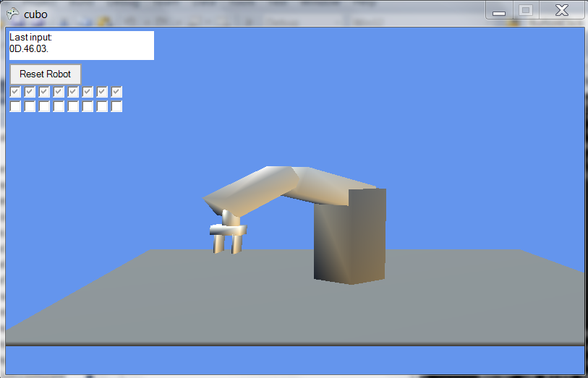

At this moment it can simulate the following robot’s functionality:

* Move single axis
* Move multiple axis
* Move single axis with speed
* Move multiple axis with speed
* Read steps of single axis
* Read steps of multiple axis
* Read digital input
* Write to digital output

At the left upper corner of the window, you can see each command buffer the robot receives. If the received buffer does not hold a valid command, the robot will not do anything.

2 Using the simulador

Perform the following steps to install and use the simulator:

* Download Rob3Sim.rar from CLIP
* Extract into a folder, e.g. c:\rob3sim
* It you did not do it before, install the xnafx40_redist.msi (it has been extracted into the mentioned folder)
* Run Rob3Sim as administrator (otherwise it will not launch).

Perform the following steps to prepare your project to run the simulator:

* Replace the file serial32.cpp with the one provided inside rob3sim.rar
* Goto project properties->linker->input->additional dependencies; add wsock32.lib library, as illustrated in the figure below (don’t forget the semicolon)

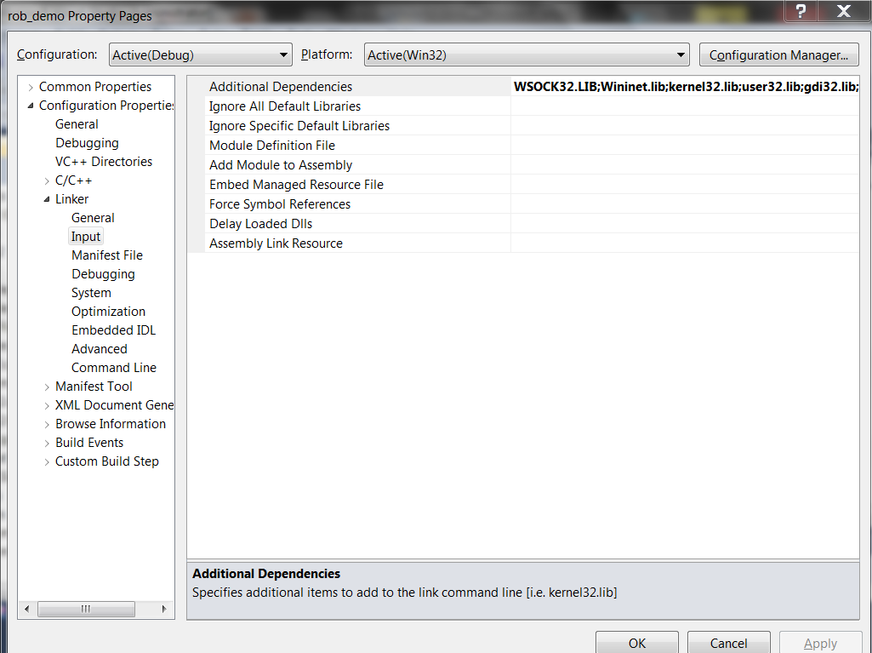

Switching from simulator to robot:

Inside serial32.cpp, uncomment the macro USE_REAL_ROBOT

Good work.