Group Cross Selling Management System

Administration Module User Manual - 2018-10-04

V.1.0

CONTENT

1.0 General Information 03

1.1 System Overview 03

1.2 Organization of the Manual 03

2.0 System Summary 04

2.1 System Configurations 04

2.2 User Access Levels 04

3.0 Getting Started 05

3.1 Logging On 05

3.2 System Menu 06

3.3 Changing User ID and Password 06

4.0 Using The System 07

4.1 Administration Module 07

4.1.1 Business Entity Management 07 - 08

4.1.2 Product Management 09 - 10

4.1.3 User Management 11 - 13

4.1.4 User Role Management 14 - 15

1.0 GENERAL INFORMATION

1.1 System Overview
Selling of group of company products/services to a customer irrespective to the assigned
unit, is the broad definition of what cross sell means. It can be selling an existing account
customer a credit card or selling an existing credit card customer a mortgage.

NDB has been using cross sell as a marketing approach to expand its footprint and also increase its customer base. The more relationships the bank has with a customer is as good as one having a better wallet share of the customer.

More spends on all the products of the bank leads to better top- and bottom-line performance. Cross-selling comes with its advantages.It considerably reduces customer acquisition costs, servicing, and marketing and communication costs and thereby substantially increases spread for the bank. It is well understood and key finding that greater the number of products held by customer leads to an increased probability of retention.

1.2 Organization of the Manual
The user manual consists of four sections: General Information, System Summary, Getting Started and Using the System.

General Information section explains in general terms about the system and the purpose for which it is intended.

System Summary section provides a general overview of the system. The summary outlines the uses of the system hardware and software requirements, system configuration, user access levels and system behavior in case of any contingencies.

Getting Started section explains how to get NDB GCSM System and install it on the device. The section briefly presents system menu.

Using the System section provides a detailed description of system functions.

2.0 SYSTEM SUMMARY
System Summary section provides a general overview of the system. The summary outlines the uses of the system hardware and software requirements, system configuration, user access levels and system behavior in case of any contingencies.

2.1 System Configurations
NDB GCSM System operates as a Web based application. It is compatible with Chrome browser level 9. This system is not compatible with Internet Explorer.

Live Web URL:
Note: IP and port will change depending on other environments.

Test Web URL: https://10.96.197.5:8443/.../...

2.2 User Access Levels
Access Levels | Functions
Inputer | - Cross Selling Management - Enter  - Manage Individual Target Achievement - Enter
Business Head | - Cross Selling Management - Approval  - Manage Individual Target Achievement - Approval  - Reward Values - Approval  - Point Values - Approval
Finance Administrator | - Cross Selling Management - View Approved Records  - Shadow Revenue  - Reward Values - Enter  - Point Value - Enter  - Calculate Rewards - Enter
Administrator | - Business Entities  - Products  - Users  - User Roles

3.0 GETTING STARTED
The Getting Started section explains how to login into NDB GCSM System and operate its functions.

3.1 Logging On
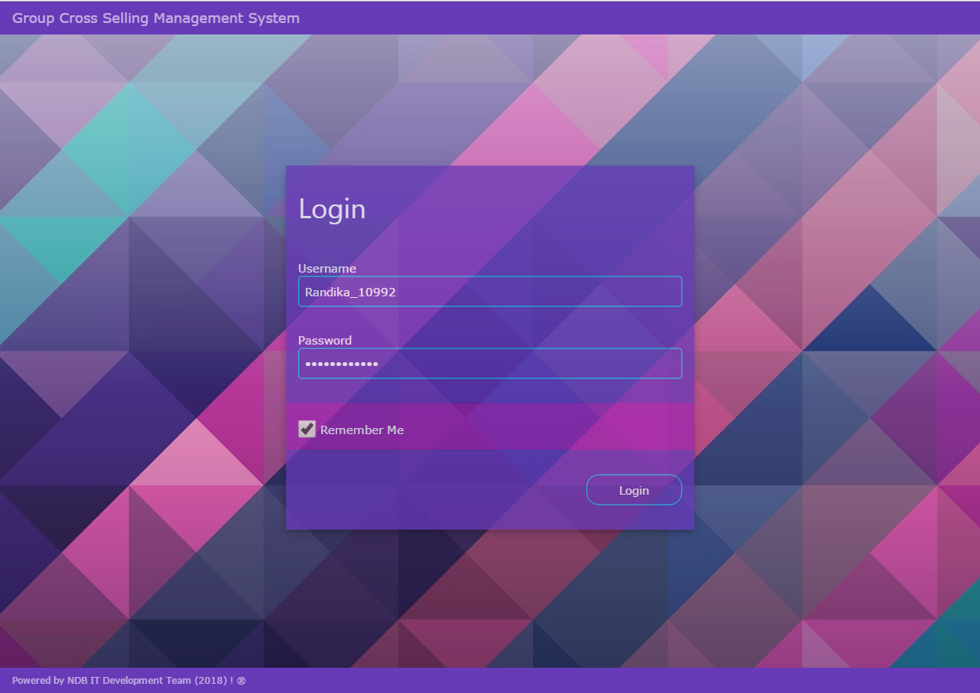

Image 1.0 - NDB GCSM Login Screen

3.2 System Menu
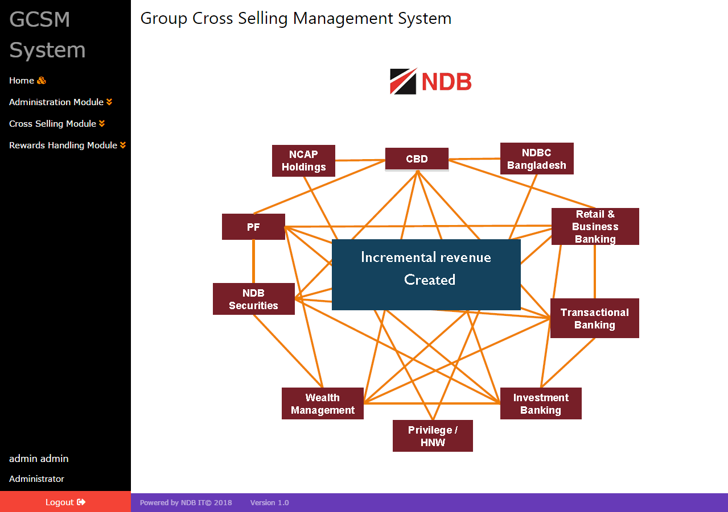

Image 2.0 - NDB GCSM System Menu

NDB GCSM System is a web application, which consists of 3 main menus.

- Administration Module
- Cross Selling Module
- Rewards Handling Module

Note – The process flow is as follows:

- Administration Module Creates Business lines , Products , Users and User roles.
- Cross Selling Module Initiates Cross Selling Management and Shadow Revenue Calculation.
- Rewards Handling Module Manages Reward Values,Points Values,Individual Target values , Rewards Calculations , points Calculations and Reports.

3.3 Changing User ID and Password
Username and Password can be change by via Admin User.

4.0 USING THE SYSTEM

4.1 Administration Module
In the administration module admin user can create business lines , products , users ,user roles and make inquires.

4.1.1 Business Entities Management
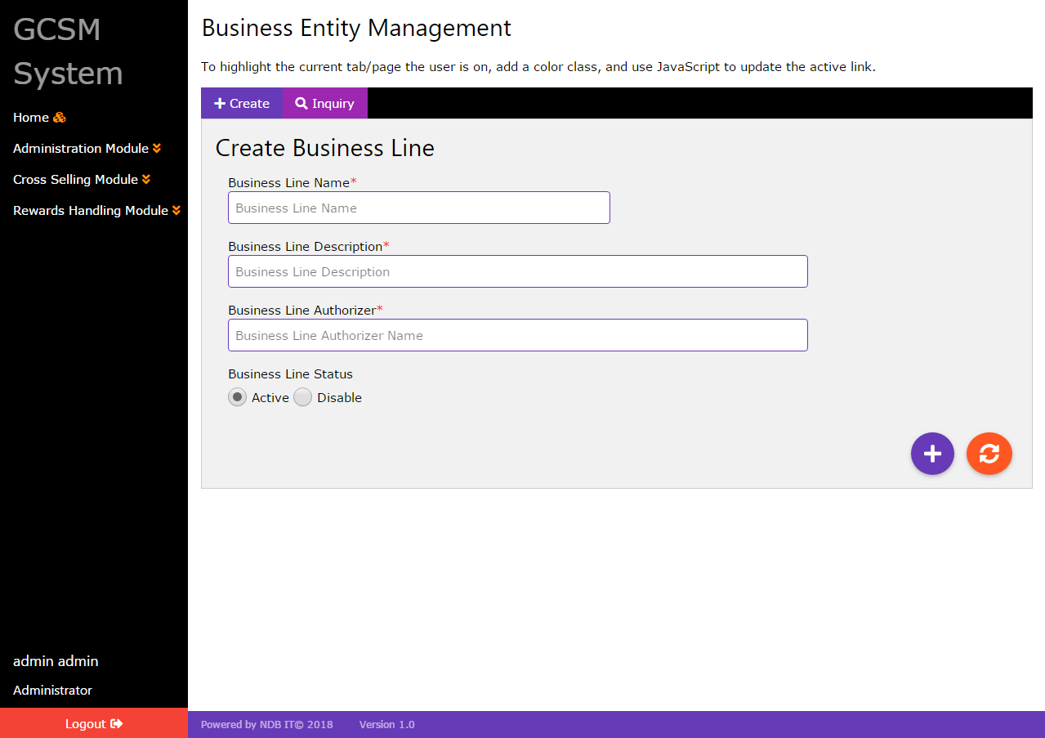

Image 3.0 - NDB GCSM Business Entity Management

This function is related to creating or modifying business entities. Administrator has the
privilege to perform this activity. If a new business line started that is performing cross
selling activities among the NDB group, that line must be registered to this system. Each
Entity will have an identification number including sub entities as well.

For add business line to the system, admin user must enter business line name,description and authorizer/head.those mentioned fields are mandatory.if user failed to enter those values into system then system will show error notification.In the inquiry tab user can view already inserted data and do changes to them.

- Create Business Line - In the Create Tab
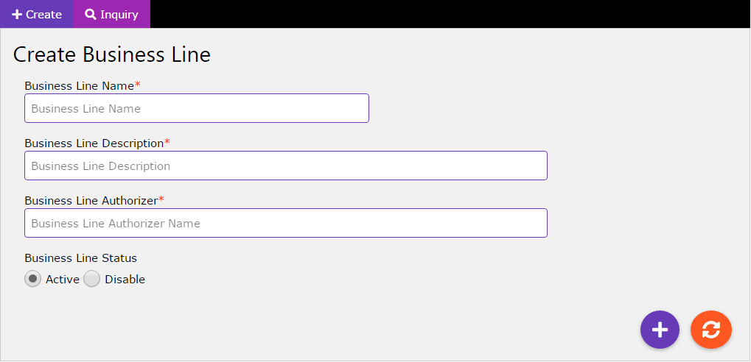

Image 4.0 - Create Business Line

- Enter the business line name - Mandatory.
- Enter the business line description - Mandatory.
- Enter the business line authorizer/business line head name - Mandatory.
- Select business line status active or disable - default business line status always active.
- Click add button for save data.
- For fields RESET - click refresh button.

- Inquire/Edit Business Line - In the Inquire/Edit Tab
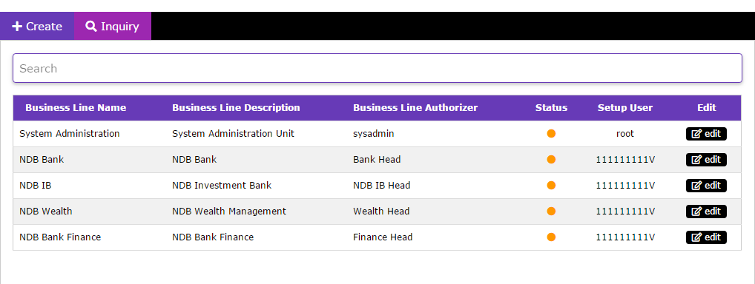
Image 5.0 - Inquire Business Line

- For search data - enter keywords in the search text box.
- Click edit button for the change saved data.

4.1.2 Product Management
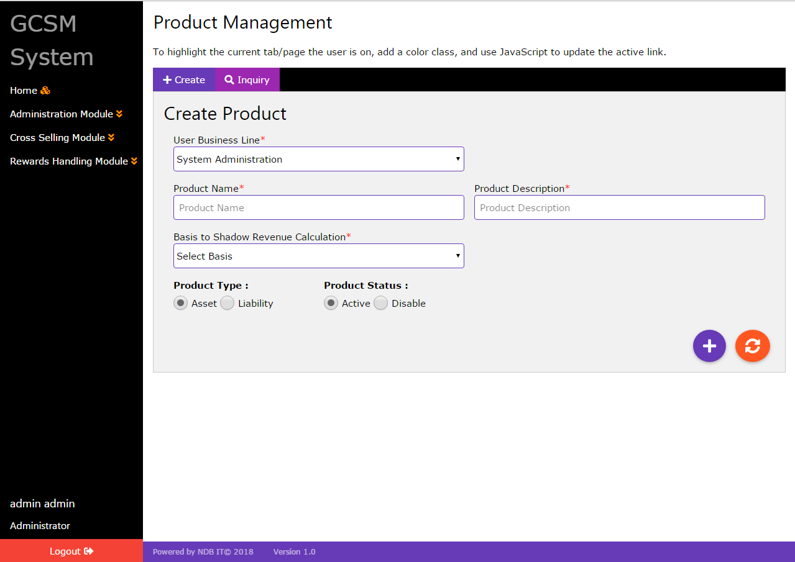

Image 6.0 - NDB GCSM Product Management

This above interface is related to creating or modifying products. Administrator has the
privilege to perform this activity. If a new product initiated, that product must be
registered to this system.

Add product to the system, admin user must select user business line first and enter product name,description. after enter those values into system user must need to select type of shadow revenue calculation and product type.In default product type is asset.

Those above mentioned fields are mandatory.if user failed to enter those values into system then system will show error notification.In the inquiry tab user can view already inserted data and do changes to them.

- Create Product - In the Create Tab
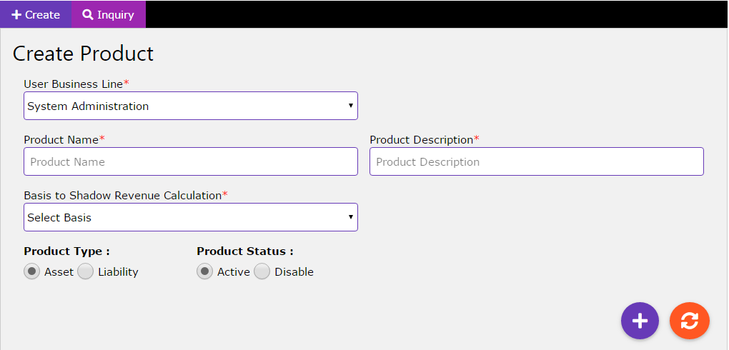

Image 7.0 - Create Product

- Select the business line - Mandatory.
- Enter the product name - Mandatory.
- Enter the product description - Mandatory.
- Select basis of shadow revenue calculation. - Mandatory.
- Select product type - Mandatory.
- Select product status active or disable - default product status always active.
- Click add button for save data.
- For fields RESET - click refresh button.

- Inquire/Edit Product - In the Inquire/Edit Tab
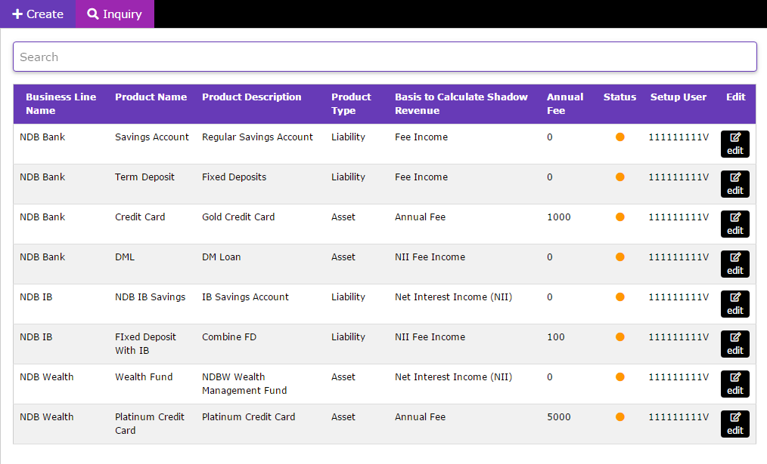

Image 8.0 - Inquire Products

- For search data - enter keywords in the search text box.
- Click edit button for the change saved data.

4.1.3 User Management
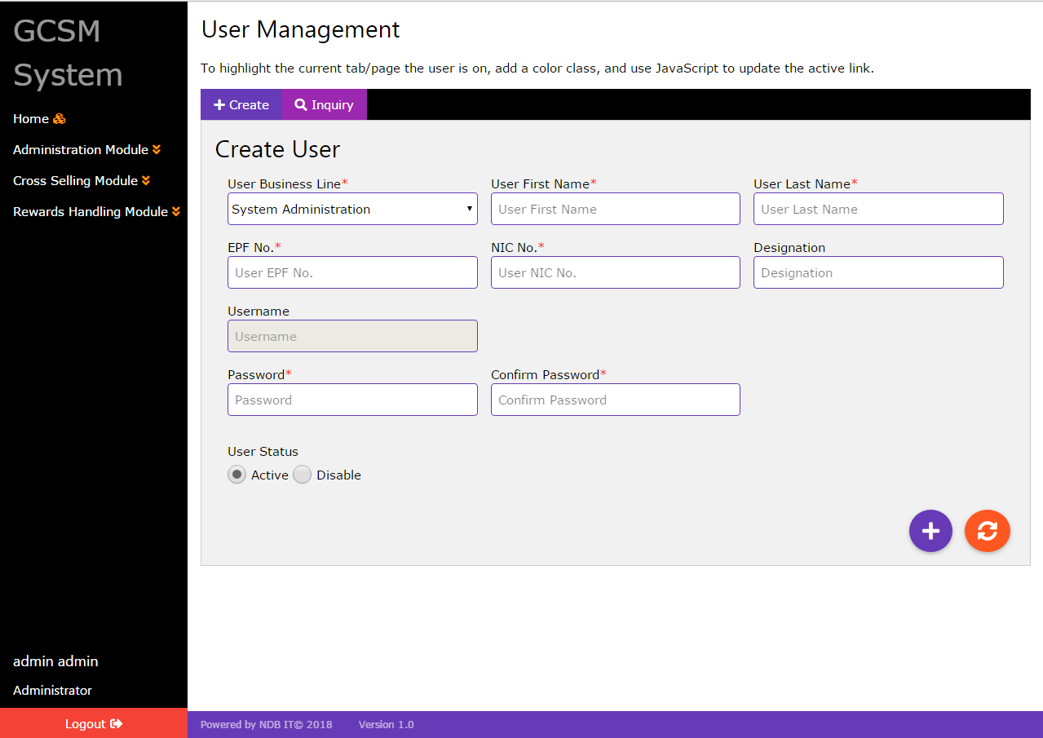

Image 9.0 - NDB GCSM User Management

This interface is related to adding or modifying users of the system. Administrator has the
privilege to perform this activity. User’s username will be NIC.

Add users into the system, admin user must select user’s business line first and enter user first name,last name , EPF no,NIC and designation after user need to set password and confirm it.

Those above mentioned fields are mandatory except designation.if user failed to enter those values into system then system will show error notification.In the inquiry tab user can view already inserted data and do changes to them.

- Create User- In the Create Tab
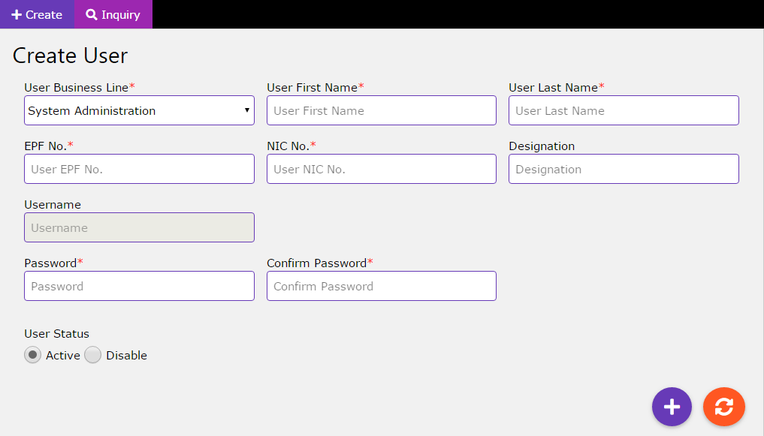

Image 10.0 - Create User

- Select the business line - Mandatory.
- Enter the user first name - Mandatory.
- Enter the user last name - Mandatory.
- Enter the EPF- Mandatory.
- Enter the NIC. - Mandatory.
- Enter the user designation - Not Mandatory.
- Default NIC become user’s username.
- Enter the password and confirm password - Mandatory.
- Select user status active or disable - default user status always active.
- Click add button for save data.
- For fields RESET - click refresh button.

- Inquire/Edit user- In the Inquire/Edit Tab
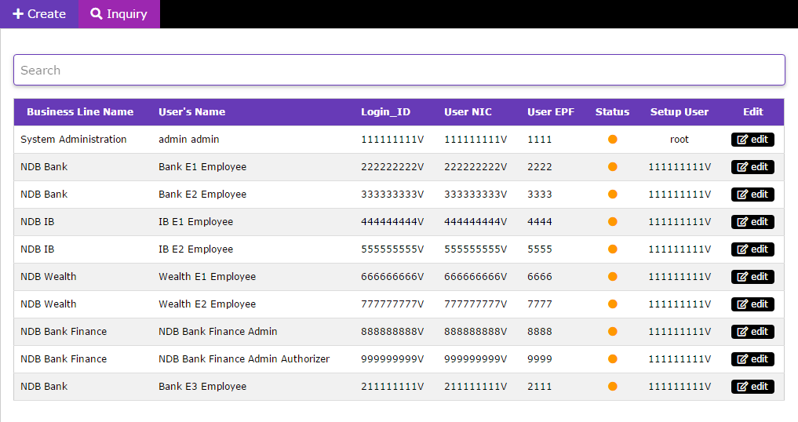
Image 11.0 - Inquire User

- For search data - enter keywords in the search text box.
- Click edit button for the change saved data.

4.1.4 User Roles Management
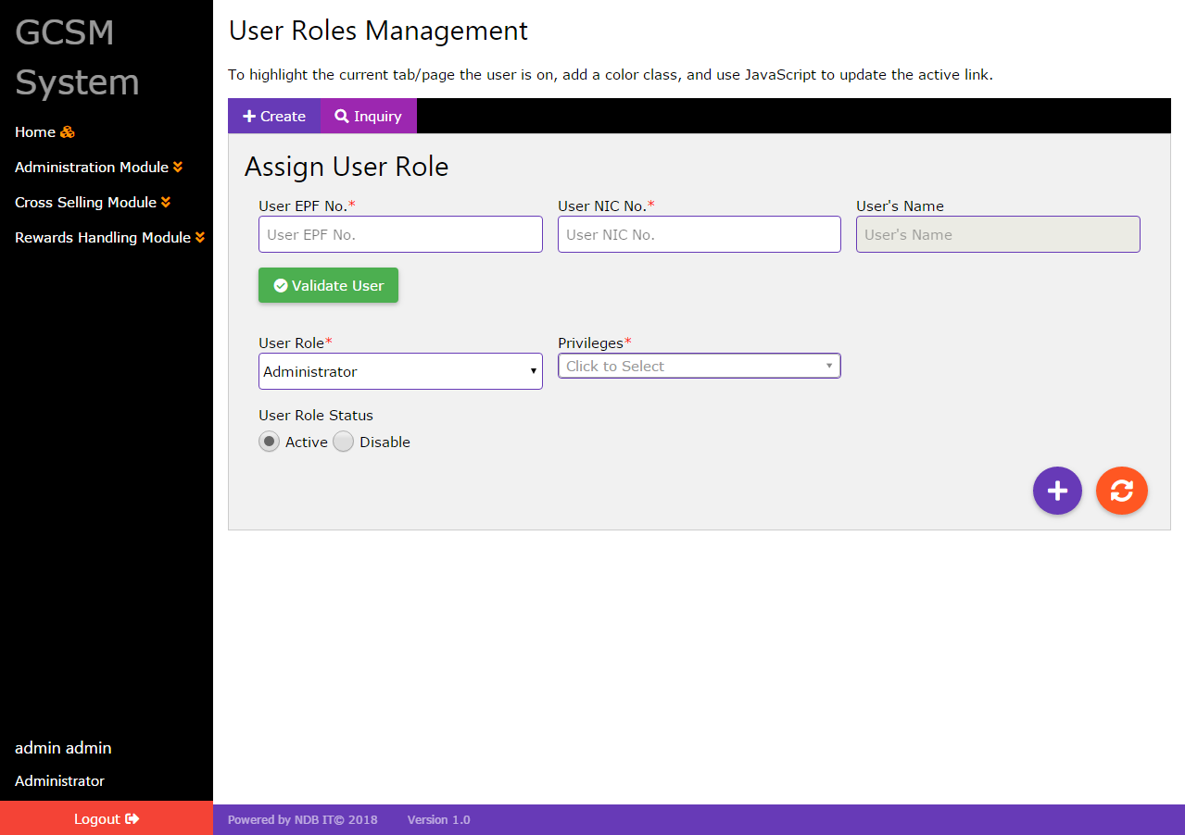

Image 12.0 - NDB GCSM User Roles Management

This window is related to assigning user roles to the users. This activity is performed by
the administrator.

For assign user roles into the system, admin user must first enter user’s EPF no and NIC and need to validate it clicking validate user button. After user must select User’s user roles and privileges.

Those above mentioned fields are mandatory.if user failed to enter those values into system then system will show error notification.In the inquiry tab user can view already inserted data and do changes to them.

- Create User roles- In the Create Tab
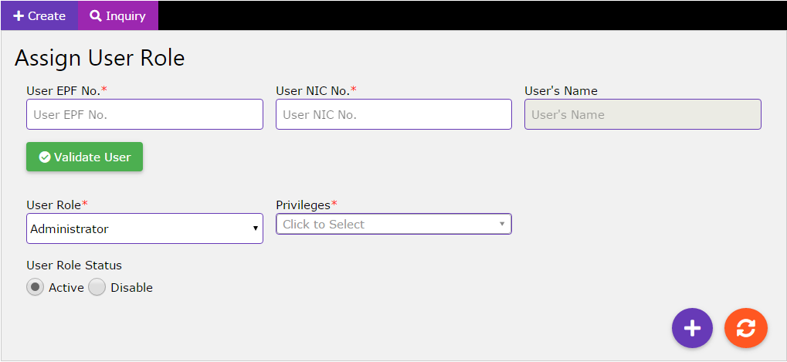

Image 13.0 - Create User Roles

- Enter the EPF- Mandatory.
- Enter the NIC. - Mandatory.
- Click validate user button for check validity of user.
- Select user role - Mandatory.
- Select user privileges - Mandatory
- Select user role status active or disable - default user role status always active.
- Click add button for save data.
- For fields RESET - click refresh button.

- Inquire/Edit users roles- In the Inquire/Edit Tab

Image 14.0 - Inquire User Roles

- For search data - enter keywords in the search text box.
- Click edit button for the change saved data.

