Group Cross Selling Management System

User Manual - 2018-10-04

V.1.0

CONTENT

1.0 General Information 03

1.1 System Overview 03

1.2 Organization of the Manual 03

2.0 System Summary 04

2.1 System Configurations 04

2.2 User Access Levels 04

3.0 Getting Started 05

3.1 Logging On 05

3.2 System Menu 06

3.3 Changing User ID and Password 06

4.0 Using The System 07

4.1 Cross Selling Module 07

4.1.1 Add Cross Selling Info 07 - 09

4.1.2 Shadow Revenue Calculation 10 - 12

4.2 Rewards Handling Module 11

4.2.1 Rewards Value Management 11 - 12

4.2.2 Calculate Rewards 13 - 14

4.3 Points Handling Module 15

4.3.1 Points Values Management 15 - 16

4.3.2 Calculate Points 17

1.0 GENERAL INFORMATION

1.1 System Overview
Selling of group of company products/services to a customer irrespective to the assigned
unit, is the broad definition of what cross sell means. It can be selling an existing account
customer a credit card or selling an existing credit card customer a mortgage.

NDB has been using cross sell as a marketing approach to expand its footprint and also increase its customer base. The more relationships the bank has with a customer is as good as one having a better wallet share of the customer.

More spends on all the products of the bank leads to better top- and bottom-line performance. Cross-selling comes with its advantages.It considerably reduces customer acquisition costs, servicing, and marketing and communication costs and thereby substantially increases spread for the bank. It is well understood and key finding that greater the number of products held by customer leads to an increased probability of retention.

1.2 Organization of the Manual
The user manual consists of four sections: General Information, System Summary, Getting Started and Using the System.

General Information section explains in general terms about the system and the purpose for which it is intended.

System Summary section provides a general overview of the system. The summary outlines the uses of the system hardware and software requirements, system configuration, user access levels and system behavior in case of any contingencies.

Getting Started section explains how to get NDB GCSM System and install it on the device. The section briefly presents system menu.

Using the System section provides a detailed description of system functions.

2.0 SYSTEM SUMMARY
System Summary section provides a general overview of the system. The summary outlines the uses of the system hardware and software requirements, system configuration, user access levels and system behavior in case of any contingencies.

2.1 System Configurations
NDB GCSM System operates as a Web based application. It is compatible with Chrome browser level 9. This system is not compatible with Internet Explorer.

Live Web URL:
Note: IP and port will change depending on other environments.

Test Web URL: https://10.96.197.5:8443/.../...

2.2 User Access Levels
Access Levels | Functions
Inputer | - Cross Selling Management - Enter  - Manage Individual Target Achievement - Enter
Business Head | - Cross Selling Management - Approval  - Manage Individual Target Achievement - Approval  - Reward Values - Approval  - Point Values - Approval  - Calculate Points -Approval  - Calculate Rewards-Approval
Finance Administrator | - Cross Selling Management - View Approved Records  - Shadow Revenue  - Reward Values - Enter  - Point Value - Enter  - Calculate Rewards - Enter  - Calculate Points- Enter
Administrator | - Business Entities  - Products  - Users  - User Roles

3.0 GETTING STARTED
The Getting Started section explains how to login into NDB GCSM System and operate its functions.

3.1 Logging On
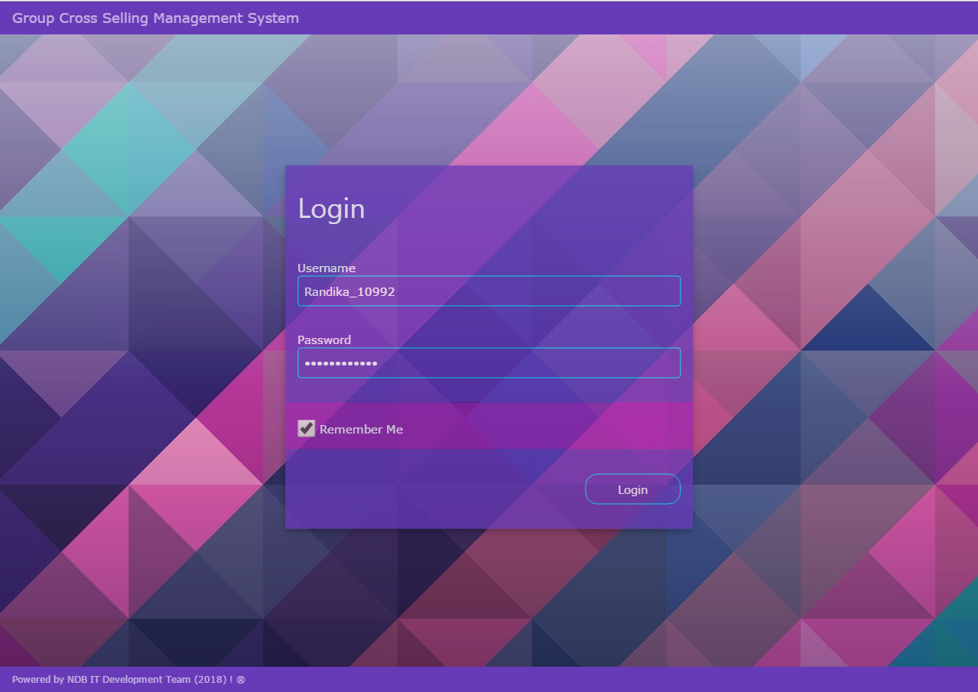

Image 1.0 - NDB GCSM Login Screen

3.2 System Menu
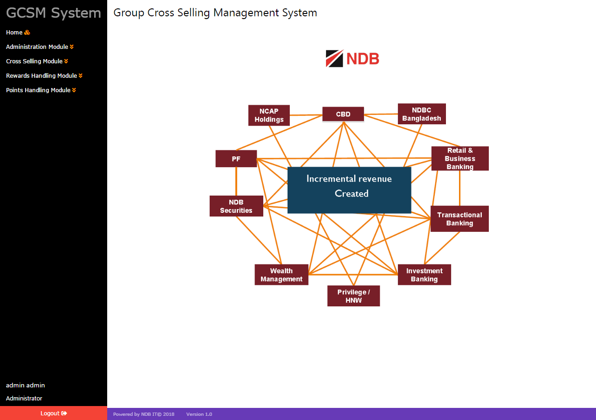

Image 2.0 - NDB GCSM System Menu

NDB GCSM System is a web application, which consists of 3 main menus.

- Administration Module
- Cross Selling Module
- Rewards Handling Module
- Points Handling Module

Note – The process flow is as follows:

- Administration Module Creates Business lines , Products , Users and User roles.
- Cross Selling Module Initiates Cross Selling Management and Shadow Revenue Calculation.
- Rewards Handling Module Manages Reward Values,Points Values,Individual Target values , Rewards Calculations , points Calculations and Reports.

3.3 Changing User ID and Password
Username and Password can be change by via Admin User.

4.0 USING THE SYSTEM

4.1 Cross Selling Module
In the cross selling module user can add cross selling info, make inquires and generate shadow revenue.

4.1.1 Cross Selling Management
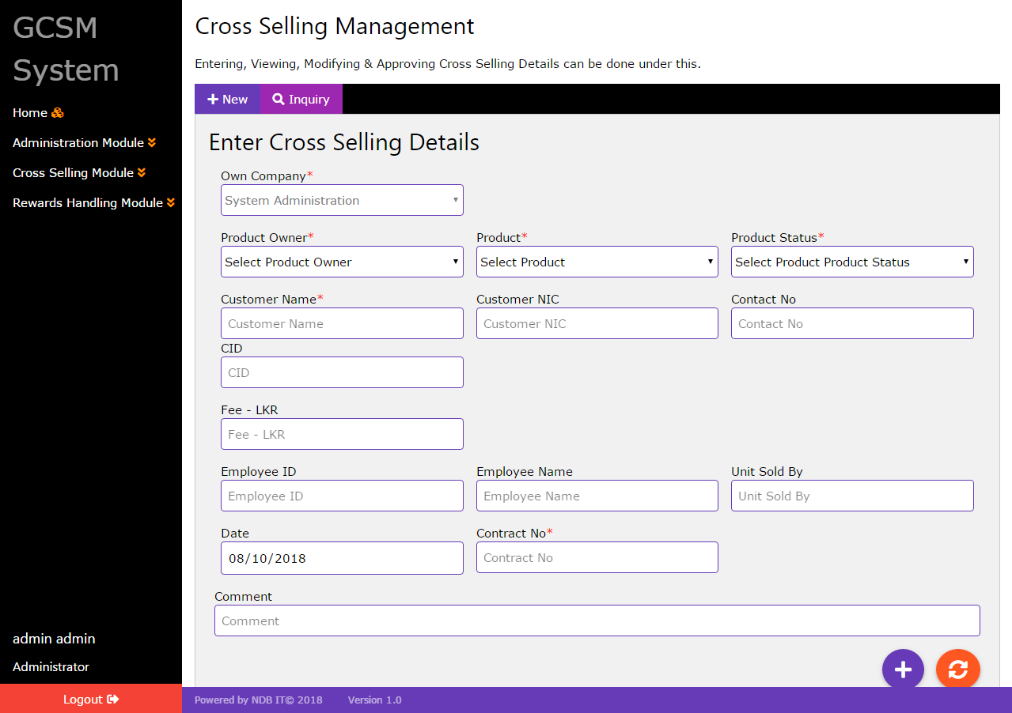

Image 3.0 - NDB GCSM Cross Selling Management

This function is related to adding or modifying cross selling details into system. Inputer has the privilege to add new entries to the system and do modifications. Business head has privilege to view and approve the entered cross selling details by intputer. Finance administrator can view approved cross selling details by business head.

For add cross selling details into system , inputer must select product owner , product and product status. After that need to enter customer name , NIC ,contact no , CID , fee ,employee id , employee name , unit , date ,contract no and comment , if it necessary.After clicking add button send record approval to business head .

those mentioned fields are mandatory.if user failed to enter those values into system then system will show error notification.In the inquiry tab user can view already inserted data and do changes to them.

- Add Cross Selling Info- In the New Tab
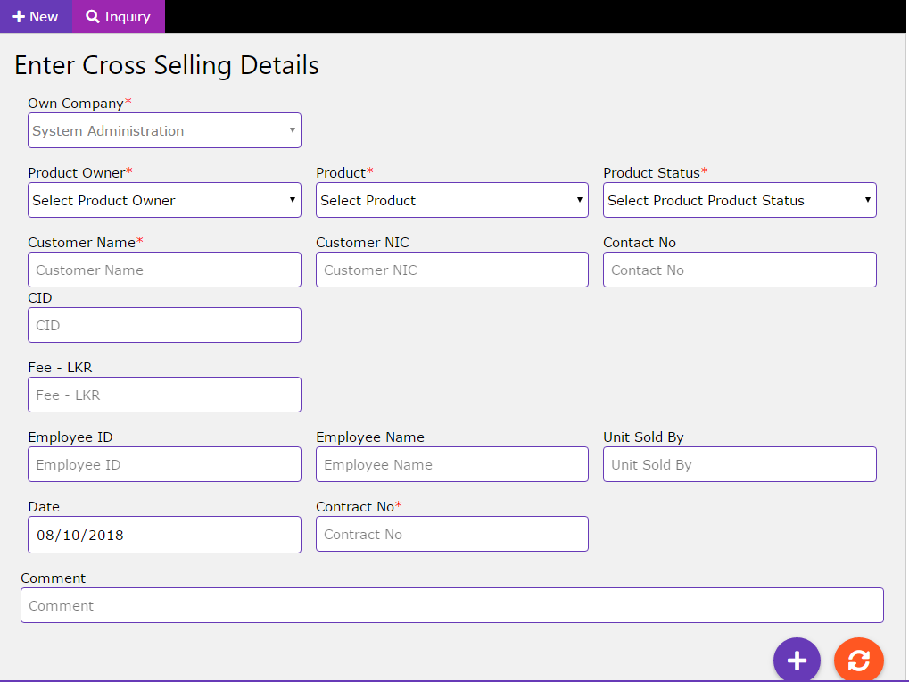

Image 4.0 - Add Cross Selling Info

- Select own company - Mandatory.
- Select product owner - Mandatory.
- Select the product- Mandatory.
- Select product status - Mandatory
- Enter customer name -Mandatory.
- Enter customer NIC - Not Mandatory.
- Enter contact no - Not Mandatory.
- Enter CID - Not Mandatory.
- Enter fee-LKR - Not Mandatory.
- Enter employee id - Not Mandatory.
- Enter employee name - Not Mandatory.
- Enter unit sold by - Not Mandatory.
- Select Date
- Enter Contract No - Mandatory.
- Add Comments - Not Mandatory
- Click add button for send approval.
- For fields RESET - click refresh button.

- Inquire/Edit Cross Selling info - In the Inquire/Edit Tab
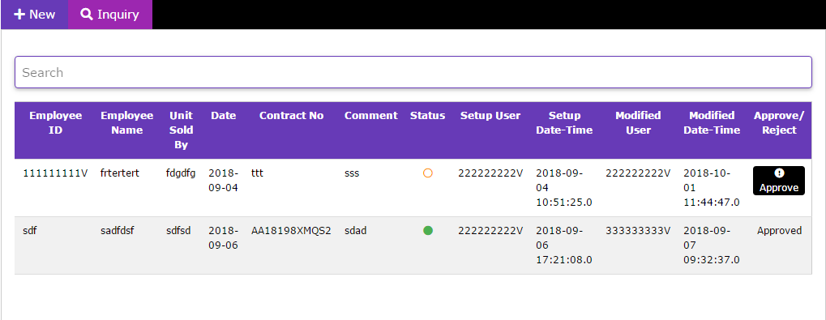
Image 5.0 - Inquire Cross Selling Info

- For search data - enter keywords in the search text box.
- Click edit button for the change saved data.
- Click approve button for the approval (user - business line head).

4.1.2 Shadow Revenue Calculation
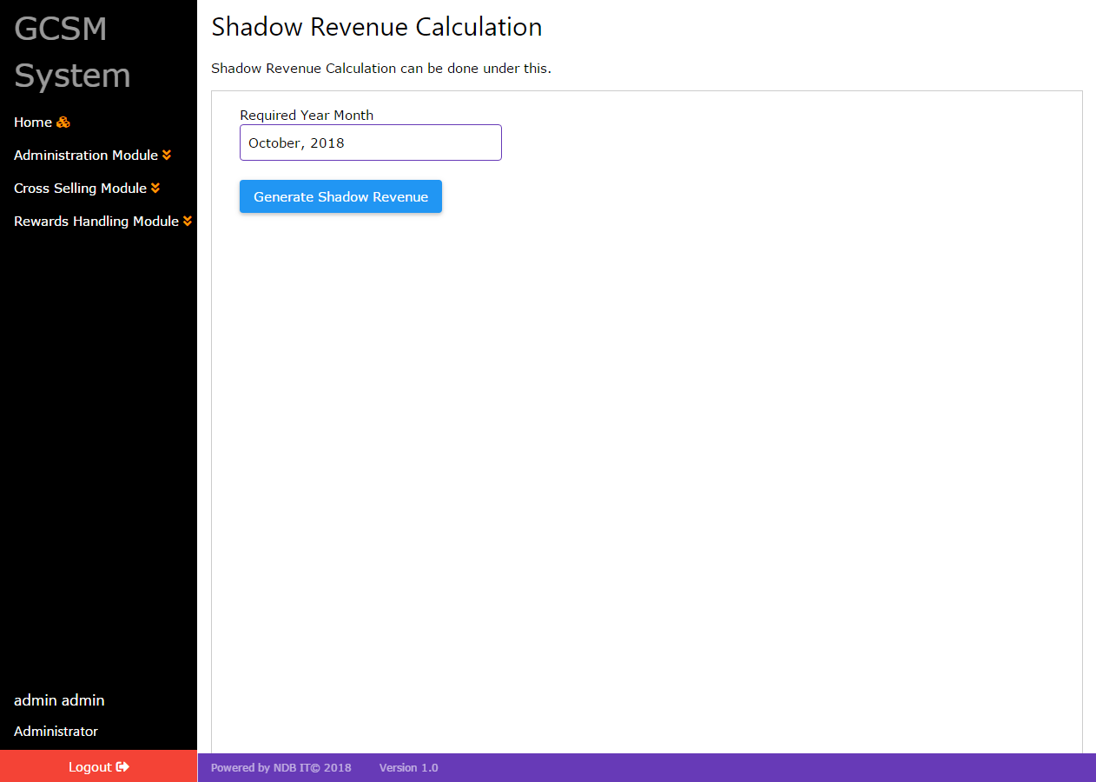

Image 6.0 - NDB GCSM Shadow Revenue Calculation

This function is related to calculating shadow revenue. Finance administrator has the only privilege to perform this activity.

- Select the date - Mandatory.
- Click Generate Shadow Revenue button for the calculation.

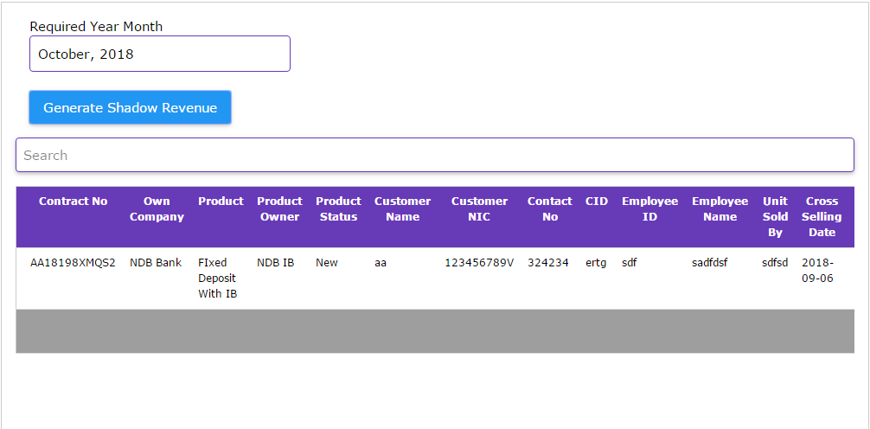

Image 7.0 - Shadow Revenue Calculation Result

4.2 Rewards Handling Module
In the rewards handling module user can manage rewards values , individual targets and calculate rewards.

4.2.1 Rewards Value Management
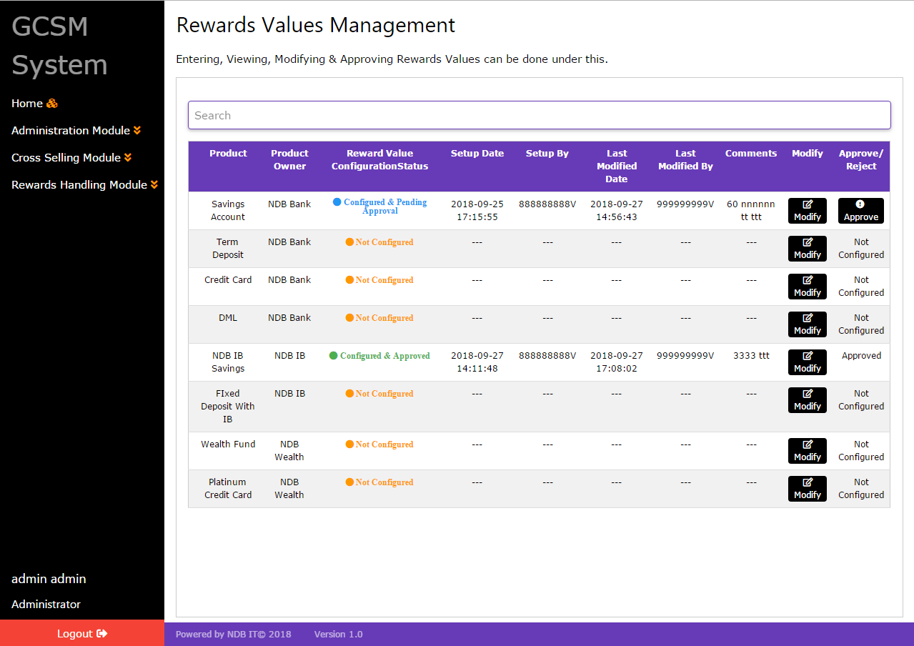

Image 8.0 - NDB GCSM Rewards Value Management

- Reward Value Configuration (user - Finance Administrator)
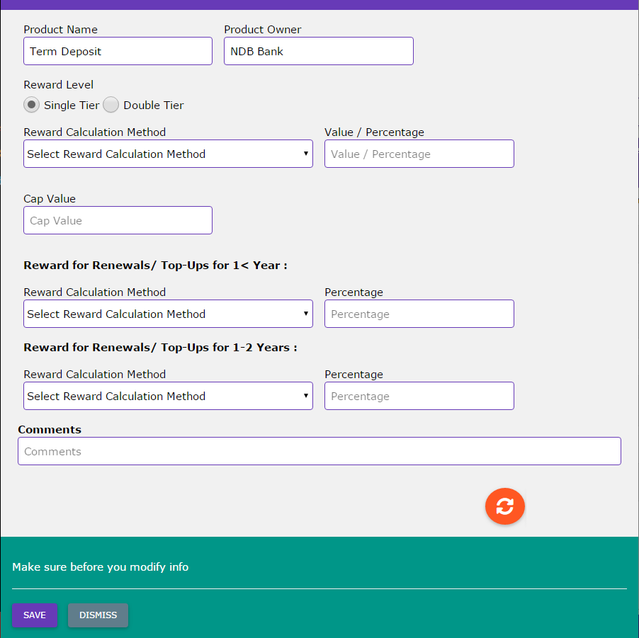

Image 9.0 - Configure product
- Click modify button.
- Select reward level- Mandatory.
- Select calculations methods and add values- Mandatory.
- Enter the cap value- Mandatory.
- Enter the comments - Not Mandatory.
- Click save button for send approval.
- For fields RESET - click refresh button.

- Reward Value Approval (user - Finance Administrator Head)
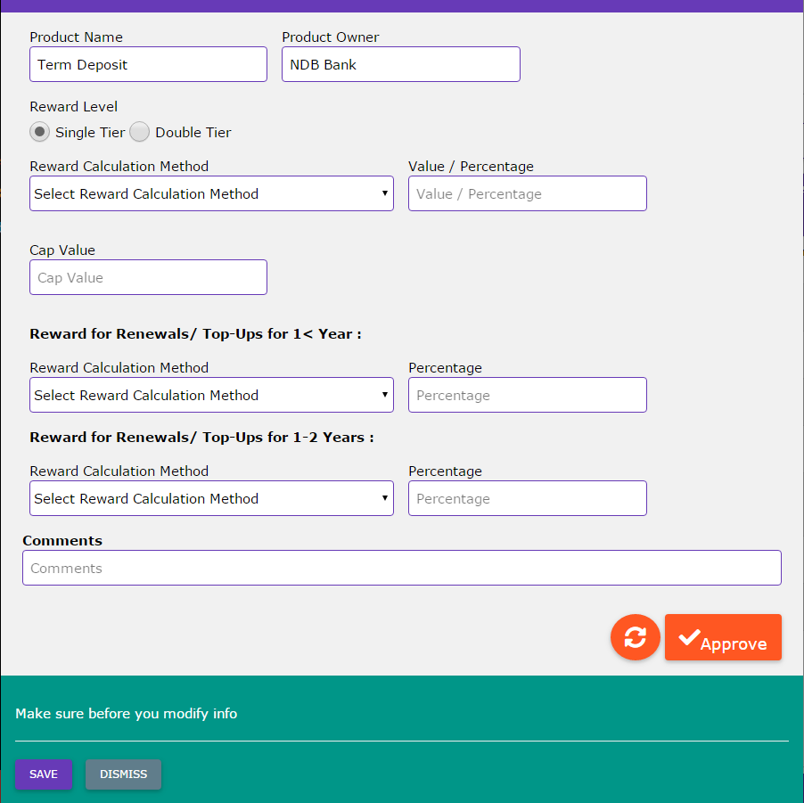

Image 10.0 - Product approval

- Click approve button for product configuration approval.

Main purpose of this function is assigning rewards values to the product. Reward values management configuration perform by finance administrator.After enter above mentioned necessary values to the system by finance administrator, system will send record approval to finance administrator head.

4.2.2 Calculate Rewards
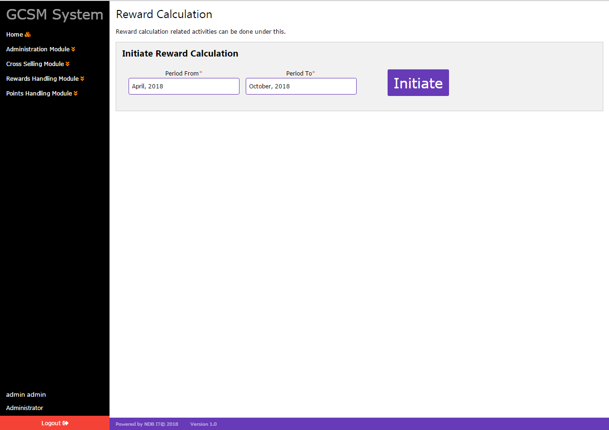

Image 11.0 - NDB GCSM Reward Calculation

This process contain one of the sub task which is individual target achievement management.
As the first step finance administrator should initiate the the reward calculation process.

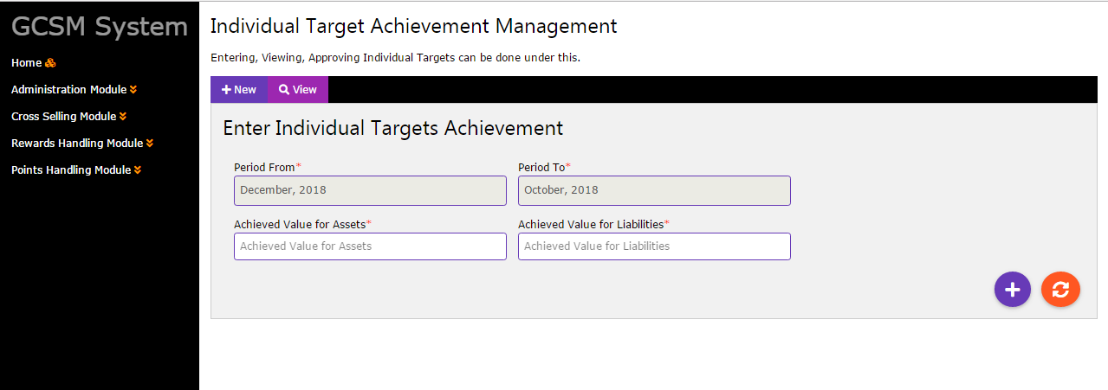

Image 12.0 - NDB GCSM Individual Target Achievement Management

Once reward calculation process is initiated other users can enter their individual targets for the given period.Finance administrator can then start the reward calculation process which will calculate the reward values for each contracts based on the calculation logic specified in the reward values management section.

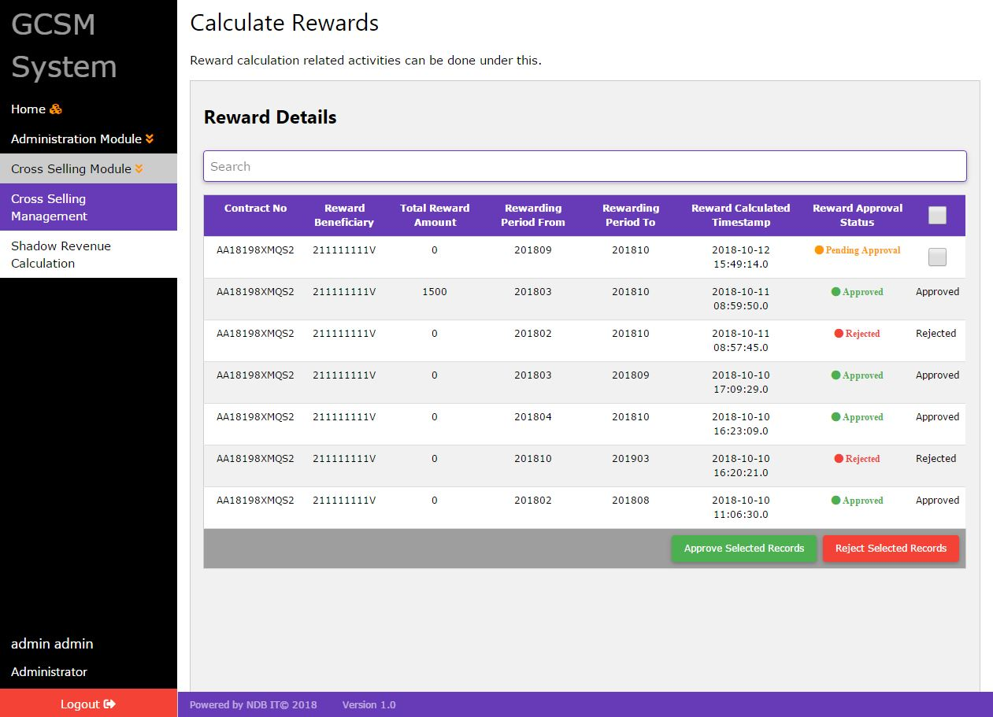

Image 13.0 - NDB GCSM Reward Calculation Approval Status List

The authorizer should approve/reject the calculated reward values in the shown list. After approving/ rejecting all the records a new rewarding cycle can be initiated.

4.3 Points Handling Module
In the points handling module user can manage point values and calculate points.

4.3.1 Points Values Management
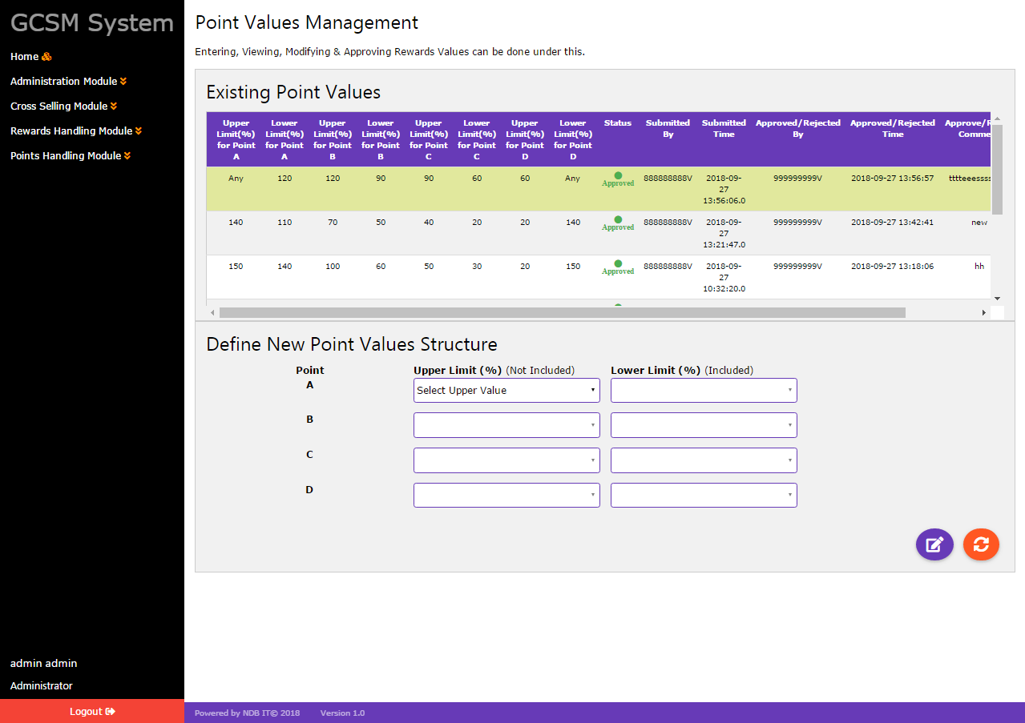

Image 14.0 - NDB GCSM Points Values Management

Users will be awarded with a point value based on their target achievement.Once the point calculation process happens, the system will get the details of the achieved values through cross selling by each employees who are performing cross selling.

- Define New Point Values Structure
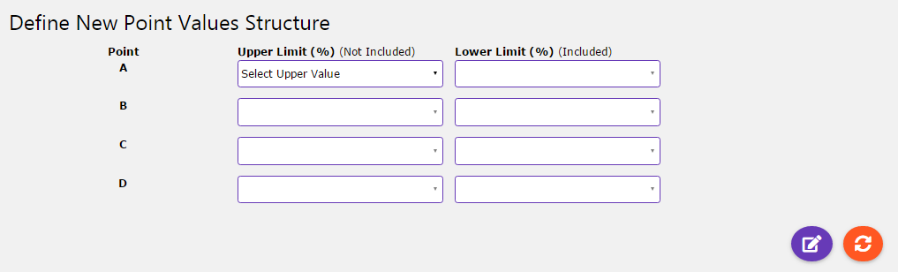

Image 15.0 - Define New Point Values Structure

Initially all the users will be communicated about their cross selling targets which should be achieved with the given period of time. Employee will be awarded with a point (A,B,C,D) based on their target achievement percentage.

- Add point values.
- Click add button for send record approval.
- For fields RESET - click refresh button.

- Inquire/Edit/Approve points values
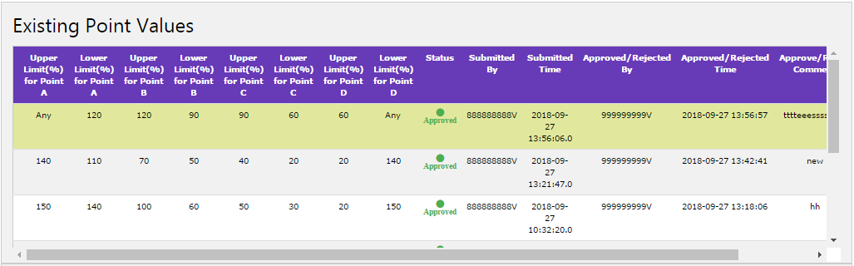

Image 16.0 - Inquire existing point values

Point values should be configured by the Finance Administrator while authorizer approves them. Then the Finance Administrator have to upload the file which contains target of the employees as the initial stage of point calculation.Then users will be awarded with the specific point value.

4.3.2 Calculate Points
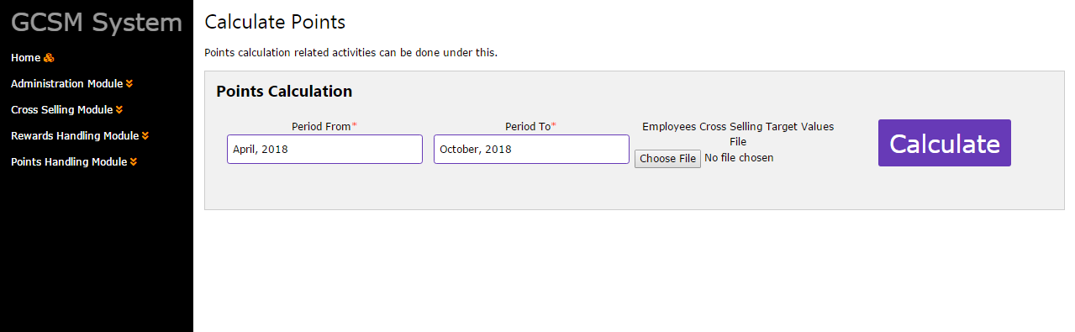
Image 17.0 - Calculate Points

Finance Administrator has the privilage to calculate points. After specifing the period of calculation, Employee Cross Selling Target Values file should be uploaded.

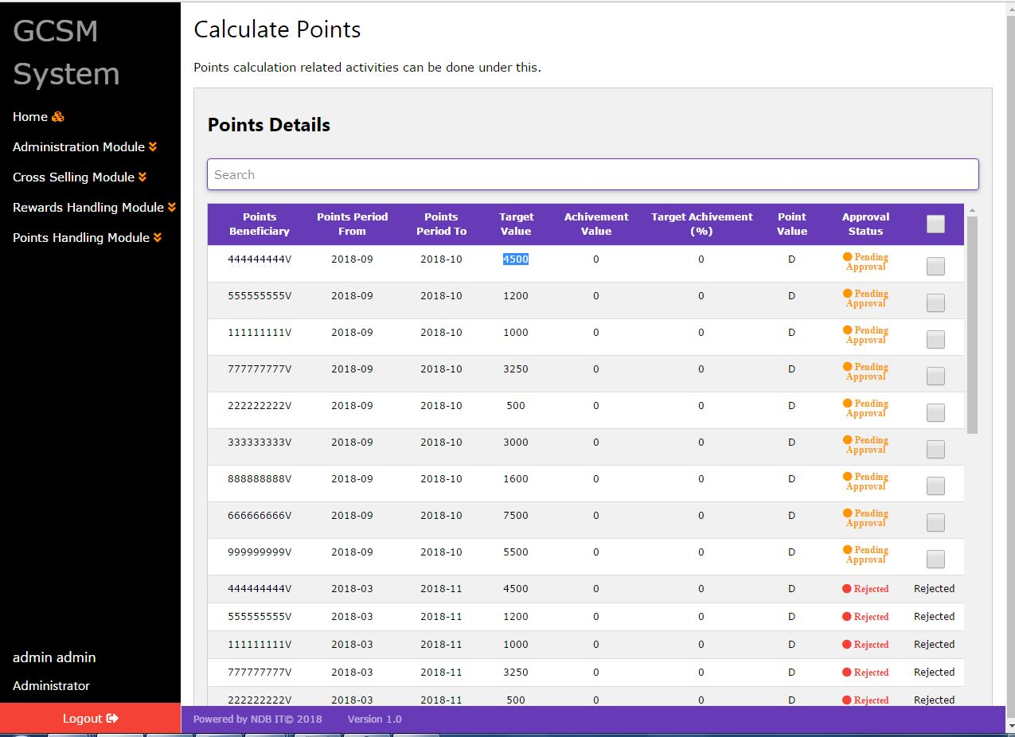

Image 18.0 - Calculated Employee Points

After performing calculation based on the specification in Point Values Management Section, the point values will be displayed for each employee as a list which should be approved by the authorizer.

