Influencing Game Dynamics in A Roguelike Game Through Procedural Content Generation Using Genetic Algorithm
Josiah Maius Ebia, John Kenneth Bunagan, John Carl Manalansan, Kate Danielle Guino
Computer Science Department, Adamson University
900 San Marcelino Street, Ermita, 1000 Manila

josiah.maius.ebia@gmail.com
johnkenneth.bunagan0219@gmail.com
manalansanjohncarl@gmail.com
kdguino@gmail.com

Abstract— Procedural content generation and evolving game content based on player preferences, performance, and behavior has been an ever-growing research topic in the field of computer science and game design. The goal of this research is to contribute to the field by associating the concept of genetic algorithms to evolve and optimize the generated game content based on the performance of the player. To demonstrate our proposition, we designed a 2D roguelike game called Fireflies which significantly involves the player in the generation of content through her exploration and interaction with the game environment.
Index terms— Procedural Content Generation, Genetic Algorithm, Game Design, Roguelike, Machine Learning

- INTRODUCTION
Procedural content generation (PCG) has been a very popular technique in game design since the past decades. It lets game designers and developers add more replay value to their game. Procedurally generating content will always lead to mostly new and exciting playthroughs every time the player hits the "new game" button. For developers, this design technique saves much more time, in the long run, and resources when creating a game with large amounts of content e.g. The Elder Scrolls: Arena [12].
One of the most popular uses of PCG in game development are in roguelike games. Roguelikes are games with core mechanics similar to the game
Rogue [11], which was released on 1980. Some of the key features of Roguelikes are procedural generation, permadeath, and character progression [6]. Roguelikes, being primarily PCG-based in terms of design, makes it a practical game genre to work on for research titles on PCG and game design theory such as presented in this paper.
Game dynamics are the emergent behavior from the player and game elements when the game's mechanics, which are the particular components of the game such as the game's rules and A.I., are implemented. An example of this is when a player runs from an enemy when her health points are lower than the enemy, or when a player tries to find a key when discovering that a door that is the goal is locked.
In this research, we looked into influencing the emergent behaviors in the game that is game dynamics through procedural generation. This will allow a more personalized play experience for the player, and at the same time, staying true to the unforgiving nature of roguelikes since the game's environment will start to adapt against the player as she progresses.
To accomplish this, we used genetic algorithms, which is a kind of evolutionary algorithm that is inspired by natural selection, to evolve specified elements in the generated content of the game's level depending on the results of the previous level of the game. Lastly, we designed and developed Fireflies, an experimental 2D roguelike game, to demonstrate the objectives of this research.

- Significance of the Study

This study can be a model for game designers and developers to improve their understanding on the effectiveness of genetic algorithms in designing roguelike games. It shows a specific way, using genetic algorithms, on how to make the procedural content generated in roguelike games and the play experience delivered to the player be personalized and more meaningful. This study can also be a framework for students and future researchers in conducting research on game design, procedural content generation, and genetic algorithms.

- Scope and Limitation of the Study

The focus of this research is to utilize genetic algorithms in the procedural generation of content to influence the game dynamics (emergent behavior) in the Fireflies game, giving the player a more personalized experience and at the same time staying true to the nature of roguelikes being both very challenging and fun. Although the methods used in this research project is promising for very challenging games such as that of the roguelike genre, this paper doesn’t promise to be as effective on other less challenging games in providing the amount of fun that this can give when applied on roguelikes.

- REVIEW OF RELATED LITERATURE

- Procedural Content Generation

Procedural content generation (PCG) simply refers to the algorithmic generation of game content with limited or no human contribution [1, 2]. PCG has been used for decades in the games industry. It was primarily used to deliver more content in games that runs in a very limited hardware, popular examples of this are Rogue [11] and The Elder Scrolls: Arena [12]. In both games mentioned, the developers used PCG to generate game content that would be too large for the existing technology in their time to store and run in memory if predefined. Today, PCG is mainly used to give games more replay value and varied content.

- Roguelike Games

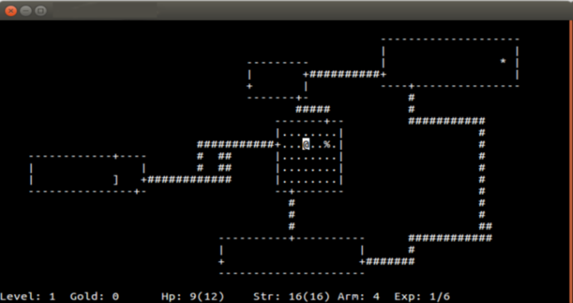
Fig. 1 A screenshot of the game Rogue running on the Ubuntu Linux terminal

Roguelikes are games whose core features are similar to those of the game Rogue [11], thus the name. Rogue was developed by Michael Toy and Glenn Wichman which was initially released on 1980. It was a turn-based dungeon-crawler that used ASCII characters to represent its game content.

The Berlin Interpretation [10] split the factors that defines roguelikes into two, the high value factors and low value factors, the factors listed under the former are the more important features to be found in roguelikes than those under the latter which are likely optional. The following are the high value factors of roguelikes according to The Berlin Interpretation, in no specific order of importance:
• Random environment generation
• Permadeath (which stands for permanent death)
• Turn-based
• Grid-based
• Non-modal
• Complexity
• Resource Management
• Hack'n'Slash
• Exploration and discovery

Below are the low value factors, in no specific order of importance:
• Single player character
• Monsters are similar to players
• Tactical challenge
• ASCII display
• Dungeons
• Numbers

- Game Dynamics

According to the MDA (Mechanics-Dynamics-Aesthetics) framework [7], the consumption of games is broken down into three distinct components which are rules, system, and fun, and their design counterpart are mechanics, dynamics, and aesthetics. According to Hunicke et al. [7], mechanic is defined as the particular components of the game, at the level of data representation and algorithms; the dynamics are the run-time behavior of the mechanics acting on player inputs and each other output over time; and aesthetics are the desirable emotional responses evoked in the player, when she interacts with the game system.
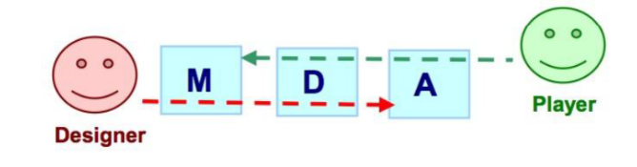
Fig. 2 The MDA framework. Shows the difference in perspective of the player (consumer) and the designer (or developer).

- Genetic Algorithms

Genetic algorithms (GA) are stochastic, parallel search algorithms based on the mechanics of natural selection and evolution [3,5]. It was first introduced by John Holland on 1992 [4] which is very similar to Darwin's theory of natural selection.

A genetic algorithm starts off with a population of elements, or chromosomes, which carry their own genetic information commonly referred to as genes. The algorithm will then evaluate the fitness of each of the chromosomes in the population, the evaluation function of a genetic algorithm depends on the problem being solved. A chromosome's fitness value will determine its likelihood of being picked as a parent for the new generation of likely more optimal chromosomes. When the parent chromosomes are picked the algorithm will perform crossover and mutation. The crossover function will combine genes from the parent chromosomes to form a new chromosome for the next generation, a mutation may occur once the crossover is done which will mutate a certain gene that is unique from its parents. The above explanation may also be described as:
P = {x|x is the return value of ƒ (c₁, c₂, …, c_{n})}
where ƒ is a genetic function that takes n number of chromosome c and returns a child chromosome x, and ƒ runs N times where N is the required number of chromosomes for the population set P in the next generation. The genetic algorithm stops when it produces the most optimal result that satisfies the problem.

- PROPOSED METHODOLOGY

- The Fireflies Game

Fireflies is an experimental 2D turn-based roguelike game. In Fireflies, the player is thrown in a series of procedurally generated dungeon levels with harmful and helpful game elements such as enemies and loot. The main objective of the player is to utilize her resources and strategize to find a way to the goal of each level and finally see end game.

Fireflies features procedurally generated levels, this means that certain parameters (e.g. the x and y coordinates of the objects) of every game object in every new level that the player enters isn't predefined and will not be always the same. Each dungeon level generated will contain matching rooms and corridors, enemies, loot, and a goal.

The game is heavily turn-based, all actors in the game including the player have one action per turn. Every turn, an actor either attacks or moves to a tile to change its position, as shown in Figure 3. The turn of every other actor in the game starts after the player finishes her turn.

During the player's turn, she can choose to attack instead of moving to another tile. This will cause the player to enter the attack phase, where a marker will appear one (1) tile from her position and she may choose to attack one tile north, east, south, or west, this is shown in Figure 4. The player may also cancel the attack and return to her normal state, doing this will not cost the player a turn and she may either choose to move or attack again.

The core combat mechanics in the game is adapted from the mechanics of the traditional rock, paper, and scissors (RPS) game where 2 players
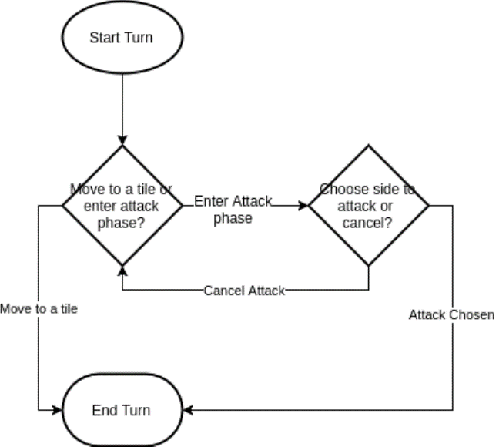
Fig. 3 The general flow of an actor’s turn in the game
choose from the three (rock, paper, and scissors) per turn and the victor are determined by the very simple rule: rock beats scissors, scissors beats paper, and paper beats rock. We chose to adapt the concept for the combat system of our game because it proves to be one of the most balanced mechanics in a game available, since all the players are given a similar set of tools and rules so that everyone has the same chances of winning given that they know how to play and use their tools correctly. In Fireflies, the RPS system is implemented in the attacks and defense of both the player and enemy actors, where one attack is stronger than the defense of the other. The rock, paper, and scissors are represented as red, blue, and green element types, respectively. The player may choose to attack using any of the three elements, but the enemies will only have one element for attacking and defense.
The player may be proficient with an element type (red, blue, green). She may choose to become proficient with only one element at a time. This will increase her damage output to the enemy when attacking with an element that matches her proficiency, but will also increase the damage of an enemy with an element that is stronger than her proficient type. Switching her proficient type requires spending four (4) fireflies which can be collected after defeating an enemy. Each enemy drop two (2) fireflies when their health reaches zero (0).
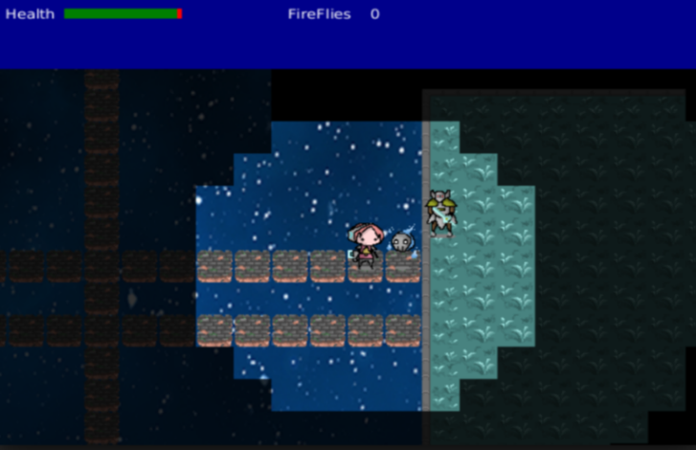
Fig. 4 A screenshot of Fireflies. Shows the player with the type C paper-element-proficient enemy (beside player) and the type B scissors-element-proficient enemy (enemy second to the right)
The game Fireflies can be played using keyboard controls. Using the arrow keys will allow the player to move around and explore the map while the space bar will show an indicator and allow the player to attack once an enemy is encountered.
Once the indicator is shown, the player can choose whether which direction she will attack using the arrow keys. When the player determines which direction she will attack, the player can choose which skill she will use in order to defeat an enemy using the Q, W and E keys.
The Q key will stand for the cut skill which will output a bleed effect, the W key being the stable which will have a disarm effect and the E key will be the brute skill which will have a stun effect.
- The Genetic Algorithm

Every level has a population of enemies, and every enemy in the game has an element that defines their strength and weaknesses in combat. These elements are, as discussed above, the red, blue, and green elements.

The game's genetic algorithm (GA) resides in the level generator, where the enemies are also generated. The GA takes in the population of enemy non-playable character (NPC) and evaluates the fitness of every NPC in the population. The NPCs' fitness is based on their remaining health after the player has exited the level in which they are in. This enables the enemies of the previous level that the player did not or cannot kill or find to get significantly better chances of being a parent than the other enemy NPCs.

- RESULTS AND DISCUSSION

- CONCLUSION AND RECOMMENDATIONS

- REFERENCES

- Julian Togelius, Georgios N. Yannakakis, Kenneth O. Stanley, and Cameron Browne. Search-Based Procedural Content Generation: A Taxonomy and Survey. IEEE Transactions on Computational Intelligence and AI in Games, vol. 3, no. 3, 2011.
- Julian Togelius, Alex J. Champandard, Pier Luca Lanzi, Michael Mateas, Ana Paiva, Mike Preuss, and Kenneth O. Stanley. Procedural Content Generation: Goals, Challenges and Actionable Steps. Dagstuhl Follow-Ups 6, 2013.
- Nicholas Cole, Sushil J. Louis, and Chris Miles. Using a genetic algorithm to tune first-person shooter bots. Evolutionary Computation, 2004. CEC2004. Congress on. Vol. 1. IEEE., 2004.
- John Holland. Genetic algorithms. 1992.
- Darrell Whitley. A genetic algorithm tutorial. Statistics and computing 4.2 (1994): 65-85, 1994.
- Simon Almgren, Leo Anttila, David Oskarsson, Fabian Sorensson, and Samuel Tiensuu. Astrogue: A Roguelike. 2014.
- Robin Hunicke, Marc LeBlanc, and Robert Zubek. MDA: A formal approach to game design and game research. Proceedings of the AAAI Workshop on Challenges in Game AI. Vol. 4. No. 1. 2004, 2004.
- Gillian Smith, Elaine Gan, Alexei Othenin-Girard, and Jim Whitehead. PCG-based game design: enabling new play experiences through procedural content generation. Proceedings of the 2nd international workshop on procedural content generation in games. ACM, 2011, 2011.
- Karl Sims. Genetic Images. http://www.karlsims.com/genetic-images.html, 1993.
- The Berlin Interpretation. http://www.roguebasin.com, 2008.
- Michael Toy, Glenn Wichman. Rogue. (Game) 1980.
- Bethesda Softworks. The Elder Scrolls: Arena. (Game) 1994.

