**Team:** Amit, Jim, James, Thomas

**Database Name** :

Telephone Database

**Purpose**:

To process calls of customers and generate monthly bills, traffics and sales commission for all the calls

**ER Diagram**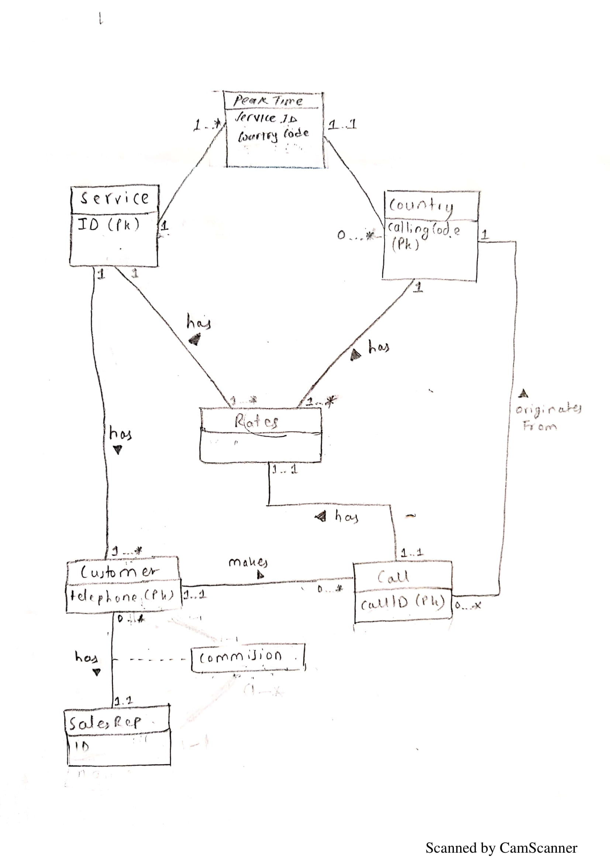

**Logical DB Design**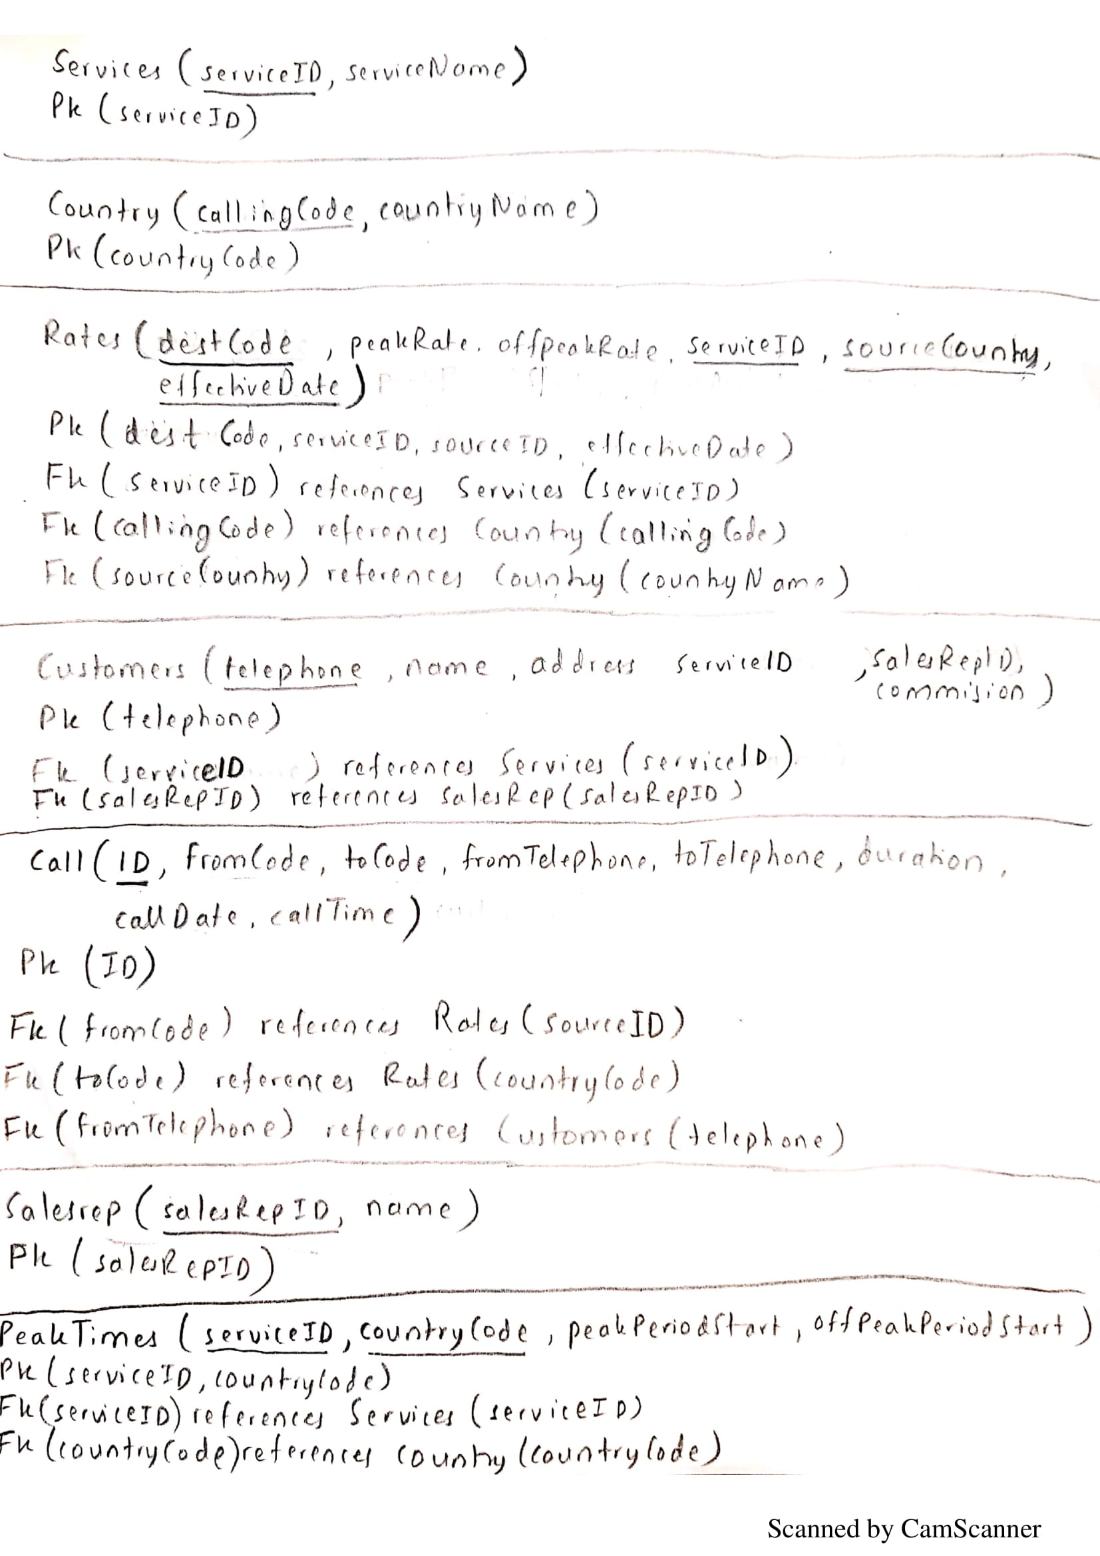

**Tables**

**Call**

callId int NOT NULL IDENTITY(1, 1) – Unique id for each call

fromCode int NULL – source country calling code

toCode int NULL – destination country calling code

fromTelephone bigint NULL – customer phone number

toTelephone bigint NULL – destination phone number

duration int NULL – duration of call

callDate date NULL – call date

callTime int NULL – call time

PRIMARY KEY (callId),

FOREIGN KEY (fromTelephone) references dbo.customer(telephone),

FOREIGN KEY (fromCode) references dbo.country(callingCode),

FOREIGN KEY (toCode) references dbo.country(callingCode)

**Country**

callingCode int NOT NULL – calling code for country

countryName varchar(50) NULL – name of country

PRIMARY KEY (callingCode)

**Customer**

telephone bigint NOT NULL – telephone number of customer

name varchar(500) NULL – name of customer

address varchar(500) NULL – address of customer

serviceId int NULL – service id of service used by customer

salesRepId int NULL – sales representative for the particular customer

commission float NULL – commission for the sales representative

PRIMARY KEY (telephone),

FOREIGN KEY (serviceId) references dbo.service(serviceId),

FOREIGN KEY (salesRepId) references dbo.salesRep(salesRepId)

**PeakTime**

serviceId int NOT NULL – service id of service

countryCode int NOT NULL – country code of the service origin

peakPeriodStart int NULL – peak period time start for the service

offPeakPeriodStart int NULL – off peak period time start for the service

CONSTRAINT PK_peakTime PRIMARY KEY NONCLUSTERED (serviceId, countryCode)

**Rate**

destCode int NOT NULL -- destination country calling code

peakRate float NULL – peak rate for the service and destination

offPeakRate float NULL – off peak rate

serviceId int NOT NULL – service id of service

sourceCode int NOT NULL – source country calling code

effectiveDate int NOT NULL – effective date for the rate for that service

CONSTRAINT PK_rate PRIMARY KEY NONCLUSTERED (destCode, serviceId, sourceCode, effectiveDate),

FOREIGN KEY (serviceId) references dbo.service(serviceId),

FOREIGN KEY (sourceCode) references dbo.country(callingCode),

FOREIGN KEY (destCode) references dbo.country(callingCode)

**SalesRep**

salesRepId int NOT NULL – unique sales rep id

firstName varchar(50) NULL – first name

lastName varchar(50) NULL – last name

PRIMARY KEY (salesRepId)

**Service**

serviceId int NOT NULL IDENTITY(1, 1) – unique service id

serviceName varchar(50) NULL – name of the service

PRIMARY KEY (serviceId)

**Manual and automatic steps for all major actions**

**Step1:** Run the Query_Configuration.sql first.

**Follow these steps afterwards:**

1. **Add new customer**EXEC addNewCustomers 'path to Customers.xlsx’  
   param1: path to Customers.xlsx
2. **Update rates**EXEC updateRates ‘path to \Rates_20080115.xls'

param1: path to Rates_20080115.xls

1. **Create Rate Sheets**

EXEC getRateSheet servicename, sourceCountry, ‘path to Rates folder’

param1: servicename

param2: sourceCountry

param3: path to rates folder

1. **Add call details**EXEC addCallDetails 'path to \Calls_Jan_2008.xls'

param1: path to \Calls_Jan_2008.xls

1. **Create Customer Bills**  
   EXEC createCustomerBill telephone, year, month, ‘path to \Bills\Bill.xlsx'

param1: customer telephone

param2: year

param3: month

param4: path to bill.xlsx

1. **Generate Salesrep commission information**

EXEC getSalesRepCommission year, month, 'path to \Commission\january.xlsx'  
param1: year

param2: month

param3: path to \Commission\january.xlsx

1. **Export rates**

EXEC getRateSheet servicename, sourceCountry, 'path to \Rates’  
param1: servicename

param2: sourceCountry  
param3: path to \Rates

1. **Generate traffic summary**

EXEC getMonthlyTrafficSummary year, month, 'path to \Traffic\january.xlsx'

param1: year

param2: month

param3: path to \Traffic\january.xlsx