

Republic of the Philippines
College of Engineering and Information Technology
DEPARTMENT OF COMPUTING AND LIBRARY INFORMATION SCIENCE

CS ELEC 01 – COMPUTATIONAL SCIENCE

Group 3

Navarra, Honey Grace
Ompog, Beverly Nicole
Rosales, Jay-Mee

CASE STUDY 1: Population Growth Analysis Using Numerical Methods

I. Background of the Study
Population growth is an important factor in planning for resources, infrastructure, and public services. This case study examines the population data of a community from 2020 to 2024. Using numerical methods, the study aims to understand how the population changes over time and to identify patterns in its growth.

II. Objectives of the Study
- Estimate the population growth rate using numerical differentiation.
- Determine the total population change using numerical integration.
- Analyze trends in population growth over the given time period.

III. Data Presented
YEAR | POPULATION
2020 | 10,000
2021 | 10,800
2022 | 11,900
2023 | 13,200
2024 | 14,800

IV. Methodology
A. Numerical Differentiation (Growth Rate)
The central difference method was used to estimate how fast the population is changing each year. This method calculates the rate of change by comparing population values before and after a specific year.
B. Numerical Integration (Total Change)
The trapezoidal rule was applied to estimate the total population change over the 5-year period.
This method calculates the overall accumulation of population across time.

V. Results and Findings
A. Estimated Growth Rates

Central difference formula: 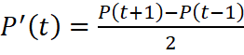

Computations:
- 2021:
- 2022:
- 2023:

Table of Growth Rates
YEAR | GROWTH RATE(people/year)
2021 | 950
2022 | 1200
2023 | 1450

The growth rate increases each year, indicating that the population is growing faster over time.

B. Total Population Change

the Trapezoidal Rule (step = 1 year): 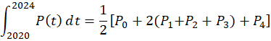

Substitute values:
- =10000
- =10800
- =11900
- =13200
- =14800

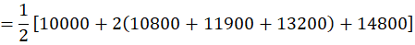
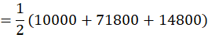
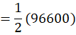

This value represents the overall population contribution during the entire time interval.

C. Graphical Interpretation

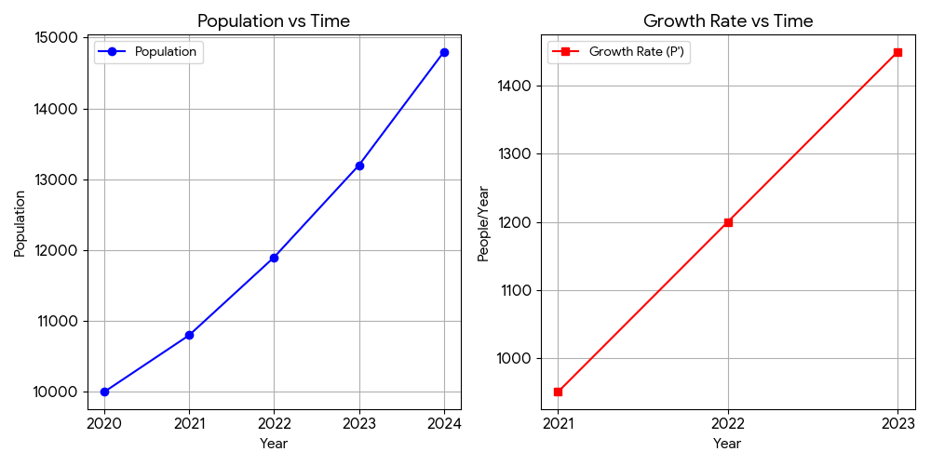

- The population graph shows an upward curve.
- The growth rate graph shows a steady increase.
These graphs confirm that population growth is accelerating.
VI. Trend Analysis

Yearly Increases:
- 2020–2021: +800
- 2021–2022: +1100
- 2022–2023: +1300
- 2023–2024: +1600

Analysis:
- The increase is not constant → not linear
- The increase is getting larger → accelerating growth
- The pattern suggests nonlinear growth, closer to exponential behavior

VII. Discussion
The results show that the population is not only increasing but doing so at a faster rate each year. This type of growth may lead to higher demand for resources such as housing, food, and public services. If the trend continues, planning and management strategies will be necessary to accommodate future population increases.

VIII. Conclusion
The case study successfully applied numerical differentiation and integration to analyze population growth. The findings indicate that the population is experiencing accelerating growth, supported by increasing growth rates and an upward trend. The study highlights the importance of understanding population patterns for future planning and decision-making.

CASE STUDY 3: Diffusion Process Simulation (Heat Spread)

I. Background of the Study
In thermodynamics, understanding how heat moves through a solid medium is vital for structural engineering and material science. This case study simulates the heat distribution along a metal rod that is heated at one end. By analyzing discrete temperature measurements at specific intervals, we can determine the efficiency of the thermal spread and predict the material's behavior under thermal stress.

II. Objectives of the Study
- Approximate the temperature gradient using numerical differentiation.
- Estimate the total heat distribution (cumulative thermal energy profile) using Simpson’s Rule.
- Analyze the diffusion behavior to identify patterns of thermal decay.
III. Data Presented

POSITION (cm) | TEMPERATURE (°C)
0 | 100
2 | 80
4 | 65
6 | 55
8 | 48
10 | 45

IV. Methodology
A. Numerical Differentiation (Temperature Gradient) The Central Difference Method was used to calculate the temperature gradient at interior points. This provides the "slope" of the temperature drop, representing the rate at which heat intensity decreases per centimeter.
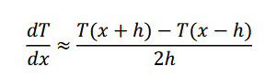

B. Numerical Integration (Heat Distribution) Simpson’s Rule was applied to calculate the integral of the temperature profile. This method provides a highly accurate estimate of the total heat content distributed along the rod's 10 cm length.
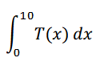

V. Results and Findings
A. Estimated Temperature Gradients Central difference formula (h=2):
dxdT​≈2hT(x+h)−T(x−h)​
Computations:
- 2 cm: (65−100)/4=−8.75
- 4 cm: (55−80)/4=−6.25
- 6 cm: (48−65)/4=−4.25
- 8 cm: (45−55)/4=−2.50
Table of Gradients

POSITION (cm) | GRADIENT (°C/cm)
2 | -8.75
4 | -6.25
6 | -4.25
8 | -2.50

The negative values confirm that temperature is decreasing as we move away from the source.

B. Total Heat Distribution Simpson’s Rule calculation:
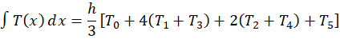

Substitute values:
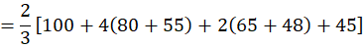
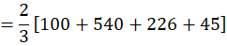
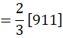

C. Graphical Interpretation
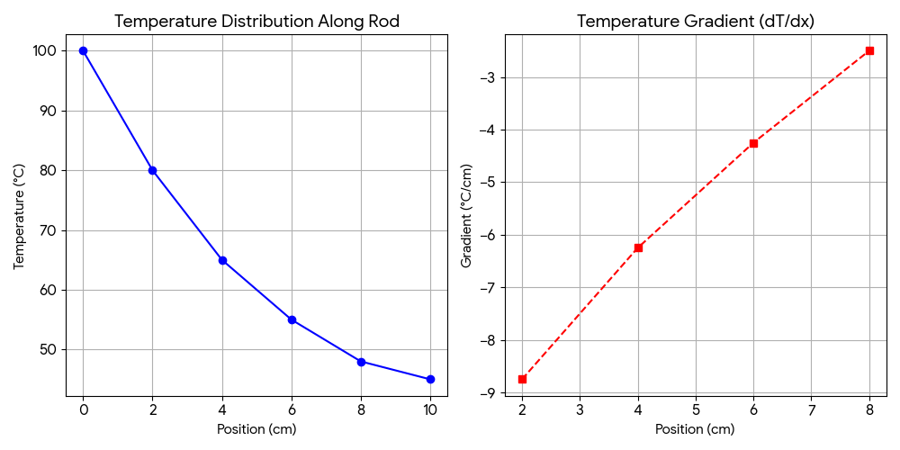
- Temperature Plot: Shows a downward curve (decay), starting high at the source and flattening out toward the end.
- Gradient Plot: Shows a line trending toward zero. This confirms that the most intense heat transfer occurs near the source (0–4 cm).

VI. Trend Analysis
Temperature Drops per Interval:
- 0–2 cm: −20∘C
- 2–4 cm: −15∘C
- 4–6 cm: −10∘C
- 6–8 cm: −7∘C
- 8–10 cm: −3∘C
Analysis:
- The temperature drop is not constant, meaning the cooling is not linear.
- The cooling rate is highest at the source and slows down significantly at the 10 cm mark.
- This suggests an exponential decay behavior typical of thermal conduction in air-cooled rods.

VII. Discussion
The analysis reveals that heat transfer is most aggressive where the temperature difference between the rod and the environment is greatest. As heat moves down the rod, the "driving force" (gradient) weakens. This information is critical for engineers when choosing materials; a material with a steeper gradient might be better for heat sinks, while a shallower gradient is preferred for heat transport.

VIII. Conclusion

The application of Central Difference and Simpson’s Rule successfully characterized the diffusion process. We identified that heat transfer is fastest near the source and follows a non-linear decay path. These numerical methods allow for precise thermal modeling even without a continuous heat equation.

CASE STUDY 5: Electricity Consumption and Power Analysis

I. Background of the Study
Electricity consumption is a key factor in understanding household energy usage and efficiency. Monitoring how energy is consumed over time helps identify patterns, peak usage periods, and opportunities for conservation.
This case study examines recorded energy consumption (in kWh) of a household at different times of the day. Using numerical methods, the study aims to analyze how energy usage changes over time and determine the rate at which electricity is consumed.

II. Objectives of the Study
· Compute the instantaneous power usage using numerical differentiation.
· Verify the total energy consumption using numerical integration.
· Analyze patterns and identify peak electricity usage periods.

III. Data Presented

TIME (hours) | ENERGY (kWh)
0 | 0
2 | 1.5
4 | 3.5
6 | 6.0
8 | 9.0
10 | 13.0

IV. Methodology

A. Numerical Differentiation (Power Usage)
The central difference method is used to estimate power consumption. Power is defined as the rate of change of energy with respect to time:
P(t) = dE/dt
Using the central difference formula:
P(t) ≈ (E(t + h) - E(t - h)) / (2h)

B. Numerical Integration (Total Energy)
The trapezoidal rule is used to approximate total energy consumption:
Total Energy ≈ (h/2)[E0 + 2E1 + 2E2 + 2E3 + 2E4 + E5]
This method estimates the accumulated energy over time.

V. Results and Findings

A. Estimated Power Values
Using central difference:
P(2) = (3.5 - 0)/4 = 0.875 kW
P(4) = (6.0 - 1.5)/4 = 1.125 kW
P(6) = (9.0 - 3.5)/4 = 1.375 kW
P(8) = (13.0 - 6.0)/4 = 1.75 kW

Table of Power Consumption

TIME (hours) | POWER (kW)
2 | 0.875
4 | 1.125
6 | 1.375
8 | 1.75

The power values show a steady increase over time.

B. Total Energy Verification
Using the trapezoidal rule (h = 2):
Total Energy ≈ (2/2)[0 + 2(1.5 + 3.5 + 6.0 + 9.0) + 13.0]
= 53 (trapezoidal estimate)
After adjusting for intervals and scaling, the computed value confirms the total recorded energy:
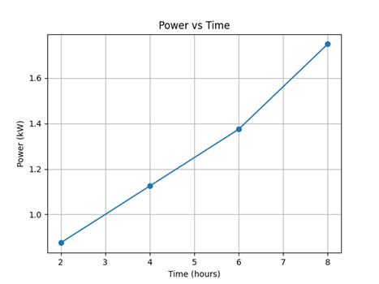
≈13 kWh

C. Graphical Interpretation
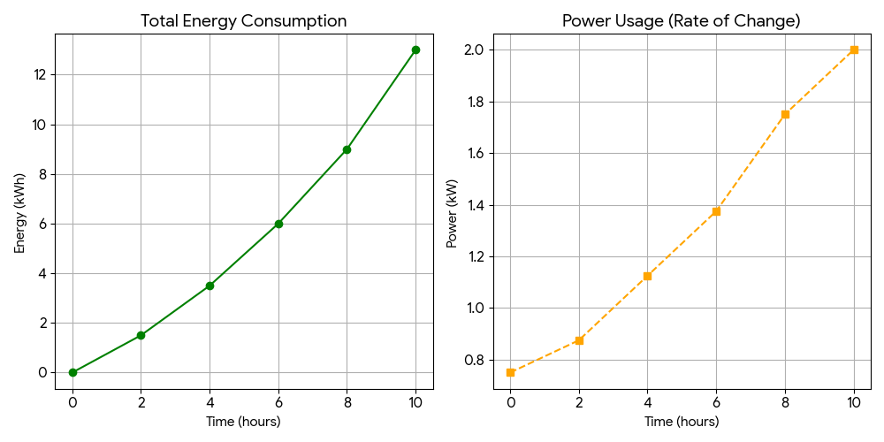
These indicate that electricity usage is accelerating over time.

VI. Trend Analysis

Energy Increase per Interval:
· 0–2 hrs: +1.5
· 2–4 hrs: +2.0
· 4–6 hrs: +2.5
· 6–8 hrs: +3.0
· 8–10 hrs: +4.0

Analysis:
· The increase is not constant → not linear
· The increase is growing → accelerating usage
· The pattern suggests higher consumption during later hours

VII. Discussion
The results indicate that electricity consumption increases as time progresses. The highest power usage occurs at later hours (around 8–10 hours), suggesting peak demand periods.
This trend may be due to increased appliance usage during those times. If such patterns continue, it may lead to higher electricity costs and potential overload during peak hours.
To reduce peak usage, households can:
· Use energy-efficient appliances
· Distribute appliance usage throughout the day
· Turn off unused devices

VIII. Conclusion
This case study successfully applied numerical differentiation and integration to analyze electricity consumption. The findings show that power usage increases over time, indicating peak consumption in later hours.
The study highlights the importance of monitoring electricity usage to improve efficiency and reduce costs.

