**Java Servlet**

### Interfaces

1. HttpServletRequest
2. HttpServletResponse
3. HttpSession
4. HttpSessionListener
5. HttpSessionAttributeListener
6. HttpSessionBindingListener
7. HttpSessionActivationListener
8. HttpSessionContext (deprecated now)

Classes

1. HttpServlet
2. Cookie
3. HttpServletRequestWrapper
4. HttpServletResponseWrapper
5. HttpSessionEvent
6. HttpSessionBindingEvent

**JSP Standard Actions**

* jsp:include - Includes a file at the time the page is requested.
* jsp:useBean - Finds or instantiates a JavaBean.
* jsp:setProperty - Sets the property of a JavaBean.
* jsp:getProperty - Inserts the property of a JavaBean into the output.
* jsp:forward - Forwards the requester to a new page.
* jsp:plugin - Generates browser-specific code that makes an OBJECT or EMBED tag for the Java plugin.
* jsp:element - Defines XML elements dynamically.
* jsp:attribute - Defines dynamically-defined XML element's attribute.
* jsp:body - Defines dynamically-defined XML element's body.
* jsp:text - Used to write template text in JSP pages and documents.

**Custom Action (JSTL)**

* **Core Tags**
  + <c:out>
  + <c:set >
  + <c:remove >
  + <c:catch>
  + <c:if>
  + <c:choose>
  + <c:when>
  + <c:otherwise >
  + <c:import>
  + <c:forEach >
  + <c:forTokens>
  + <c:param>
  + <c:redirect >
  + <c:url>
* **Formatting tags**
  + <fmt:formatNumber>
  + <fmt:parseNumber>
  + <fmt:formatDate>
  + <fmt:parseDate>
  + <fmt:bundle>
  + <fmt:setLocale>
  + <fmt:setBundle>
  + <fmt:timeZone>
  + <fmt:setTimeZone>
  + <fmt:message>
  + <fmt:requestEncoding>
* **SQL tags**
  + <sql:setDataSource>
  + <sql:query>
  + <sql:update>
  + <sql:param>
  + <sql:dateParam>
  + <sql:transaction >
* **XML tags**
  + <x:out>
  + <x:parse>
  + <x:set >
  + <x:if >
  + <x:forEach>
  + <x:choose>
  + <x:when >
  + <x:otherwise >
  + <x:transform >
  + <x:param >
* **JSTL Functions**
* fn:contains()
* fn:containsIgnoreCase()
* fn:endsWith()
* fn:escapeXml()
* fn:indexOf()
* fn:join()
* fn:length()
* fn:replace()
* fn:split()
* fn:startsWith()
* fn:substring()
* fn:substringAfter()
* fn:substringBefore()
* fn:toLowerCase()
* fn:toUpperCase()
* fn:trim()

**JSP Expression Language (EL)** makes it possible to easily access application data stored in JavaBeans components. JSP EL allows you to create expressions both (a) arithmetic and (b) logical. Within a JSP EL expression, you can use integers, floating point numbers, strings, the built-in constants true and false for boolean values, and null.

**Scriptlet** is a piece of Java-code embedded in the HTML-like JSP code. The scriptlet is everything inside the <% %> tags. Between these the user can add any valid Scriptlet i.e. any valid Java Code.

**PHP**

SuperGlobals

* $GLOBALS
* $_SERVER
* $_REQUEST
* $_POST
* $_GET
* $_FILES
* $_ENV
* $_COOKIE
* $_SESSION

**NodeJS**

Node.js has a built-in module called HTTP, which allows Node.js to transfer data over the Hyper Text Transfer Protocol (HTTP).

To include the HTTP module, use the require() method:

var http = require('http');

**WEB Security**

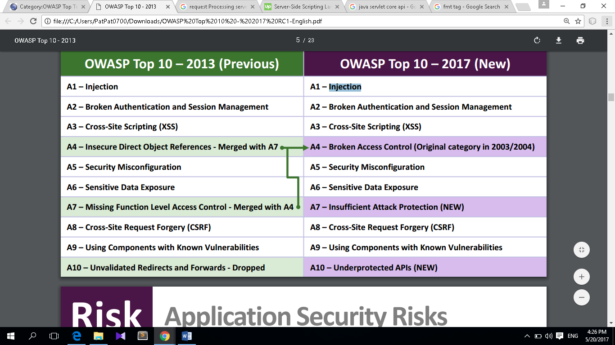

References:

<https://www.javatpoint.com/servlet-api>

<https://www.tutorialspoint.com/jsp/jsp_standard_tag_library.htm>

<https://en.wikipedia.org/wiki/Scriptlet>

<https://www.tutorialspoint.com/jsp/jsp_expression_language.htm>

<https://www.w3schools.com/nodejs/nodejs_http.asp>

<https://www.w3schools.com/php/php_superglobals.asp>