Table of Contents

Blockchain Trajectories in Graph Databases: A Neo4j-Based Model for Ethereum Transaction Analytics
Francisco Javier Moreno Arboleda · Juan Esteban Mejía Espejo · Georgia Garani

Abstract
Blockchain platforms generate large volumes of interconnected transactional data, whose analysis can reveal important patterns of account activity, value transfer, and user interaction. This paper proposes a graph database model for representing and analyzing Ethereum blockchain data. The proposed model captures blocks, accounts, external transactions, and internal transactions as graph nodes, while relationships represent temporal block succession, transaction recording, sender and receiver participation, and the decomposition of external transactions into internal transactions. By interpreting the blockchain as a trajectory of consecutive blocks, the model enables trajectory-style analytics over selected temporal windows. The model was implemented in Neo4j, using Ethereum data collected through Google BigQuery’s public Ethereum dataset, and evaluated through Cypher queries over cumulative block ranges spanning 2 to 10,000 blocks and across four distinct eras of Ethereum’s history (2016, 2020, 2023, and 2024). The queries analyze account activity, sender–receiver relationships, transaction volumes, and statistical properties of external and internal transactions. The experimental results show that the proposed graph representation can effectively identify highly active accounts, recurrent sender–receiver pairs, and key intermediaries such as the Wrapped Ether contract, and that these patterns are stable across nearly four orders of magnitude of window size. At the ten-thousand-block scale (over 1.5 million external and 0.8 million internal transactions for the 2024 window) all queries execute in seconds once expressed in a single-traversal form. The cross-era comparison further reveals the structural evolution of the network: the number of transactions per block, the proportion of internal transactions, and the identity of the dominant intermediaries all change markedly from 2016 to 2024, with Wrapped Ether emerging and rising to dominance over this period. The findings demonstrate the suitability of graph databases for blockchain transaction analysis at scale and provide a foundation for future work on anomaly detection, community discovery, and real-time graph-based monitoring.
Keywords: Blockchain analytics; Ethereum; Graph databases; Neo4j; Cypher queries; External transactions; Internal transactions; Transaction networks; Account activity; Blockchain trajectories

1. Introduction
Blockchain technology has revolutionized several sectors (Tschorsch & Scheuermann, 2016) due to its ability to provide a decentralized, immutable, and secure ledger for transactional data. Blockchain databases (DBs) usually store millions of transactions; e.g., as of late December 2025 Bitcoin has more than 1.2 billion transactions and Ethereum more than 3.2 billion. This offers an opportunity to perform data analysis, which helps us understand the relationships and dynamics among their users (participants).
Graph DBs (GDBs) stand out for their ability to manage graphs and query the relationships between their nodes. Unlike relational DBs (RDBs), which use relations (informally, tables) to store data, GDBs represent data as nodes and the relationships between them as edges (edges can also carry data), facilitating the formulation of neighborhood queries, e.g., finding the nodes connected to a given node. This capability is well suited for modeling a blockchain DB, where blocks, transactions, and user accounts are interconnected, i.e., they form a network (a graph). Thus, the convergence of blockchain and GDBs offers opportunities for analyzing blockchain data modeled as a graph: representing a blockchain DB in a GDB not only enables visualization of the network’s structure, but also facilitates the formulation of queries to detect patterns, explore relationships between users, and gain valuable insights about user behavior.
However, blockchain data analysis using GDBs remains relatively underexplored (see Section 2). The few existing studies, such as Estupiñán (2020) and Lin et al. (2020), mainly address address clustering, performance evaluation, and link prediction. The main contribution of this study lies in the analysis of the Ethereum network using graph queries to identify patterns and relationships among user accounts. Furthermore, the study introduces a formal graph model for the Ethereum blockchain and examines the composition and interrelation of external and internal transactions, an aspect not usually detailed in related work. The analysis spans cumulative windows from 2 to 10,000 consecutive blocks and four distinct eras of Ethereum’s history, in order to study how the observed interaction patterns evolve over time.
For the representation of a blockchain DB in a GDB, this work adopts a trajectory-based graph perspective. A blockchain can naturally be modeled as a trajectory, namely an ordered sequence of transactions anchored to a temporal backbone formed by the sequence of blocks, where each block contains a set of transactions. Under this representation, nodes correspond to blocks, transactions, and user accounts, while edges represent (i) the temporal succession of blocks, (ii) the participation of accounts as senders or receivers in transactions, and (iii) the decomposition of external transactions into internal transactions. This perspective enables trajectory-style analytics, such as the analysis of sender–receiver behavior over a specific interval of blocks, and differs from a conventional temporal-graph representation in that the ordered sequence of blocks is the primary temporal backbone rather than a per-edge timestamp attribute.
The remainder of the paper is organized as follows. Section 2 reviews related work on trajectory modeling and blockchain analysis using GDBs. Section 3 introduces the proposed model. Section 4 presents the experimental setup and results. Section 5 discusses the model’s capabilities, strengths, and limitations in light of the scaled and cross-era experiments. Section 6 concludes and outlines future work.

2. Related work
This section reviews existing studies on trajectory modeling and blockchain analysis based on graph databases.

2.1 Trajectory modeling with GDBs
In Bakkal et al. (2017), trajectories are modeled and implemented in Neo4j to build a ridesharing (carpooling) system, using the Neo4j Spatial library for spatial querying/indexing and GraphAware Neo4j TimeTree for second-level time representation. A trajectory is represented by a set of nodes (user, moment in time, position, and a link node connecting them); each link node is a point within a trajectory. Experiments on the Geolife dataset (182 users, 18,000 trajectories) demonstrate feasibility, though the results are not analyzed for broader conclusions.
Khan et al. (2017) present a performance comparison between a RDBMS (Oracle 11g) and a GDBMS (Neo4j 3.0.3 Community) on healthcare data. Neo4j outperforms Oracle, with the gap widening as the dataset grows, owing to Neo4j’s native handling of relationships versus Oracle’s join operations.
Gómez, Kuijpers & Vaisman (2019) model semantic trajectories (STs) as a graph in Neo4j and compare against a PostgreSQL implementation, defining aggregation hierarchies for POI and temporal dimensions. GDB queries execute 1.2–7× faster than their relational counterparts, except for transitive-closure queries, which perform better relationally.
Tamilmani & Stefanakis (2019) model and analyze Semantically Enriched Simplified Trajectories (SESTs) in Neo4j, applying the SED criterion and SELF structure for semantics-preserving simplification, and focus on shortest/longest-trajectory and collision-region queries.
Karim et al. (2021) propose a framework for collecting, storing, and analyzing pedestrian trajectories using PostGIS and Neo4j with spatial APIs, modeling trajectory events, intents, and activities via a UML class diagram, though without Neo4j implementation details or analytical queries.
Xue et al. (2022) propose CoGAT, a graph-based model in Neo4j for Argo float trajectories, modeling parking/surface segments and subtrajectories; it achieves higher computational efficiency than an Oracle Spatial baseline (OSATDB).
Elayam et al. (2022) introduce a hierarchical graph-based model for mobility data, evaluated on the European maritime network, combining MovingPandas, Uber H3 spatial indexing, and Neo4j to support analysis at micro, meso, and macro levels.

2.2 Blockchain analysis with GDBs
Estupiñán (2020) analyses Ethereum-blockchain modelling, loading, and querying with Neo4j, JanusGraph, and DSE Graph, focusing on address-clustering (airdrop multi-participation and deposit-address re-use, per Victor 2019). Two graph models (transaction-as-node and transaction-as-edge) are implemented; Neo4j and DSE Graph perform best with transaction-as-node, and indexing is decisive for query performance.
Lin et al. (2020) model Ethereum transaction records as a temporal weighted multidigraph (TWMDG) and introduce temporal random-walk strategies for link prediction, outperforming traditional random-walk techniques on real Ethereum data.

2.3 Positioning
Most previous works are trajectory-centric, focusing on spatial/temporal features, performance comparisons in Neo4j, or semantic simplification, rather than on blockchain analytics in a GDB. Although Ethereum has been modeled as a TWMDG for link prediction (Lin et al., 2020) and as a graph for address-clustering and query-performance studies (Estupiñán, 2020), limited attention has been given to formal graph-based models supporting broader analytical processing of blockchain data. The proposed contribution addresses this gap with a formal model enabling graph-style analytical queries over Ethereum data — including both external and internal transactions — and demonstrates it at scale (up to 10,000 blocks) and across four eras. Table 1 summarizes the analyzed works and their limitations.

3. Model definition
The proposed model is designed around the notion of a blockchain trajectory: an ordered sequence of consecutive blocks that defines the temporal progression of blockchain activity. Each block is a trajectory point, and the transactions recorded in that block are the activity associated with that point. This interpretation enables the analysis of Ethereum behavior over block windows while preserving the relationships among blocks, accounts, external transactions, and internal transactions.
Ethereum distinguishes two transaction types. An external transaction is a user-initiated action submitted by an Externally Owned Account (EOA), recorded directly in a block and uniquely identified by a transaction hash. An internal transaction is a value transfer or contract call triggered during the execution of an external transaction through smart-contract code; it is identified by its parent external transaction together with a sequential number.

3.1 Block node
Attributes: blockNumber (the block height, unique) and dateCreation (creation timestamp). Datatype: NblockDt = (blockNumber, dateCreation), with blockNumber ∈ ℕ, dateCreation ∈ Timestamp.

3.2 Transaction node
Attributes: transactionHash (unique id of an external transaction; empty for internal), isInternalTransaction (Boolean), value (ETH transferred), sequenceId (per-parent counter for internal transactions), and parentTransactionHash (for internal transactions). Datatype: NtransactionDt = (transactionHash, isInternalTransaction, value, sequenceId, parentTransactionHash).

3.3 Account node
Attributes: address (unique id) and isContract (Boolean: contract vs EOA). Datatype: NaccountDt = (address, isContract).
The account model deliberately carries only address and isContract. A balance attribute is intentionally excluded: none of the analytical queries depend on it, and a current-balance value would not correspond to an account’s state during the analyzed block window, so it is not meaningful for the historical, window-based analysis pursued here. Block nodes likewise retain only number and timestamp.

3.4 Edges
The model defines: previous block (currentBlockNumber = previousBlockNumber + 1); recorded in (external transaction → containing block); sent by / received by (external transaction ↔ sender/receiver account); internal transaction (external transaction → its internal transactions, keyed by parentTransactionHash + sequenceId); and internal sent by / internal received by (internal transaction ↔ sender/receiver account). Constraints and datatypes are illustrated in Figures 2 and 3.

4. Experiments
The experiments were conducted on a MacBook Air (Apple M4, 16 GB RAM, macOS Tahoe 26.3), with the GDB managed by a local instance of Neo4j Community Edition version 2026.01.3.

4.1 Data acquisition
Data were obtained from the public crypto_ethereum dataset on Google BigQuery, which mirrors the Ethereum blockchain and is updated continuously. Four tables were used: blocks (number, timestamp), transactions (external transactions), traces (internal transactions, i.e. message calls generated during contract execution), and contracts (deployed contract accounts). For a given block window, a small set of queries retrieves all blocks, external transactions, and internal transactions, together with the participating accounts. An account is classified as a smart contract when it appears in the contracts table with a deployment block no later than the end of the window — a point-in-time classification consistent with the analyzed window. Internal transactions are operationalized as successful, value-transferring sub-calls (traces with a non-empty trace address and non-zero value); purely zero-value message calls are thus excluded. This understates the absolute count of internal calls, but the criterion is applied uniformly across all eras and window sizes, so the internal-to-external ratios reported in Section 4.4 remain comparable. Because the BigQuery tables are partitioned by day on their timestamp column, the extraction queries constrain both the block-number range and the corresponding block-timestamp range so that only the relevant daily partitions are scanned; this reduces the data processed for a 100-block window from several terabytes to a few gigabytes.
The retrieved rows are written to Neo4j in batches using parameterized UNWIND statements, with uniqueness constraints declared in advance on Block.number, ExternalTransaction.transactionHash, and User.address, and a composite index on the internal-transaction key. With this design the dominant cost is neither data acquisition nor writing, and the analysis scales to windows of up to ten thousand blocks.

4.2 Experimental design
Queries are evaluated over cumulative, nested block ranges: 2, 10, 50, 100, 1,000, and 10,000 consecutive blocks. The same ladder is evaluated over four eras drawn from structurally distinct periods of Ethereum’s history:
Era | Start block | Date (10k-block span) | Character
Pre-DeFi (2016) | 2,000,000 | Aug 02–04, 2016 | sparse activity, few internal transactions, prior to WETH
DeFi Summer (2020) | 10,700,000 | Aug 20–22, 2020 | rise of WETH/decentralized exchanges, PoW gas competition
Post-Merge (2023) | 17,000,000 | Apr 07–09, 2023 | proof-of-stake, 12-second blocks, MEV
Post-Dencun (2024) | 20,512,878 | Aug 12–13, 2024 | post-Dencun, L2-oriented activity
The block count is held fixed across eras (the corresponding time spans are reported above); because block-production rates and per-block transaction counts differ across eras, the transaction volume for a fixed block count varies, and this variation is itself part of the findings. All queries are executed unchanged in every era. Queries are organized into four groups: (i) account activity by ETH transferred, (ii) account activity by number of transactions, (iii) relationships between accounts, and (iv) general transaction statistics. The complete per-run and comparison outputs are in data/results/ and data/output/.
The external-transaction node is labelled ExternalTransaction. For example, the ten accounts that received the most ETH:
MATCH (u:User)-[:RECEIVED_BY]->(tx)
WITH u.address AS account,
CASE WHEN tx:ExternalTransaction THEN tx.value
WHEN tx:InternalTransaction THEN tx.amount END AS received_amount
RETURN account, SUM(received_amount) AS total_received
ORDER BY total_received DESC LIMIT 10

4.3 Scaling within a single era (post-Dencun, 2024)
At 1,000 and 10,000 blocks (from block 20,512,878) the model operates efficiently at scale and the patterns identified on small samples persist. The 10,000-block window comprises 1,530,170 external transactions, 849,527 internal transactions, and 532,348 distinct accounts (about 5.3% smart contracts), a graph of ~2.9M nodes and ~5.8M relationships. All queries execute in a few seconds on this graph once the total-participation query is expressed in its single-traversal form (Section 4.6).
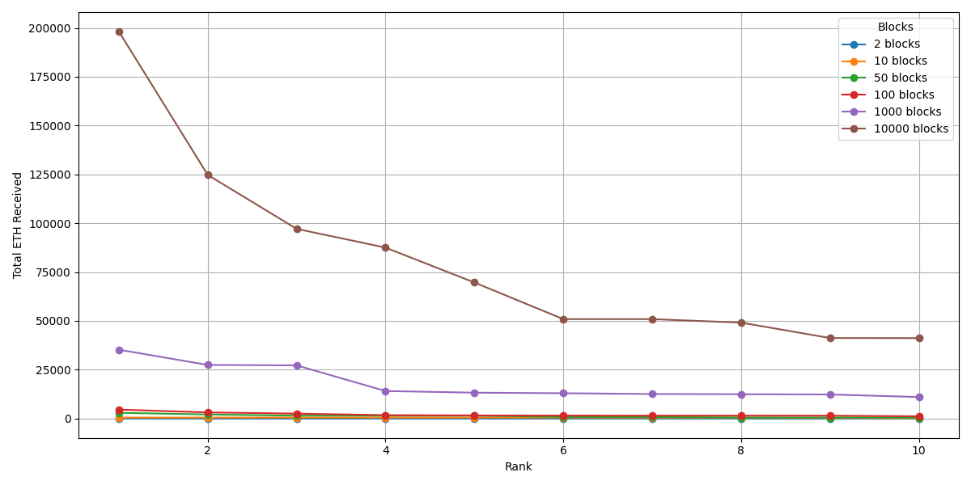
Figure 4. Top-ten accounts by total ETH received, across cumulative block ranges (2–10,000 blocks) in the post-Dencun 2024 era. The Wrapped Ether contract (0xc02a…56cc2) dominates the larger windows.
Concentration is stable across window sizes. The Wrapped Ether contract (0xc02aaa39…756cc2) is the single most active account by overall transaction participation at every window size, and its share is essentially flat as the window grows: 7.00%, 6.03%, 5.76%, 5.92%, 5.96%, and 6.03% of all transaction participations at 2, 10, 50, 100, 1,000, and 10,000 blocks respectively (Query 4.2.3; a participation is one sender or one receiver role in a transaction). If anything the share is marginally highest at the smallest window. The Tether (USDT) contract (0xdac17f95…831ec7) and the aggregator 0x3fc91a3a…2b7fad occupy the second and third positions at every scale, swapping ranks 2↔3 between the smallest and largest windows but never leaving the top three. The centrality of the key intermediaries is thus a robust property of the network, well defined already at small samples and neither sharpening nor dissipating as the window grows across nearly four orders of magnitude.
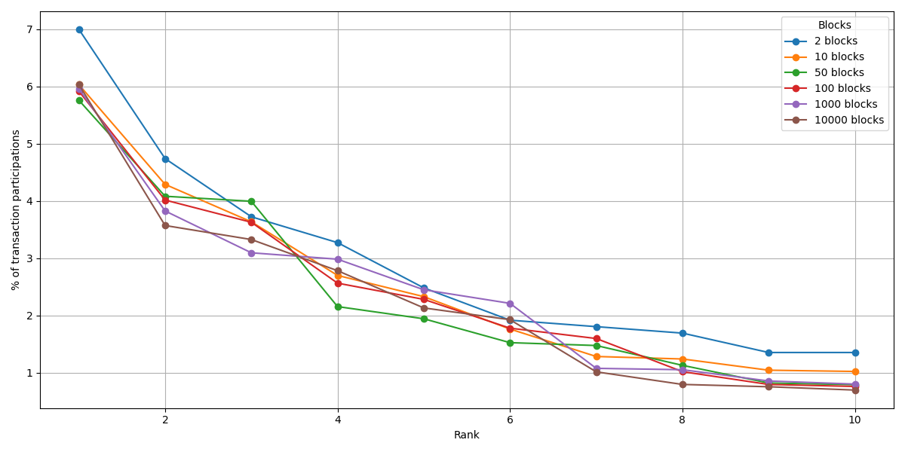
Figure 5. Top-ten accounts by transaction-participation percentage, across cumulative block ranges (2–10,000 blocks) in the 2024 era. The curves for every window size overlap: Wrapped Ether (rank 1) holds between 5.8% and 7.0% of participations across all scales (highest at the smallest window), and the whole top-ten profile is stable.
Value distributions. For external transactions the median transferred value is 0 ETH at every window size (Query 4.4.1), confirming that a large fraction of external transactions are contract interactions carrying no direct ETH transfer. The mean is dominated by rare large transfers: the maximum is already ~17,540 ETH by 1,000 blocks (17,568 ETH at 10,000) while the 75th percentile stays ~0.02–0.05 ETH. For internal transactions the mean amount is outlier-driven and non-monotonic across the ladder (0.55, 6.07, 3.42, 2.71, 2.38, 1.92 ETH at 2, 10, 50, 100, 1,000, 10,000 blocks) while the median stays low and stable (~0.04 ETH) — i.e. most internal transfers are small and a few large ones move the mean.

4.4 Cross-era comparison
Running the same 10,000-block ladder in four eras shows how Ethereum’s interaction structure has changed. Holding the block count fixed, the eras differ sharply:
Era (start block) | External txs | Internal txs | Accounts | Contract share | ext-tx / block | internal/external | Most-received account (rank 1) | WETH rank
Pre-DeFi 2016 (2,000,000) | 80,796 | 16,133 | 28,723 | 7.2% | 8.1 | 0.20 | 0xaa1a…6444 (contract) | absent
DeFi Summer 2020 (10,700,000) | 1,878,933 | 385,042 | 590,445 | 5.3% | 187.9 | 0.20 | 0x7a25…488d — Uniswap V2 Router | 2
Post-Merge 2023 (17,000,000) | 1,301,965 | 739,050 | 524,965 | 5.8% | 130.2 | 0.57 | 0x8358…28fe | 2
Post-Dencun 2024 (20,512,878) | 1,530,170 | 849,527 | 532,348 | 5.3% | 153.0 | 0.56 | 0xc02a…56cc2 — Wrapped Ether | 1
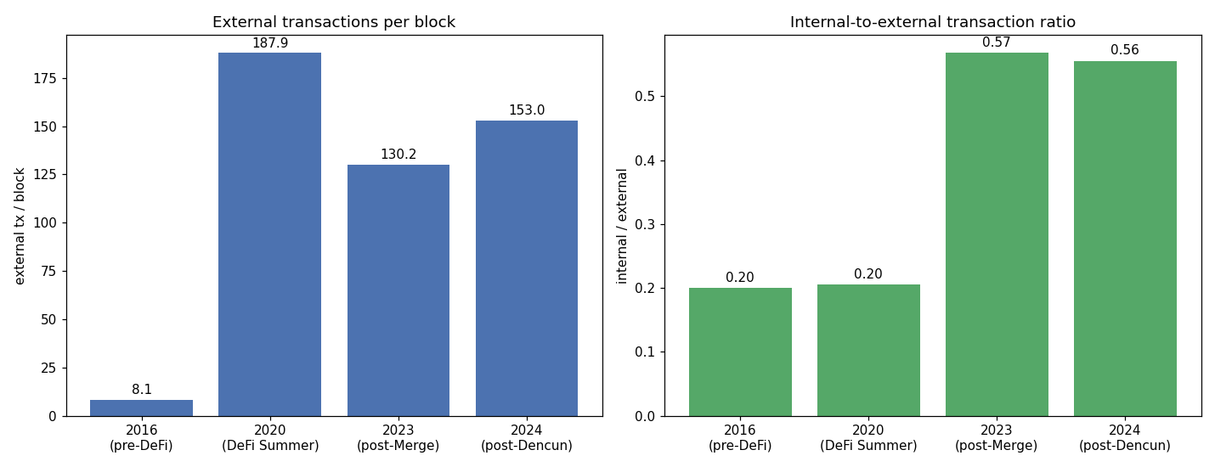
Figure 6. Cross-era transaction volume at fixed 10,000-block windows. Left: external transactions per block rise from ~8 (2016) to 130–188 in the modern eras (densification). Right: the internal-to-external transaction ratio jumps from 0.20 (2016, 2020) to ~0.57 after the Merge (rising smart-contract complexity).
- Densification. External transactions per block rise from about 8 in 2016 to 130–190 in the modern eras (roughly twentyfold), so a fixed 10,000-block window represents ~81k transactions in 2016 but ~1.3–1.9M in 2020–2024. The DeFi-Summer window has the highest raw throughput (187.9 tx/block), consistent with the gas competition of that period. Block count and transaction volume are therefore not interchangeable across eras — the block-trajectory model fixes the former and reports the latter.
- Rise of contract complexity. The ratio of value-transferring internal transactions to external transactions is flat at 0.20 in both 2016 and 2020 but jumps to ~0.57 in 2023 and 2024: modern external transactions each trigger far more value-bearing internal transfers, reflecting the shift from simple transfers and first-generation DeFi toward more deeply composed smart-contract interactions (staking, MEV, multi-hop routing). Because the measured ratio counts only value-transferring calls (§4.1), it is a conservative lower bound on the true growth in internal-call complexity — zero-value message calls, common in routers and aggregators, are excluded. The contract share of accounts stays in a narrow 5–7% band, so the growth is in activity per contract, not in the proportion of contracts.
- Emergence of Wrapped Ether. WETH is entirely absent from the 2016 window (deployed December 2017). By 2020 it is the second most-received account, behind the Uniswap V2 Router (0x7a250d…488d), the defining contract of DeFi Summer; it remains second in 2023 and becomes the single most-received account in 2024. The “key intermediary” the single-era analysis highlights is thus not a fixed feature of the network but one that emerged and rose to dominance. Era-specific intermediaries are also visible — e.g. the Beacon-chain deposit contract (0x0000000021…705fa) is the second most-received account in 2024, reflecting post-Merge staking flows.
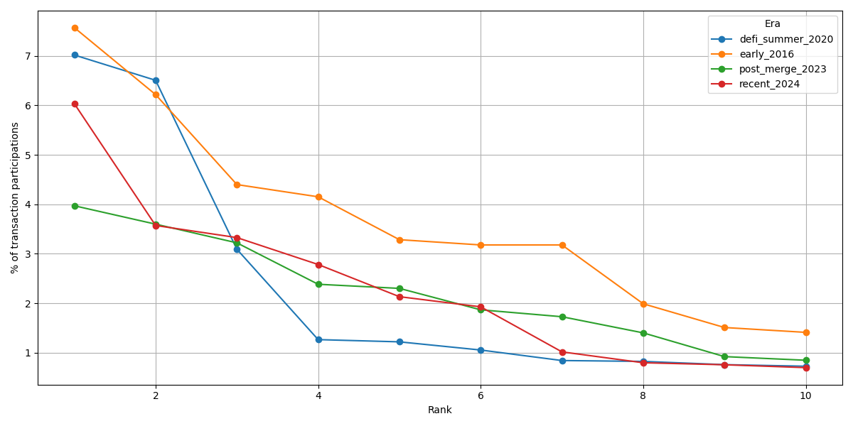
Figure 7. Top-ten accounts by transaction-participation percentage, compared across the four eras (10,000-block windows). The concentration profile differs by era — the post-Merge 2023 window is notably flatter (more distributed) than 2016, 2020, and 2024.
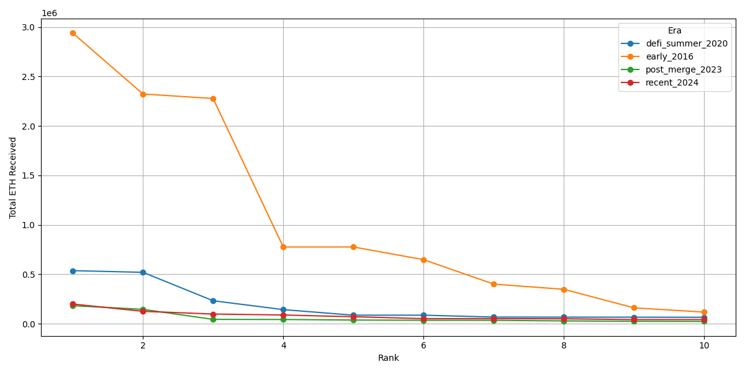
Figure 8. Top-ten accounts by total ETH received, compared across the four eras (10,000-block windows). The dominant recipient shifts across eras: an early contract in 2016, the Uniswap V2 Router in 2020, and Wrapped Ether in 2024.
Cross-era comparison charts and pivot tables for every query and cut-off are in data/output/cross_era_<n>/; within-era ladders are in data/output/<era>/. The main result tables are collected in Appendix A.

4.5 Relationships between accounts and statistics
The sender–receiver pair queries (Query 4.3) and the transaction-statistics queries (Query 4.4) were executed for all eras and cut-offs. The persistent presence of specific sender–receiver pairs across window sizes indicates stable behavioural patterns and identifies high-traffic corridors and key intermediaries; the cross-era view shows these corridors themselves shift with the dominant applications of each period (e.g. Uniswap routing in 2020, staking flows in 2024). Detailed tables are provided under data/output/.

4.6 Query scalability note
The total-participation query (4.2.3), as originally written, performs two OPTIONAL MATCH traversals over an account’s sent and received edges before aggregating, materializing the cross-product of the two edge sets per account. For hub accounts this is prohibitive (WETH has ≈128k sent and ≈159k received edges at 10,000 blocks, i.e. ~2×10^10 intermediate rows) and the query does not complete. Rewriting it to aggregate the two traversals in separate stages — the single-traversal reformulation — returns identical results in about two seconds. This is the only query requiring reformulation to reach 10,000 blocks; the remaining queries scale directly.

5. Discussion: capabilities, strengths, and limitations
The scaled and cross-era experiments allow a more critical assessment of what the proposed model enables — and where it does not — more clearly than a single-era, small-scale analysis could.

5.1 Analytical capabilities demonstrated
Capability | How the model supports it | Evidence from the experiments
Rank the most active accounts (by value and by participation) | SENT_BY/RECEIVED_BY aggregation over transaction nodes | WETH, USDT and a small set of aggregators identified as stable leaders (§4.3)
Detect recurrent sender–receiver corridors | pair pattern (:User)-[:SENT_BY]->(tx)<-[:RECEIVED_BY]-(:User) | Uniswap-router-centred corridors in 2020, staking flows in 2024 (§4.4–4.5)
Separate user↔contract from user↔user flows | isContract on User + pair queries | ~5–7% of accounts (contracts) mediate most activity across all eras
Decompose external into internal transactions | distinct ExternalTransaction/InternalTransaction labels + HAS_INTERNAL_TRANSACTION | value-transferring internal/external ratio 0.20→0.57 across eras — invisible to external-only models
Windowed (“trajectory”) analysis | cumulative block ranges over the block backbone | stabilization curves 2→10,000 blocks (§4.3)
Compare across time with no new queries | era-agnostic schema; identical 14 queries | WETH’s emergence and the complexity jump (§4.4)

5.2 Strengths (where the model is useful)
- Locality and expressiveness. Neighborhood, pair, and participation queries map directly to graph traversals and run in seconds even on the 10,000-block 2024 graph (~2.9M nodes, ~5.8M relationships). The questions the model answers best are exactly the relational ones that are awkward in a relational schema.
- Portability across time. The same schema and the same fourteen queries ran unchanged over windows spanning 2016 to 2024; the cross-era study required zero new queries. This makes the model well suited to longitudinal, comparative blockchain studies, not just single-snapshot analysis.
- The internal-transaction modeling earns its place. The external/internal distinction — rarely modeled explicitly in related work — is what surfaced the post-Merge tripling of contract-mediated activity (Figure 6, right). This is the clearest example of a finding the model enables that a transactions-as-edges graph could not express.
- Small samples are representative — for structure. The ranking of dominant intermediaries is already stable by ~100–1,000 blocks; the 10,000-block runs confirmed rather than overturned it. This shows that representative behavior can be extracted from modest samples. Larger windows refine the magnitudes of value-based metrics (e.g. maximum transfers), while the participation-share concentration itself stays flat across scales (§4.3).

5.3 Limitations (where it struggles)
- Uneven query scalability. Global aggregations that fan out over high-degree hubs can blow up: the total-participation query built a cartesian product on WETH’s ~287k edges and did not complete at 10,000 blocks until reformulated (78 min → 2 s, §4.6). The model is fast for local and pair queries but naive global queries need careful, sometimes non-obvious, formulation — a genuine cost of the approach, not merely an implementation detail.
- Operational cost at scale. Bulk loading and, especially, bulk deletion require capacity planning: a single-transaction wipe of the 2.9M-node graph exhausted the heap and had to be batched. Beyond ~10^7 elements the GDB stops being “just fast.”
- The temporal backbone is under-exploited. PREVIOUS_BLOCK is loaded and gives the model its trajectory framing, yet almost none of the analytical queries actually traverse the block chain; the trajectory is currently more organizational than query-driving. Making the backbone earn its place (e.g. inter-block flow or persistence queries) is an open opportunity.
- Block count is not volume-comparable across eras. A fixed 10,000-block window is ~81k transactions in 2016 but ~1.9M in 2020 (Figure 6, left). Cross-era claims must therefore always report volume alongside block count; the block-trajectory abstraction, while clean, hides this by design.
- No block-time economic state. Dropping balance simplified ingestion at no cost to the present queries, but the model consequently cannot answer wealth/holdings questions without adding block-time state.
- Each era is a single ~2-day window (n = 1). Every era is one contiguous 10,000-block window (~1.4–1.9 days at 12–14 s/block). The cross-era “evolution” findings (densification, the internal/external ratio jump, WETH’s rise, the Figure 7 profiles) are therefore single-window snapshots, not statistically estimated era means: a day-specific event (a large airdrop, NFT mint, exploit, or MEV episode) could move a window’s ratios or top recipients, and three of the four windows fall in August. The cross-era differences should be read as indicative of era character; attaching confidence would require several windows per era. (The within-era ladder, by contrast, does vary the sample — across block-count — and shows stability there.)
- Contract classification is a slight undercount. An account is labeled a contract only if it appears in BigQuery’s contracts table with a deployment block within the window; contracts created in-window but not otherwise referenced, precompiles, and L2 alias/system addresses are therefore counted as EOAs. This makes the reported contract share (5–7%) a mild lower bound; it does not affect the value/participation rankings.

5.4 Were the two new axes worth it?
- Scaling to 10,000 blocks — worth it, with diminishing returns for ranking. For identifying the key players, returns diminish beyond a few hundred blocks; for distributional/magnitude claims and for stress-testing the model, returns increase — the scale is precisely what exposed the query-scalability limitation (§4.6) and confirmed that the concentration of key intermediaries is stable across nearly four orders of magnitude of window size, rather than a small-sample artifact. The value is credibility and the surfacing of a real limitation, more than new rankings.
- Cross-era comparison — the most valuable addition. It converted static single-era observations (“WETH is a key intermediary”) into evolutionary findings (“WETH emerged from non-existence in 2016 to dominance in 2024; contract complexity tripled after the Merge; the network densified ~20×”), and it doubled as a portability test of the model. Its costs — 4× the data/compute and the block-count comparability caveat — are modest against that. If only one of the two extensions were kept, the cross-era axis is the one that most enlarges what the model can say.

6. Conclusions and future work
This work proposed a GDB model for representing Ethereum blockchain transactions, distinguishing external and internal transactions and defining nodes for accounts, blocks, and transactions together with their relationships. The model was implemented with a BigQuery-based ingestion pipeline and batched loading, which allowed the analysis to scale to 10,000 blocks and to be replicated across four eras of Ethereum’s history.
The results are consistent and clear. Within a single era, behavioural patterns are stable as the analyzed window grows: the Wrapped Ether contract’s share of transaction participations holds at ~6% between 2 and 10,000 blocks, and the same small set of intermediaries dominates at every scale. Across eras, the model reveals structural evolution that a single-era study cannot: a roughly twentyfold densification in transactions per block from 2016 to the modern network, a near-tripling of the internal-to-external transaction ratio after the Merge, and the emergence of Wrapped Ether from non-existence in 2016 to the dominant intermediary in 2024. These results demonstrate that graph databases are suitable for blockchain transaction analysis at realistic scale, and that the block-trajectory representation supports both within-era stabilization analysis and cross-era comparison.
Future work may (i) extend the model with additional block- and transaction-level metadata (base fee, miner/validator, gas used, maximum fee); (ii) generalize the schema to other blockchains to compare behavioural patterns across platforms; (iii) integrate streaming and near-real-time ingestion for continuous analytics; (iv) explore anomaly detection (e.g. wash trading), community discovery, and activity prediction; and (v) define high-level operators to simplify the formulation of blockchain analytical queries, since complex Cypher queries — as the total-participation case in Section 4.6 shows — can be both hard to write and sensitive to scale.

References
(Bakkal et al. 2017; Elayam et al. 2022; Gómez, Kuijpers & Vaisman 2019; Karim et al. 2021; Khan et al. 2017; Lin et al. 2020; Tamilmani & Stefanakis 2019; Xue et al. 2022; Estupiñán 2020; Said et al. 2021; Kiffer et al. 2018; Victor & Weintraud 2021; Victor 2019; Tschorsch & Scheuermann 2016.)
Data source: - Google BigQuery public dataset bigquery-public-data.crypto_ethereum (Ethereum ETL), used for all data acquisition in Section 4.

Appendix A — Result tables
Curated results referenced in Section 4. Full per-run tables (all queries, all cut-offs and eras) and comparison pivots are also available under data/results/<era>/<n>/ and data/output/.
The ETH totals in Tables A.1 and A.6 sum external-transaction value and internal-transaction amount over incoming edges, so ETH forwarded through a contract may be counted at more than one hop; these tables are intended for ranking, not exact fund accounting.

Table A.1 — Top-ten accounts by total ETH received and sent (post-Dencun 2024, 10,000 blocks)
Rank | Account (received) | ETH received | Account (sent) | ETH sent
1 | 0xc02a…6cc2 | 198,186.49 | 0xc02a…6cc2 | 150,524.44
2 | 0x0000…05fa | 124,741.00 | 0x28c6…1d60 | 121,171.97
3 | 0xb5d8…f511 | 97,121.07 | 0xb5d8…f511 | 103,128.36
4 | 0x28c6…1d60 | 87,524.79 | 0xae7a…fe84 | 95,596.98
5 | 0xa9d1…3e43 | 69,661.62 | 0x889e…f9b1 | 73,291.14
6 | 0x1714…17eb | 50,906.99 | 0xa9d1…3e43 | 67,164.87
7 | 0xae7a…fe84 | 50,906.99 | 0xceb6…66ea | 61,343.35
8 | 0x8934…b2b9 | 49,121.18 | 0x8934…b2b9 | 49,121.18
9 | 0xc364…fe88 | 41,233.48 | 0xf2f3…0d60 | 45,234.17
10 | 0xceb6…66ea | 41,177.70 | 0xfddf…2999 | 44,672.00

Table A.2 — Top-ten accounts by transaction-participation percentage (post-Dencun 2024, 10,000 blocks)
Rank | Account | Sent tx | Received tx | Total participation (%)
1 | 0xc02a…6cc2 | 127,869 | 159,322 | 6.03
2 | 0x3fc9…7fad | 63,351 | 106,654 | 3.57
3 | 0xdac1…1ec7 | 0 | 158,362 | 3.33
4 | 0x7a25…488d | 57,572 | 74,887 | 2.78
5 | 0x3328…9c49 | 62,174 | 39,332 | 2.13
6 | 0x80a6…5d9e | 53,603 | 38,130 | 1.93
7 | 0xa0b8…eb48 | 0 | 48,392 | 1.02
8 | 0x1111…0582 | 14,653 | 23,269 | 0.80
9 | 0x3a10…981f | 22,835 | 13,160 | 0.76
10 | 0xa69b…e78c | 20,955 | 12,285 | 0.70

Table A.3 — External-transaction value statistics across the block-count ladder (post-Dencun 2024, ETH)
Blocks | Average | Minimum | Maximum | P25 | Median | P75
2 | 0.1225 | 0.0000 | 7.4514 | 0.0000 | 0.0000 | 0.0223
10 | 0.4178 | 0.0000 | 199.0352 | 0.0000 | 0.0000 | 0.0300
50 | 0.8540 | 0.0000 | 1,462.0000 | 0.0000 | 0.0000 | 0.0200
100 | 1.1449 | 0.0000 | 2,505.7346 | 0.0000 | 0.0000 | 0.0206
1,000 | 1.9498 | 0.0000 | 17,536.8474 | 0.0000 | 0.0000 | 0.0450
10,000 | 1.1807 | 0.0000 | 17,568.3202 | 0.0000 | 0.0000 | 0.0292

Table A.4 — Internal-transaction amount statistics across the block-count ladder (post-Dencun 2024, ETH)
Blocks | Average | Minimum | Maximum | P25 | Median | P75
2 | 0.5514 | 0.0000 | 50.0000 | 0.0109 | 0.0466 | 0.1178
10 | 6.0682 | 0.0000 | 512.0000 | 0.0063 | 0.0424 | 0.1507
50 | 3.4190 | 0.0000 | 1,462.0000 | 0.0063 | 0.0419 | 0.1500
100 | 2.7065 | 0.0000 | 1,462.0000 | 0.0050 | 0.0380 | 0.1384
1,000 | 2.3793 | 0.0000 | 4,500.0000 | 0.0115 | 0.0626 | 0.2040
10,000 | 1.9225 | 0.0000 | 28,382.1031 | 0.0050 | 0.0429 | 0.1874

Table A.5 — Top-ten sender→receiver pairs (post-Dencun 2024, 10,000 blocks)
Rank | Pair (by tx count) | Tx count | Pair (by ETH) | ETH transferred
1 | 0xae2f…ae13→0x1f2f…f387 | 8,097 | 0xb5d8…f511→0xa9d1…3e43 | 60,722.48
2 | 0x0000…cbe0→0x68d3…0dc9 | 5,303 | 0x28c6…1d60→0xdfd5…963d | 32,049.43
3 | 0x0000…4a5f→0x68d3…0dc9 | 5,301 | 0xcfec…9ff5→0x0000…05fa | 24,544.00
4 | 0x4634…9758→0xdac1…1ec7 | 3,770 | 0x28c6…1d60→0x21a3…5549 | 21,588.05
5 | 0x7830…6f43→0xa9d1…3e43 | 3,272 | 0x28c6…1d60→0x4976…2327 | 20,369.97
6 | 0x9379…7551→0x68d3…6fbf | 2,896 | 0x28c6…1d60→0x56ed…b17f | 19,567.25
7 | 0x89e5…7c40→0xdac1…1ec7 | 2,716 | 0xfae1…4cf6→0xcd53…ca7b | 17,568.32
8 | 0x355d…09d5→0xaf12…d58e | 2,635 | 0xbe9f…696b→0xceb6…66ea | 17,536.85
9 | 0x4481…5af8→0x68d3…6fbf | 2,610 | 0xfaff…4497→0xceb6…66ea | 17,513.06
10 | 0x56ed…b17f→0xdac1…1ec7 | 2,283 | 0xceb6…66ea→0x930f…c785 | 17,491.36

Table A.6 — Top-five accounts by total ETH received, per era (10,000-block windows)
Rank | 2016 | 2020 | 2023 | 2024
1 | 0xaa1a…6444 (2,938,082.38) | 0x7a25…488d (536,109.63) | 0x8358…28fe (181,792.00) | 0xc02a…6cc2 (198,186.49)
2 | 0x32be…2d88 (2,322,598.73) | 0xc02a…6cc2 (519,004.51) | 0xc02a…6cc2 (144,639.95) | 0x0000…05fa (124,741.00)
3 | 0xbfc3…5bdd (2,276,719.06) | 0x3f5c…f0be (231,722.33) | 0xef1c…bf6b (43,212.43) | 0xb5d8…f511 (97,121.07)
4 | 0x04c9…3ee5 (775,333.68) | 0x8358…28fe (141,912.00) | 0x28c6…1d60 (42,099.06) | 0x28c6…1d60 (87,524.79)
5 | 0xd5c6…06b7 (775,333.00) | 0xfa52…40b3 (85,549.30) | 0xc364…fe88 (36,557.31) | 0xa9d1…3e43 (69,661.62)

