January 25, 2017

When we are happy with the spectra, we will set a cut-off to isolate 511-511 and 511-1275.
The markings on the platform are in 5 degrees intervals.
How many peaks/counts will be necessary for adequate precision?
Plugging in the Oscilloscope to where the computer was receiving output produced a solid pulse of orbs going horizontal across the screen.
When we see histogram, they will be in order from 3.3.3 "Predefined histograms"
Disk number: 3702
Acquire -> runtime '# in seconds'
Amplifier is setup right because we are getting a good range of bins.
Setting up the detector:
- Want source as close as possible to the center/middle
- Adjust height of the sample until happy
Detectors are at 180% angles. Sample is placed near the center of the Na-22
First edge is pulse setting amplifier
Left side of equipment = Gamma 2; Right = Gamma 1
Close to saturation, may need to reduce gain.
Gamma 2 looks fine.
'clear *' clears all data at a time
'sav' saves all 10 historgrams
0 bin = stop with no startother end = stop signal with no start
*Check gate settings to ensure they are consistent with what we want.
Total gain = product of course and fine gain
Gain Gamma 2: 500 * .9 = 450
Gain Gamma 1: 1.33 * 200 = 266
Pick some values for setting from gtac:
- Gate 0: Start = 160, End =290
- Gate 1: Gamma #
- Gate 2: Gamma #
Gamma 2 approx 10.5cm
Gamma 1 approx 11.5cm
g21 -> Requiring the two gammas -> clean 511 peak
g11 -> gamma 1 on gate 1
g21 -> gamma 2 on gate 1
Rate of function of angle \sigma on error*time
90% = lowest instance rate
Relative error = 1/sqrt(N) where N is the number of counts
'aquire' ignores time
'run' does run with time interval
Make sure tags end with 0
Every group = 10 graphs of data
x6 and x8 will be the more important bins
integrate certain bin ranges to find four cases
gam1->511-511<-gam2 ; gam1->1275-511 <-gam 2 } =g11
gam 1->511-1275<-gam 2 ; gam 1->1275-1275 <-gam 2 } =g12

January 30, 2017

We are expecting less of a peak from the gated spectra.
We plan on using the un-gated spectra to find the peaks and use these regions in the gated spectra.
Tag 100: 180\degrees, 450 seconds, few counts in the gated spectra. Going to 600 seconds.
Tag 110: 180\degrees, 600 seconds
Tag 120: 175\degrees, 600 seconds
Tag 130: 165\degrees, 600 seconds
Tag 140: 150\degrees, 600 seconds
Tag 150: 90\degrees, 600 seconds
For different data of the same measurement:
<rate> = \frac{\sum\frac{R_i}{\sigma_i^2}}{\sum\frac{1}{\sigma_i^2}}
\sigma_{tot} = \frac{1}{\sum\frac{1}{simga_i}}
February 01, 2017

Today we are placing aluminum and copper blocks between the source and detector.

Thickness for Copper block = ½”
Thickness for Aluminum block = ½”

Source to Gamma 2 = 10.10 cm
Source to Gamma 1 = 10.30 cm

Diameter in increments of ¼” from ½” to 3”
Height in increments of ¼” from ½” to 3”

Gamma 1 detector diameter (7 D 4) = 2.00 in
Gamma 2 detector diameter (6 D 4) = 1.75 in
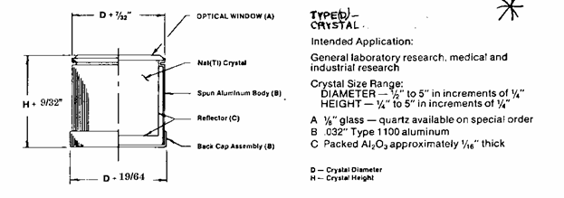
Peaks should be same location, but the intensity should be less. The background should be enhanced.

Tag 1000: with no blocks. Time = 300 seconds
Tag 1010: Copper between Gamma 1, Aluminum between Gamma 2. Time = 600 seconds
Tag 1020: Aluminum between Gamma 1, Copper between Gamma 2. Time = 600 seconds
Tag 1030: 2*Aluminum between Gamma 1, 2*Copper between Gamma 2. Time = 600 seconds
Tag 1040: 2*Copper between Gamma 1, 2*Aluminum between Gamma 2. Time = 600 seconds
Next plate with copper is going to be pretty small compared to background. We may adjust time. ﻿﻿We will compare peaks in rates anyway which is independent of total run time
Tag 1050: 3*Copper between Gamma 1, 3*Aluminum between Gamma 2. Time = 600 seconds

February 06, 2017

gtac ensures that when you’re looking at two detectors, the two detectors have good portion of the signal.
Timing is important to tell what the full peak of the signal was. The gtac measures the highest point in both detectors to make sure they're lined up. In angle analysis, we’ll use g11 and g12.
Take more angle scan data. Match up some points to provide consistency.
Read_xy_file.C is a small routine to load a spectrum from our x-y format data files into a ROOT histogram.
To use it, start ROOT, then execute
> .L Read_xy_file.C
within the ROOT session. You will then be able to load the spectra with the command:
> Read_xy_file(“filename”, “histogramname”)
; note that the filename and histogramname should be enclosed in quotation marks in this command. You would then be able to display the histogram by doing
> histogramname.Draw()
Tag 5000: Runtime = 600 seconds. Angle of 110 Degrees.
Tag 5010: Runtime = 600 seconds. Angle of 165 Degrees.
Tag 5020: Runtime = 600 seconds. Angle of 210 Degrees.
Tag 5030: Runtime = 600 seconds. Angle of 195 Degrees.
Tag 5040: Runtime = 600 seconds. Angle of 180 Degrees.
Tag 5050: Runtime = 600 seconds. Angle of 180 Degrees.
*All measured angles are in counter clockwise orientations.
Right click on data brings up Gaussian fitting
From the menu you can hist1.Integrate(lowbin, highbin)
bins may be different than axis labels.
February 9, 2017

Tags 100-119, 1000-1009, 5040-5059 are all sets of data taken at 180° on different days. The average bin on each peak can be used for the energy calibration. Only tagxxx0 and tagxxx1 will be needed for the calibration.
Put the file read macros where root can load them easily
> cp ./Read_xy_file.C /usr/share/root/macros/
.L Read_xy_file.C
Read_xy_file(“/home/jamison/Dropbox/School/PHYS-3702/lab2/rawdata/tag0100.xy”,”hist0100”)
hist0100->Draw()
Histogram was successfully made.
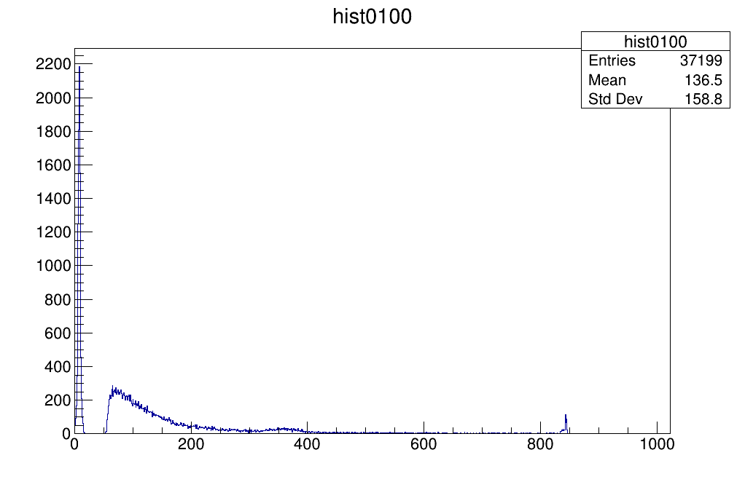
Read_xy_file(“/home/jamison/Dropbox/School/PHYS-3702/lab2/rawdata/tag0110.xy”,”hist0110”)
hist0110->GetXaxis()->SetRange(225,350);
hist0110->GetXaxis()->SetTitle("Bin Number");
hist0110->GetXaxis()->CenterTitle(true);
hist0110->GetYaxis()->SetTitle("Counts");
hist0110->GetYaxis()->CenterTitle(true);
hist0110->Draw()
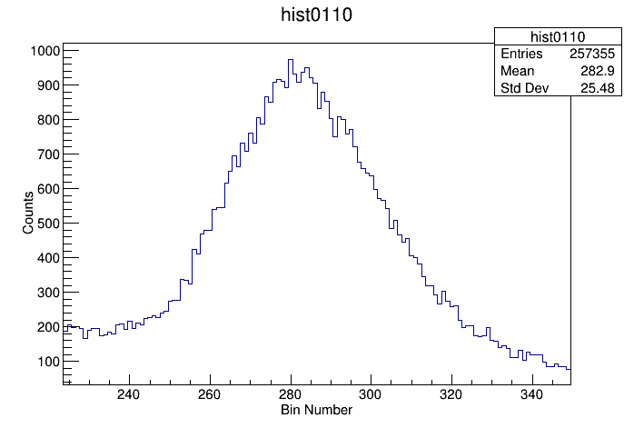
hist0110->GetXaxis()->SetRange(575,750);
hist0110->Draw();
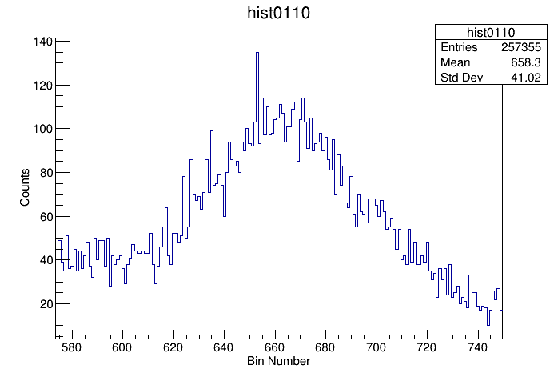
"Entries" is over the entire domain, not the region unlike the other two. Applying a background and then subtracting removes all other entries except in the desired domain, I suspect.
hist0110->ShowBackground(30,"same");
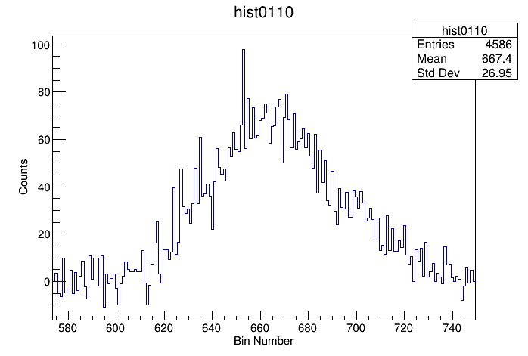
hist0110->Add(hist0110_background, -1);

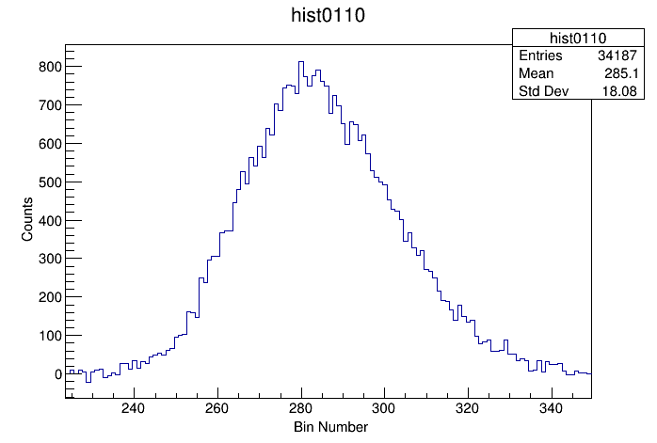
Gamma 1 Calibration Data

Calibration for Gamma 1: Energy = (1.99816±0.00073) x + (-58.21±0.33), Cov(a,b) = -0.0002247

Calibration for Gamma 2 Data
Calibration for Gamma 2: Energy = (2.14349±0.00072) x + (-41.52±0.29), Cov(a,b) = -0.0001881

Gamma Ray Attenuation Data

