Liam Healy and Riley Meloy

Professor Mettu

CMPS 4010 - Capstone Project I

3 May 2022

Milestone 8

Neurofeedback is a therapeutic method in which participants can train their brain to modulate their own brain activity, enabling long-term changes in brain activity 1. Participants real time brain activity is displayed to the participant as a form of stimuli, facilitating a bidirectional control of the signal. In doing so, the participant can train their brain to respond better to situations brought about by mental health issues (e.g. anxiety, PTSD, depression)2.

In most situations, neurofeedback is performed using an EEG or an fMRI, but an EEG’s signal processing is messy, difficult to understand, and focuses on brain waves rather than localized activity3. An fMRI can provide vast amounts of data, but can be inaccessible due to its size and cost. For our project, we used functional near-infrared spectroscopy (fNIRS) to acquire brain readings via non-invasive near-infrared light being shined into the participant’s skull (see figure 1 below), which in turn outputs the concentration of deoxygenated and oxygenated hemoglobin in the brain — similar to that of an fMRI, which instead uses induction. FNIRS has a spatial and temporal resolution between that of fMRI and EEG2.4. Its spatial resolution is higher than EEG, and its temporal resolution is higher than fMRI.4 In addition, fNIRS’ depth is limited to neocortical brain regions.5 However, fNIRS’ is quiet, portable, and cheaper than fMRI while allowing more head movement than EEG and fMRI, enabling fNIRS’ use in more realistic, natural environments (e.g. movement and interaction with other people) with more diverse populations (e.g. infants).

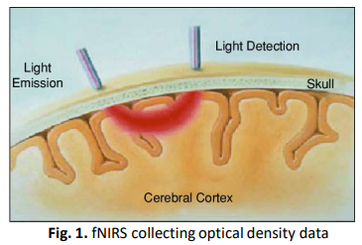

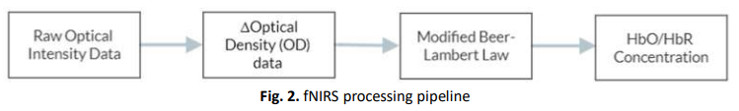

While multiple neurofeedback software for fNIRS exist, many are limited to a thermometer, rising objects, or smiling figures. There are no other options, and there is little customizability as well. The rate at which the thermometer moves up or down is static, and there is no option to choose to correspond to an anti-correlation between two areas. Moreover, not all the current software allows for multiple ways to process the signals, commonly restricted to the amplitude or derivative of the signal. Our goal was to create a plugin built on top of the signal processing software that corrects for this. For our project, we decided to pursue the creation of a high quality virtual reality (VR) neurofeedback environment that allows for fNIRS data to be output and represented in multiple ways. A large focus of ours was to allow the flexibility that an experimenter would like when designing their study. For example, a researcher can select the region(s) to analyze, how they compare to other selected regions, whether or not the object moves corresponding in direct relation to or as the slope of the blood oxygenation levels, and at what order should GLM analysis be run at, among other processing options. The higher quality VR environment increases the participant’s immersion, leading to better neurofeedback performance.6 The fNIRS signal is able to be output as either the amplitude, derivative, correlation, or anti-correlation. In addition, the signal will be scalable in real time if needed.

Neuroscientists and psychologists have been researching neurofeedback for several decades, and they have since shown that neurofeedback is effective with respect to conditions such as PTSD and ADHD5. Therefore, our goal was not to prove that neurofeedback works. Instead, we planned to develop a neurofeedback software that enables researchers to study neurofeedback more effectively with fNIRS. A difficult part of this process, the majority of the signal processing, was already dealt with through TurboSatori, a neurofeedback software that links up to an fNIRS device, and can read and perform data pre-processing in real time, but much time was spent creating a connection from TurboSatori to the Unity environment. As mentioned earlier, neurofeedback in the fNIRS community is not as developed as that of the EEG and fMRI, so while there is a framework of neurofeedback, there is no fleshed out basis for more in-depth fNIRS neurofeedback. Therefore, our idea is novel as well.

* The signal extraction through TurboSatori did not progress as quickly as we initially thought it would, as the documentation uses Visual Studio 2008, which would have required us to learn how to move and compile a dynamic link library in the modern Visual Studio. Fortunately, we were able to contact one of the developers of Turbo Satori, and he was able to provide valuable insight as to how to integrate the external plugin into the software using Matlab. After performing the calculations with the TurboSatori software, they are then sent to Matlab through a localhost connection. In Matlab, we modified the signal’s presentation (e.g. derivative vs. amplitude) through a TCP connection. Matlab is connected to a Unity environment in which the incoming signal is used to affect the environment. The changes in the environment provide the visual feedback for the participant to react from.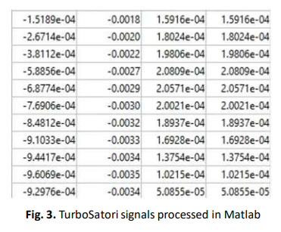

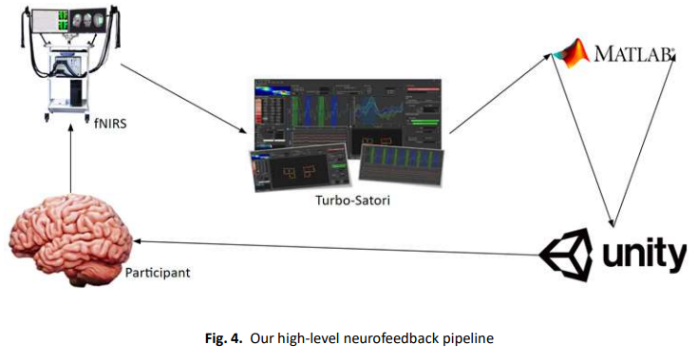

Our Unity environment (figure 6 below) is a forest clearing with a white tree in the center. The driving force behind its design was to make something for the user to feel most at ease. It’s also extremely important that the environment is fully immersive so that participants can entirely focus on the task at hand. A tree was chosen as the object of transformation as the participant’s process of “growing” something for themselves seemed like a better, more therapeutic model as opposed to simply stretching some foreign object. The existing infrastructure was designed in such a way that the object can be easily changed if so desired. The white tree is surrounded by a bed of blue and red flowers that gives way to a field of tall green grass. The environment was also designed for virtual reality use, allowing the participant to walk around in this field so as to not feel entirely claustrophobic or trapped by the task at hand, as well as to further contribute to the immersion. In addition, the scaling of the incoming signal, the minimum size, and the maximum size of the tree can be changed in real-time within the Unity environment, allowing full flexibility for future researchers (see figure 5). It’s also important to note that providing a VR environment for the participant can allow researchers to test and improve different areas of the participant’s brain without them fully understanding what they are working on. Maybe one day they are working on the part of the brain that yields anxiety, and the next they are working on the part concerning PTSD, either way the participant will simply be given the task of making the tree grow. The participant may not immediately see the effects, but they are subconsciously training and reworking their brain.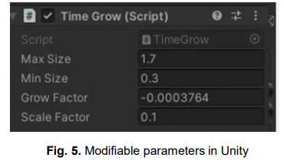

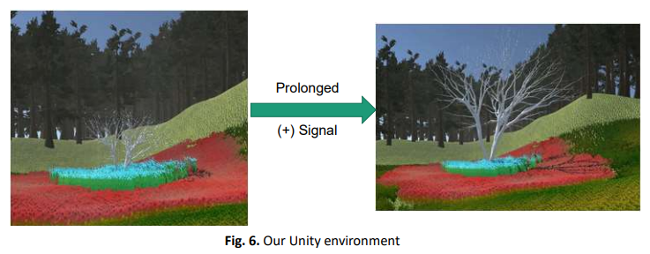

The amplitude is calculated based on the distance the HbO/HbR concentration is from the participant’s baseline. The derivative is calculated based on the relationship between the amplitude of 5 signals sampled at consecutive time points. The correlation and anti-correlation are calculated by comparing two arrays of the amplitude of 50 signals sampled at consecutive points. The two arrays represent the selected regions of interest, upon which either the correlation or anti-correlation will be calculated. Channels can be selected within Turbo-Satori, causing the signal to change in real-time to reflect the change in channels. Issues arose when streaming this information to our Unity environment as MatLab was sending too many signals to Unity, causing the connection to close. In theory, this was due to our data stream not being open and closed quickly enough, causing multiple information streams to be sent before a socket was opened or closed correctly. Fortunately, much of the signal sent was repeated information, and the signal only began to change every ~0.3-0.5 seconds. As a result, by using the built-in pause() function from MatLab, we were able to delay the signals enough to not interrupt the connection.

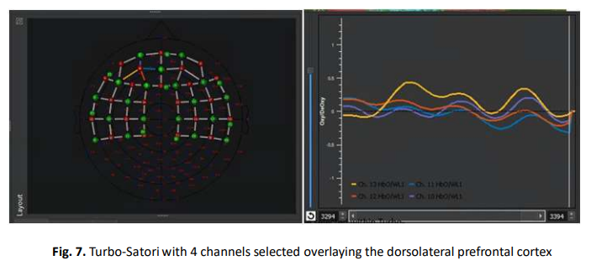

After discussing with researchers interested in the potential use of our plugin, we intend to include a saved output of the neurofeedback experience in the form of time points, tree size, and the actual signal itself. In addition, we want to enable a concrete performance indicator in the form of the duration the tree was maintained above or below a certain height. For example, if a participant is able to maintain the tree at sixty percent growth or higher for 10 seconds one week and 15 seconds the next week, the participant has improved at the neurofeedback task. One researcher in particular discussed with us the potential benefits of using our project to help veterans experiencing PTSD.

Using Unity as our environment and Turbo-Satori as our real-time connection and preprocessing of the data stream, we have created a flexible, immersive neurofeedback environment for use with fNIRS. Because the data is completely processed before it is sent to Unity, the Unity environment can be easily modified to anything that can move based off a numerical signal (e.g. instead of the tree, a face changing emotions, a flame growing or going out, etc.). Therefore, we intend for our plugin to be used in future fNIRS neurofeedback experiments. Future directions could involve implementing a support-vector classifier to determine when a participant is in a certain “brain state” or increasing the immersion of the environment with more detailed textures and audio.

References

1 Kohl, Simon H., et al. "The potential of functional near-infrared spectroscopy-based neurofeedback—a systematic review and recommendations for best practice." Frontiers in neuroscience (2020): 594.

2 Chiba, T., Kanazawa, T., Koizumi, A., Ide, K., Taschereau-Dumouchel, V., Boku, S., Hishimoto, A., Shirakawa, M., Sora, I., Lau, H., Yoneda, H., & Kawato, M. (2019). Current status of neurofeedback for post-traumatic stress disorder: A systematic review and the possibility of decoded neurofeedback. *Frontiers in Human Neuroscience*, *13*. https://doi.org/10.3389/fnhum.2019.00233

3 Enriquez-Geppert, S., Huster, R. J., & Herrmann, C. S. (2017). EEG-neurofeedback as a tool to modulate cognition and behavior: A review tutorial. *Frontiers in Human Neuroscience*, *11*. <https://doi.org/10.3389/fnhum.2017.00051>

4 Cui, Xu, et al. "A quantitative comparison of NIRS and fMRI across multiple cognitive tasks." Neuroimage 54.4 (2011): 2808-2821

5 Pinti, Paola, et al. "The present and future use of functional near-infrared spectroscopy (fNIRS) for cognitive neuroscience." Annals of the New York Academy of Sciences1464.1 (2020): 5-29.

6 Accoto, Floriana, et al. "The Effect of Neurofeedback Training in CAVE-VR for Enhancing Working Memory." Technology-Augmented Perception and Cognition. Springer, Cham, 2021. 11-45.