# Goal:

Create a software product that helps students maximize their time and efforts in college to start a successful company after receiving their undergraduate degree.

# Team Feature List

* Enter Interests
* Enter Business Idea and Information
* Begin to review and create a business plan
* Find, review, and apply for finance
* Review, fill out, and submit necessary legal documents

# Crazy-Eights

## Finance

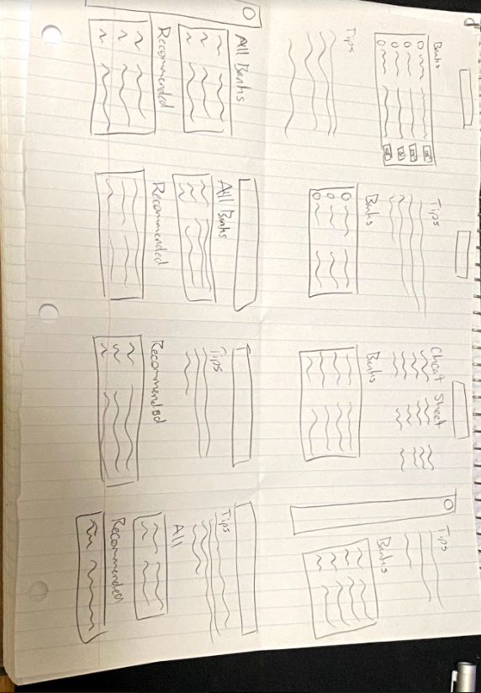

## Interests

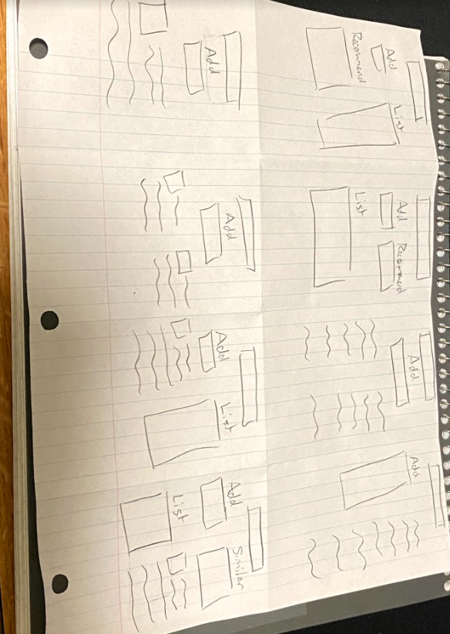

## Legal Documents

