The data interface description v4.7

[1 Home](https://ssl.translatoruser.net/bv.aspx?from=zh-CHS&to=en&a=https%3A%2F%2Fssl.translatoruser.net%2Fbvsandbox.aspx%3F%26lo%3DSS%26dl%3Den%26from%3Dzh-CHS%26to%3Den%23_Toc429414711)

[1.1 sale](https://ssl.translatoruser.net/bv.aspx?from=zh-CHS&to=en&a=https%3A%2F%2Fssl.translatoruser.net%2Fbvsandbox.aspx%3F%26lo%3DSS%26dl%3Den%26from%3Dzh-CHS%26to%3Den%23_Toc429414712)

[1.2 the latest product (background for new supplies,new)](https://ssl.translatoruser.net/bv.aspx?from=zh-CHS&to=en&a=https%3A%2F%2Fssl.translatoruser.net%2Fbvsandbox.aspx%3F%26lo%3DSS%26dl%3Den%26from%3Dzh-CHS%26to%3Den%23_Toc429414713)

[1.3 pre-online sale](https://ssl.translatoruser.net/bv.aspx?from=zh-CHS&to=en&a=https%3A%2F%2Fssl.translatoruser.net%2Fbvsandbox.aspx%3F%26lo%3DSS%26dl%3Den%26from%3Dzh-CHS%26to%3Den%23_Toc429414714)

[1.4 product list in the specified directory (you can sortfilter - non-priority)](https://ssl.translatoruser.net/bv.aspx?from=zh-CHS&to=en&a=https%3A%2F%2Fssl.translatoruser.net%2Fbvsandbox.aspx%3F%26lo%3DSS%26dl%3Den%26from%3Dzh-CHS%26to%3Den%23_Toc429414715)

[1.5 Quick search returns a list of products and ordering](https://ssl.translatoruser.net/bv.aspx?from=zh-CHS&to=en&a=https%3A%2F%2Fssl.translatoruser.net%2Fbvsandbox.aspx%3F%26lo%3DSS%26dl%3Den%26from%3Dzh-CHS%26to%3Den%23_Toc429414716)

[1.6 return specified list Filter field](https://ssl.translatoruser.net/bv.aspx?from=zh-CHS&to=en&a=https%3A%2F%2Fssl.translatoruser.net%2Fbvsandbox.aspx%3F%26lo%3DSS%26dl%3Den%26from%3Dzh-CHS%26to%3Den%23_Toc429414717)

[1.7 return to the advanced search fields](https://ssl.translatoruser.net/bv.aspx?from=zh-CHS&to=en&a=https%3A%2F%2Fssl.translatoruser.net%2Fbvsandbox.aspx%3F%26lo%3DSS%26dl%3Den%26from%3Dzh-CHS%26to%3Den%23_Toc429414718)

[1.8 Advanced search returns a list of products and ordering](https://ssl.translatoruser.net/bv.aspx?from=zh-CHS&to=en&a=https%3A%2F%2Fssl.translatoruser.net%2Fbvsandbox.aspx%3F%26lo%3DSS%26dl%3Den%26from%3Dzh-CHS%26to%3Den%23_Toc429414719)

[2 classification](https://ssl.translatoruser.net/bv.aspx?from=zh-CHS&to=en&a=https%3A%2F%2Fssl.translatoruser.net%2Fbvsandbox.aspx%3F%26lo%3DSS%26dl%3Den%26from%3Dzh-CHS%26to%3Den%23_Toc429414720)

[2.1 obtaining classification list](https://ssl.translatoruser.net/bv.aspx?from=zh-CHS&to=en&a=https%3A%2F%2Fssl.translatoruser.net%2Fbvsandbox.aspx%3F%26lo%3DSS%26dl%3Den%26from%3Dzh-CHS%26to%3Den%23_Toc429414721)

[3 products](https://ssl.translatoruser.net/bv.aspx?from=zh-CHS&to=en&a=https%3A%2F%2Fssl.translatoruser.net%2Fbvsandbox.aspx%3F%26lo%3DSS%26dl%3Den%26from%3Dzh-CHS%26to%3Den%23_Toc429414722)

[3.1 specific product details (for exchange rate reasons shall be adjusted)](https://ssl.translatoruser.net/bv.aspx?from=zh-CHS&to=en&a=https%3A%2F%2Fssl.translatoruser.net%2Fbvsandbox.aspx%3F%26lo%3DSS%26dl%3Den%26from%3Dzh-CHS%26to%3Den%23_Toc429414723)

[3.2 specific picture list (current Mag , to adjust for write)](https://ssl.translatoruser.net/bv.aspx?from=zh-CHS&to=en&a=https%3A%2F%2Fssl.translatoruser.net%2Fbvsandbox.aspx%3F%26lo%3DSS%26dl%3Den%26from%3Dzh-CHS%26to%3Den%23_Toc429414724)

[3.3 for the specified product custom options](https://ssl.translatoruser.net/bv.aspx?from=zh-CHS&to=en&a=https%3A%2F%2Fssl.translatoruser.net%2Fbvsandbox.aspx%3F%26lo%3DSS%26dl%3Den%26from%3Dzh-CHS%26to%3Den%23_Toc429414725)

[3.4 for the specified custom property (non-priority, and see if we can achieve, or implementation returns the contents of the specified attribute name only)](https://ssl.translatoruser.net/bv.aspx?from=zh-CHS&to=en&a=https%3A%2F%2Fssl.translatoruser.net%2Fbvsandbox.aspx%3F%26lo%3DSS%26dl%3Den%26from%3Dzh-CHS%26to%3Den%23_Toc429414726)

[4 login](https://ssl.translatoruser.net/bv.aspx?from=zh-CHS&to=en&a=https%3A%2F%2Fssl.translatoruser.net%2Fbvsandbox.aspx%3F%26lo%3DSS%26dl%3Den%26from%3Dzh-CHS%26to%3Den%23_Toc429414727)

[4.1 user login](https://ssl.translatoruser.net/bv.aspx?from=zh-CHS&to=en&a=https%3A%2F%2Fssl.translatoruser.net%2Fbvsandbox.aspx%3F%26lo%3DSS%26dl%3Den%26from%3Dzh-CHS%26to%3Den%23_Toc429414728)

[4.2 obtains a user's login status](https://ssl.translatoruser.net/bv.aspx?from=zh-CHS&to=en&a=https%3A%2F%2Fssl.translatoruser.net%2Fbvsandbox.aspx%3F%26lo%3DSS%26dl%3Den%26from%3Dzh-CHS%26to%3Den%23_Toc429414729)

[4.3 user registration](https://ssl.translatoruser.net/bv.aspx?from=zh-CHS&to=en&a=https%3A%2F%2Fssl.translatoruser.net%2Fbvsandbox.aspx%3F%26lo%3DSS%26dl%3Den%26from%3Dzh-CHS%26to%3Den%23_Toc429414730)

[4.4 user logged out](https://ssl.translatoruser.net/bv.aspx?from=zh-CHS&to=en&a=https%3A%2F%2Fssl.translatoruser.net%2Fbvsandbox.aspx%3F%26lo%3DSS%26dl%3Den%26from%3Dzh-CHS%26to%3Den%23_Toc429414731)

[4.5 user forgot password](https://ssl.translatoruser.net/bv.aspx?from=zh-CHS&to=en&a=https%3A%2F%2Fssl.translatoruser.net%2Fbvsandbox.aspx%3F%26lo%3DSS%26dl%3Den%26from%3Dzh-CHS%26to%3Den%23_Toc429414732)

[5 shopping](https://ssl.translatoruser.net/bv.aspx?from=zh-CHS&to=en&a=https%3A%2F%2Fssl.translatoruser.net%2Fbvsandbox.aspx%3F%26lo%3DSS%26dl%3Den%26from%3Dzh-CHS%26to%3Den%23_Toc429414733)

[5.1 access to shopping cart quantity](https://ssl.translatoruser.net/bv.aspx?from=zh-CHS&to=en&a=https%3A%2F%2Fssl.translatoruser.net%2Fbvsandbox.aspx%3F%26lo%3DSS%26dl%3Den%26from%3Dzh-CHS%26to%3Den%23_Toc429414734)

[5.2 access to shopping cart content, options, prices,](https://ssl.translatoruser.net/bv.aspx?from=zh-CHS&to=en&a=https%3A%2F%2Fssl.translatoruser.net%2Fbvsandbox.aspx%3F%26lo%3DSS%26dl%3Den%26from%3Dzh-CHS%26to%3Den%23_Toc429414735)

[5.3 Add to cart](https://ssl.translatoruser.net/bv.aspx?from=zh-CHS&to=en&a=https%3A%2F%2Fssl.translatoruser.net%2Fbvsandbox.aspx%3F%26lo%3DSS%26dl%3Den%26from%3Dzh-CHS%26to%3Den%23_Toc429414736)

[5.4 Update shopping cart (adjustment quantity, delete, etc)](https://ssl.translatoruser.net/bv.aspx?from=zh-CHS&to=en&a=https%3A%2F%2Fssl.translatoruser.net%2Fbvsandbox.aspx%3F%26lo%3DSS%26dl%3Den%26from%3Dzh-CHS%26to%3Den%23_Toc429414737)

[5.5 take the total and coupons in the shopping cart usage](https://ssl.translatoruser.net/bv.aspx?from=zh-CHS&to=en&a=https%3A%2F%2Fssl.translatoruser.net%2Fbvsandbox.aspx%3F%26lo%3DSS%26dl%3Den%26from%3Dzh-CHS%26to%3Den%23_Toc429414738)

[5.6 use in the shopping cart or cancel coupon coupons](https://ssl.translatoruser.net/bv.aspx?from=zh-CHS&to=en&a=https%3A%2F%2Fssl.translatoruser.net%2Fbvsandbox.aspx%3F%26lo%3DSS%26dl%3Den%26from%3Dzh-CHS%26to%3Den%23_Toc429414739)

[5.7 view added wishlist](https://ssl.translatoruser.net/bv.aspx?from=zh-CHS&to=en&a=https%3A%2F%2Fssl.translatoruser.net%2Fbvsandbox.aspx%3F%26lo%3DSS%26dl%3Den%26from%3Dzh-CHS%26to%3Den%23_Toc429414740)

[6 Shop information](https://ssl.translatoruser.net/bv.aspx?from=zh-CHS&to=en&a=https%3A%2F%2Fssl.translatoruser.net%2Fbvsandbox.aspx%3F%26lo%3DSS%26dl%3Den%26from%3Dzh-CHS%26to%3Den%23_Toc429414741)

[6.1 shop and view the list of current site](https://ssl.translatoruser.net/bv.aspx?from=zh-CHS&to=en&a=https%3A%2F%2Fssl.translatoruser.net%2Fbvsandbox.aspx%3F%26lo%3DSS%26dl%3Den%26from%3Dzh-CHS%26to%3Den%23_Toc429414742)

[6.2 current store basic parameters](https://ssl.translatoruser.net/bv.aspx?from=zh-CHS&to=en&a=https%3A%2F%2Fssl.translatoruser.net%2Fbvsandbox.aspx%3F%26lo%3DSS%26dl%3Den%26from%3Dzh-CHS%26to%3Den%23_Toc429414743)

[6.3 get the specified CMS block](https://ssl.translatoruser.net/bv.aspx?from=zh-CHS&to=en&a=https%3A%2F%2Fssl.translatoruser.net%2Fbvsandbox.aspx%3F%26lo%3DSS%26dl%3Den%26from%3Dzh-CHS%26to%3Den%23_Toc429414744)

[7 store management functions and interfaces](https://ssl.translatoruser.net/bv.aspx?from=zh-CHS&to=en&a=https%3A%2F%2Fssl.translatoruser.net%2Fbvsandbox.aspx%3F%26lo%3DSS%26dl%3Den%26from%3Dzh-CHS%26to%3Den%23_Toc429414745)

[7.1 plug-in management](https://ssl.translatoruser.net/bv.aspx?from=zh-CHS&to=en&a=https%3A%2F%2Fssl.translatoruser.net%2Fbvsandbox.aspx%3F%26lo%3DSS%26dl%3Den%26from%3Dzh-CHS%26to%3Den%23_Toc429414746)

[7.2 Enter address gets close to stores](https://ssl.translatoruser.net/bv.aspx?from=zh-CHS&to=en&a=https%3A%2F%2Fssl.translatoruser.net%2Fbvsandbox.aspx%3F%26lo%3DSS%26dl%3Den%26from%3Dzh-CHS%26to%3Den%23_Toc429414747)

Notes:

● All data is returned JSON format

● Current @baseSite= http://w.sunpop.cn/ baseLang=en

baseUrl=http://w.sunpop.cn/cn

1 Home

1.1 sale

● Parameter description:

Cmd: command keyword, the default "daily_sale"

Order: sort field, the default entity_id

Desc: sort by ASC/DESCdefault desc in reverse order

Page: page number, the default is 1 page

Limit: units of data per page by default displays 20 items

● Default url:

[http://w.sunpop.cn/cn/restconnect/index/index/cmd/daily_sale/order/name/dir/asc/limit/10/page/1](https://ssl.translatoruser.net/bv.aspx?from=zh-CHS&to=en&a=http%3A%2F%2Fw.sunpop.cn%2Fcn%2Frestconnect%2Findex%2Findex%2Fcmd%2Fdaily_sale%2Forder%2Fname%2Fdir%2Fasc%2Flimit%2F10%2Fpage%2F1)

Alternative URL format (?,& the parameter formatting, the following are the same )

http://w.sunpop.cn/cn/restconnect/?cmd=daily_sale&page=1&limit=10

● Return value:

|  |  |  |
| --- | --- | --- |
| Type | Name | Description |
| string | entity_id | Product ID |
| string | type_id | Product type(simple,group...) |
| string | sku | Product SKU |
| string | name | Product name |
| string | regular_price_with_tax | Product price |
| string | final_price_with_tax | The current price, that is, when a product is on sale when the specials, not in the period for the original price |
| string | special_from_date | Date starting from which the special price is applied to the product |
| string | special_to_date | Date till which the special price is applied to the product |
| string | url_key | Relative URL path that can be entered in place of a target path |
| string | image_url | Image URL |

1.2 new products (background for new goods,new )

● Parameter description:

Cmd: command key, you need to change the "new"

Order: sort field, the default entity_id

Desc: sort by ASC/DESCdefault desc in reverse order

Page: page number, the default is 1 page

Limit: units of data per page by default displays 20 items

● Default url:

http://w.sunpop.cn/cn/restconnect/index/index/cmd/new/limit/10/page/1

● Return value:

|  |  |  |
| --- | --- | --- |
| Type | Name | Description |
| string | entity_id | Product ID |
| string | type_id | Product type(simple,group...) |
| string | sku | Product SKU |
| string | name | Product name |
| string | regular_price_with_tax | Product price |
| string | final_price_with_tax | The current price, that is, when a product is on sale when the specials, not in the period for the original price |
| string | new_from_date | Date starting from which the special price is applied to the product |
| string | new_to_date | Date till which the special price is applied to the product |
| string | url_key | Relative URL path that can be entered in place of a target path |
| string | image_url | Image URL |

1.3 pre-online sale

● Parameter description:

Cmd: command key, you need to change "coming_soon"

Order: sort field, the default entity_id

Desc: sort by ASC/DESCdefault desc in reverse order

Page: page number, the default is 1 page

Limit: units of data per page by default displays 20 items

● Default url:

http://w.sunpop.cn/cn/restconnect/index/index/cmd/coming_soon/limit/10/page/1

● Return value:

|  |  |  |
| --- | --- | --- |
| Type | Name | Description |
| string | entity_id | Product ID |
| string | type_id | Product type(simple,group...) |
| string | sku | Product SKU |
| string | name | Product name |
| string | regular_price_with_tax | Product price |
| string | final_price_with_tax | The current price, that is, when a product is on sale when the specials, not in the period for the original price |
| string | special_from_date | Date starting from which the special price is applied to the product |
| string | special_to_date | Date till which the special price is applied to the product |
| string | url_key | Relative URL path that can be entered in place of a target path |
| string | image_url | Image URL |

1.4 product list in the specified directory (you can sortfilter - Non-preferred)

● Parameter description:

Cmd: command key, you need to change "catelog"

Category_id: directory ID

Order: sort field, the default entity_id

Desc: sort by ASC/DESCdefault desc in reverse order

Page: page number, the default is 1 page

Limit: units of data per page by default displays 20 items

Filter: Min(minimum price: optional) Max(maximum price: optional) dir(sort: optional) order(arranged by: optional) limit(number per page: optional)

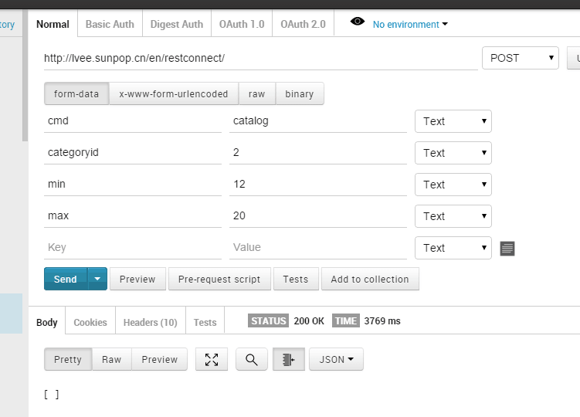

● Default url:

http://w.sunpop.cn/cn/restconnect/index/index/cmd/catalog/categor

yid/121/limit/10/page/1

● Return value:

|  |  |  |
| --- | --- | --- |
| Type | Name | Description |
| string | product_id | Product ID |
| string | sku | Product SKU |
| string | name | Product name |
| ArrayOfString | website_ids | Array of website IDs |
| string | price | Product price |
| string | special_price | Product special price |
| string | special_from_date | Date starting from which the special price is applied to the product |
| string | special_to_date | Date till which the special price is applied to the product |
| string | url_key | Relative URL path that can be entered in place of a target path |
| string | image_url | Image URL |

1.5 Quick search returns a list of products and ordering

● Parameter description:

Cmd: command key, you need to change "search"

Name: product name, separated by a space

Additional query fields: the background is set to Quick search field

Order: sort field, the default entity_id

Desc: sort by ASC/DESCdefault desc in reverse order

Page: page number, the default is 1 page

Limit: units of data per page by default displays 20 items

● Default url:

[http://w.sunpop.cn/cn/restconnect/search/index/q/2015](https://ssl.translatoruser.net/bv.aspx?from=zh-CHS&to=en&a=http%3A%2F%2Fskymazon.sunpop.cn%2Frestconnect%2Fsearch%2Findex%2Fq%2F2015)

● The search results can refer to

[http://w.sunpop.cn/cn/catalogsearch/result/?q=2015](https://ssl.translatoruser.net/bv.aspx?from=zh-CHS&to=en&a=http%3A%2F%2Fskymazon.sunpop.cn%2Fcatalogsearch%2Fresult%2F%3Fq%3D2015)

● Return value:

|  |  |  |
| --- | --- | --- |
| Type | Name | Description |
| string | product_id | Product ID |
| string | sku | Product SKU |
| string | name | Product name |
| ArrayOfString | website_ids | Array of website IDs |
| string | price | Product price |
| string | special_price | Product special price |
| string | url_key | Relative URL path that can be entered in place of a target path |
| string | image_url | Image URL |

1.6 return specified list Filter Field

● Parameter description:

Categoryid: directory ID

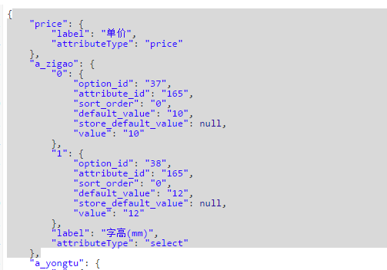

● Default url:

http://w.sunpop.cn/cn/restconnect/search/getfilter/categoryid/2

1.7 return to the advanced search fields

● Parameter description

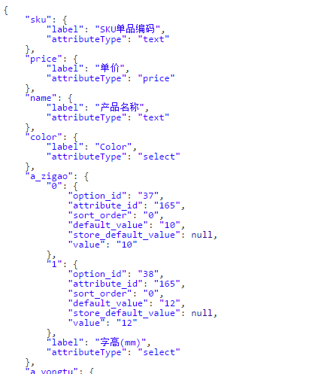

● Default url:

http://w.sunpop.cn/cn/restconnect/searchadv/getfield

1.8 Advanced search returns a list of products and ordering

● Parameter description:

Name: product name, separated by a space

SKU:SKU product identification number

Additional query fields: the background is set to Advance search fields, that is, from the interface to get fields

http://w.sunpop.cn/cn/restconnect/searchadv/getfield

Order: sort field, the default entity_id

Desc: sort by ASC/DESCdefault desc in reverse order

Page: page number, the default is 1 page

Limit: units of data per page by default displays 20 items

● Default url:

[http://w.sunpop.cn/cn/restconnect/searchadv/index](https://ssl.translatoruser.net/bv.aspx?from=zh-CHS&to=en&a=http%3A%2F%2Fw.sunpop.cn%2Fcn%2Frestconnect%2Fsearchadv%2Findex)

● For example

Http://w.sunpop.CN/CN/restconnect/searchadv/index/a_baozhuang/46/name/ new/price/66to100/CategoryID/10

2 classification

2.1 obtaining classification list

● Parameter description:

Cmd: command key, you need to change "menu"

Note: Once loaded all the level classification.

● Default url:

[http://w.sunpop.cn/cn/restconnect/index/index/cmd/menu](https://ssl.translatoruser.net/bv.aspx?from=zh-CHS&to=en&a=http%3A%2F%2Fskymazon.sunpop.cn%2Frestconnect%2F%3Fcmd%3Dmenu)

● Return value: reference

|  |  |  |
| --- | --- | --- |
| Type | Name | Description |
| int | category_id | Category ID |
| int | parent_id | Parent category ID |
| string | name | Category name |
| int | is_active | defines whether the category is active |
| int | position | Category position |
| int | level | Category level |
| string | url_key |  |
| String | Thumbnail_url |  |
| string | Image_url |  |
|  | has_children | Whether there are subdirectories |
|  | product_count | count |
|  | children | Subdirectories ID list |
|  | is_virtual | This directory is a virtual product |

3 products

3.1 specific product details (for exchange rate reasons shall be adjusted)

● Description: If the conversion rate is set in the global, this interface without adjustment

Cmd: command key, you need to change " product 】

ID: product ID

● Default url

http://w.sunpop.cn/cn/restconnect/products/getproductdetail/productid/:id

Temporary URL (Mag )

http://w.sunpop.cn/api/rest/products/75

For example: products ID385,http://w.sunpop.CN/CN/restconnect/products/getproductdetail/ProductID/75

Visit the product page to see the effect

http://w.sunpop.cn/cn/index.php/catalog/product/view/id/385

● Return value: reference returns a result

|  |  |  |
| --- | --- | --- |
| Type | Name | Description |
| string | entity_id | Product ID |
| string | type_id | Product type(simple,group...) |
| string | sku | Product SKU |
| string | name | Product name |
| string | regular_price_with_tax | Product price |
| string | final_price_with_tax | The current price, that is, when a product is on sale when the specials, not in the period for the original price.  Returns the converted currency value |
| string | special_from_date | Date starting from which the special price is applied to the product |
| string | special_to_date | Date till which the special price is applied to the product |
| string | url_key | Relative URL path that can be entered in place of a target path |
| string | image_url | Image URL |
| int | is_in_stock | Is in stock or not |
| int | has_custom_options | Whether custom options, shopping cart  1 Yes,0 for no  Use case: ID=385 Options,386-free |

3.2 specific picture list (current Mag Since, to adjust for write)

● Parameter description:

Cmd: command key, you need to change " product 】

ID: product ID

● Interface

[http://w.sunpop.cn/cn/restconnect/Products/getPicLists](https://ssl.translatoruser.net/bv.aspx?from=zh-CHS&to=en&a=http%3A%2F%2Fdemo.sunpop.cn%2Fen%2Frestconnect%2FProducts%2FgetPicLists)

[http://w.sunpop.cn/cn/restconnect/Products/getPicLists](https://ssl.translatoruser.net/bv.aspx?from=zh-CHS&to=en&a=http%3A%2F%2Fdemo.sunpop.cn%2Fen%2Frestconnect%2FProducts%2FgetPicLists)/product/76

● Temporary url

http://w.sunpop.cn/api/rest/products/:id/images

For example: products ID 385,http://w.sunpop.CN/API/rest/products/76/images

● Return value: reference returns a result

3.3 for the specified product custom options

● Parameter description:

ID: enter the product ID

Return values can be viewed with the following page, need to support custom options to the page content and optional value for all outputs from a front-end personnel use the data to show

http://w.sunpop.cn/cn/restconnect/products/getcustomeroption/76

● Default url

http://w.sunpop.cn/cn/restconnect/products/getcustomoption/productid/:id

For example: products ID 535,

http://w.sunpop.cn/cn/restconnect/products/getcustomoption/productid/75

● Return value: Custom Option[], the reference returns a result

● Example: simplify 535, complex ID=385 products , no option for 533

Subsequent

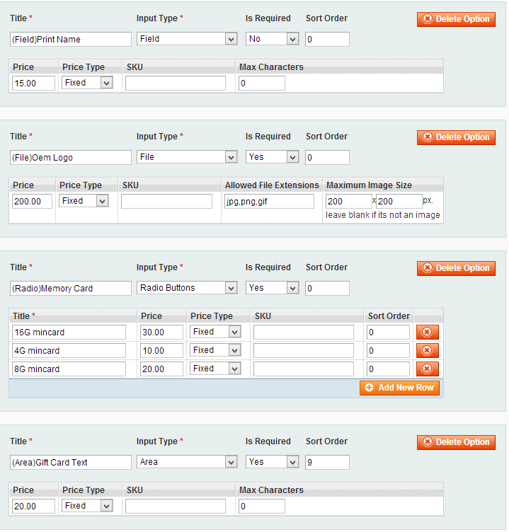

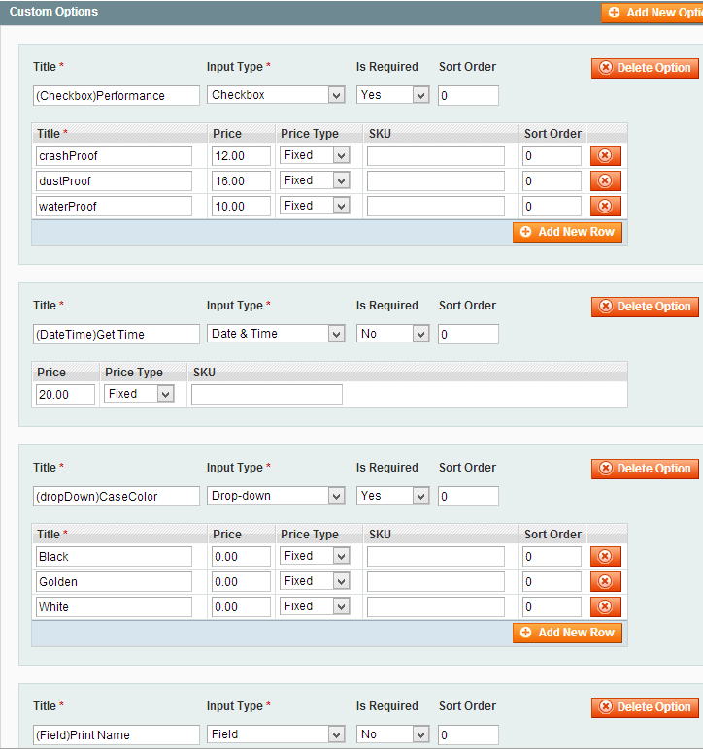

Web front-end shows such as (this is the target):

|  |  |
| --- | --- |
|  |  |

JSON data returned form (this is the source of data)

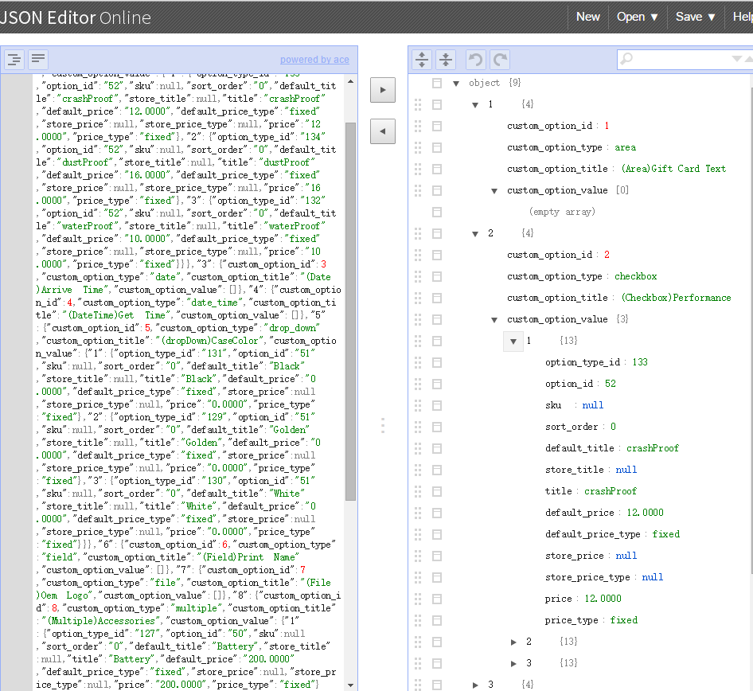

3.4 for the specified custom property (non-priority, and see if we can achieve, or implementation returns the contents of the specified attribute name only)

Merge into 3.1 specific product details

4 login

4.1 user login

● Parameter description:

Username: enter the user name

Password: enter the password

● Sample

User 1:[a@qq.com](mailto:a@qq.com) abc123

User 2:[i@qq.com](mailto:i@qq.com) 111111

http://w.sunpop.cn/cn/restconnect/customer/login/?username=a@qq.com&password=111111

● The return value, true,false

4.2 obtains a user's login status

● Parameter description:

If not logged in, return false

If logged in, return the sample

{"name":"a b","email":"a@qq.com","avatar":"http:\/\/w.sunpop.cn\/media\/customer\/i\/c\/icon_72.png","storeUrl":"http:\/\/w.sunpop.cn\/media\/","tel":"131311131"}

● Sample url:

[http://w.sunpop.cn/cn/restconnect/customer/status](https://ssl.translatoruser.net/bv.aspx?from=zh-CHS&to=en&a=http%3A%2F%2Fskymazon.sunpop.cn%2Frestconnect%2Fcustomer%2Fstatus)

4.3 user registration

● Interface url

http://w.sunpop.cn/cn/restconnect/customer/register

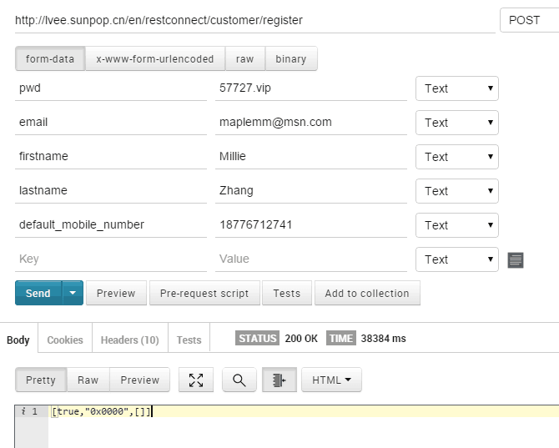

● Description: enter the parameters on this page (text message verification completed in front)

[http://w.sunpop.cn/cn/kikuuapp3/register.html](https://ssl.translatoruser.net/bv.aspx?from=zh-CHS&to=en&a=http%3A%2F%2Fskymazon.sunpop.cn%2Fkikuuapp3%2Fregister.html) Gender- gender

Returns whether the normal registration, error codes and messages, and so on.

4.4 user logged out

Get request:baseUrl /customer/account/logout

Such as: [http://w.sunpop.cn/cn/customer/account/logout](https://ssl.translatoruser.net/bv.aspx?from=zh-CHS&to=en&a=http%3A%2F%2Fskymazon.sunpop.cn%2Fcustomer%2Faccount%2Flogout)

4.5 user forgot password

http://w.sunpop.cn/cn/restconnect/customer/forgotpwd

Parameters: email

5 shopping

5.1 access to shopping cart quantity

● Interface: [http://w.sunpop.cn/cn/restconnect/Cart/getQty](https://ssl.translatoruser.net/bv.aspx?from=zh-CHS&to=en&a=http%3A%2F%2Fdemo.sunpop.cn%2Fen%2Frestconnect%2FCart%2FgetCartInfo)

● Returns: {"items_qty": "1"}

5.2 access to shopping cart content, options, prices,

● Interface: [http://w.sunpop.cn/cn/restconnect/Cart/getCartInfo](https://ssl.translatoruser.net/bv.aspx?from=zh-CHS&to=en&a=http%3A%2F%2Fdemo.sunpop.cn%2Fen%2Frestconnect%2FCart%2FgetCartInfo)

● Return, see the following example

{"is_virtual":false,"cart_items":[{"cart_item_id":"206","currency":"TZS","entity_type":"simple","item_id":"27","item_title":"Women's blouse","qty":3,"thumbnail_pic_url":"http:\/\/w.sunpop.cn\/media\/catalog\/product\/cache\/1\/thumbnail\/75x\/9df78eab33525d08d6e5fb8d27136e95\/b\/l\/blouse_1.jpg","custom_option":[{"label":"color","value":"black","print_value":"black","option_id":"12","option_type":"drop_down","option_value":"24","custom_view":false},{"label":"size","value":"M","print_value":"M","option_id":"11","option_type":"drop_down","option_value":"23","custom_view":false}],"item_price":96740},{"cart_item_id":"207","currency":"TZS","entity_type":"simple","item_id":"45","item_title":"Iphone5s slash ","qty":1,"thumbnail_pic_url":"http:\/\/w.sunpop.cn\/media\/catalog\/product\/cache\/1\/thumbnail\/75x\/9df78eab33525d08d6e5fb8d27136e95\/_\/1\/_1_2_2.jpg","custom_option":[],"item_price":7739.2},{"cart_item_id":"208","currency":"TZS","entity_type":"simple","item_id":"67","item_title":"Light blue jeans 2015 New Fashion","qty":1,"thumbnail_pic_url":"http:\/\/w.sunpop.cn\/media\/catalog\/product\/cache\/1\/thumbnail\/75x\/9df78eab33525d08d6e5fb8d27136e95\/1\/1\/116_-1.png","custom_option":[],"item_price":92870.4}],"messages":null,"cart_items_count":5,"payment_methods":[],"allow_guest_checkout":false}

● Shopping cart total: Cart_items_count, of the items from the shopping cartID:cart_item_id

5.3 Add to cart

● Parameter description (can be adjusted according to actual):

JSON array

entity_id : Input, product ID

Qty: type, quantity

Options[]: input, custom options array variable name

Optionvalue[]: input an array of customization options for variable values

● Default url

http://w.sunpop.cn/cn/restconnect/cart/add/

Simple include Qty, complex with a variety of options

● Examples of parameters are sent, and Mag shopping form sends its contents, or useJSON package

Such as: ?product=535&related_product=&options%5B67%5D=abc&options%5B62%5D=148&options%5B63%5D%5B%5D=150&options%5B60%5D=143&options%5B61%5D%5B%5D=144&qty=1

Free options

http://w.sunpop.cn/cn/restconnect/cart/add/?product=533&qty=1

● JSON example

{'name':'xxxxxx','product':'535','qty':'1','option':['62':'146','60':'143']}

● The return value, True,false, shopping cart current number of total entries

5.4 Update shopping cart (adjustment quantity, delete, etc)

Update Cart specified items for the specified number of parametersCart_item_id,Qty,Qty is set to 0 will complain, best its front is set to 0, or is set to 0 is called when the remove event.

[http://lvee.sunpop.cn/en/restconnect/Cart/update](https://ssl.translatoruser.net/bv.aspx?from=zh-CHS&to=en&a=http%3A%2F%2Flvee.sunpop.cn%2Fen%2Frestconnect%2FCart%2Fupdate)

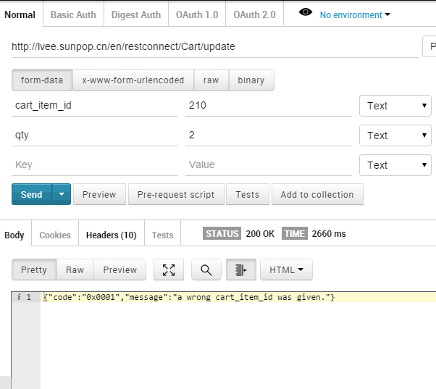

Delete parameters Cart_item_id, before you delete a message asking the customer to confirm the deletion

[http://lvee.sunpop.cn/en/restconnect/Cart/remove](qq://txfile/)

5.5 take the total and coupons in the shopping cart usage

[http://w.sunpop.cn/en/restconnect/Cart/getTotal](https://ssl.translatoruser.net/bv.aspx?from=zh-CHS&to=en&a=http%3A%2F%2Fw.sunpop.cn%2Fen%2Frestconnect%2FCart%2FgetTotal)

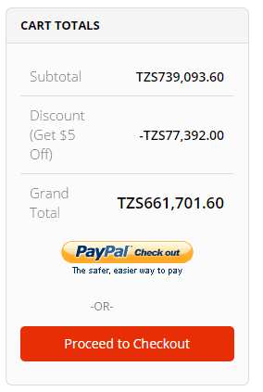

5.6 use in the shopping cart or cancel coupon Coupon

[http://w.sunpop.cn/cn/restconnect/Cart/postCoupon](https://ssl.translatoruser.net/bv.aspx?from=zh-CHS&to=en&a=http%3A%2F%2Fdemo.sunpop.cn%2Fen%2Frestconnect%2FCart%2FpostCoupon)

Parameters 1, and coupon_code: coupon code 2, andremove : 1 Remove coupons said, 0 , said using coupons, default to 0

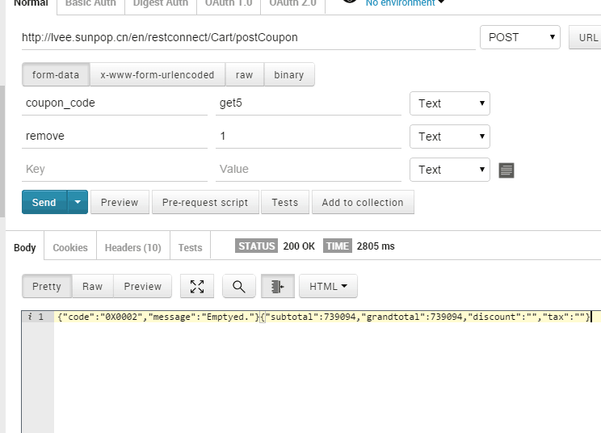

5.7 view added wishlist

Views: [http://lvee.sunpop.cn/en/restconnect/Wishlist/getWishlist](https://ssl.translatoruser.net/bv.aspx?from=zh-CHS&to=en&a=http%3A%2F%2Flvee.sunpop.cn%2Fen%2Frestconnect%2FWishlist%2FgetWishlist)

Join: [http://lvee.sunpop.cn/en/restconnect/Wishlist/addToWishlist](https://ssl.translatoruser.net/bv.aspx?from=zh-CHS&to=en&a=http%3A%2F%2Flvee.sunpop.cn%2Fen%2Frestconnect%2FWishlist%2FaddToWishlist)

    Input parameter - product ID: theproduct

6 Shop information

6.1 shop and view the list of current site

● View

http://w.sunpop.cn/cn/restconnect/store/websiteinfo

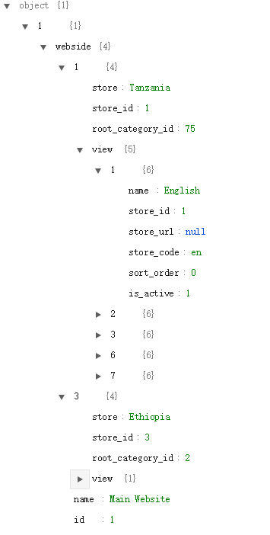

6.2 current store basic parameters

● View

http://w.sunpop.cn/cn/restconnect/store/storeinfo

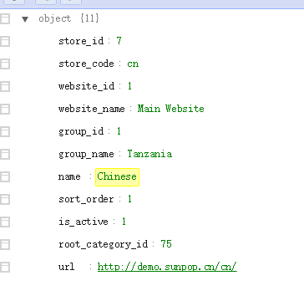

6.3 get the specified CMS block

http://w.sunpop.cn/cn/restconnect/index/getstaticblock?block=app_home_banner1

Parameters: block=[xxx]

6.4 specific Banner block ( converted to Ionic form)

This interface Magento static HTML in the <p> into <ion-slide>

http://w.sunpop.cn/cn/restconnect/index/getbannerblock?block=app_home_banner1

Parameters: block=[xxx]

7 store management functions and interfaces

7.1 plug-in management

● Front (North Canton, a store test data)

http://w.sunpop.cn/cn/storelocator

7.2 Enter address gets close to stores

● Parameter description:

LNG: the longitude

LAT: latitude

RADIUS: search radius (km), the default 200 km

Baidu Gets the address of the interface through latitude and longitude ( js)

[http://developer.baidu.com/map/jsdemo.htm#i7_1](https://ssl.translatoruser.net/bv.aspx?from=zh-CHS&to=en&a=http%3A%2F%2Fdeveloper.baidu.com%2Fmap%2Fjsdemo.htm%23i7_1)

Baidu sk: Ggg84DrtSDEWnG2XNVLxUG1GWIDEeshA

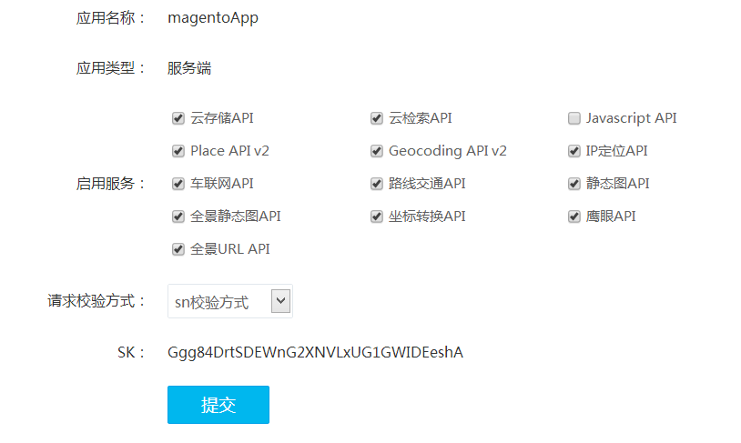

● Default url:

http://w.sunpop.cn/cn/storelocator/index/city/

It looks like:

[http://w.sunpop.cn/cn/storelocator/index/city/lat/23.191411/lng/113.266943/radius/200](https://ssl.translatoruser.net/bv.aspx?from=zh-CHS&to=en&a=http%3A%2F%2Fw.sunpop.cn%2Fcn%2Fstorelocator%2Findex%2Fcity%2Flat%2F23.191411%2Flng%2F113.266943%2Fradius%2F200)

8 information management functions and interfaces (annex)

8.1 front side effects

http://w.sunpop.cn/en/news

8.2 list of access to information

[http://w.sunpop.cn/cn/clnews/api/category](https://ssl.translatoruser.net/bv.aspx?from=zh-CHS&to=en&a=http%3A%2F%2Fw.sunpop.cn%2Fcn%2Fclnews%2Fapi%2Fcategory)

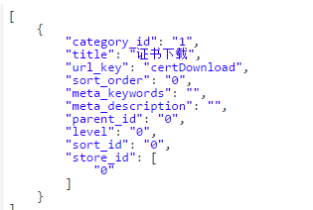

8.3 Get a list of specific articles and information

[http://w.sunpop.cn/cn/clnews/api/article](https://ssl.translatoruser.net/bv.aspx?from=zh-CHS&to=en&a=http%3A%2F%2Fw.sunpop.cn%2Fcn%2Fclnews%2Fapi%2Farticle)

Directory filtering can be added, such as:

http://w.sunpop.cn/cn/clnews/api/article/categoryid/1

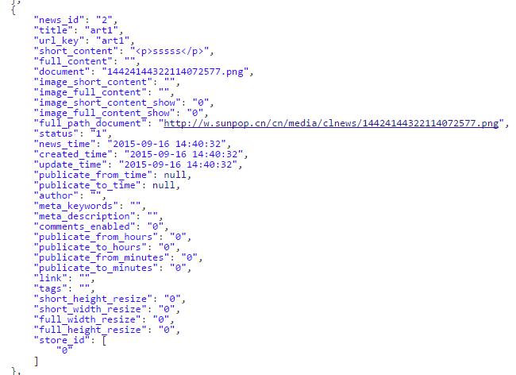

9 short message interface

Supplier: http://www.yuntongxun.com

9.1 sending the verification code

Interface addresses: [http://w.sunpop.cn/smsapi/SendTemplateSMS.php](https://ssl.translatoruser.net/bv.aspx?from=zh-CHS&to=en&a=http%3A%2F%2Fw.sunpop.cn%2Fsmsapi%2FSendTemplateSMS.php)

Parameters: Get sent

Mobile: mobile phone number

Validation: verification code

Timeout: how many minutes to enter a valid

Template: the template temporarily use 1

