This report summarizes and analyzes the results from the 2013 survey of the BUS system. The report has two primary objectives:

1. Determine the characteristics of the population who ride the BUS system; and
2. Identify areas of improvement.

To answer these questions the report is divided into three sections. The first describes the people who use the BUS system. This includes demographic information, such as race and age, in addition to why people ride and how they pay for their trip. The second section identifies areas of deficiency in existing service. The third section prioritizes recommendations for improvement based on the issues riders find most important.

The instrument underpinning this report is a questionnaire with 33 questions. There are responses from 493 individuals captured in this questionnaire. Respondents are actual users of the BUS system and the questionnaires were completed during people’s commute. This report assumes that these respondents are a reasonable representation of BUS’ total ridership.

**Section 1: Rider Profiles**

*Describing BUS Riders*

The ridership of BUS skews younger and has slightly more female riders than male riders. The median age of riders surveyed is 33 and the gender split of riders is 52% female and 48% male.

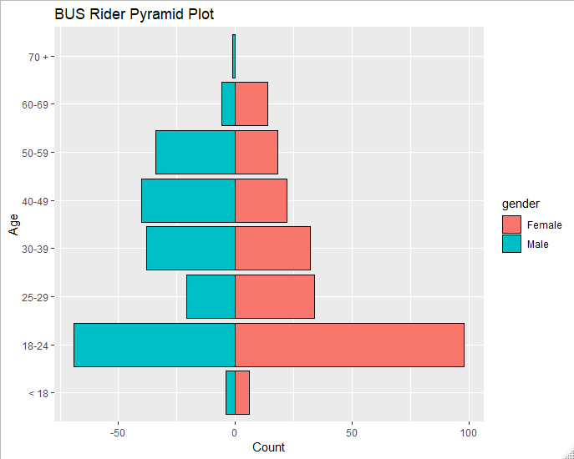Looking at a pyramid plot (*Figure 1*) two trends jump out. The first is large number of 18-24 year olds who use the system, compared to other age groups. The other is that, as the age brackets increase, the higher the proportion of male riders. The median age for male riders is 33 while the median age for female riders is 29.

The racial makeup of the population is majority African American (52%), followed by Caucasian (40%) and Hispanic (3%), Asian (1%) and Other (4%).

Compared to the racial demographics of Jefferson County[1], BUS riders are disproportionately African American (*Figure 2*). However, an Analysis of Variance (ANOVA) test comparing the two groups reveals that there is not a statistically significant difference between the two populations (*Figure 3*).

Figure 1

|  |  |  |  |  |  |
| --- | --- | --- | --- | --- | --- |
|  | African American | Caucasian | Hispanic / Latino | Asian | Other |
| BUS Ridership | 52% | 40% | 3% | 1% | 4% |
| Jefferson County | 22.2% | 67% | 5.7% | 3.1% | 2% |

Figure 2

Df Sum Sq Mean Sq F value Pr(>F)

ind 1 0 0.1 0 0.991

Residuals 8 5393 674.1

Figure 3

Riders of BUS are more likely to be people with lower incomes compared to the county writ large. Jefferson County has a median income of $52,237 (in 2017 dollars)[2] while only 17% of BUS riders surveyed reported an annual income above $50,000 (*Figure 4*).

Figure 4

|  |  |  |  |  |
| --- | --- | --- | --- | --- |
| **< $25k** | **$25k - $35K** | **$35k - $50k** | **$50k - $75k** | **> $75k** |
| 59% | 16% | 8% | 8% | 9% |

More than a third of riders surveyed are not ‘banked.’ With only 64% reporting that they have a bank account, debit card, or credit card.

However, 71% of respondents are ‘connected’ or have access to the internet through a desktop or mobile device or can send and receive text messages. Of respondents that answered this question, 67% reported that they had access to a smartphone or tablet device.

Another trend among riders is that the more people are in each rider’s household, the more likely those other people are to also use the BUS system. That is, if one member of the family rides the bus, it is likely that other members of the family will ride the bus as well. A single variable regression analysis that used the number of people in the household who rode BUS as a function of the number of people a BUS

Residuals:

Min 1Q Median 3Q Max

-1.2918 -1.0979 -0.2918 0.7082 4.9021

Coefficients:

Estimate Std. Error t value Pr(>|t|)

(Intercept) 1.48567 0.11826 12.56 <2e-16 ***

in_home_int$riders_in_household 0.80611 0.04765 16.92 <2e-16 ***

---

Signif. codes: 0 ‘***’ 0.001 ‘**’ 0.01 ‘*’ 0.05 ‘.’ 0.1 ‘ ’ 1

Residual standard error: 1.411 on 371 degrees of freedom

Multiple R-squared: 0.4355, Adjusted R-squared: 0.434

F-statistic: 286.2 on 1 and 371 DF, p-value: < 2.2e-16

Figure 5

rider reported in their household shows a statistically significant correlation between the two (*Figure 5*). Though the low Adjusted R Squared does not suggest a robust ability to predict the number of riders based on the size of household, the p value identifies that the relationship is significant. A visual representation of this trend can be seen in the follow chart (*Figure 6*).

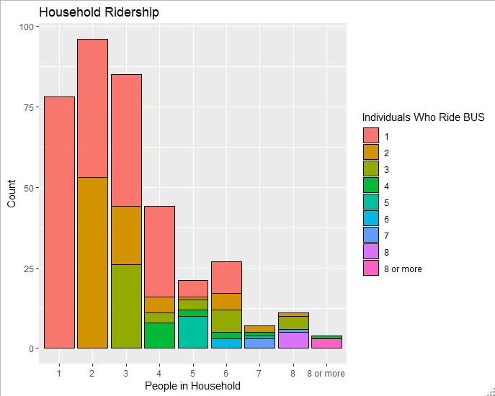

Figure 6

*How and Why People Ride BUS*

**Section 2: Areas of Deficiency**

Overall, the BUS system receives high marks from riders in aggregate satisfaction, with 30% of respondents saying they are ‘Completely Satisfied’ that the BUS system meets their transportation needs (*FIGURE ##)*. On a scale from 1 to 5, where 1 is Not Satisfied, 93% of riders rank the system at 3 or above and only 2% are ‘Not at all satisfied.’

These are good numbers and, with regards to most of the areas of concern that were raised in the survey, the BUS system consistently saw a strong majority of respondents rating BUS at 3 or above.

However, there were 3 areas that riders identified as areas in which they are not satisfied with BUS’ performance. They are the crowding on the bus (*FIGURE XX)*, the state of bus stops (*FIGURE XX and FIGURE XX*), and the cost of fares (*FIGURE XX*). Questions in these areas were the only ones where ‘Not at all satisfied’ surpassed 15% of respondents.

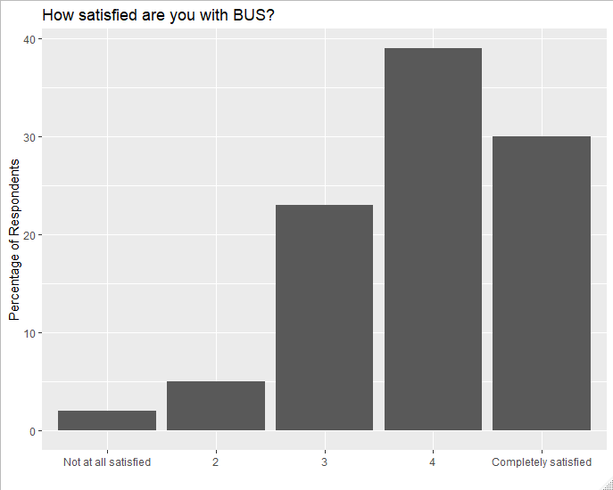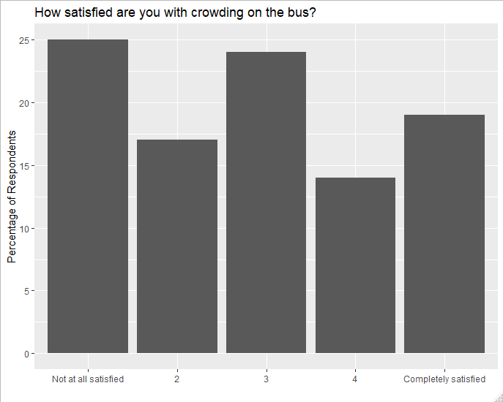

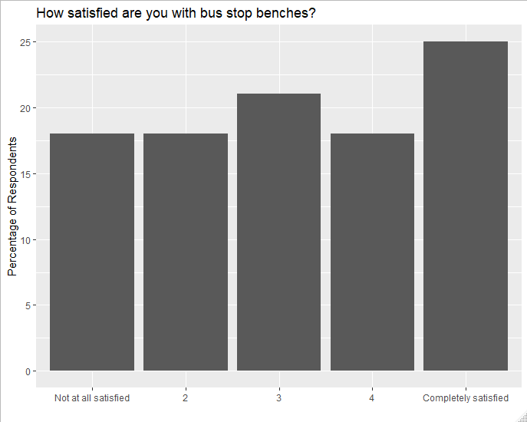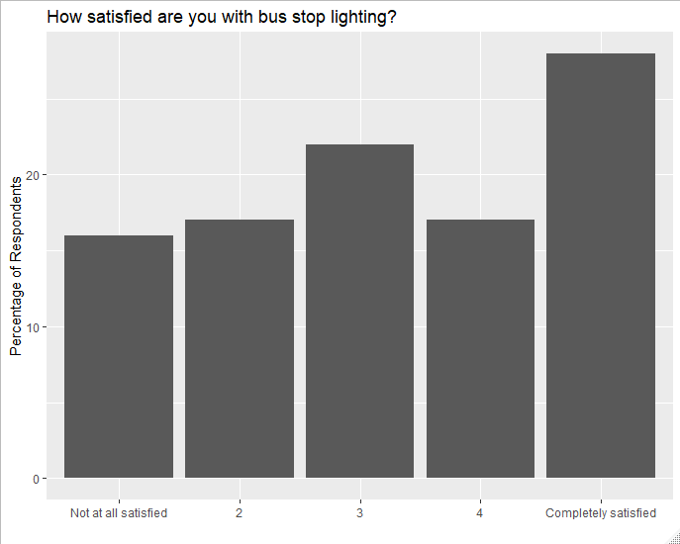

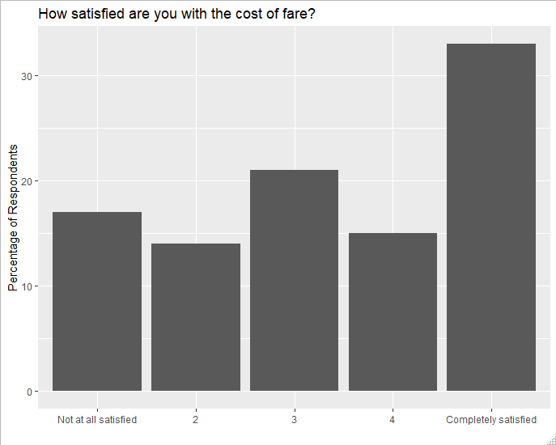

Starting in the top left and moving counterclockwise: Figure XX, Figure XX, Figure XX, Figure XX, and Figure XX

**Section 3: Recommendations for Improvement**

Quickly review Q21; highlight that the bus stop oriented ones get the most universal support vs those that have higher “not at all important” ratings

Priority improvements:

Focus on improving bus stops – benches, lighting per complaints section; adding routes info and bus arrival time indicators. Big investments in improving stops would address a lot of riders top concerns. Can start with less capital intensive things and move up from there (eg lighting or dispensers with paper schedules).

Addressing crowding is also important but there are serious constraints for solving that (basically just adding busses at peak times) so probably better to focus on the low hanging fruit in the bus stops category (if there are any) first

Technology improvements (wifi on busses, text alerts) aren’t as high priority for riders; what they seem to want are physical improvements to bus stops and less crowded busses.

1. Data from US Census Bureau 2018 estimates https://www.census.gov/quickfacts/jeffersoncountykentucky
2. Data from US Census Bureau 2018 estimates https://www.census.gov/quickfacts/jeffersoncountykentucky