Regression Analysis of Water Systems

John Meroth

2019-10-17

## DRINKING WATER VIOLATIONS

The following logistic regression analysis in R estimates the probability of a violation occurring based upon the chosen feature vectors. For most choices, it is believed that no correlation will be seen (ROC plot a straight line). In the event a collection of useful features are discovered, the AUC of the ROC plot will increase and the associated model may prove useful in highlighting at-risk water systems.

Notes:  
Sparse data exists prior to 2008, therefore we use data from 2008 and later.  
Only data from currently “Active” water systems are considered.  
Although some systems report violations quarterly, some report only annually.

## ORGANIZING TEST DATA

The EPA’s SDWIS tables WATER_SYSTEM, VIOLATION, and WATER_SYSTEM_FACILITY can be used to generate a set of labelled test data. Each record, identified by “PWSID” represents a water system in the United States.

### Setup the environment

library(dplyr)  
library(dummies)  
library(readr)  
library(tidyverse)  
library(pROC)  
library(lubridate)  
library(effects)

### Import data from pwsid.csv

This file was created by querying the WATER_SYSTEM table for all active water systems.  
SQL code: SELECT PWSID FROM WATER_SYSTEM WHERE PWS_ACTIVITY_CODE = 'A'

getwd()

## [1] "C:/Users/jmeroth/WATER"

setwd('C:/Users/jmeroth/WATER/derived')  
df <- read_csv("pwsid.csv")

## Parsed with column specification:  
## cols(  
## PWSID = col_character()  
## )

summary(df)

## PWSID   
## Length:146055   
## Class :character   
## Mode :character

### Import data from vHealth.csv

This file was created by filtering the VIOLATION table for health-based violations.  
SQL code: SELECT PWSID , cast(VIOLATION_ID AS TEXT) VIOLATION_ID , COMPL_PER_BEGIN_DATE FROM VIOLATION WHERE IS_HEALTH_BASED_IND = "Y"

setwd('C:/Users/jmeroth/WATER/derived')  
vH <- read_csv("vHealth.csv", col_names = TRUE, cols(VIOLATION_ID = "c"))  
summary(vH)

## PWSID VIOLATION_ID COMPL_PER_BEGIN_DATE  
## Length:200718 Length:200718 Length:200718   
## Class :character Class :character Class :character   
## Mode :character Mode :character Mode :character

Convert character field to date:

vH <- vH %>% mutate(COMPL_PER_BEGIN_DATE = as.Date(COMPL_PER_BEGIN_DATE, format = "%d-%B-%y"))  
str(vH)

## Classes 'spec_tbl_df', 'tbl_df', 'tbl' and 'data.frame': 200718 obs. of 3 variables:  
## $ PWSID : chr "NJ1413324" "CA5403141" "CA5403141" "CA4300614" ...  
## $ VIOLATION_ID : chr "13" "1300004" "1200002" "1217002" ...  
## $ COMPL_PER_BEGIN_DATE: Date, format: "2018-09-11" "2013-01-01" ...

Create label field “H_viol_2017” from health violation data:

vH <- vH %>%   
 filter(year(vH$COMPL_PER_BEGIN_DATE) == 2017) %>%  
 group_by(PWSID) %>%  
 summarise(H_viol_2017 = 1)  
head(vH)

## # A tibble: 6 x 2  
## PWSID H_viol_2017  
## <chr> <dbl>  
## 1 010502003 1  
## 2 055294401 1  
## 3 055294801 1  
## 4 062002156 1  
## 5 063500006 1  
## 6 063500119 1

Merge data into df forming the test data set:

df <- merge(df, vH, by.x="PWSID", by.y="PWSID", all.x=TRUE)  
df[is.na(df)] <- 0  
summary(df)

## PWSID H_viol_2017   
## Length:146055 Min. :0.0000   
## Class :character 1st Qu.:0.0000   
## Mode :character Median :0.0000   
## Mean :0.0387   
## 3rd Qu.:0.0000   
## Max. :1.0000

## FEATURE ENGINEERING

“Features” are characteristics or measurments of each sample in our data set. A good feature will be somehow related to the chances of a system registering a violation. The exact relationship to a violation need not be know for the feature to be useful.

### TREATED_SOURCE

Add a binary predictor variable, “TREATED_SOURCE” (1 if treatment facility exists). The file treated_source.csv was created using this SQL code:  
with active_facilities AS ( select ws.PWSID from WATER_SYSTEM2 ws left join WATER_SYSTEM_FACILITY_3 fa on ws.PWSID = fa.PWSID where ws.PWS_ACTIVITY_CODE = ‘A’ and fa.IS_SOURCE_TREATED_IND = ‘Y’ and fa.FACILITY_ACTIVITY_CODE = ‘A’) Select DISTINCT PWSID from active_facilities

setwd("C:/Users/jmeroth/water/derived")  
treated_source <- read_csv("treated_source.csv")

## Parsed with column specification:  
## cols(  
## PWSID = col_character()  
## )

treated_source$TREATED_SOURCE = 1  
df <- merge(df, treated_source, by.x="PWSID", by.y="PWSID"  
 , all.x=TRUE)  
df[is.na(df)] <- 0

### VIOLATION_CATEGORY_CODE

Add a group of variables indicating the occurrance of a non-health violation in the prior year (2016). The file violation_category_code.csv was created using this SQL code:  
SELECT PWSID, VIOLATION_CATEGORY_CODE, substr(COMPL_PER_BEGIN_DATE, -2) AS vYear FROM VIOLATION2 WHERE IS_HEALTH_BASED_IND = “N” and PWS_ACTIVITY_CODE = ‘A’ and vYear = ‘16’ GROUP by PWSID, VIOLATION_CATEGORY_CODE, vYear  
The resulting records were pivoted by PWSID on VIOLATION_CATEGORY_CODE.

setwd("C:/Users/jmeroth/water/derived")  
violation_category_code <- read_csv("violation_category_code.csv")

## Parsed with column specification:  
## cols(  
## PWSID = col_character(),  
## MON = col_double(),  
## MR = col_double(),  
## Other = col_double(),  
## RPT = col_double()  
## )

df <- merge(df, violation_category_code, by.x="PWSID", by.y="PWSID"  
 , all.x=TRUE)  
df[is.na(df)] <- 0

### PRIMARY_SOURCE_CODE

The file primary_source_code.csv was created using this SQL code:  
SELECT PWSID, PRIMARY_SOURCE_CODE FROM WATER_SYSTEM WHERE PWS_ACTIVITY_CODE = ‘A’

Add a categorical variable “PRIMARY_SOURCE_CODE”:

setwd("C:/Users/jmeroth/water/derived")  
psc <- read_csv("primary_source_code.csv")

## Parsed with column specification:  
## cols(  
## PWSID = col_character(),  
## PRIMARY_SOURCE_CODE = col_character()  
## )

# Merge the new feature vector:  
df <- merge(df, psc, by.x="PWSID", by.y="PWSID", all.x=TRUE)  
# Convert empty cells to zero:  
df[is.na(df)] <- 0

### PWS_TYPE_CODE

The file pws_type_code.csv was created using this SQL code:  
*SELECT PWSID, PWS_TYPE_CODE FROM WATER_SYSTEM WHERE PWS_ACTIVITY_CODE = ‘A’*

Add a categorical variable “PWS_TYPE_CODE”:

setwd("C:/Users/jmeroth/water/derived")  
ptc <- read_csv("pws_type_code.csv")

## Parsed with column specification:  
## cols(  
## PWSID = col_character(),  
## PWS_TYPE_CODE = col_character()  
## )

# Merge the new feature vector:  
df <- merge(df, ptc, by.x="PWSID", by.y="PWSID", all.x=TRUE)  
# Convert empty cells to zero:  
df[is.na(df)] <- 0

## MODELLING

### Run the Logistic Regression Model:

logit <- glm(H_viol_2017 ~ TREATED_SOURCE + PRIMARY_SOURCE_CODE + PWS_TYPE_CODE + MON + MR + Other + RPT  
 , data = df, family = "binomial")  
summary(logit)

##   
## Call:  
## glm(formula = H_viol_2017 ~ TREATED_SOURCE + PRIMARY_SOURCE_CODE +   
## PWS_TYPE_CODE + MON + MR + Other + RPT, family = "binomial",   
## data = df)  
##   
## Deviance Residuals:   
## Min 1Q Median 3Q Max   
## -1.5772 -0.2712 -0.2174 -0.1953 2.8933   
##   
## Coefficients:  
## Estimate Std. Error z value Pr(>|z|)   
## (Intercept) -3.90972 1.00883 -3.875 0.000106 ***  
## TREATED_SOURCE 0.04206 0.02950 1.426 0.153844   
## PRIMARY_SOURCE_CODEGU 1.34306 1.01534 1.323 0.185910   
## PRIMARY_SOURCE_CODEGUP 0.25472 1.13055 0.225 0.821739   
## PRIMARY_SOURCE_CODEGW 0.43686 1.00900 0.433 0.665045   
## PRIMARY_SOURCE_CODEGWP 0.27449 1.01354 0.271 0.786527   
## PRIMARY_SOURCE_CODESW 1.73563 1.00982 1.719 0.085660 .   
## PRIMARY_SOURCE_CODESWP 0.98771 1.00982 0.978 0.328020   
## PWS_TYPE_CODENTNCWS -0.26057 0.04805 -5.423 5.86e-08 ***  
## PWS_TYPE_CODETNCWS -0.47704 0.03391 -14.066 < 2e-16 ***  
## MON 0.66502 0.04155 16.006 < 2e-16 ***  
## MR 0.78269 0.03392 23.073 < 2e-16 ***  
## Other 0.89981 0.03682 24.439 < 2e-16 ***  
## RPT 0.68810 0.08008 8.593 < 2e-16 ***  
## ---  
## Signif. codes: 0 '***' 0.001 '**' 0.01 '*' 0.05 '.' 0.1 ' ' 1  
##   
## (Dispersion parameter for binomial family taken to be 1)  
##   
## Null deviance: 47843 on 146054 degrees of freedom  
## Residual deviance: 44115 on 146041 degrees of freedom  
## AIC: 44143  
##   
## Number of Fisher Scoring iterations: 6

Result of regression using the “effects” library:

par(mfrow=c(2,1))  
plot(effects::allEffects(logit), axes=list(grid=TRUE))

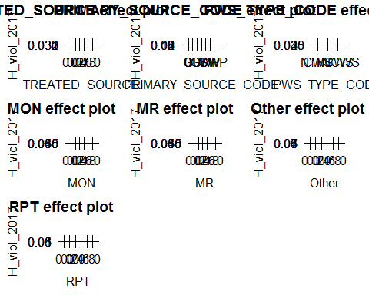

### Create Test Data

test_data <- df  
test_data$PWSID <- NULL  
test_data$H_viol_2017 <- NULL

Calculate probabilities P, add to data frame.

df["P"] <- predict(logit, test_data, type="response")

## ANALYSIS

### Analysis of Means

df %>% group_by(H_viol_2017) %>% summarise(mean = mean(P))

## # A tibble: 2 x 2  
## H_viol_2017 mean  
## <dbl> <dbl>  
## 1 0 0.0372  
## 2 1 0.0771

### Pivot tables

xtabs(~H_viol_2017 + PRIMARY_SOURCE_CODE, data = df)

## PRIMARY_SOURCE_CODE  
## H_viol_2017 0 GU GUP GW GWP SW SWP  
## 0 60 882 131 123724 3441 4382 7783  
## 1 1 92 4 4165 110 712 568

xtabs(~H_viol_2017 + PWS_TYPE_CODE, data = df)

## PWS_TYPE_CODE  
## H_viol_2017 CWS NTNCWS TNCWS  
## 0 46763 16959 76681  
## 1 2915 599 2138

### Probability Distribution

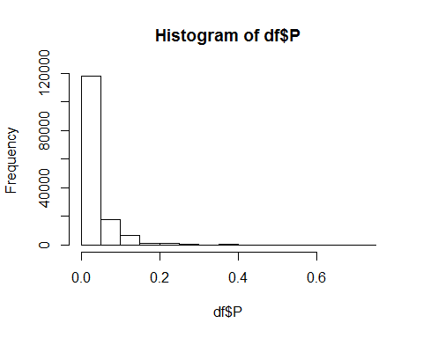

### Confusion Marix with threshold set as P = 0.3

df %>% group_by(P > 0.3) %>% filter(H_viol_2017 == 1) %>% summarise(n())

## # A tibble: 2 x 2  
## `P > 0.3` `n()`  
## <lgl> <int>  
## 1 FALSE 5520  
## 2 TRUE 132

df %>% group_by(P > 0.3) %>% filter(H_viol_2017 == 0) %>% summarise(n())

## # A tibble: 2 x 2  
## `P > 0.3` `n()`  
## <lgl> <int>  
## 1 FALSE 140088  
## 2 TRUE 315

### ROC

#Create a square plot  
par(pty = "s")  
roc(df$H_viol_2017, df$P, plot=TRUE, legacy.axes=TRUE, percent=FALSE, xlab="False Positive Rate", ylab="True Positive Rate", col="#377eb8", lwd=4, print.auc=TRUE)

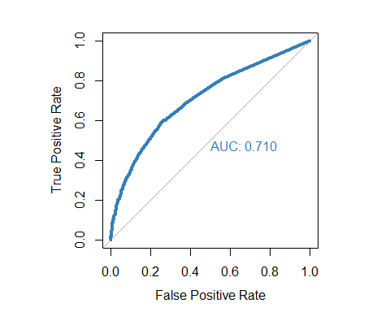

##   
## Call:  
## roc.default(response = df$H_viol_2017, predictor = df$P, percent = FALSE, plot = TRUE, legacy.axes = TRUE, xlab = "False Positive Rate", ylab = "True Positive Rate", col = "#377eb8", lwd = 4, print.auc = TRUE)  
##   
## Data: df$P in 140403 controls (df$H_viol_2017 0) < 5652 cases (df$H_viol_2017 1).  
## Area under the curve: 0.7096

## CONCLUSION

More feature vectors must be included to improve the probability estimates.